Rules of Operation

Lukáš Trantírek Research Group

.:

Contents

Introduction 4

Contact Details 4

Building Layout 5

Laboratory 5

Requirements Applicable to the Workplace 5

Work Description 6

Work Conditions 6

Medical Fitness 6

Conditions for the Presence in the Laboratory 7

Theoretical and Practical Training 7

Entry of Persons into the Laboratory 8

Work and Presence in the Laboratory 9

Work with Biological Agents 10

Handling of biological substances 10

Rules for handling of dangerous biological substances 11

Formation of aerosols 11

Handling of biological agents of class 2 12

Work with Dangerous Chemical Substances and Mixtures 12

Work with pressure vessels 14

Work with Cryogens 14

Guidelines for handling cryogenic liquids 15

Storage conditions 15

Work with Radioactive Substances 16

Limits for radiation personnel 16

Work with Genetically Modified Organisms 17

Work with Burners 17

Work with the Instrumentation 17

Prohibited Activities 18

Personal Protective Equipment (PPE) at the Workplace 19

Handling of Hazardous Waste 20

Emergency Procedures 23

Injury 23

Fire 24

Conclusion 25

Annexes 25

# Introduction

The purpose of this safety regulation is to determine the work procedures for the use of devices and the rules of presence of persons within the premises of Lukáš Trantírek Researg Group in building E35, to the maximum extent possible, the probability of occupational injuries occurring at the workplace.

These Rules of Operation are binding for all persons entering the aforementioned rooms appointed to perform these activities and, to a reasonable extent, also for other persons carrying out works associated with the rules of operation of the aforementioned RG. All persons present within the specified premises are obliged to observe also the Rules of Operation of CEITEC MU and the Rules of Operation of UKB.

In the case of any inquiries, comments or requirements, please feel free to contact the research group leader.

# Contact Details

|  |  |  |
| --- | --- | --- |
| Research group leader |  | [lukas.trantirek@ceitec.muni.cz](mailto:lukas.trantirek@ceitec.muni.cz) |
| Central security desk |  |  |
| Reception desk at building E35 | 549 49 2911 |  |
| Occupational safety, health protection and fire prevention manager | 777 926 633 111  549 49 8037 | [barbora.louckova@ceitec.muni.cz](mailto:barbora.louckova@ceitec.muni.cz) |
| GMO expert advisor | tel.: 736 542 386  549 49 4537 | [petr.mokros@ceitec.muni.cz](mailto:petr.mokros@ceitec.muni.cz) |

# Building Layout

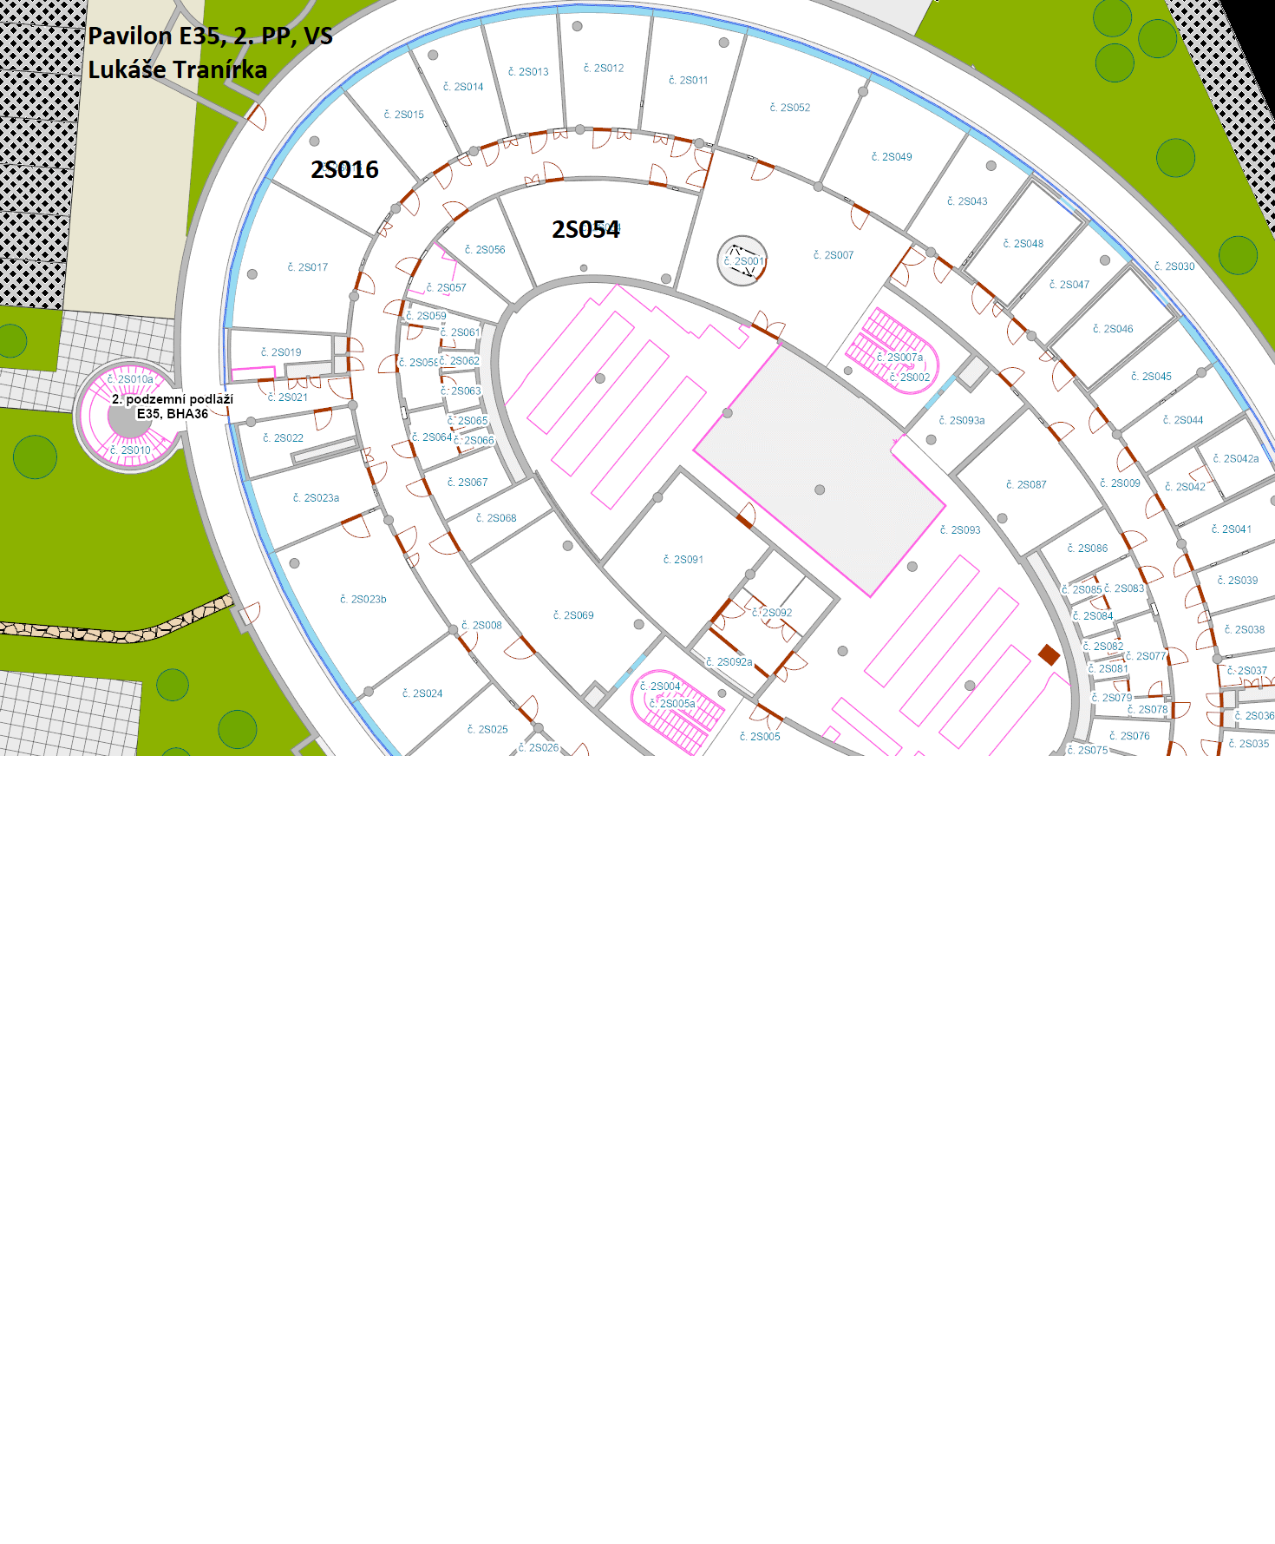

## 

## Laboratory

The laboratory of RG Lukáše Trantírka (rooms 1S142, 1S143, 1S147 - cold room, 1S125 (shared room for car washes, autoclaves, 1S124 - shared room for centrifuges, freezers, then in the 2nd floor, 2S054 and 2S016, hazardous waste is stored in room 2S096) in building E35 of Bohunice University Campus, Kamenice 753/5, 625 00 Brno. It is not a generally accessible or passable space. It is equipped with a lockable door, with a ball on the outside of the door to prevent entry by unauthorized persons. The door is provided with a window and marked with a combined biohazard sign. Access to the laboratory is restricted to trained staff who have been demonstrably acquainted with the Rules of Operation.

The laboratory has a tight dust-proof raster ceiling, the walls are covered with ceramic tiles and there is a trowel-finished floor. Laboratory bench surfaces are easy to clean and accessible for maintenance, impervious to water and resistant to disinfectants, detergents, acids, alkalis, solvents and other chemicals available in the laboratory. The laboratory is of microbiological and biochemical nature and is equipped with the necessary instrumentation for work with biological agents.

## Requirements Applicable to the Workplace

1. Cleaning shall be carried out by a specialized company once a day on weekdays. For extraordinary cleaning, please contact the Operations Department.
2. Further cleaning, repairs, revisions are arranged by the RG leader in cooperation with the Operations Department. Inspections of the autoclave, electrical appliances and electrical installations are arranged by the Operations Department. The documentation pertaining to these inspections shall be kept by the occupational safety, health protection and fire prevention manager. Inspection dates are governed by the current legislation in force. Inspections of devices and tools shall be carried out at least once a year together with occupational safety, health protection and fire prevention inspections at the specific workplace. These inspections shall be organised by the RG leader and confirmed with a record.
3. The documentation shall be kept by the technician, the documentation keeping includes updates when necessary; the technician shall keep the following documentation:
   1. records of biological agents;
   2. Rules of Operation and demonstrable acquaintance therewith by the employees;
   3. safety data sheets;
   4. identification sheets of hazardous waste;
   5. instructions for use.

## Work Description

Study of nucleic acids and proteins under *in vitro* and *in vivo* conditions - chromatography, NMR, electrophoresis, CD, western blot, confocal microscope, flowcytometry, mass spectrometry, work with cell cultures.

## Work Conditions

Only persons who are professionally and medically qualified and demonstrably familiar with these Rules of Operation, the safety data sheets of the chemical substances and mixtures used and the instructions for use of the machines, instruments and equipment used may work in the laboratory.

### Medical Fitness

Only medically fit employees may work at the workplace of Lukáš Trantírek RG. The assessment of medical fitness for work is issued by the provider of occupational health services, MUDr. Věra Přibylová, who issues the relevant medical certificate.

Employees are classified according to the categorization of jobs and workplaces as follows:

* category 2 in terms of biological agents;
* category 2 in terms of chemical substances.

Employees are subject to the following occupational risks:

* operation of stable pressure vessels (selected employees only)
* operation of pressure cylinders

The time limits for occupational medical examinations are set at a minimum of once every 4 years for persons under 50 years of age, once every 2 years for persons over 50 years of age.

## Conditions for the Presence in the Laboratory

### Theoretical and Practical Training

* Work in the laboratory may be carried out and the laboratory devices may be attended only by employees appointed for this purpose by the RG leader, having adequate professional qualification and health fitness.
  + - * The RG leader decides on professional competence of the staff;
      * The occupational health services provider decides on medical fitness.
* A condition for obtaining professional qualification is successful completion of theoretical and practical training by the employee.
* Each employee must undergo an MU e-learning course on fire prevention, occupational safety and health protection and first aid, and training in the use of pressure vessels. Employees who operate autoclaves must have valid training in the operation of stable pressure vessels.
* In the course of the practical training, the employee attending the device must get acquainted in particular with the following:
  + work with biological agents within the group - loading, handling, storage, transfer, etc.;
  + compliance with safety regulations;
  + carrying out regular attendance of the device;
  + safe handling with the device;
  + proper use of the prescribed personal protective equipment at the workplace;
  + emergency procedures;
  + risks, their prevention and measures taken against them.
* In the course of the theoretical training, the employee must be demonstrably informed of the following:
  + this safe operation regulation;
  + safety data sheets for all hazardous chemical substances and mixtures present at the workplace:
  + operating instructions for machines, devices, equipment at the workplace;
  + placement and use of the first aid kit;
  + use of personal protective equipment at the workplace;
  + identification sheets of hazardous waste;
  + fire alarm guidelines, evacuation plans, location and use of portable fire extinguishers and hydrants.
* The scope of the information on the necessary provisions of the above regulations and instructions shall be determined by the RG leader who will also inform the trainee of all the aforementioned regulations. The frequency of repeating on-the-job training is at least once every 2 years.

### Entry of Persons into the Laboratory

1. The entry to the laboratory must not be freely accessible and must be locked outside of operating hours.
2. Only trained persons may enter the workplace.
3. The laboratory door must be marked with a biohazard sign and the door must be provided with a window.
4. Due to the possibility of laboratory infection, pregnant women are obliged to inform the group leader about this in the interest of their health.

### Work and Presence in the Laboratory

1. The workplace must be kept clean and tidy, in a condition that does not endanger the safety and health of persons.
2. There must be a sufficient amount of disinfecting agents at the work area to be used for the current needs in the event of urgent decontamination need (spillage of liquid or powdery material).
3. The following disinfectants and inactivators must be available at the workplace: Gigasept
4. No work steps are to be taken hastily; in case of doubt, the group leader is to be consulted about the procedure.
5. It is necessary to avoid any hand movements towards the mouth, eyes, etc. in the laboratory, it is prohibited to eat, drink, smoke, lick stickers, operate the pipette with the mouth etc.! (contaminated hands or anything else can transfer infection to the body orifices).
6. It is prohibited to keep any personal edibles in the refrigerators (food, drinks - the refrigerator in the day room is designated for this purpose).
7. All injuries, including those not resulting in work incapacity, must be recorded in the injury information sheet; each injury must be reported to the group leader and the   
   occupational safety, health protection and fire prevention manager.
8. Employees are obliged to report immediately to the group leader all defects that threaten the safety of work, accidents in the laboratory, explosions, fires and the like, and a record of this fact is to be made; if possible, the authorized personnel shall eliminate the consequences of any non-standard events with their own forces.
9. For example, it is not possible to work with a flammable solvent in one fume hood and heat anything with a gas burner. In case of a flammable substance spillage, turn off the fire immediately. Never leave a burner lit without supervision.
10. Employees are required to get acquainted with the safety data sheets that must be available at the workplace.
11. No smoking, drinking alcohol and using other intoxicants at all CEITEC MU workplaces.

# Work with Biological Agents

**What is a biological infectious substance**

* Biological infectious substances are defined as all microorganisms (bacteria, archaea, viruses, candidae, lower fungi, protozoae in both pure and mixed culture, including metabolites), as well as these microorganisms potentially present in the material samples;
* Biological infectious substances further include any laboratory material that has been in contact with and might have been contaminated by such microorganisms;
* Any raw metabolites potentially containing the original culture; or
* Any biological material that can, by its very nature, contain any microorganisms.

### Handling of biological substances

* All works with biological materials are subject to the regime of “Technical Safety Level 1”,
* All microorganisms are considered potentially pathogenic and all infectious materials must be clearly labelled in order to prevent errors;
* The processed materials are usually known in terms of their potential dangerousness for humans and for the environment – in microbiological laboratories, these are microorganism cultures on solid or in liquid media (Petri dish, tube); in the case of work with an unknown material, it is always considered pathogenic;
* All handling of infectious materials is always done with tools: loops, needles, injection needles and syringes, forceps, pipettes, etc.; operating a pipette with one’s mouth is absolutely impermissible;
* Metal loops and tweezers are annealed to a red heat before and after use; when annealing loops with culture residue, it is necessary to avoid sizzling and splashing of the material by drying the loops on the edge of the flame; if disposable plastic tools are used, they are placed in a disinfectant solution after use and autoclaved;
* If an employee of the laboratory becomes ill, they must inform the physician that they work in an infectious environment with potential human-transmitted pathogens;
* It is necessary to keep the working area of the entire microbiology workplace clean and tidy;
* Items not related to work activities do not belong in the laboratory or other areas of the microbiology workplace; They are a source of unnecessary complications during the daily cleaning of the workplace or during any kind of accident (breakage of culture vessels, etc.).
* Aerosol formation must be avoided. However, dangerous aerosol formation can occur even when working with common bacterial cultures. This usually happens in cases which, on superficial observation, may seem quite trivial and therefore insignificant. For example a wrongly disposed of broken Petri dish or culture tube. When dropped on the ground, the infectious material splashes into the air - irresponsible way of firing the bacteriological loops – “splashing” of the culture occurs – careless pouring of the culture in the liquid medium associated with splashing of droplets into the surroundings or bursting of bubbles.
* Wven conditionally pathogenic or so-called "non-pathogenic" microorganisms in high concentrations act as strict pathogens.

**The most frequent ways of infecting employees are in particular the following:**

* Failure to maintain the necessary level of personal hygiene;
* Inhalation of aerosol of microorganisms;
* Negligent remediation of broken or spilled cultures at the workplace;
* Unprofessional disposal of multiplied cultures when washing laboratory glassware;
* Penetration of the multiplied culture into small superficial skin lesions or eyes.

# Work with Dangerous Chemical Substances and Mixtures

1. When working with flammable substances, care must be taken to ensure that vapours from open flames, i.e. particularly from nearby burners but also from electrical appliances, cannot ignite.
2. When handling any hazardous chemical substances and chemical mixtures, the employees are obliged to protect human health and the environment and to observe hazard pictograms, standard statements indicating the specific risks and hazards and standard instructions for safe handling pursuant to the Chemical Substances Act and any directly applicable regulations of the European Union pertaining to chemical substances and chemical mixtures. Chemical substances and mixtures with hazard class of acute toxicity category 1 or 2 are subject to registration, for their handling professional competence is required according to Section 44b of Act No. 258/2000 Coll., as amended.
3. The Director's Measure No. 7/2016 , with which the employees have been demonstrably acquainted, must be complied with.
4. It is necessary to become familiar with the safety data sheets of hazardous chemicals and mixtures handled in the laboratory.
5. Safety data sheets must be available.
6. Food and beverage packaging not to be used.
7. The personal protective equipment to be used at the workplace.
8. The manufacturer's instructions for safe storage must be followed, especially as regards temperature, humidity, ventilation, etc.

**Storage of chemical substances and chemical mixtures**

* Hazardous substances may only be stored in places designated for this purpose, in the prescribed quantities and in secure packaging, and the packaging must be marked with the contents and a safety label. Only hazardous substances (mixtures of hazardous substances) that do not react dangerously with each other may be stored together; examples of substances that cannot be stored together can be found in Director's Measure No. 7/2016. Chemicals and mixtures may not be stored in alphabetical order!
* If possible, chemical substances or mixtures must be stored in their original packaging, i.e. in closed, tight, undamaged and labelled containers. Containers must be handled and opened carefully, preventing splashing, spilling or spreading of the chemical substance or mixture. The container must be carefully closed after each use.
* Each bottle or other type of packaging must be clearly labelled with its contents.
* The Operations Department to be contacted to print labels for the packaging. Even syringes containing dangerous mixtures must be properly labelled (warning symbols, name, H phrases, P phrases or signal word).
* Packaging containing flammable liquids must be marked with safety signs indicating their contents and fire protection hazards.
* Highly toxic substances (acute toxicity of categories 1 and 2) must be locked away to prevent unauthorised access. Highly toxic substances may be stored together with toxic substances in the same compartment, but they must be clearly separated from each other. They can only be stored in a common room with other chemicals if they are separated from the other substances, e.g. placed in a separate cabinet, on a separate shelf or rack. Highly toxic substances must be registered, and a registration sheets are to be kept for each such substance separately.
* A maximum of 5 litres of flammable liquids of hazard class I per person is allowed in the laboratory. Alcohol must be collected from the SUKB central warehouse using a labelled container.
* Containers with chemical substances and mixtures must be secured against falling and must not be placed on the floor, table, etc.
* Chemical substances and mixtures may only be stored at a place designated for that purpose.
* The maximum storage height for hazardous chemicals and mixtures is 1.8 m.
* Flammable liquids must be stored in containment containers so that the container captures the largest volume of the container being stored.
* There is a safety ventilated cabinet under the fume hood for storage of flammable substances.

# Work with Pressure Vessels

1. Handling, transport or storage of pressure vessels may only be performed by persons over 18 years of age, medically fit and trained to perform these activities, with the training interval being once every 3 years; the training may be taken in electronic form. To open the training, contact the occupational safety, health protection and fire prevention manager.
2. Employees must be demonstrably acquainted with the Director's Measure No. 6/2017.
3. Vessels containing technical gases may only be kept in the laboratory if they are necessary for the operation. Any permanently not necessary or empty vessels must be removed.
4. Pressure vessels must be appropriately secured against fall and impact
5. The vessels must be located in a sufficient distance from heating units and heat-emitting surfaces, so that the surface temperature of the vessels does not exceed the critical temperature value in the case of liquified gases and 50°C in the case of other gases, respectively. The vessels must be located in the distance of at least 3 meters from sources of open fire.
6. Prior to commencing work with technical gases, it is necessary to read the gas safety data sheets and to comply with the procedures and safety precautions arising from them.
7. Prior to commencing work with technical gases, it is necessary to ensure the possibility of ventilation, to prepare adequate protective, fire extinguishing and decontamination tools, to inspect sealing and the functionality of reduction valves and sealing of the installations.
8. While working with technical gases, the following is prohibited:
   1. Using vessels with expired date of periodic tests or damaged vessels;
   2. Using unsuitable or damaged reduction valves;
   3. Using force or unsuitable tools for opening and closing valves, including pipe extensions;
   4. Using the vessels for any other purposes or for any other gases than intended;
   5. Repairing the vessels or valves or altering their labelling;
   6. Accelerating the gas discharge by means of heating;
   7. Free discharging of gases within closed areas, except where this is a part of the work process.

### Carbone dioxide CO2

* contains gas under pressure, may explode when heated
* colourless, tasteless and odourless gas, may have a slight sour taste in the mouth at higher concentrations
* heavier than air
* at high concentrations it is suffocating
* contact with liquid CO2 may cause frostbite

# Work with Cryogens

* Cryogen liquids are substances that are in gaseous state at normal temperature and pressure. Upon cooling down to a very low temperature, they become liquid. Their boiling point is usually lower than -150°C. The vapours and gases evaporating from these liquids are very cold. They often condensate humid air, thus creating a very dense mist. Various cryogens become liquid under different thermal conditions and different pressure levels, but they all are extremely cold and even a small amount of these substances can generate enormous amounts of gas. Every person working with cryogens must be aware of their dangerousness and must know how to handle them safely.
* Employees who work with cryogenic liquids must be familiar with the [Director's Measure No. 3/2023.](https://is.muni.cz/auth/do/ceitec/uredni_deska/opatreni_reditele/opatreni_reditele_2023_03_-_bezpecnost_prace_s_kapalnym_dusikem_a_dalsimi_kryoge/)

## Guidelines for handling cryogenic liquids

1. Non-insulated pipes or containers with cryogenic liquids never to be touched with an unprotected part of the body. The tissue damage that could result is the same as frostbite or burns.
2. Dewars to be handled with care. To be placed only on a flat surface so that they do not tip over.
3. No tools to be used to scrape the inner glass of the containers. No hard tools to be used to search the contents inside the containers.
4. Extremely cold metal will cause the tissue to stick very quickly and tear when trying to separate.
5. Many substances and materials become brittle on contact with cryogens, and objects made of them can be more easily broken or otherwise damaged – pieces can fly a great distance. The use of ordinary glass and plastics to be avoided.
6. The release of cryogens into the space can cause damage to the floor, electrical cables and their insulation, pipes, etc.
7. Storage containers may tip over when obstacles are being overcome. Containers to be handled with the utmost care. Ensure that there are no obstructions on the floor. Observe the manufacturer’s instructions.
8. Water from the air can condense and/or freeze in cryogenic liquid storage containers, leaving water on the floor where personnel can slip. The water must be mopped up immediately to avoid the risk of slipping.
9. If water continues to condense in the cryogenic liquid container, the operator must place absorbent materials around the container to prevent the water from becoming a slipping hazard. If the floor cannot be kept dry, it must be clearly marked with a sign “Wet floor, danger of slipping!” Signage can be obtained from the cleaning service.

## Storage conditions

1. Cryogens to be stored and used only in places with adequate ventilation (avoiding atmospheres with oxygen deficiency below 19.5%).
2. The workplace manager is obliged to ensure that cryogens are not stored in confined spaces (risk of suffocation, explosion).
3. Cryogenic containers are equipped with pressure relief valves to control the internal pressure. Under normal conditions, these vessels periodically release some of the gas. It is prohibited to block, remove or otherwise replace these valves, as this may lead to an explosion.
4. Containers should be carried and stored upright with the bottom down.
5. Small quantities of liquid nitrogen can be stored with care in glass-lined thermoses.

# Work with Genetically Modified Organisms

* We proceed according to Act No. 78/2004 Coll., on the handling of genetically modified organisms and genetic products.
* Implementing Decree No. 209/2004 Coll., on more detailed conditions for handling of genetically modified organisms and genetic products.
* The expert advisor is Mgr. Petr Mokroš, Ph.D.

# Work with Burners

1. Never leave a burner lit without supervision.
2. Follow the manufacturer’s instructions.
3. Inspect the burner prior to its use.
4. It is not possible to work with flammable solvents and to heat anything with a burner in the fume hood.
5. In case of a flammable substance spillage, turn off the burner immediately.

# Work with the Instrumentation

1. Keep instructions for use of the devices at the workplace.
2. Employees operating electrical appliances must follow work procedures specified in the manufacturer’s instructions for use of such devices.
3. Employees operating electrical appliances must ensure an adequate and safe work area for this activity.
4. The safe operation of any device is the responsibility of the operator who switches it on.
5. To work with the autoclave, employees should receive training in the operation of stable pressure vessels at regular intervals of every 3 years.
6. Each defect on the instrumentation to be reported to the RG leader. Defective devices not to be operated, they should be tagged and put out of service.
7. When the work is finished, the devices that are unnecessary for the operation must be switched off.
8. The accompanying documentation (excluding revisions) shall be kept in the laboratory.
9. Adequate access to the devices must be ensured.
10. Inspections of operational documentation and instruments to be carried out at least once every 12 months. The inspection shall be carried out by the RG leader as a part of occupational safety, health protection and fire prevention inspections at the given workplace.
11. It is prohibited:
    1. to use electrical appliances with damaged power supply;
    2. to use electrical appliances with missing protective cover;
    3. to subject power cords to tensile stress;
    4. to overload electrical appliances above the technical limits prescribed by the manufacturer;
    5. to use electrical appliances for any other purposes than those specified by the manufacturer;
    6. to use unregistered electrical appliances; the prohibition of their use applies also to activities associated with activities carried out for CEITEC MU and activities carried out outside the premises of CEITEC MU;
    7. to route power cords across sharp edges;
    8. to arbitrarily change the location of electric heaters;
    9. to continue working with an electrical appliance if a serious defect or malfunction occurs on such appliance.

# Prohibited Activities

* No unauthorised persons may work in the laboratories.
* It is prohibited to eat, drink and smoke in the laboratories.
* It is prohibited to use any unsuitable or damaged devices, tools and laboratory dishes.
* It is prohibited to use defective glass.
* It is prohibited to have dishes washed if they are contaminated by strong acids or alkalis, toxic or irritating substances that are rapidly decomposed in water.
* It is prohibited to use laboratory dishes for eating, drinking or for keeping food.
* It is prohibited to store food and beverages intended for consumption in refrigerators or freezers designated for keeping chemical substances or biological materials.
* It is prohibited to transfer open packages containing toxic and highly toxic substances (acutely toxic categories 1 and 2) or corrosives.
* It is prohibited to pour in the sewage pipes any solvents that do not perfectly mix with water, any toxic and highly toxic substances, acids and hydroxides above the defined concentrations, explosives, any substances releasing toxic or irritating gases upon contact with water, acids and hydroxides.
* It is prohibited to pour any liquid or powdery chemicals or reaction waste in the sanitary facilities.
* It is prohibited to use plastic containers for collecting waste solvents.
* It is prohibited to discard any substances capable of causing fire in the waste containers.
* It is prohibited to leave burners lit without supervision.
* It is prohibited to carry out works on electrical devices by employees without adequate electrical engineering qualification.
* It is prohibited to carry out any activities or interventions in the technical equipment of the laboratory without adequate qualification or permit.
* It is prohibited to work without the provided personal protective equipment.

Emergency shutdown buttons are located in the corridors outside the entrances to the laboratories (see Figure 1), emergency buttons are also located inside some laboratories.

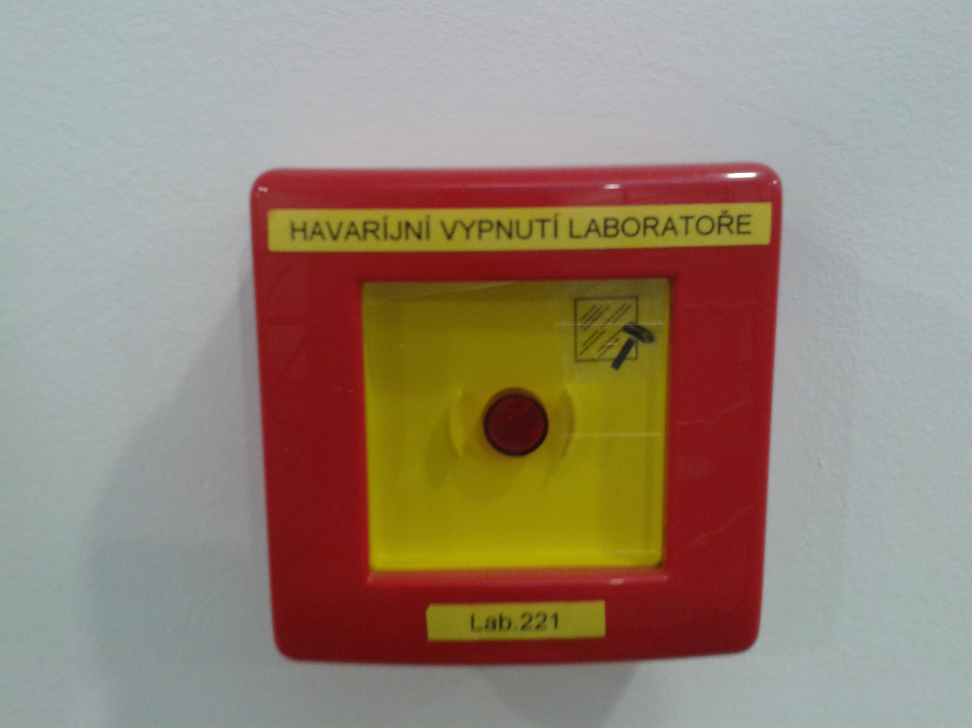

Figure Emergency shutdown of the laboratory

# Personal Protective Equipment (PPE) at the Workplace

* PPE means protective equipment that must protect employees against risks, may not endanger their health, may not cause obstacles for the work performance and must comply with the requirements stipulated by applicable legal regulations.
* Personal protective equipment shall be assigned to employees whenever the original equipment has reached the end of its service life as specified by the manufacturer, has lost its functional characteristics or effectiveness against the hazards involved, or if its use poses an additional risk. PPE shall be assigned by the RG leader based on the risk assessment.
* PPE shall be released against signature and getting acquainted with the PPE;   
  the PPE registration sheet is set out in Annex No. 1 hereof. Signed registration sheets are to be kept at the workplace.
* Laundry of working clothes and coats is provided by the laundry of the Brno University Hospital at regular intervals. The laundry is collected in room 1S046. The clothes are to be marked with a textile marker with the code 163/1000 for the Centre for Structural Biology, and the user's name.
* It is prohibited to use protective gloves from the laboratories in the corridors!

Based on the risk assessment, the following PPE shall be used:

|  |  |
| --- | --- |
| Name of the PPE | Details |
| Laboratory coat | chemically resistant |
| Nitrile gloves | available in laboratory 1S132 |
| Laboratory footwear |  |
| Protective shield |  |
| Protective goggles | clear, chemical, closed |
| Cryogenic gloves |  |

# Handling of Hazardous Waste

Waste is sorted at the point of generation, each catalogue number has one sealed leak-proof container marked with the catalogue number into which leak-proof plastic bags are placed. Liquid waste is placed in special plastic labelled containers. When the container is full or at the end of the shift, the responsible employee shall take the sealed, labelled bags of waste to the waste cool room no. 2S096 in building E35. The waste cool room maintains a temperature of 4-6 °C and waste is sorted there according to codes. The waste room is emptied twice a week or as required by the SUKB waste management service. The waste is sorted in its premises for waste removal by a specialized contracting company FCC Česká republika, s.r.o., ID No.: 45809712. The waste cool room is equipped with ILNO, lockable, with impermeable floor and walls, fully washable, equipped with ventilation system. It is not a central waste collection point.

Waste code stickers are available from the Operations Department, contact person: Barbora Loučková, 777 926 633, they are also supplied to the rack by the waste cool room. The number or name of the workplace must be written on the sticker.

Sharps waste shall be placed in labelled, incinerable, full-walled, leak-proof and leak-proof containers. Liquid waste is sorted at the point of generation into special containers that are labelled according to the waste code. These containers are taken to the waste cool room no. 2S096 in building E35 as needed or at the end of the shift.

In the event of spillage of powders or liquids, immediately start remediation work, solids to be collected in original or replacement solid containers, liquid substances and their residues to be covered with absorbent material and subsequently swept away and placed in impermeable collection devices.  
 Leakage into the waterways is prevented.

Absorbent material is provided at the workplace, spare packaging at the workplace and by the waste cooling room no. 2S096.

List of wastes

|  |  |  |
| --- | --- | --- |
| 15 02 02* | Absorbents, filter materials (including oil filters not specified otherwise), cleaning cloths and protective clothing contaminated with hazardous substances | * gloves from biological laboratories (except for gloves contaminated with human biological material); * soiled cloths; * cotton wool; * paper contaminated with CHL, etc.   This is contamination exclusively with hazardous chemicals and mixtures classified under CLP. The discarded carbon filter from the hood, including its construction, can also be included. |
| 15 01 10* | Packaging containing residues of or contaminated with dangerous substances | This is only **chemical pollution**, not biological:  test tubes;  eppendorfs;  empty glass vessels;  spray paint bottles, etc..;  microbial dishes after inactivation;  Pasteur pipettes, tips;  serological pipettes;  plates and plastic for tissue culture after inactivation;  aluminum foil from GMO cultivation after inactivation, plastic after cultivation of anything;  syringes;  plastic, glass, metal (spray) containers contaminated with CLP chemicals and mixtures;  needles placed in an impenetrable container and scalpels, but it must be indicated that there are sharp or cutting items. |
| 16 03 03* | Inorganic waste containing hazardous substances | This can include both expired chemicals in their original packaging partially or completely full of NCHLaS, but also their mixtures (compound reagents, etc.) with packaging. |
| 16 03 05* | Organic waste containing hazardous substances | * e.g. compounds of carbon, hydrogen, oxygen, nitrogen, sulphur and phosphorus (not applicable to flammable non-chlorinated liquids and solvents, such as isoamyl)   In terms of waste disposal requirements, flammable non-chlorinated liquids and solvents, i.e. isoamyl alcohol, isopropanol, ethanol, etc., need to be separated out (sorted out) from chemicals of organic nature and classified as code no. ***14 06 03* Other solvents and solvent mixtures.*** Extraction mixtures with a major proportion of chlorinated liquid hydrocarbons (i.e. chloroform, TCE, PCE, terachloromethane, etc.) to be classified as waste code no. ***14 06 02* Other halogenated solvents and solvent mixtures.***  Pump oil and other oils, e.g. from compressors, etc., will be classified exclusively in waste group ***13 WASTES OF OILS AND WASTES OF LIQUID FUELS (EXCEPT FOR EDIBLE OILS AND WASTES LISTED IN WASTE GROUPS 05, 12 AND 19).*** Specifically, as code no. ***13 01 13* Other hydraulic oils.*** Emulsions (mixture of oil and water e.g. from compressors, etc.) to be classified as code no. ***13 08 02* Other emulsions.*** |
| 16 03 07* | Metallic mercury | Mercury |
| 16 05 06* | Laboratory chemicals and their mixtures that are or contain hazardous substances | e.g. agarose and acrylamide gels with dyes, e.g. trizol reagent, TAE buffers with ETBr  Various mixtures of organic and inorganic origin. Furthermore, also developers, fixer, etc. |
| 16 05 07* | Discarded inorganic chemicals that are or contain hazardous substances | see above, but discarded, e.g. historical remains from warehouses |
| 16 05 08* | Discarded organic chemicals that are or contain hazardous substances | see above, but discarded, e.g. historical remains from warehouses, whereas it needs to be distinguished between flammable non-chlorinated liquids and solvents (isoamyl alcohol, isopropanol, ethanol in cat. 14 06 03*) and extraction mixtures with a major proportion of chlorinated liquid hydrocarbons (i.e. chloroform, TCE, PCE, terachloromethane in cat. 14 06 02*). Hydraulic oils, emulsions cannot be included. |
| 18 01 01 | Sharp items (except for cat. 18 01 03) | decontaminated needles, scalpels, etc.  Broken glass cannot be included. |
| 18 01 03* | Waste for the collection and disposal of which special requirements are imposed with regard to the prevention of infection | gloves used for human biological material, etc. |
| 18 01 04 | Waste for the collection and disposal of which no special requirements are imposed with regard to the prevention of infection | Waste that has demonstrably undergone a decontamination process (e.g. sterilization of pipettes, gloves, cotton wool, etc. in an autoclave, microwave sterilization device, etc.). (Does not apply to CLP chemicals and mixtures, but to biological pollution). |
| 18 01 06* | Chemicals that are or contain hazardous substances | Chemical substances from medical research |
| 18 01 07 | Chemicals not listed under 18 01 06* | residual chemicals in medical research (no pictogram, safety data sheet, H phrases, P phrases, signal words, not hazardous chemical substances) |

# Emergency Procedures

## Injury

* Each injury must be reported immediately to the supervisor and recorded on the Injury Information Sheet located in the first aid kit. The Injury Information Sheet is to be submitted to the occupational safety and health protection and fire prevention manager, building E35, room no. 1S066.
* First aid kit is located in the kitchens.
* In the event of an injury, provide first aid to the injured person, call the Integrated Emergency Service (emergency medical service 155) if necessary.
* Co-operate in investigating the injury, not to alter the place of the injury.
* The AED is located in the 2nd underground floor of building E35 near the MRI reception.

What to do in the event of an injury:

## Fire

Each person present at the workplace must be familiar with the fire alarm directives, fire regulations and evacuation plans.

When a fire alarm is announced, employees are to inactivate the bacteria, remove gloves, coat, half-mask, shoe covers and eye protection (if the situation allows it) and evacuate according to the evacuation plan. Building E35 is equipped with electronic fire signaling system. When the fire alarm is triggered, the alarm system will send a signal to the central security desk, the fire siren will sound, the lifts will descend to the 1st underground floor, open and lock, the doors at the reception desk and the exit from the reception desk will open, the bulkhead doors will close, ventilation in the protected escape routes will start, the skylights in the atrium will be blown up, and the emergency lighting will be switched on.

In the event of a fire inside the laboratory, the employee is to attempt to extinguish the fire with their own efforts (unless there is an immediate threat to life or health), portable fire extinguishers are available in the corridor outside the laboratory. Next, employees will follow the fire alarm guidelines and evacuation plan.

**Being struck by electrical current**

Protect the parts of the electrical device that are under voltage against contact and humidity. Avoid touching any electrical devices with wet hands. Ensure regular inspections of machinery, devices and equipment. The laboratory emergency shutdown is located in the corridor behind the door of laboratory 1S132.

**Main shut-offs and switches and signage for E35 Pavilion**

|  |  |  |
| --- | --- | --- |
| Značka | Popis | Umístění |
| Kombinovaná značka | ATTENTION ELECTRICAL EQUIPMENT!  DO NOT EXTINGUISH WITH WATER OR FOAM DEVICES | 2nd underground floor up to 2nd floor always on the switchboard |
| Značka Hasicí přístroj | FIRE EXTINGUISHER | 2nd underground floor (including technical 3rd underground floor) to 2nd ground floor - always above the fire extinguisher |
| Značka Požární hadice | HYDRANT | 2nd underground floor to 2nd ground floo r- always on the hydrant box |
| http://www.eshop-tabulky.cz/1024-654-large/hlasic-pozaru.jpg | FIRE ALARM CALL POINT | 2nd underground floor to 2nd ground floor - always at the fire alarm call point |
| http://www.seaspol.cz/shopfoto/5/15/23/869_7-3001.jpg | THIS LIFT IS NOT USED TO EVACUATE PEOPLE | 2nd underground floor to 2nd ground floor always on the lift |
| Tabulka - Hlavní uzávěr vody | MAIN WATER SHUT-OFF | 1st ground floor on door 1S102 |
| http://eshop.dk1.cz/images_zbozi/460_1.jpg | MAIN GAS SHUT-OFF | on the door to the main gas shut-off located in the English courtyard outside the pavilion |
| http://www.eshop-tabulky.cz/3226-1541-thickbox/hlavni-vypinac.jpg | TOTAL STOP, CENTRAL STOP | protected escape route in the 1st floor (corridors leading to the external escape staircase) |

# Conclusion

These Rules of Operation must be demonstrably communicated to all employees of Lukáše Trantírka RGstudents, interns and other persons present within the premises of Lukáš Trantírek RG.

The provisions of these Rules of Operation shall also apply mutatis mutandis to persons who, with the employer's knowledge, are present at the employer's workplaces and carry out agreed activities there.

In ............................, on ............................

Approved by: ………………………………………..

doc. Mgr. Lukáš Trantírek, Ph.D.

# Annexes

Annex No. 1 – Registration Sheet of Personal Protective Equipment

Annex No. 2 – List of Used Machinery, Devices and Equipment

Annex No. 3 – List of Hazardous Chemical Substances and Mixtures

Annex No. 1 – Registration Sheet of Personal Protective Equipment

**REGISTRATION SHEET**

**Personal Protective Equipment at the Workplace**

|  |  |
| --- | --- |
| **Name and surname of employee, ID No.:** |  |
| **Work position of employee:** |  |

|  |  |  |  |  |
| --- | --- | --- | --- | --- |
| **PERSONAL PROTECTIVE EQUIPMENT** | **Detailed specification** | **Date of release** | **Employee’s signature** | **Notes (e.g. return, damage, size)** |
| Laboratory coat | 2 pcs |  |  |  |
| Nitrile gloves | in the laboratory |  |  |  |
| Laboratory footwear | 1 pc |  |  |  |
| Protective goggles | 2 pcs |  |  |  |
| Protective shield | 1 pc |  |  |  |
| Cryogenic gloves |  |  |  |  |

The employee confirms with their signature that they have received the personal protective equipment specified above and that they have been informed of the manner of using the provided personal protective equipment and acquainted with the manufacturer’s instructions. The employee assumes responsibility for the PPE and must reimburse the employer for the value of the PPE if it is lost, damaged or destroyed, unless the employee proves that the loss, damage or destruction was not caused by them. The employee is required to notify their supervisor of any defects or damage of the received PPE, including a request for replacement. Employees may not use any non-functional or damaged PPE.

Annex No. 2 – List of Used Machinery, Devices and Equipment

**List of Used Machinery, Devices and Equipment**

Instructions for use are available <https://is.muni.cz/auth/do/ceitec/bozp_po/pracoviste/vs_lukase_trantirka/navody_k_pouziti/> or at the workplace of Lukáše Trantírka RG.

|  |  |  |
| --- | --- | --- |
| **Laboratory 1S145** |  |  |
| **device** | **model** | **producer** |
| mikrocentrifuga s jedním rotorem | IR | ROTH |
| centrifuga | AS24-2 | DLAB |
| centrifuga | C1301B-230 V | Labnet |
| centrifuga | 5424R | Eppendorf |
| centrifuga | 5910R | Eppendorf |
| třepačka | 230 VU | Labnet |
| vortex | V-1-plus | Biosan |
| mini vortex |  | Heathrow Scientific |
| Roler | R3005 | Benchmark |
| Rotátor | R5010 | Benchmark |
| Trans Blot Transfer System |  | Biorad |
| Termostat 2-blokový | QBD2 | Grant |
| suchy termostat | BTD | Grant |
| digitální suchý termostat | D1100-230V | Labnet |
| platform shaker | PMR 100 | Grant |
| magnetické michadlo s ohřevem | RCT B | IKAMAG |
| magnetické michadlo s ohřevem | RH | IKAMAG |
| analytická pumpa | ECP2010 | ECOM |
| vodní lázeň | 462-0556 | VWR |
| mikrovlná trouba | MTM 2070W | ECG |
| digestoř |  | Merci |
| pipetor | FastPette | Labnet |
| membránová vývěva | N86KN18 | KNFLab |
| degaser | DG4040 | ECOM |
| lednička | comfort frost | Liebherr |
| lednička | MED line | Liebherr |
| vortex | lab dancer | S40 |
| elektroforetická vana | OWLD2 | ThermoScientific |
| elektroforetická vana | AGT2 | VWR |
| elektroforetická vana | Protean II x icell | BioRad |
| eletrický zdroj | Power pac basic | BioRad |
| eletrický zdroj | Enduro power supplies | BioRad |
| pH metr | Five easy | Mettler toledo |
| magnetické míchadlo | C MAG MS4 | IKA |
| ZP sada protean II | F250 | Julabo |
| magneticke michadlo | MIX 15 ECO | John Morris group |
|  |  |  |
| **Laboratory 1S124** |  |  |
| **device** | **model** | **producer** |
| centrifuga | Avanti J-26S XPI | Beckman coulter |
| centrifuga | optima XPN-80-ultracentrifuge | Beckman coulter |
| hlubokomrazící box | MDF-V76V-PE | Panasonic |
| hlubokomrazící box | HFC286 basic | Thermo Scientific |
|  |  |  |
| **Laboratory 1S142** |  |  |
| **device** | **model** | **producer** |
| termocykler | T100 | Biorad |
| nanodrop | nanodrop one C | Thermo Scientific |
| laboratorní váha | BC-EE | Sartorius |
| analytická váha | SQP-F | Sartorius |
| UV transluminátor | genoview smart LM | VWR |
|  |  |  |
| **Laboratory 1S125** |  |  |
| **device** | **model** | **producer** |
| výrobník ledu |  | Brema |
| úprava vody (ultra pure water systém) | PWVF | Heal Force |
| autokláv | 3870 ELV | Tuttnauer |
| autokláv | 2840 EL | Tuttnauer |
| autokláv | DE-65 | Systec |
| autokláv | DE-200 | Systec |
| myčka nádobí | G 7883CD | Miele professional |
|  |  |  |
| **Laboratory 2S016** |  |  |
| **device** | **model** | **producer** |
| CO2 incubator | NB-203XL | N-biotec |
| laminární box | Bio II advance | Telstar |
| electroporační systém | ECM 830 | BTX Harvard |
| thermo shaker | TS 100C | Biosan |
| invertní fluorescenční mikroskop | NIB-100F | Ceteromics |
| vodní lázeň | NB-301L | N-biotec |
| vortex mixer (třepačka) | S0200 | Labnet |
| centrifuga | 22331 | Eppendorf |
| centrifuga | C131B-230V | Labnet |
| lednička | med line | Liebherr |
|  |  |  |
| **Laboratory 2S054** |  |  |
| **device** | **model** | **producer** |
| CD-Spetrometer | J-815 | Jasco |
| pH metr | Five easy | Metter Toledo |
| hybridizační incubátor | NB-202/202R | N-Biotek |
| magnetické míchadlo | coloress squid S000 | IKA |
| digestoř |  | Merci |
|  |  |  |
| **corridor** |  |  |
| **device** | **model** | **producer** |
| shaker incubátor | Innova 44 | Eppendorf |
| mrazák -20°C | profiline | Liebherr |
| horkovzdušná sušárna | UNB500 | Memmert |
|  |  |  |
| **cold room** |  |  |
| **device** | **model** | **producer** |
| roler | MX-T6-S | Scilogex |
| platform shaker | reciprocal 30 | Labnet |
| elektický zdroj | Power pac universal | BioRad |

Annex No. 3 – List of Hazardous Chemical Substances and Mixtures

**List of Hazardous Chemical Substances and Mixtures**

Safety data sheets are available <https://is.muni.cz/auth/do/ceitec/bozp_po/pracoviste/vs_lukase_trantirka/bezpecnostni_listy/> at the workplace of Lukáše Trantírka RG.

**Attendance List**

I hereby confirm with my signature that I have understood the Rules of Operation and that I have been properly informed of the aforementioned regulations and policies aimed at ensuring occupational safety and health protection, I have understood such information and all my questions have been answered. I confirm that I have read the instructions for use of all machinery, devices and equipment listed in Annex No. 2 and all safety data sheets for hazardous chemicals and mixtures listed in Annex No. 3 that I will handle. I confirm that I have familiarized myself with the risks at the workplace, the measures to be taken, I have understood such information and my questions have been answered.

|  |  |  |  |
| --- | --- | --- | --- |
| **Date** | **Name and surname** | **Employee ID No.** | **Signature** |
|  |  |  |  |
|  |  |  |  |
|  |  |  |  |
|  |  |  |  |
|  |  |  |  |
|  |  |  |  |
|  |  |  |  |
|  |  |  |  |
|  |  |  |  |
|  |  |  |  |

The information was presented b doc. Mgr. Lukáš Trantírek, Ph.D.

Supervisor’s signature