Programme board meeting minutes

Faculty: ECON: Faculty of Economy and Administration
Name of the degree programme: Public Finance and Economics,
Type: Master's degree programme
The Chair of the Programme Board: Ivan Malý
Number of degree programmes in the Programme Board: 1
Date of the meeting: 27.9.2024

Presence
Name | Position
Ivan Malý | The Chair of the Programme Board – the degree programme guarantor
Eduard Bakoš | Degree programme academic staff
Martin Guzi | Degree programme academic staff
Robert Jahoda | Degree programme academic staff
Vojtěch Müllner | Degree programme academic staff
Nader Tadrous | Student representative
Viktor Novysedlák (absent) | Employer/graduate representative

- Evaluate the past year of the degree programme implementation (e.g. admissions, academic failure, final state examinations, internationalization). If the degree programme includes a distance or combined study plan, also focus on evaluating these plans. Please specifically address the results of the student quality assessment (subject survey and other instruments), what measures have been taken, and with what results.
The programme suffers from serious problems related to low number of students. The changes adopted in the content and organisation of the admission procedure have not brought improvements. On the contrary, the situation has significantly worsened this semester (autumn 2024), with not a single student enrolled in the programme. Considering the countries from which applicants have applied so far, it is reasonable to assume that the decline in interest in our programme (19 applications - 4 accepted - 1 enrolled - 0 studies) is mainly related to the changes in the “Student Regime”, which MEYS has adopted as of 1 January 2024. (They excluded candidates from many Asian and African countries, including Bangladesh, Ghana, etc.). It’s worth mentioning that the decline in applications affected all degree programmes offered by the Faculty of Economics and Administration (FEA).
Compared to this critical situation, evaluating other areas of the programme implementation seems to be less difficult. There are currently a total of 10 students in the programme with the prospect of successful completion. In the past academic year, 3 students passed the state examinations, and two students graduated unsuccessfully. The fall rate after the 1st year dropped from 36 to 20 per cent.
Addressing the student quality assessment results is difficult. The subject survey is organized strictly by subject, not by program. Thus, the results of the survey can only be partially used. The degree programme guarantor has only limited influence on the content and form of teaching of courses that are primarily intended for other, larger degree programmes. However, overall, the regular results of student evaluations did not indicate major problems with the quality of teaching. We deal with students' feedback in accordance with the relevant rules set by the faculty, and they provide a valuable impetus for improving the quality of teaching.
- Describe the significant and non-significant changes in the degree programme during the last evaluation period (typically since the previous Programme Board meeting).
There was no significant change in the degree programme during the period under review. In terms of non-significant changes, there was a transfer of the Academic Writing course from the second to the first semester and changes of course supervisors in three cases (see Annex 1).

Describe the extent to which the objectives have been achieved, evaluate the development plan you have drawn up during the last evaluation and formulate the goals for the next period.
The Degree programme development plan set up six objectives:
- To increase the number of students to achieve overall stabilization and long-term sustainability of the programme
As was mentioned above, this objective was not achieved. The programme is in a critical situation. The programme guarantor has discussed possible solutions with marketing and promotional staff. It seems clear that it is not in the power of the PFAE alone to reverse the negative consequences of the above change in the student mode setup. Given the very low numbers of our students and even lower numbers of graduates, implementing the Ambassador scheme independently does not seem realistic now. We have agreed with OZS to find a way to use other ESF students who go abroad to study to promote the benefits of studying in Brno. We have identified countries where it would be worth intensifying promotional activities (trade fairs, online marketing) in the current situation. We will continue our intensive search for further opportunities. We must also be aware that such events require a lot of resources.
- Gradually increase the proportion of interactive and problem-based learning methods in the programme courses through dialogue with individual course guarantors and tutors. (Due to XII/2024)
The programme guarantor is currently reviewing the syllabi of each course and preparing for the above dialogue. These discussions can be expected to be quite a delicate task, given how few students in many courses come from PFAE.

- To increase the number of incoming lecturers from abroad and the involvement of external experts in teaching
The programme guarantor proposed that the Board postpone implementing this task until the number of students in the programme can be stabilised. The Board approved that. The board will return to the task at the next annual meeting.

- To introduce internship as an integral part of the curriculum. Offer students the opportunity to do an internship in a public or private company related to the program
Fulfilled as an option.

- To effectively promote the Double degree with Université Rennes among our students

The low number of students complicates effective promotion. In the year under review, no students were placed in the Double Degree at Université Rennes. Indeed, the partner programme in Rennes was similarly affected.

- Initiate a discussion on possible ways to involve programme students in research and other creative activities.
Delayed. Brainstorming at the Programme board did not take place last year. The board will return to the task at the next annual meeting.

Tasks for the next period
- In cooperation with the OZS, participate in promotional activities of the programme to increase the number of applications from countries that have a chance to obtain a study visa.
- Reach out to all FEA's students going on internships abroad, especially in countries with a relatively higher chance of getting applicants. Motivate and prepare these our "ambassadors".
- Discuss the composition of the Programme Board so that we also benefit from the experience of the programme alumni.
- Develop an analytical basis for a serious discussion on the focus and content of the programme to increase its attractiveness to applicants.

- If lifelong learning programmes (LLL) are associated with the degree programme, evaluate the past year of implementation and describe changes and plans for further development of the LLL programme based on participant feedback.
No LLL associated.

- Comments and observations beyond the above topics.
The Board discussed the position of the programme relative to other master programmes offered by FEA. It noted that one way to respond to the current situation may be some change in the profile or focus of the programme. The programme coordinator is tasked to prepare analytical documents for the Programme Board to enable a responsible decision to be taken on this matter.

Compiled by: I.Malý
Date: 2.10.2024
Annex 1
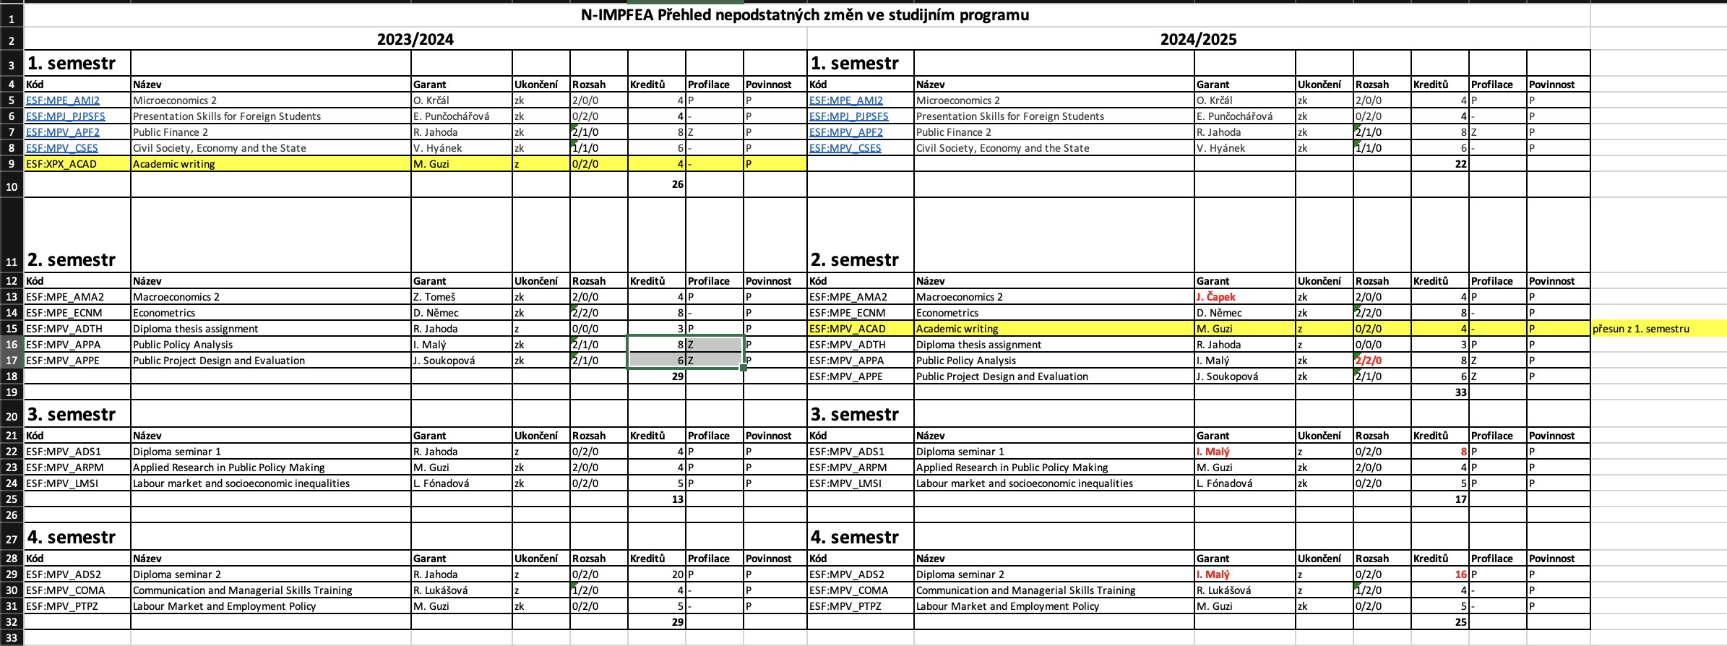

In the case of a joint programme board, please list all degree programmes involved.
This is the third highest number of all English-taught Master's programmes at FEA.

