Zápis ze zasedání programové rady

Název studijního programu: Public Finance and Economics
Fakulta: Ekonomicko-správní fakulta MU
Typ: magisterský navazující prezenční

Jméno, příjmení a titul garanta: doc. Ing. Robert Jahoda, Ph.D.
Datum a místo zasedání programové rady: 24. 9. 2020, ESF MU
Účast:
Jméno | Zařazení
Robert Jahoda | Garant studijního programu
Ivan Malý | Akademický pracovník z daného programu
Vladimír Hyánek | Akademický pracovník z daného programu
Anastasiia Korotkikh | Zástupce studentů
Viktor Novysedlák (absent) | Zástupce zaměstnavatelů/absolventů
* Doplňte řádky podle potřeby

- Popište podstatné a nepodstatné změny, ke kterým došlo v rámci studijního programu za poslední hodnocené období.
The following minor changes were prepared in the program from the academic year 2020/2021:
Course | Type of change | Process | Note
XPX_ACAD | Filling in course information | assignment of teachers, setting of hourly allowance | from Fall 19
MPV_ADTH | change in the objectives of the course MPV_ADTH Diploma Thesis | The course MPV_ADTH Diploma Thesis (3 ECTS) is renamed to Diploma thesis assignment - the aim of this course is to prepare the official diploma thesis protocol. Students enroll in this course in the second semester. | from Fall 20

The Program Board agrees with the above changes.

Popište, do jaké míry se podařilo naplnit stanovené cíle, a zhodnoťte plán rozvoje, který jste vypracovali během posledního hodnocení.
Comment:
The last meeting of the Program Board took place on September 9, 2019. Minutes of the meeting outlined the future steps for the development of the program in the coming years. The Covid-19 pandemic significantly affected the fulfilment of the goals, since there was only online teaching during the spring semester. The main ambition during that situation was to keep the program running with regard to different educational opportunities for international students (some of them remained in Brno, others returned to their countries of origin). The health situation has an impact on the demand of those interested in studying the program, but especially on the real number of students accepted and finally enrolled in the program. For the numbers of students accepted/enrolled, we can say:
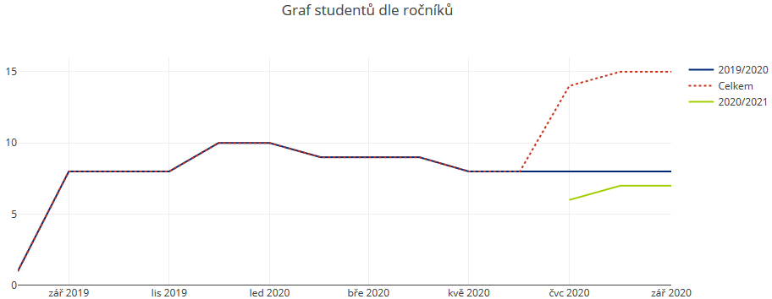
- The number of program students grows slowly. According to the managerial data from IS, we have currently 15 active students, with the view on the optimal target of 40 students (1 seminar group per year). Currently, the program has two successful graduates.
- The study program has the potential to accept students to Double Degree studies offered in cooperation with partner universities in Europe. We would welcome greater promotion of this opportunity since we expect that it may bring more students in the future. The expansion (and renewal of existing contracts) of Double Degree agreements was slowed down by the unclear attitude of the MUNI Rector's Office (Quality Office and Centre for International Cooperation) toward current and future contracts on programs provided in cooperation with a foreign university. Numerous seminars and consultations took place during the academic year 2019/20. They resulted in the preparation of the methodological document, which was published only in September 2020. We plan to re-open discussion with our partners from fall 2020, depending on the situation with Covid-19.
- In addition to the ongoing survey on teaching quality in IS, we collect feedback on program satisfaction from program graduates and through an appointed student representative on the program board.

- Popište aktuální témata, problémy a výzvy, kterým čelí studijní program.
Comment:
We can recapitulate the main topics, problems and challenges from the last year since they remain valid also this year:
- As students in the program have to pay tuition fee, the number of people interested in the program is limited. We discuss strategies on how to get more students into the program with faculty management.
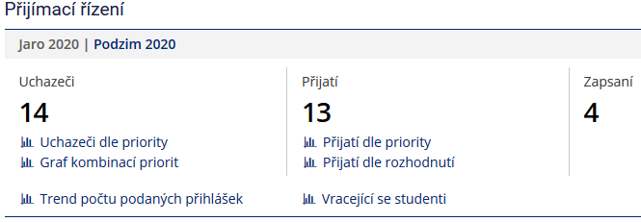
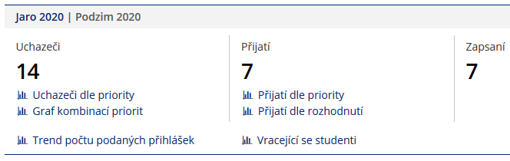
- The other problem is the low enrolment rate of successful applicants, which is partly connected to the Czech Republic visa policy (information of Office for International Relation).
- The quality of program internationalisation may be improved by increased teacher mobility. The guarantor of the program will look for ways how to incentivise incoming/outcoming activities of the staff involved in the program.
- We must ensure the conformity of current Double Degree agreements with the recommendations from the newly prepared methodological document on the promotion of programs provided in cooperation with foreign universities (see above). Another reason for the revision is the expiration of the five-year cooperation as agreed in current contracts. We have experienced several difficulties (mainly connected with the process of diploma thesis elaboration) and therefore have the opportunity to amend them in coming agreements.
- The consortium (MUNI, UR1, UNITO, UMinho) has applied for the Erasmus Mundus project call in 2019 and 2020. Both applications were unsuccessful. As MUNI was the leader of the consortium, we decided to resign on the leadership role for the next challenges and rather focus on other ways of cooperation deepening within the current consortium partners.
- The current coronavirus situation requires greater involvement of online teaching techniques. The fact that only 44% of courses provide students with information in the form of interactive syllabi is not satisfactory. The goal is to increase this share to at least 70% by next year.
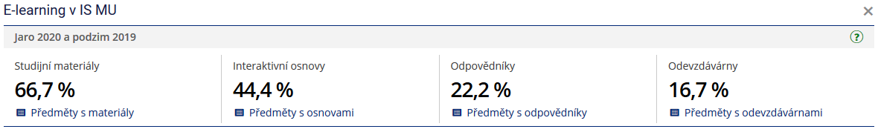
- We should pay more attention to quality assessment of current teaching since the subject survey in IS does not provide sufficient data (see managerial data).

- Formulujte další doporučení pro budoucí rozvoj studijního programu (v bodech či shrnujícím slovním komentářem).
Study Programme Development Goal | Actions leading to the objective | Implementation of measures (time)
Increase number of admitted students | - Offer of study programme by faculty on ad portals  - Development of bilateral contracts to ensure internationalisation  - Discussion on marketing strategy | Ad1) continuous  Ad 2) continuous  Ad 3) continuous
Increase programme internationalisation | - Motivation of students to take a semester of study at partner institution during their 3rd or 4th semester.  - Develop a system of incentives (with Foreign Office) for regular participation of foreign academics in program  - Create a course for the regular arrivals of visiting academics who could offer a course for a certain number of credits over a shorter period of time | Ad1) continuous  Ad2) June 2021  Ad3) December 2021
Improve the quality of teaching of key programme subjects | - Improve the system of student’s feedback  - Improved cooperation with the student representative in program board on the quality issues  - Increase share of subjects with e-learning support | Ad1) December 2020  Ad2) continuous  Ad3) August 2021

Further commentary:
The next steps should aim to increase the number of enrolled students with the aim to achieve around 20 students enrolled each academic year. We propose more measures that both increase awareness of the programme among potential students and make the programme itself more attractive.

- Prostor pro komentáře a postřehy nad rámec výše uvedených témat.
Further commentary:
- Increase student’s awareness of diploma thesis writing
  - Diploma Thesis – students should be better informed how to select a suitable topic for diploma thesis and what are the outcomes of the subject
  - Diploma seminar I – discuss desired outcomes of the subject with students
- Utilise current EDUC project to increase internationalization

