**Scholarship proposal submission procedure**

Scholarships are entered electronically in the INET application in the Economics and Accounting section - Financial Control menu:

Click on the following menu to select Scholarship Proposals:

then click on the Add Scholarship Proposal button:

Now you need to select the Unit (faculty), the type of PhD scholarship and the option Support Scholarship for creative work (PhD students). In the justification you will select either the option "for the preparation of outputs in accordance with the project research" or "to cover the costs of participation on the conference/study stay":

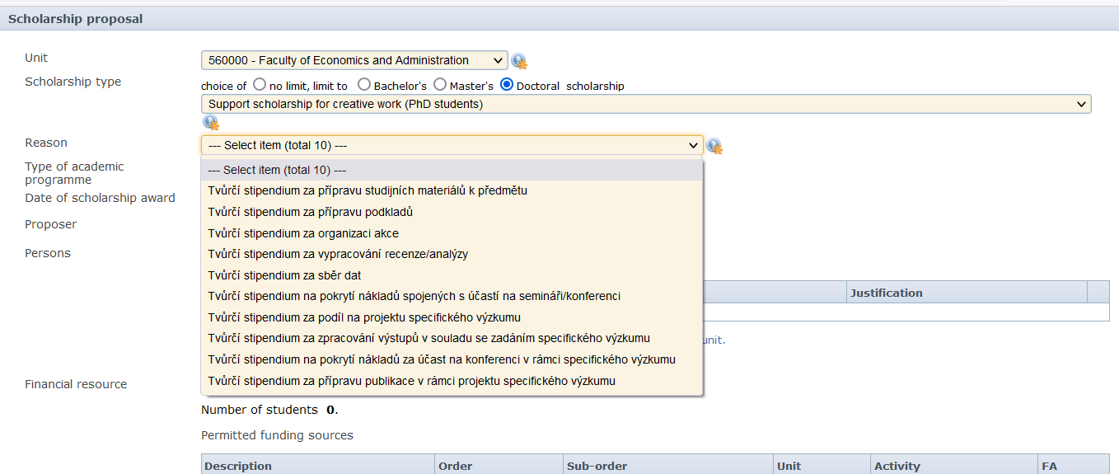

Scholarship for the costs of participation on the conference/study stay

Scholarship for the preparation of outputs in accordance with the project research

Next, choose the PhD programmes at MU, fill in yourself as the Proposer, the Periodicity „one-off“ and the month in which the scholarship should be paid. Under the Persons menu, click on the Add Student button: Obsah obrázku text

You will again fill in yourself, the proposed amount of the scholarship, and justify what the scholarship is proposed for. Then you save it:

In the Funding source section, fill in your project order and click Look up by number, all other fields will be filled in automatically, except for the last field Faculty account, where you select the option "administrative overhead not tracked":

At the end you will save and hand over for approval.