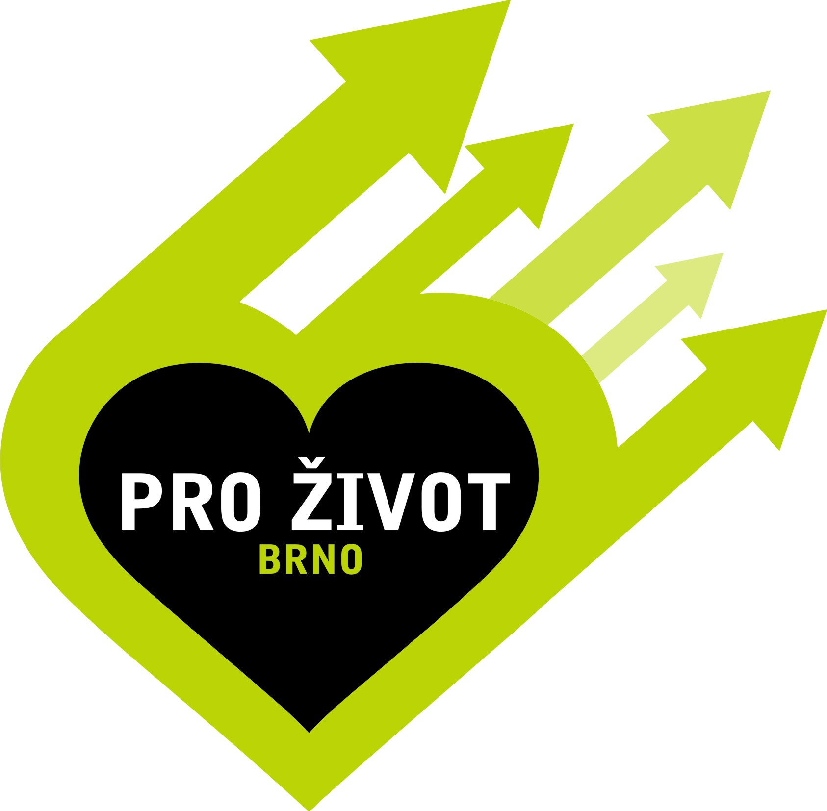

Dear students,

We would like to invite you to a first aid workshop within the project For life (Pro život) under the patronage of the students’ organisation IFMSA CZ.
During this workshop our lecturers will teach you techniques of non-professional first aid. All of our lecturers are students of the Faculty of Medicine of Masaryk University, they were trained especially for this course and they have passed the first aid exam.
You will have the opportunity to practice cardiopulmonary resuscitation on our human-body models; to practice bandaging techniques and experience model situations.
We assure you that the participants of these trainings should be able to handle crisis situations and in case of emergency they should be able to give first aid and safe a life!
The workshop is for free; it’s not compulsory and it’s awarded with neither credits, nor grades.
It will take place on Monday 13th of April in the room S308 at 18:00 (approx. duration is 2 hours)
The capacity is limited to 20 students maximum, therefore do not hesitate and apply on email:
395226@mail.muni.cz (Tereza Prokopová)
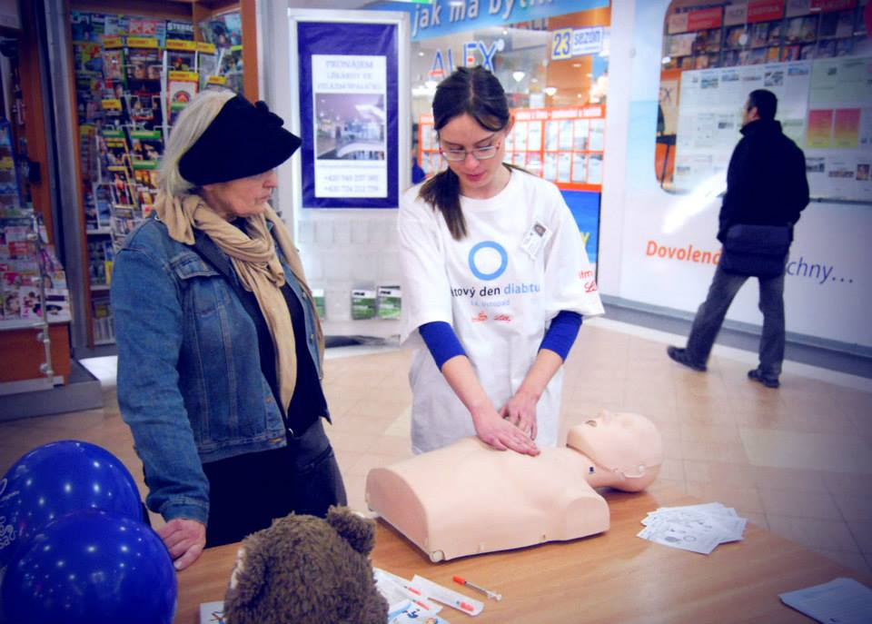
We are looking forward to seeing you!
On behalf of IFMSA CZ and project Pro život
With best regards,
Tereza Prokopová
As. of local coordinator for universities
Project For life
Faculty of Medicine, MU Brno
IFMSA CZ
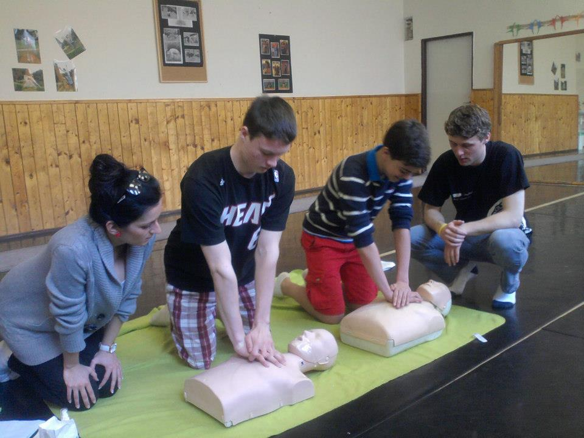

https://www.facebook.com/ProZivotBrno

www.ifmsa.cz

