Title (Title 1, capitalize first letter)

Abstract
Click The abstract should: State the principal objectives and scope of the research, describe the methodology employed, summarize results and findings, state the principal conclusions.
References to literature, bibliographic information, figures or tables should NOT be included in the abstract! (max. 150-200 words)

Keywords:Key words should generally be nouns instead of adjectives or adverbs, Put maximum of 5 Keywords.
JEL Classification:

Introduction (Title 2)
(TEXT) The file must be in MS Word format only. Follow this order when typing manuscripts: Title, Authors, Affiliations, Abstract, Keywords, Main text (including figures and tables), Acknowledgements, References, Appendix. Collate acknowledgements in a separate section at the end of the article and do not include them on the title page, as a footnote to the title or otherwise. PLEASE DO NOT USE FOOTNOTES!!
In this chapter the paper must provide a short review of the current state in the area of the paper’s aim. The paper should refer to significant sources, particularly scientific journals and conference proceedings listed in the databases of Web of Science (former ISI).
Please, finish this chapter with a clear description of the paper’s objective and methodology. You can highlight the important words in italics. Bulleted lists may be included and should look like this:
- First point
- Second point
- And so on

Heading (Title 3)
If necessary, use heading 2, but not heading 3!! Section headings should be left justified, with the first letter capitalized and numbered consecutively, starting with the Introduction. Sub-section headings should be in capital and lower-case italic letters, numbered 1.1, 1.2, etc, and left justified, with second and subsequent lines indented.

Constructions of references (Title 3)
References should be added at the end of the paper, they have to be consistent throughout the text of the paper. Their corresponding citation will be added in the alphabetical order. Authors should ensure that every reference in the text appears in the list of references and vice versa. In the text citations should be numbered and use the brackets [1].

Material and Methods (Title 2)
In this chapter, please provide the description of used methods, characteristics of data files, etc. If you stem from your previous work, describe it here shortly too.

Tables (Title 3)
All tables should be numbered with Arabic numerals. Headings should be placed above tables, left justified. Place sources under the object. Only horizontal lines should be used within a table. Tables must be embedded into the text and not supplied separately. Below is an example which authors may find useful.

Table 1. An example of a table (Source: Authors)
An example of a column heading | Column A (t) | Column B (T)
And an entry | 1 | 2
And another entry | 3 | 4
And another entry | 5 | 6

(TEXT) All figures should be numbered with Arabic numerals (1,2,...n). All photographs, schemas, graphs and diagrams are to be referred to as figures. Figures must be embedded into the text and not supplied separately. Lettering and symbols should be clearly defined either in the caption or in a legend provided as part of the figure. Figures should be placed at the top or bottom of a page wherever possible, as close as possible to the first reference to them in the paper.
Figure 1. An economist (Source: Authors, only black-and-white)

Figure 2. Public revenue (Source: Authors, only black-and-white)
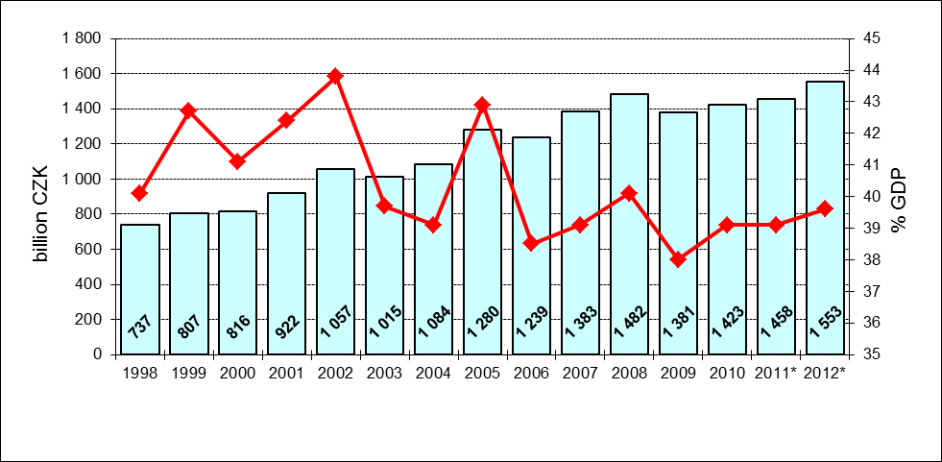

Results and Discussion (Title 2)
(TEXT) Use this chapter to describe the results as clearly as possible. Discuss your results in comparison to the results of other authors.
Equations and formulae should be typed and numbered consecutively with Arabic numerals in parentheses on the right hand side of the page (if referred to explicitly in the text),
$ρ=\frac{\vec{E}}{J_{C}\left(T=\text{const}\text{.}\right)⋅\left(P⋅{\left(\frac{\vec{E}}{E_{C}}\right)}^{m}+\left(1−P\right)\right)}$ (1)
They should also be separated from the surrounding text by one space.

Conclusion (Title 2)
(TEXT) Summarize your paper and stress the most important points of it. Think about topics for the future work.

Acknowledgements (Title 2)
(TEXT) These and the Reference headings are in bold but have no numbers. Text below continues as normal. Acknowledgement is necessary if the paper was funded by a grant agency or other foreign sources (e.g. “This article was supported by….” or “This article has been elaborated as one of the outcomes of research project…”).

References (Title 2)
- DOSTÁL, J. 2014. The Influence of the Type of Replacement Wage on the Economic Value of Volunteering: Emergencies in the Czech Republic. In Špalková, D., Matějová, L. (Eds): Proceedings of the 18th International Conference: Curent Trends in Public Sector Research. Brno: Masaryk University, 232-240.
- Eurostat, 2013. [online] Government finance statistics (GFS). European Commission. Available on <http://epp.eurostat.ec.europa.eu/portal/page/ portal/government_ finance_statistics/introduction>
- JACKSON, P. M., BROWN, C. 1994. Public Sector Economics, Oxford UK & Cambridge USA: Blackwell.
- KAPLAN, R.S., NORTON, D.P. 1992. The Balanced Scorecard - Measures That Drive Performance. Harvard Business Review; 70(1):71-79.
- OATES, W.E. 2006. On the Theory and Practice of Fiscal Decentralization. IFIR Worning Paper No 2006 – 05.
- PÉTERI,G., HORVÁTH, T.M. 2003. Regulation and Competition in Local Utilities Sector in Central and Eastern Europe. In Péteri,G., Horváth, T.M. (Eds.): Navigation to the Market. Budapest: OSI/LGI, pp. 13 – 98.

