Paper title

First Author[1]*, Second Author[2]†, Third Author[3]‡

Abstract

Abstract goes here (150-250 words). Lorem ipsum dolor sit amet, consectetuer adipiscing elit. Proin in tellus sit amet nibh dignissim sagittis. Quisque porta. Sed ut perspiciatis unde omnis iste natus error sit voluptatem accusantium doloremque laudantium, totam rem aperiam, eaque ipsa quae ab illo inventore veritatis et quasi architecto beatae vitae dicta sunt explicabo. Aliquam erat volutpat. Fusce dui leo, imperdiet in, aliquam sit amet, feugiat eu, orci. Aliquam in lorem sit amet leo accumsan lacinia. Phasellus et lorem id felis nonummy placerat. Nemo enim ipsam voluptatem quia voluptas sit aspernatur aut odit aut fugit, sed quia consequuntur magni dolores eos qui ratione voluptatem sequi nesciunt. Pellentesque arcu. Duis condimentum augue id magna semper rutrum. Class aptent taciti sociosqu ad litora torquent per conubia nostra, per inceptos hymenaeos. Etiam commodo dui eget wisi. Ut enim ad minim veniam, quis nostrud exercitation ullamco laboris nisi ut aliquip ex ea commodo consequat.

Keywords: excepteur, occaecat, cupidatat, proident.

JEL Classification: O30, C30

# Introduction

The first paragraph has no indent. Etiam egestas wisi a erat. Aenean placerat. Excepteur sint occaecat cupidatat non proident, sunt in culpa qui officia deserunt mollit anim id est laborum. In laoreet, magna id viverra tincidunt, sem odio bibendum justo, vel imperdiet sapien wisi sed libero. Nam libero tempore, cum soluta nobis est eligendi optio cumque nihil impedit quo minus id quod maxime placeat facere possimus, omnis voluptas assumenda est, omnis dolor repellendus.

If the author’s name is clearly mentioned in the text, it can be directly followed by the year of publication, in parentheses: Acemoglu & Robinson (2012) later refuted this claim.

If both the author name and year are clearly mentioned in the text, there is no need to include a parenthetical reference: In 2012, Acemoglu & Robinson refuted this claim.

“These results clearly contradict those published in 2004 by the Smith lab.” (Acemoglu & Robinson 2012, p. 56).

If a document has two authors, include both surnames separated by “and”. For works with three or more authors, include only the first author name, followed by “et al.”: (Acemoglu & Robinson 2012), (Acemoglu et al. 2000).

If you are citing several sources at once, list them in chronological order, or alphabetically if two or more works were published in the same year, and separate each one with a semicolon: … (Samson 1963; Carter and Bowles 1975; Grimes 1975; Anderson et al. 1992).

# First Section

Curabitur sagittis hendrerit ante. Integer malesuada. Nunc dapibus tortor vel mi dapibus sollicitudin. Nullam eget nisl. Maecenas ipsum velit, consectetuer eu lobortis ut, dictum at dui. Nullam rhoncus aliquam metus. Praesent id justo in neque elementum ultrices. Phasellus faucibus molestie nisl. Praesent in mauris eu tortor porttitor accumsan. Praesent dapibus. In enim a arcu imperdiet malesuada. Praesent vitae arcu tempor neque lacinia pretium. Etiam egestas wisi a erat. Aenean placerat.

## First Subsection

Fusce suscipit libero eget elit. Etiam quis quam. Aliquam erat volutpat. Cras elementum. Quisque tincidunt scelerisque libero. Nullam lectus justo, vulputate eget mollis sed, tempor sed magna. Maecenas aliquet accumsan leo. Fusce tellus odio, dapibus id fermentum quis, suscipit id erat. Etiam bibendum elit eget erat. Praesent in mauris eu tortor porttitor accumsan. Nullam rhoncus aliquam metus. Sed convallis magna eu sem. In rutrum. Duis viverra diam non justo.

### Ordered and unordered lists

**Ordered list:**

1. **duis condimentum augue id magna semper rutrum;**
2. **suspendisse sagittis ultrices augue:**
   1. **vivamus luctus egestas leo;**
   2. **aliquam ante;**
3. **integer imperdiet lectus quis justo.**

**Unordered list:**

* **duis condimentum augue id magna semper rutrum;**
* **suspendisse sagittis ultrices augue:**
  + **vivamus luctus egestas leo;**
  + **aliquam ante;**
* **integer imperdiet lectus quis justo.**

### Inserting a table

Cross-reference the following table as Table 1.

|  |  |  |
| --- | --- | --- |
| 1 | 2 | 3 |
| 4 | 5 | 6 |
| 7 | 8 | 9 |

Table 1: Sample table

### Inserting a figure

Cross-reference the following figure as Figure 1.

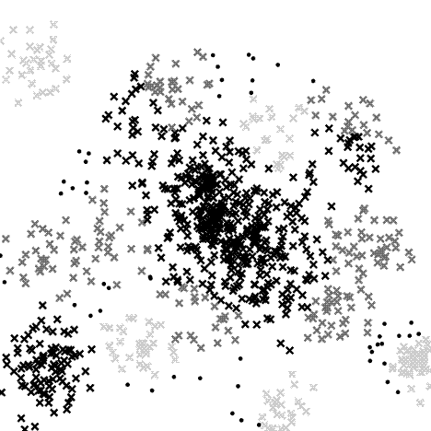

Figure 1: Sample figure

### Inserting an equation

Cross-reference the following figure as Equation 1.

|  |  |
| --- | --- |
|  | (1) |

Acknowledgements

This paper was created as a part of the specific research project no. MUNI/A/0123/2014 at Masaryk University.

References

* Acemoglu, D., & Robinson, J. (2012). *Why nations fail: the origins of power, prosperity, and poverty*. Random House Digital, Inc.
* Acemoglu, D., Johnson, S., & Robinson, J. A. (2002). Reversal of fortune: Geography and institutions in the making of the modern world income distribution. *The Quarterly Journal of Economics*, 117(4), 1231-1294.
* Acemoglu, D., Johnson, S., & Robinson, J. A. (2000). *The colonial origins of comparative development: an empirical investigation* (No. w7771). National Bureau of Economic Research.
* Acemoglu, D., Johnson, S., & Robinson, J. A. (2005). Institutions as a fundamental cause of long-run growth. *Handbook of economic growth*, 1, 385-472.
* Novák, P. (2011). A Name of the proceedings Paper. In *Proceedings of a conference*, (M. Nový, and V. Nováček, eds.), University of Economics, Prague, 369–374.

1. * University/Institute, department, address, e-mail.
2. † University/Institute, department, address, e-mail.
3. ‡ University/Institute, department, address, e-mail.