Instructions for the supervisor -

how to confirm the thesis assignment

View the topics your students plan to defend this semester by clicking on:
My topics -> awaiting approval
-> below selected topics > mark: all (this marks the topics you want to continue working with)
-> Operations with selected topics > Display details.
Go through the topics and check primarily the final description (not just preliminary)
and the Name in English. If the topic is OK, it can be confirmed by clicking Yes after the text "Does the supervisor confirm the assignment?" (This question with thumbs up symbol only appears if the required items are filled in and the student has already confirmed the assignment).
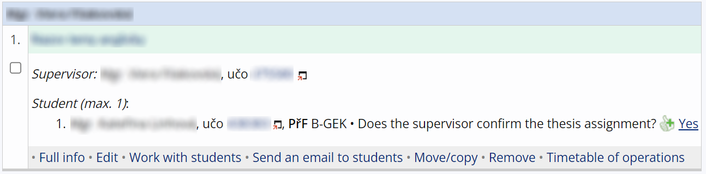

If not, follow the instructions below.

Edits in the topic
In case you want to edit/add to something, typically the official assignment or the English title of the paper, you can make changes by clicking Edit in the operations menu below the topic.
ATTENTION! Editing a topic will result in the cancellation of the student's confirmation, who will receive an automatic email about it. The topic will also no longer be automatically offered for confirmation (you will not see the question with the thumbs up symbol).

If you want to confirm the topic for defence, please follow the following instructions.

Topic approval without student confirmation
For topics that do not yet have or have lost student confirmation, the question with thumbs is not displayed. You can still approve these topics before the student does:
Topics -> select Work with students -> Edit information -> in the field "the supervisor confirms the assignment" change to yes and save
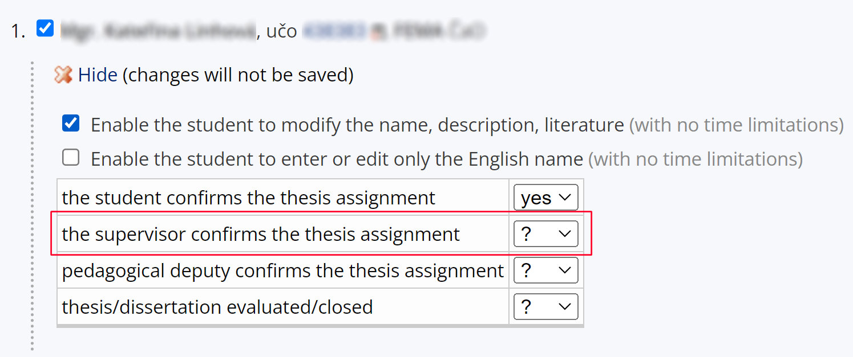

Other
If you select the option the “supervisor confirms the thesis assignment? no “, the topic will not appear to the guarantor for confirmation. If you accidentally click on No, you can change your decision as described above – Display operations -> Work with students -> Edit information -> change the value in the field "supervisor confirms the thesis assignment" (back to "?" or "yes").

