16.1.2013 Zuzana Wallnerova

Outline dizertačnej práce ako súčasť štúdijného zahraničného pobytu na Vrije Universiteit Amsterdam (VU Amsterdam), Holandsko, Faculty of Social Sciences v podzimnom semestri 2012.
Súčasť outlinu je:
- problem statement
- research question a sub-questions
- conceptual map
- literature review
V prípade potreby doplňujúcich dokumentov ich rada poskytnem a doplním.

Problem statement:
`Since the Fall of the Iron Curtain in 1989 followed by opening of the border, Slovakia and the Czech Republic started to experience `brain-drain `caused by migration of young highly-skilled Czechs and Slovaks abroad. I am looking for the motivations of this group to leave their country of origin, settle in Canada and thus become `voluntary foreigners abroad.`
By comparing voluntary migrants to the forced migration of Czechoslovaks emigrating during communism era, within perception of `home`,` feeling of belonging`, place-affiliation and transnational connectedness between home and host country of both groups , I raise the question of `return` to the country of origin to enhance the economic development of their own countries. `

Research question:
How do young `voluntary migrants` from Czech Republic and Slovakia to Canada perceive, experience and express `home`, `feeling of belonging` and place-affiliation compared to the group of forced Czechoslovak migrants moving to Canada during communism regime and how does it influence their motivation to return to the country of origin suffering from brain-drain?

Sub-Questions:
- How do `feeling of belonging` and place-affiliation to Czech Republic, Slovakia and Canada project in migrants` lives?
- How do migrants perceive and experience transnational connectedness in their everyday lives?
- What importance play virtual media and compatriotic clubs in both groups of migrants?
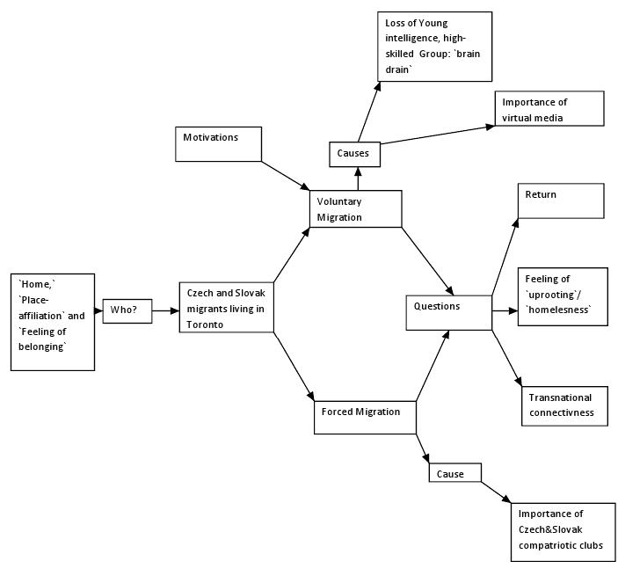

Literature:
I have sorted my literature by topics in relation to my research question. Please see below:
Home-feeling:

Ahmed, S. (1999). "Home and away narratives of migration and estrangement." International journal of cultural studies 2(3): 329-347.

Cuba, L. and D. M. Hummon (1993). Constructing a sense of home: Place affiliation and migration across the life cycle, Springer.

Marcus, C. C. (1995). House as a mirror of self: Exploring the deeper meaning of home, Nicolas-Hays.

Salih, R. (2003). Gender in transnationalism: home, longing and belonging among Moroccan migrant women, Routledge.

Brain-drain:

Baruch, Y., P. S. Budhwar, et al. (2007). "Brain drain: Inclination to stay abroad after studies." Journal of World Business 42(1): 99-112.

Dodani, S. and R. E. LaPorte (2005). "Brain drain from developing countries: how can brain drain be converted into wisdom gain?" JRSM 98(11): 487-491.

Kazlauskienė, A. and L. Rinkevičius (2006). "Lithuanian “Brain Drain” Causes: Push and Pull Factors." Engineering economics(1 (46)): 27.

Portes, A. and J. Böröcz (1989). "Contemporary immigration: theoretical perspectives on its determinants and modes of incorporation." International migration review: 606-630.

Vizi, E. S. (1993). "Reversing the brain drain from Eastern European countries: The “push” and “pull” factors." Technology in Society 15(1): 101-109.

Belonging and Place-Affiliation:

Cicognani (2010). "University Students’ Sense of Belonging to the Home
Town: The Role of Residential Mobility."

Rosenthal, G. and M. Köttig (2009). Migration and questions of belonging. Migrants in Germany and Florida.

Yuval-Davis, N. (2006). "Belonging and the politics of belonging." Patterns of Prejudice 40(3): 197-214.

Skaptadottir, U. D. and A. Wojtynska (2008). "Labour migrants negotiating places and engagements." Mobility and Place: Enacting Northern European Peripheries 970: 115.

Social Networks:

Fortin, S. (2002). "Social ties and settlement processes. French and North-African migrants in Montreal." Canadian Ethnic Studies 34(3): 76-98.

Hendrix, L. (1976). "Kinship, social networks, and integration among Ozark residents and out-migrants." Journal of Marriage and the Family: 97-104.

Return:

Gmelch, G. (1980). "Return migration." Annual review of anthropology: 135-159.

(Transnational) migration:

Labelle, M. and F. Midy (1999). "Re‐reading citizenship and the transnational practices of immigrants." Journal of Ethnic and Migration Studies 25(2): 213-232.

Lazăr, A. (2011). "Transnational migration studies. Reframing sociological imagination and research." Journal of Comparative Research in Anthropology and Sociology(2): 69.

Rabikowska, M. and K. Burrell (2004). "The material worlds of recent Polish migrants: transnationalism, food, shops and home." Polish Migration to the UK in the ‘New’European Union: After: 211e232.

Ryan, D. L., P. R. Sales, et al. (2009). "Family strategies and transnational migration: recent Polish migrants in London." Journal of Ethnic and Migration Studies 35(1): 61-77.

Schiller, N. G., L. Basch, et al. (2006). "Transnationalism: A new analytic framework for understanding migration." Annals of the New York Academy of Sciences 645(1): 1-24.

Bhugra, D. and O. Ayonrinde (2004). "Depression in migrants and ethnic minorities." Advances in Psychiatric Treatment 10(1): 13-17.

Favell, A. (2008). "The new face of East–West migration in Europe." Journal of Ethnic and Migration Studies 34(5): 701-716.

Colic-Peisker, V. (2002). "Croatians in Western Australia: migration, language and class." Journal of Sociology 38(2): 149-166.

Brettell, C. (2003). Anthropology and migration: Essays on transnationalism, ethnicity, and identity, AltaMira press.

Schiller, N. G., L. Basch, et al. (2006). "Transnationalism: A new analytic framework for understanding migration." Annals of the New York Academy of Sciences 645(1): 1-24.

Schiller, N. G., L. Basch, et al. (1995). "From immigrant to transmigrant: Theorizing transnational migration." Anthropological quarterly: 48-63.
Szaló, C. (2007). in English: Transnational Migration: Identitites, Boundaries and Interpretations in Motion, Brno: CDK.

