Event Report

Name and basic description of event

Freshers glow party. Freshers: free MIMSA/ISC/ANSA: 20 (to us) rest: 50kc (to mandarin)
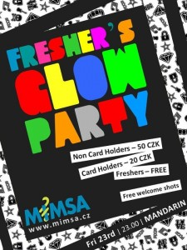
Date of event (day, month, year): 23.09.2011
Venue: Mandarin
Number of participants: 800
Reason for event: To have a welcoming party not only for the freshers but also for the rest of the students

Important contacts:
Mandarin: 777582180

Financial budget: 5000 kc
1200 kc (on alcohol which was later not used)
570 kc spray paint
2000kc glow bracelets

Evaluation of events:
Event ran smoothly with no complications during. The only complication was that we had to switch venues due to a double booking at Abajo and lack of communication from their end.
Pros:
2nd venue was very easy to work with. Provided us with 6 bottle for welcome shots and allowed us to collect money at the door. Dj’s were well organized and the music selection satisfied everyone. Also everyone enjoyed the welcome shot and glow bracelets
Cons:
Another organization was attempting to have a guest list to our party that we didn’t approve of but the issue was quickly solved. The dance area in mandarin is small.
What to do differently in the future:
Double confirm with venues even earlier if it is possible to get a hold of them, make sure no other organization is planning to have a guest list.
Conclusion:
The event was a very good success with no problems at the night of the actual event. Everyone had a great time and MIMSA made a profit.

Please have the report handed to the Secretary a maximum of 7 days after the event occurred-

Signed Date:

