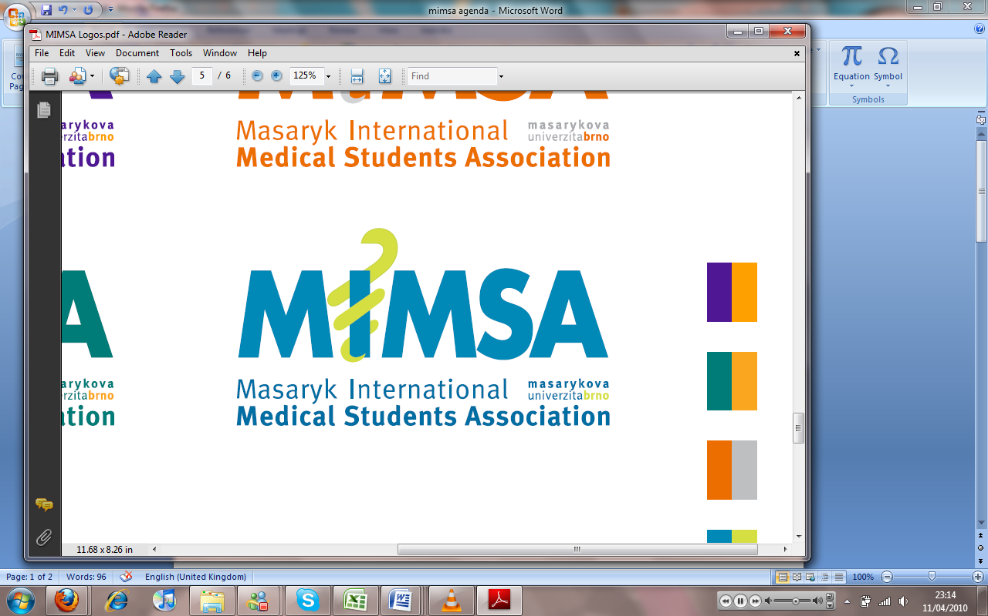Minutes

# Meeting 10

## May 2nd 2010

## 6:30pm

Meeting called by Rita Matos

# Attendees: Rita Matos, Stuart Hopkinson, Maria Margarida Gil Conde, Bhavin Doshi, Devangna Bhatia, Veronika Sykorova , Adriano Mendes, Luis Cyrillo, Roye Mauthner

Additions:

|  |  |  |
| --- | --- | --- |
|  | Vice President |  |
|  | General  * The attendance for the Tie party looks like being low due to a number of factors therefore a decision needs to be taken as to whether we should continue or not. |  |
|  | Public Relations |  |
|  | Social  * We enquired about having starobrno sponsor the MIMSA cup however, it was too late notice but, in the future it might be a nice option. * There is a chance we could have an open air festival with the IFMSA at the campus close to the end of the semester. There will be another meeting to discuss this closer to the time. * The Museum night is coming this next week so, we will publish information on the website with regards to what it is and good places to go. |  |
|  | Education |  |
|  | Treasurer  * Margarida is going home for a couple of weeks hence there is going to be a sign in/out sheet for any monetary things |  |
|  | IT  * The domain name is due for renewal. It is important this happens ASAP as if we don’t renew it anyone can buy it. * Roye will meet with everyone to show them how to edit and upload to the website. |  |
|  | Later added points |  |
|  | Wrap-up |  |