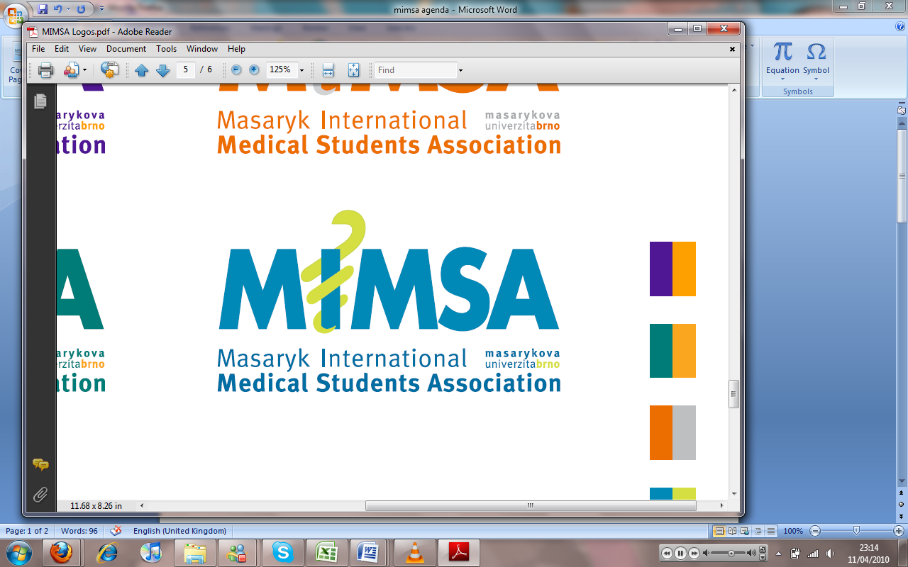Minutes

# Meeting 11

## May 11th 2011

## 6:30pm

Meeting called by Rita Matos

# Attendees: Jonathan Phillips, Rita Matos, Stuart Hopkinson, Maria Margarida Gil Conde, Bhavin Doshi, Devangna Bhatia, Veronika Sykorova , Adriano Mendes, Luis Cyrillo, Roye Mauthner

Additions:

|  |  |  |
| --- | --- | --- |
|  | Vice President |  |
|  | General  * Khuram has spoken with Rita and insists BOSS is not intended to compete with MIMSA * Boss is going to store some of their notes along with MIMSA in the MIMSA office * There will be a trip to Olomouc to meet their students and to attend a meeting held by former students on the difficulties of applying to and practicing in England after graduation. * MIMSA will subsidise 5000kc for transportation * The race for life is happening soon and Nuno Andre is taking part for the Paeds oncology dept. would like us to post the links to the website. |  |
|  | Public Relations  * Greek students have asked that we come to the Greek Obsessions party as they don’t see why they should attend MIMSA events if we don’t do the same to them. |  |
|  | Social  * Tie party- Despite some prior reservations we had a good turn out and made a good amount of money. * MIMSA CUP- we had a good response as always and the students all enjoyed the day. * We need to have proper delegation and some assistants we can rely upon. In the board there were too many people taking part leaving a few people to run everything else. * We strive for better organization next term |  |
|  | Education |  |
|  | Treasurer |  |
|  | IT  * Boss.cz is an impressive website, in response to theirs MIMSA will be undertaking a change of the website and a major upgrade. This will take some time so, IT dept will keep everyone apprised to the situation as it develops. |  |
|  | Later added points |  |
|  | Wrap-up |  |