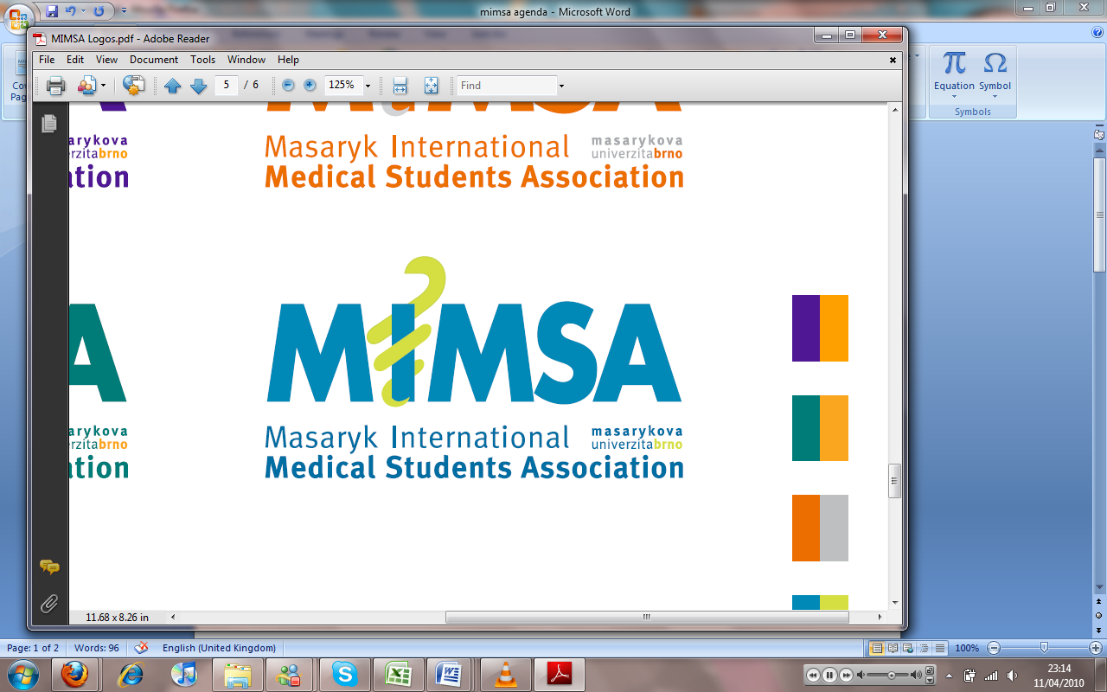Minutes

# Meeting 12

## May 16th 2011

## 6:30pm

Meeting called by Rita Matos

# Attendees: Rita Matos, Stuart Hopkinson, Maria Margarida Gil Conde, Bhavin Doshi, Devangna Bhatia, Veronika Sykorova , Adriano Mendes, Luis Cyrillo, Roye Mauthner

Additions:

|  |  |  |
| --- | --- | --- |
|  | Vice President  * After the MIMSA cup there was an issue with Paulo’s car that we used for transportation and since then it has broken down. MIMSA is partly responsible as we used the car last. Treasurer and VP to decide with Paulo what is an appropriate amount of money to reimburse him with. |  |
|  | General  * We have met with the SUDC organisation based in Olomouc and he has proposed a partnership with MIMSA. Students pay 300kc for the card and a further 150 kc yearly to have the benefits of the card- A decision is pending the arrival of the treasurer. * Recognition of Services to university via MIMSA, the university have offered to present us with an official document saying all of the services we did in MIMSA. |  |
|  | Public Relations  * For the Orientation week event on the 16th we have the idea of dividing students into groups and having games/activities in these groups in order to bring them closer together as a year group- at the moment it is a work in progress but, come Orientation week will be more firm as to what the event is. |  |
|  | Social |  |
|  | Education  * Gathering of notes is going well and the co-operation with BOSS seems to be working well at the moment. |  |
|  | Treasurer |  |
|  | IT  * The beta website is up and running so that people may experiment with website editing. There will be a meeting in Bhav’s house next week to discuss further changes for the upgrade. |  |
|  | Later added points |  |
|  | Wrap-up |  |