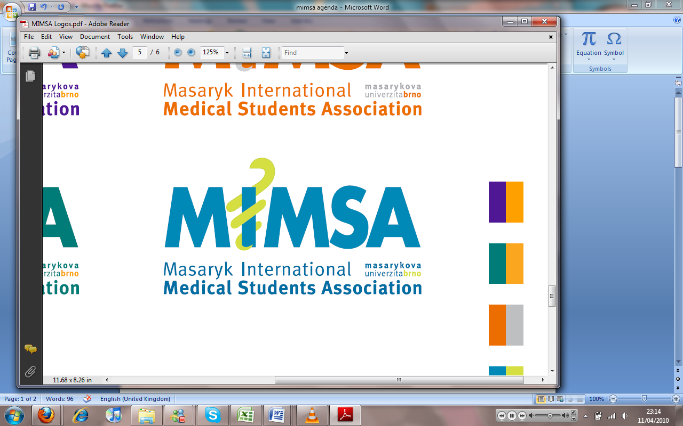Minutes

# Meeting 2

## December 13th 2010

## 6:30pm

Meeting called by Jonathan Phillips and Rita Matos

# Attendees: Jonathan Phillips, Rita Matos, Stuart Hopkinson, Maria Margarida Gil Conde, Bhavin Doshi, Devangna Bhatia, Veronika Sykorova, Adriano Mendes, Luis Cyrillo, Roye Mauthner

Additions:

|  |  |  |
| --- | --- | --- |
|  | President/Vice President  * Rita late again * Went to Helena, she is awesome- think that we should all meet the Dean- Jon will introduce us all and let us approach him more and show that we are more prepared- * New facepage for MIMSA really good- * Emailing list- ask her to make it as a database- (by year, group number and Uco and program) * Adriano- sports facility, if we can use them- there is no futsal, there is basketball, volleyball- unknown if they can be rented for MIMSA- * Sports fac facilities will be cheaper- badminton facilities in the hall next to komenskeho nam. * G.M constitution 14 days after we can change the constitution. * Get everybody to sign the new contract so that the uni don’t have to pay tax on the fee if we pay school fees in 2 instalments * Trying to mix with other universities in the Czech rep- joining with them to help our education and social events, talking to taborska- * Help to collaborate to make a group to upload lectures etc. * Music room- initially they said no as we wanted a permanent room- help to develop talents * Subjective teachers- Helena didn’t know that the teachers use the same syllabus every year- * Asking the study dept to have multiple examiners to attend an exam so that they can challenge the examiner- * Adriano please confirm in future with the board before starting to publicize * Where is my class- to show where classes are- (Devangna and Bhavin) |  |
|  | General  * CC: pres, VP and Secretary in emails * Add our emails to med.muni.cz document for the incoming student along with MIMSA.CZ email and fb page- |  |
|  | Public Relations  * Charity events for children and animals * Clothing collection * Help ISC first and then see how it works |  |
|  | Social  * Paintballing * Badminton * Go Karting * Tennis * Dodgeball tournament * Mimsa cup * Themed dinners in which we are the ones that cook and organise everything- (diet) – catering licence * Movie nights * Karaoke * Poker * Snow trip |  |
|  | Education  * Blocks- quality of teaching- cheating- Improve relations between students and the depts. And it needs to be reported to Helena immediately so that it can improve year on year- it’s a problem with a great deal of departments. * Have a schedule on the signup sheets for blocks to allow it to change for the better- Helena would like to know about past problems with blocks- Generally sorted after the first day of lessons of the blocks- * Clinical session – 10 sessions 2 hours per week- a lot more interactive than before- * Committee – thought about what we want them to do, we need to get the word out via the student reps- Awareness for each subject with problems- going to have the completed syllabi in the MIMSA office – have a person responsible for each subject- each person on the committee is responsible for the specific subject- an email has been written up (draft email) |  |
|  | Treasurer  * 68000 Kc in the account – * No relationship with the bank- business account- * Approach radio station – for sponsorship * Problems with English language for getting sponsors, Czech language is important. * Non-profitable events- social events should be profitable- cocktail party- * Have more professors come to the event and then have them speak to the students more- * Flight school- an email has been sent- |  |
|  | IT  * Write biography * Change email password |  |
|  | Later added points |  |
|  | Wrap-up |  |