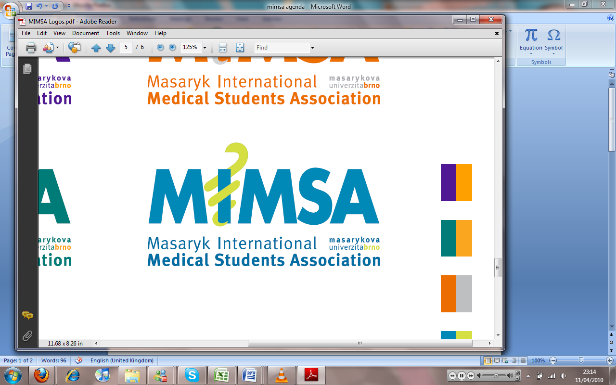Minutes

# Meeting 3

## February 28th 2011

## 6:30pm

Meeting called by Jonathan Phillips and Rita Matos

# Attendees: Jonathan Phillips, Rita Matos, Stuart Hopkinson, Maria Margarida Gil Conde, Bhavin Doshi, Devangna Bhatia, Veronika Sykorova , Adriano Mendes, Luis Cyrillo, Roye Mauthner

Additions:

|  |  |  |
| --- | --- | --- |
|  | President/Vice President  * Calendar on the website for people to scroll through – Stew to do * Poker tournament, weekends in mimsa board room * Talent show happening in next two semester, encourage people to participate * Group rep. meets with group each month and all report to Cyrillo * Reps to hand a piece of paper to see problems * 8th March 2011 ISC-MIMSA meeting- * Youth for you sponsored by Vodafone, April 13th Cultural event, after party – Jon, Stew, Veronika, Roye, Bhavin * Organise a week with the I-Store to have a discount week- * Doctors- Roye to updates- * MIMSA Music – update list |  |
|  | General  * Office Hours * Monday – 4-6pm Margarida, Adriano * Wednesday -4-6 Veronika, Cyrillo * Friday 4-6 Bhav, Roye * Meeting times – Friday |  |
|  | Public Relations  * Team building, talking with Jana PR 25th to 27th March going to cottage and 4 of us will be going- Jon, Cyrillo, Roye, Rita * MIMSA-ISC ball – 16th March, we need people to sell raffle tickets, 2 people on door 7pm -2am all on google docs, we need to find 40 prizes (donations) * Tickets ……. We get 150, we are inviting Helena, Vice Dean, Dean etc. * Kika and Dale are host for ISC * Posters will be received tomorrow * Charity event, with ISC- Red Cross hard to make an event- Salvation Army? Lenka is going to put us in contact with them- Good for MIMSA to be seen with a charity event- |  |
|  | Social  * Definitely happening party, paintball, mimsa cup, pub quiz, majales, |  |
|  | Education  * Education committee- What is the purpose of them, Carlos Soares – Joana Duarte, Vegard Nordheim * Notes Collection – * Anatomy sessions- Timetable has been made- * Lectures- Anatomy lectures not enough space for first year students- * Second year dentistry students failed pre-clinicals failed by a lot of students- She asks relevant questions but, there is a lot of emails- * Clinical sessions – same schedule but, more interactive- * Scholarships – April * Book sale- Collect books, Fb ……….sell books, 2 weeks Monday 14th 2011 deadline- * Hoodies, Devangna, printing- * Ask Helena to put a time slot in timetable for space for session- |  |
|  | Treasurer  * Sponsors – Barbara from City Real State- contract ready to send- Full translated Czech-English – No logo required, only wants a website link- 1500 kc /per month- * Real Spektrum, tried to contact her many ways but, it is becoming difficult- Think that they are avoiding us * Radio Stations for sponsorship opportunities- and a cover document that says different ways to sponsor MIMSA. * Hotel international contract- * I-style verbal agreement- * Student agency to be contacted as they have a sponsorship budget. * Committee: |  |
|  | IT  * Education Materials * Login needed- * New pictures for the new Biography- * Beta website- For developers only- it is up and running- |  |
|  | Later added points |  |
|  | Wrap-up |  |