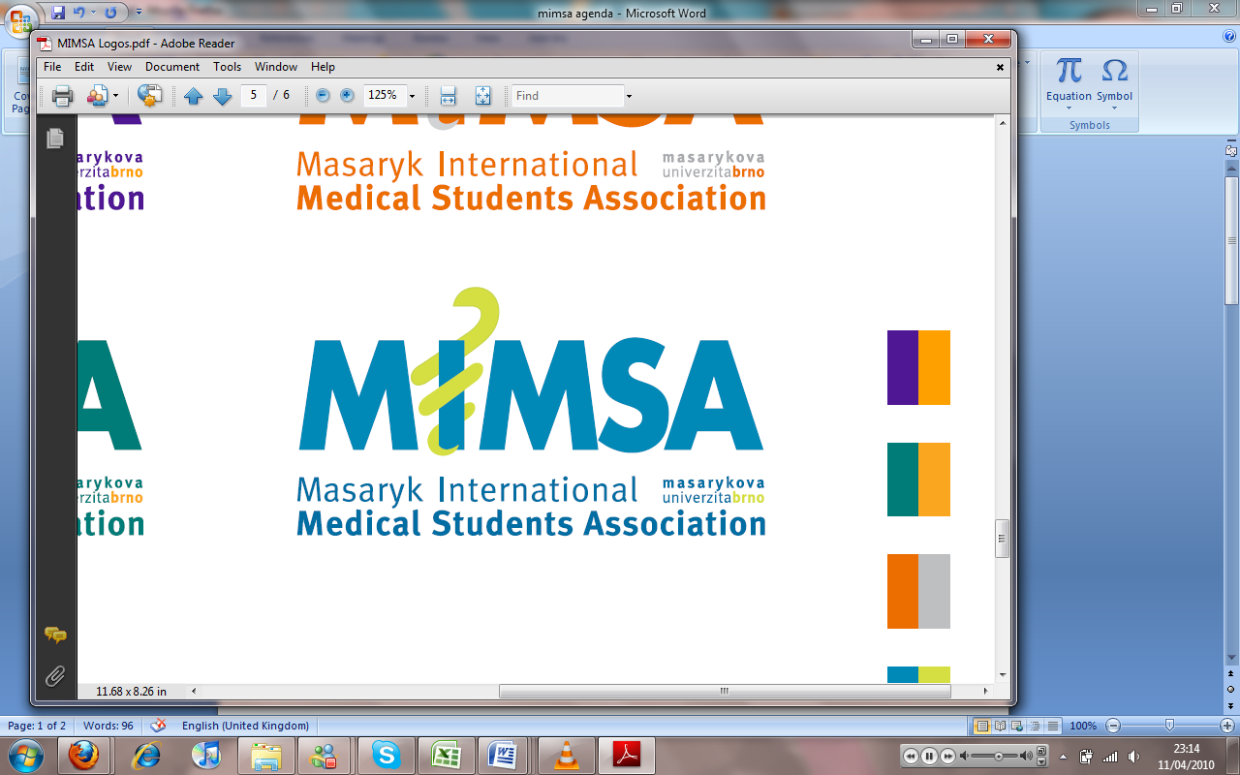Minutes

# Meeting 5

## March 14th 2011

## 7pm

Meeting called by Jonathan Phillips and Rita Matos

# Attendees: Jonathan Phillips, Rita Matos, Stuart Hopkinson, Maria Margarida Gil Conde, Bhavin Doshi, Devangna Bhatia, Veronika Sykorova , Adriano Mendes, Luis Cyrillo, Roye Mauthner

Additions:

|  |  |  |
| --- | --- | --- |
|  | President/Vice President  * There was a communication problem with regards to the General meeting meaning that the e-mail notification to students did not go out in appropriate time. * We need to increase the awareness of the G.M to the student population * For the team-building we need to make a presentation about first aid- Cyrillo, Bhavin, Jon and Rita have volunteered to create this * There has in the last week been a meeting with the lawyers to finalise the constitution * Due to discrepancies and organisational problems all dates on the MIMSA Calendar will be TBC until further notice * MIMSA/ISC ball, the ISC has sold all of their tickets, MIMSA needs to step up advertisement for this event * Doctors List needs to be updated on the website ASAP * Communication between people has been an issue in the last week, all communication and problems need to go through Jon and Rita in future. |  |
|  | General |  |
|  | Public Relations  * Would like a budget for posters in a semester to avoid having to ask for money countless times |  |
|  | Social  * Problems with interference from the President in the running of the Social dept. * Last year were allowed to independently run things and it worked well, at the moment there are too many people doing the same things which makes it difficult to work * We have an issue with the up and coming snow trip due to the changing weather meaning that the snow is melting- |  |
|  | Education  * Anatomy sessions to be run alongside clinical sessions for the upper year students if interest persists |  |
|  | Treasurer  * City real estate deal has been done for the logo to be posted on the website for 3 months and 4 days * Looking into a car rental company sponsorship * I-style discount week to be planned along with a prize from them for a specific event when we know about it- |  |
|  | IT |  |
|  | Later added points |  |
|  | Wrap-up |  |