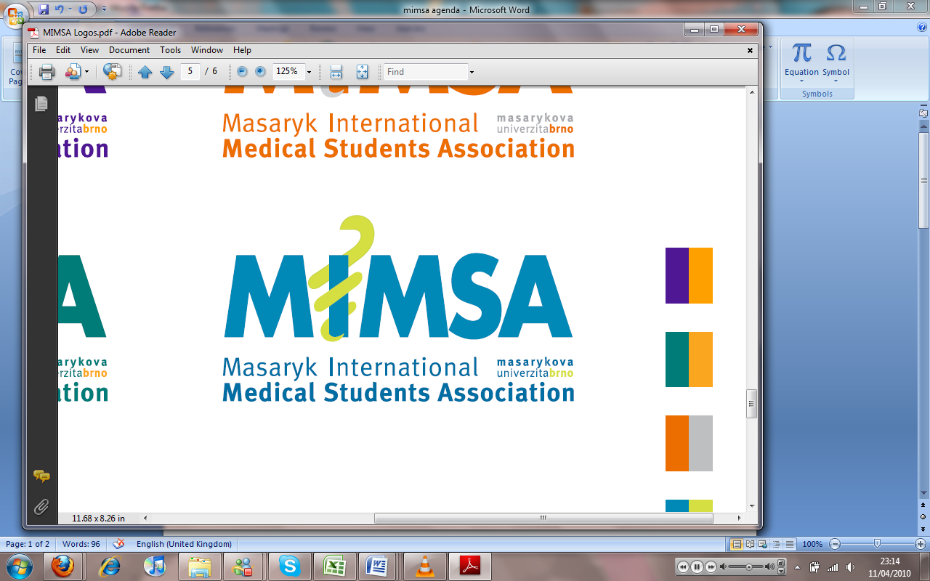Minutes

# Meeting 6

## March 21st 2011

## 6:30pm

Meeting called by Jonathan Phillips and Rita Matos

# Attendees: Jonathan Phillips, Rita Matos, Stuart Hopkinson, Maria Margarida Gil Conde, Bhavin Doshi, Devangna Bhatia, Veronika Sykorova , Adriano Mendes, Luis Cyrillo, Roye Mauthner

Additions:

|  |  |  |
| --- | --- | --- |
|  | President/Vice President  * At present the constitution is being translated into Czech Language * Helena has requested problems that our students are having, we need to have more specific examples of these cases with times and places. * We have an offer of making Tryba into a music room if we and the other organisations can raise the money to buy a drumkit. * Language program is in the process of being handed over to the heads of education from the President * Support- If you have a problem with internal issues in MIMSA then, aside from this you support the event. With regards to the internal issues in the social dept. the President has undertaken to try and solve it by having more meetings with them and the VP- * The up and coming Pub Quiz is a last chance for the resolution of the problems in the social dept. after which a decision will be reached. |  |
|  | General  * General consensus is that office hours are redundant normally except when we have specific events therefore, some of the board would like to have them reduced to a couple of days a week. The president insists on having them continued in the current format therefore a few people will keep office hours going if they are free and happy to do so. * Problem arose with the IFMSA during the recent party at 7nebe whereby they had a private party at the same venue. They are unhappy that they paied for a DJ who we actually also used. The owner had separate contacts with us and the IFMSA so we were not required to pay the amount. IFMSA are asking for 500 kc from us. There was miscommunication on the issue and the booking of this venue. |  |
|  | Public Relations  * The next event that we are pushing through is medicke celeny which is on April 21st |  |
|  | Social  * Adriano has a problem with Jon’s persistent pestering of him. * Adriano is in charge of the MIMSA cup and so booked the Venue, Jon is unhappy as he was not informed of the booking in advance. Having given the event to Adriano it is agreed that Jon should leave him to organise it himself. * The overall tone of the party is that it was a mild success on paper however, the number of MIMSA students present was minimal meaning that we need to try harder to work with the reps to get more students involved with MIMSA |  |
|  | Education |  |
|  | Treasurer |  |
|  | IT  * Vodafone, Rita is going to enquire to them about a deal for inter-board calls and also for special deals that could be offered to our students * Eli Odnopozov is joining the IT dept in the role of photographer and picture management via the website |  |
|  | Later added points |  |
|  | Wrap-up |  |