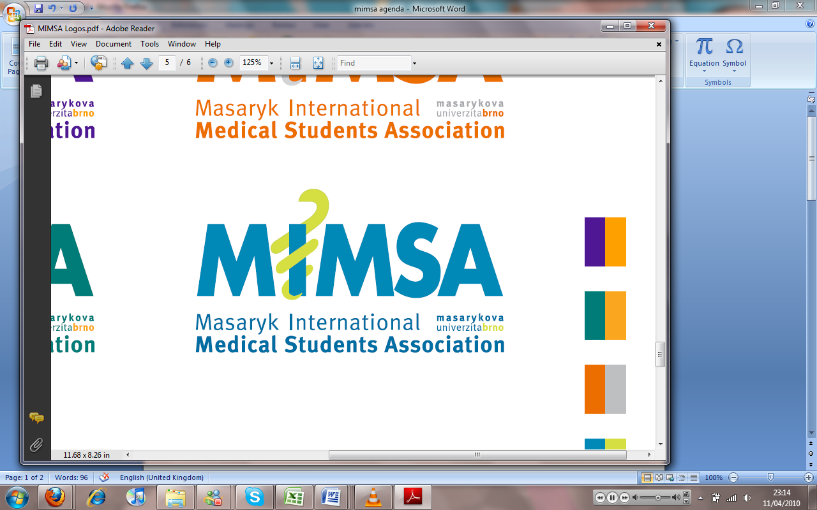Minutes

# Meeting 8

## April 11th 2011

## 6:30pm

Meeting called by Jonathan Phillips and Rita Matos

# Attendees: Jonathan Phillips, Rita Matos, Stuart Hopkinson, Maria Margarida Gil Conde, Bhavin Doshi, Devangna Bhatia, Veronika Sykorova , Adriano Mendes, Luis Cyrillo, Roye Mauthner

Additions:

|  |  |  |
| --- | --- | --- |
|  | President/Vice President  * President is continuing work with other faculties in CR with regards to having a national assembly. There has been contact with Prague and the response from there was of a positive nature. The proposition is to have a joined website whereby our students will be able to share data and resourses. |  |
|  | General  * Devangna is in the process of having hoodies made. There is a prototype which was designed by Khuram that will be ordered and made in the coming weeks, it is nice to have another person helping with MIMSA clothing. |  |
|  | Public Relations  * An email was sent out about the group reps (instead of year reps) but the email was not sent out due to an issue with the email accounts. * In future events need to be publicized in advance. The last events have not given enough time for students to attend and for Cyrillo to make proper posters. |  |
|  | Social |  |
|  | Education  * Schedule for the next semester is for there to be a 3 hour slot for anatomy sessions during which neuro/bones will be studied. * Book sale, we will send out a reminder for people to bring books to us. * Clinical cases- MIMSA MD cases from the internet and diagnosis of each case to be made and discussed. * Czech history taking lessons maybe going to happen * Dentistry meeting about the issues with the teachers not being present and sometimes there not being sufficient materials or places for the amount of students there has been offered to them. They can decide if they want to attend or not, MIMSA will represent them if they wish to be anonymous. * We are to undertake collection of notes for the exam period to help students |  |
|  | Treasurer  * Treasurer has tried to contact the Istyle people with regards to Istyle week proposition however, is still waiting for word on the event- * Phone project has been taken to 02 along with Vodafone and currently is going through the national department. * Copy centre have a contract with us with regards to a 10% discount. Will go on the website in due course. * The treasurer will meet with the ISC treasurer to gain some more contacts with people who may be interested in sponsorship |  |
|  | IT  * The president is pressuring the IT manager for things to happen at certain times without realising the difficulties to what he is requesting. Will not happen again if IT manager is to remain in MIMSA. * Cyrillo will be made an Admin of the website to help in editing it. * Eli has signed a contract with MIMSA so that we can publish his pictures on the website * In the future MIMSA.cz should publish events, not personal people * People are posting things to our mimsa.cz page is it right for us to moderate it? Decision is taken that the PR manager will moderate people posting things on the page. |  |
|  | Later added points |  |
|  | Wrap-up |  |