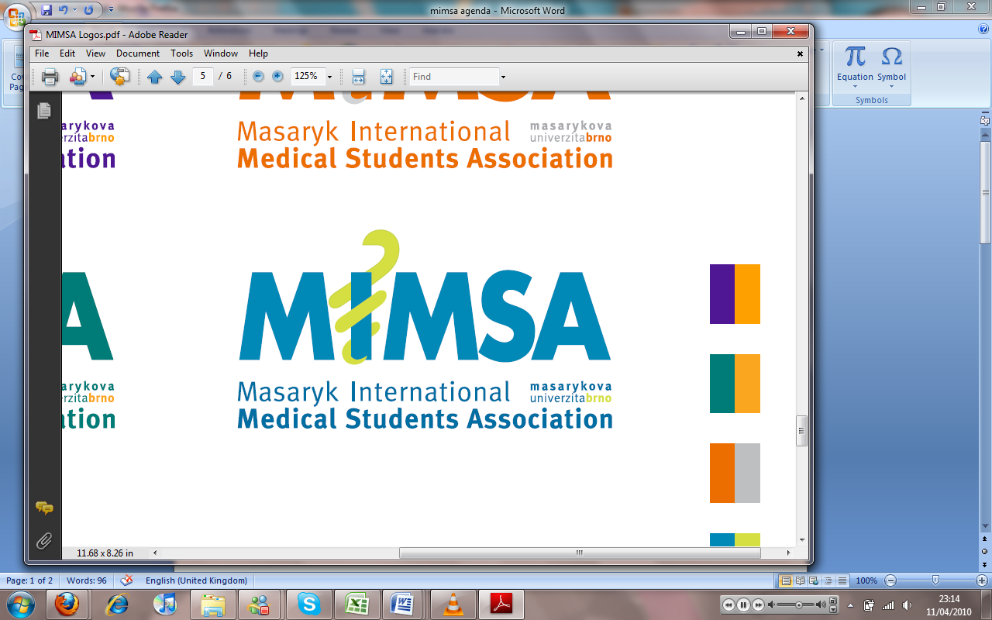AGENDA

# Meeting 1

## December 9th 2010

## 6:30pm

Meeting called by Jonathan Phillips and Rita Matos

# Attendees: Jonathan Phillips, Rita Matos, Stuart Hopkinson, Maria Margarida Gil Conde, Bhavin Doshi, Devangna Bhatia, Veronika Sykorova , Adriano Mendes, Luis Cyrillo, Roye Mauthner

Additions:

|  |  |  |
| --- | --- | --- |
|  | President/Vice President  * RITA IS LATE!!!! * Welcome to the rest of the board- * Conflicts to happen * Don’t take everything so personally * Learn to deal with conflicts in a good way * One meeting at a time, don’t interrupt people * Only English to be spoken * Be on time * Outside of boardroom we all agree on the same thing * Link all of the accounts to Google docs so that we can write the same emails/docs at the same time * Google calendars to check things online * Voting system, everybody gets one vote other than Jon who gets 2 * Write new biography for everybody (send to Roye by next week) * This week look for an English doctors- problem with quality of English of the doctors- so we need to check this out- * Deadlines should be met, if we don’t meet the deadline we are letting down people, please let people know if you are falling behind- |  |
|  | General  * Keep office tidY |  |
|  | Public Relations  * New ISC board all gone except Kika. * Will organise meetings with ISC, IFMSA and Spolek * Cards are interchangeable * We need to get more involved with them for their outreach project * Student reps were not utilized, every month we have a suggestion sheet to go around and see if there are issues in the years of the university. * Bringing the students closer to us. * Recognition of students who stands out and helps us, give them a prize of sorts to show that we care. (further thinking to go on) |  |
|  | Social  * All of the events that we want to happen next week * Joana is the trips co-ordinator * More sports events that are smaller and likely to be a weekly occurrences * Volleyball tournaments, start by having a weekly event and then seeing if we can have a tournament in the future. * Adriano- sports * Veronika – Party * Joana – trips * Committee – maximum of 10 people * Communication is a problem so, it needs to be greater |  |
|  | Education  * Plans for next semester * Carlos Soares wants to teach all of Chemistry subjects, Jon Biophysics |  |
|  | Treasurer  * Need sponsors for the new cards * Flights school- owes MIMSA 10000 Kc. Given details so, we can contact for him now we can get the money. * No money costs to be told to other students until the G.M where it is all announced * Book sales, in the office - |  |
|  | IT  * Projects to be set out and completed * Every department is able to post things on the website |  |