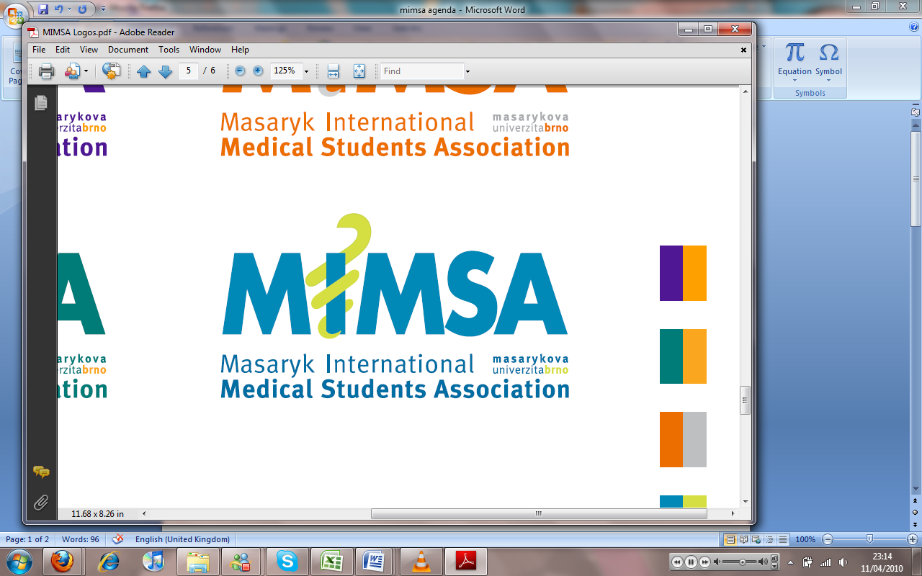AGENDA

# Meeting 4

## March 4th 2011

## 5pm

Meeting called by Jonathan Phillips and Rita Matos

# Attendees: Jonathan Phillips, Rita Matos, Stuart Hopkinson, Maria Margarida Gil Conde, Bhavin Doshi, Devangna Bhatia, Veronika Sykorova, Roye Mauthner

Additions:

|  |  |  |
| --- | --- | --- |
|  | President/Vice President  * Meeting times, Monday 7pm every week- Spare meeting on Friday- * Veronika going to retreat * Team Building, first aid- people going on the trip to do it. * Isc meeting- happening * Bank Cards- Jon sorting the handing over of the cards- * Enrolment, Uni starts on 19th September, 11th board members to be back * Booking of venues for freshers week far in advance, balancing out the events into the two weeks- * Invitations for ball to vice deans- * MIMSA music- * ISC ball- give back all unsold tickets and money to the ISC- * 4 things for 400kc – |  |
|  | General  * Laptop * Dial outnumber- and extension cable- * Calendar * General meeting, unveil MIMSA calendar, education plan, social plan and FAQ/ * Doctors lists to email * Office hours 4-6 Tuesday, Wednesday and Friday- * Publish on website the times when the tickets are being sold- |  |
|  | Public Relations |  |
|  | Social  * Snowtrip 26th -27th March- big planned trips need deposits- think to just reserve rooms for people individually- ask the uni in future to help organise as they have better deals than us alone- * Pub quiz- April 7th * Check google docs for social events timetable- |  |
|  | Education  * Language exchange- google docs with people interested- happening in the next 2-3 weeks – Veronika to help people with the organisation- * Meeting with Deejay, problems with Vice dean of dentistry Kucletova, asked to do something about it 20 started and 4 passed pre-clinical dentistry- lack of space- Problems with teachers, who don’t guide them and don’t teach them properly- Ask to write a review of the class, and this will be handed to Taborska anonymously- * Taking Jon, Rita and Bhav along with Deejay to talk with Helena- * Book sale, confirmed office hours, can bring books in next week and then sale starts the following week- * Anatomy sessions sorted * Clinical session- emailed Helena and no reply- she will try later- Tuesday 6:30 -8:30pm small lect. Hall * Khuram, ask to put online the notes which he has typed up- * Other sessions for biochem I biochem II, Bio, path, pathophys- * 3 session for physiology * Bhav is going to be heading the Biology dept. to discuss the subject problems like the organisation of the lectures and the lecturers not being very good- |  |
|  | Treasurer  * No agreement with RealSpektrum- * Agreement with the other estate agency, they are messing us around- waiting for a response to the reviewed- |  |
|  | IT  * Biographies to * Calendar done and on the website- * Prize to find mimsa mascot- Cyrillo to do image thing * Free prize at party- |  |
|  | Later added points |  |
|  | Wrap-up |  |