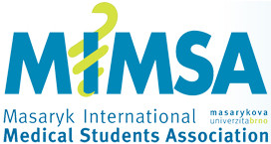

APPLICATION
2012 President and Vice President Candidate Team

Presidential Candidate (Name and UCO): ______________________________________

Vice Presidential Candidate (Name and UCO): ______________________________________

As per Title IV of the MIMSA Constitution, three weeks of campaigning begins November 7th, 2011. The election for 2012 President and Vice President will occur on Monday, November 28th from 10:00‐19:00.
Any questions with regards to the electoral process can be directed to the Election Committee at mimsa‐info@mimsa.cz. Please note “ELECTION COMMITTEE:” in subject line.

By signing below, candidates certify that they have read and understand the requirements for candidacy, especially noting that candidates may not be at risk of expulsion from the Faculty of Medicine at Masaryk University for the duration of their 1‐year term starting December 2012.

_____________________________________ ______________________________________
Presidential Candidate Date

_____________________________________ ______________________________________
Vice Presidential Candidate Date

Application Received by: _______________________________ _________________________
Name Date

