1. 25.02.2010
Introduction, organization of practicals, teaching aids.
An overview of histological methods. Tissue processing for light and electron microscopy - explanation and film. Basic histochemistry and immunocytochemistry.

Programm:
- general informations (organisation of practicals)
- histology and embryology
(what is studied in this subject)
- break 10 minutes
- tissue processing – text (laboratory methods)
- demonstration of slides (tissues stained by different staining methods)

Teachers (tutors):

Prof. MUDr. RNDr. S. Čech, DrSc. – tutor of lectures and examinator
group 41 – MUDr. I. Lauschová, Ph.D. – tutor of practice
group 40 – MUDr. L. Krejčířová – tutor of practice

web page of department: http://www.med.muni.cz/histol/histolc.html
click: Výuka – Sylaby přednášek a praktických cvičení – jarní semestr 2007

Required knowledge extent …. is also on this page

Recomended text-books:
- Junqueira, Carneiro, Kelley: Basic Histology
- Ross, Romrell: Histology (a text and atlas)
- Sadler: Langman´s medical embryology
- Collective of authors: Practical lessons in histology

Organization of practicals:

- The beginning 9:30 (exactly)
- Overshoes Don´t entry the microscopic hall without overshoes or plastic bags on shoes shoes and tops (coat or jacket), large bags leave in the cloakroom, please ☺. Mobil must be switch off or in quiet regime in the microscopic hall.
- What is not allowed in the cloakroom and microscopic hall: - entrance without the overshoes - entrance with drinks, coffee or food - smoking is prohibited on the board of MF
- Working place is constant during semester – number is written in your card! Student is personally responsible for study aids (the microscope = 35,000 crowns, the set of slides – one slide = 10 crowns (symbolic price), atlas of electron-photographs – 940 crown
- Course of practicals - introduction – demonstration (with diapositives, slides, or videorecords)
- student´s own work – study of preparates in the light microscope or photographs in the atlas and their drawing and description into record (protocol)
- Student must be prepared for each practice – use the lectures and text-books and prepare the topic of practicals according to programm (sylabus) - see notice-board in corridor before the hall or the web page of department.
- Break 10 minutes
- Substitution of practice - the absences must be immediately substituted during some other practice (according to the time-table of practicals on the notice-board in corridor before the hall; it is possible also during practice for czech students); how to register substitution: student, who completes the training have to be registered at the leader of practice (teacher) at the beginnig of practice and show him the protocol (for signature) at the end of practice.
- Requirements for credit - 100 % participation in practicals - satisfactory knowledges of topics in each practice (2 – 3 multiple-choice tests during semester)
- Teaching aids - an exercise-book or free papers A4 without lines - soft pencil, colour pencils (basic colores), pen
- The end 11:20 Student set the working place into the initial condition! Box with slides is controled at the end of each practicals.

HISTOLOGY – science about the structure and ultrastructure of the cells, tissues and organs in normal (physiological) conditions

- general histology (+ cytology)
- special histology = microscopic anatomy (structure of organs in systems)

An importance of histological examination in medical practice:
- oncology and surgery
- hematology
- patology and forensic medicine

EMBRYOLOGY – science about the prenatal (intrauterine) development of individual

- general embryology (to the end of 2nd month – EMBRYO) gametogenesis, fertilization, cleavage (zygote  blastomere  morula  blastocyst), implantation, differentiation of trophoblast and embryoblast, implantation, fetal membrane development (placenta, chorion, amnion), extraembryonic structures development – umbilical cord, yolk sac and amnionic sac; early embryo development – ectoderm, endoderm and mesoderm + mesenchyme differentiation, notogenesis.
- special embryology (from 3rd month to birth – FETUS) organogenesis (system organs development)
- teratology – defect development of organs (cause and effect), congenital malformations; prenatal screening technics – ultrasonography, amniocentesis, examination of chromosomal abnormalities.

An importance of embryology in medical practice:
- prenatal care in obstetrics and pediatric medicine

Units of mesurement used in light and electron microscopy (LM & EM)
Systéme international (SI) units | Symbol and Value
Micrometer  Nanometer | 1 μ = 0.001 mm (10⁻⁶ m)  1 nm = 0.001 μm (10⁻⁹ m

Tissue processing for the light mixroscopy (LM)
(making of permanent preparations – slides)

- SAMPLING (obtaining of material – cells, tissue pieces)
- Fixation of samples (tissue blocks)
- Rinsing (washing) of samples
- EMBEDDING of samples  embedded blocks
- Cutting of blocks  sections
- Affixing of sections
- Staining of sections
- Mounting of sections

SAMPLING
A small piece of organ (tissue) is sampled and quickly put into the fixative medium.
- Biopsy during surgical dissection of organs in living organism
= excision
= puncture (liver or kidney parenchyme, bone marrow)
= curretage (uterine endometrium)

- Necropsy from died person (sections); in experiments laboratory animals are used and tissue have to be sampled as soon as possible after the break of blood circulation

The specimens shouldn´t be more than 5 – 10 mm³ thick and fixation should follow immediatelly.

Fixation
Definition: denaturation and stabilization of cell proteins („considerate killing of the cells“ with minimum artefacts)

The reason of fixation: freshly removed tissues are chemically unstable – in the air, they will dry, shrink and undergo autolysis and bacteriological changes; to stop or prevent these changes and preserve the structure tissue samples have to be fixed. During the fixation, all tissue proteins are converted into inactive denaturated (stable) form.

3 main requirements on fixatives:
- good preservation of structure
- quick penetration into tissue block
- no negative effects on tissue staining

Fixatives: solutions of different chemicals

- organic fixatives – ALDEHYDES – formaldehyde (most frequently used for LM)
– glutaraldehyde (used for EM)
– ALCOHOLS – 96 – 100 % (absolute) ethylalcohol
– ORGANIC ACIDS – glacial acetic acid, picric acid,
trichloracetic acid

- inorganic fixatives – INORGANIC ACIDS – chromic acid, osmium tetraoxide
OsO₄
– SALT OF HEAVY METALS – mercuric chloride HgCl₂

- compound fixatives – mixtures (two or more chemical components to offset
undesirable effects fo indiviual (simple) fixatives.
FLEMMING´s fluid – with OsO₄
ZENKER´s and HELLY´s fluid, SUSA fluid
– with HgCl₂
BOUIN´s fluid – with picric acid
CARNOY´s fluid – with alcohol

Performance: fixatives are carried out at room temperature, the duration varies between 12 – 24 hours, specimen must be covered by 20 – 50 times fixative volume:

Ratio of tissue block volume to fixative volume 1 cm³ : 20 – 50 cm³

Rinsing
All samples should be washed to remove the excess of fixative; the choice of rinsing medium is determined by type of fixative: running tap-water or 70-80% ethanol .

EMBEDDING
The reason of embedding: tissues and organs are brittle and unequal in density, they must be harened before cutting.

Embedding media:
- watery – gelatine, celodal, water soluble waxes
- anhydrous – paraffin (most frequently used), celoidin

EMBEDDING into PARAFFIN
- dehydration – to remove water from fixed samples (paraffin doesn´t mix with water; an ascending serie of ethanol is used (50%, 70%, 90%, 96% each ethanol bath takes 2 – 6 hours)
- clearing – the ethanol must be replace with medium which is miscible with paraffin – benzene or xylene
- infiltration – melted paraffin wax of melting point 56 centigrades is used; the wax is carried at this temperarature in THERMOSTAT: paraffin bath - 3 x 6 hours.
- casting (blocking out) – moulds (plastic, paper or metal) are used for embedding. The moulds are field with melted paraffin and tissue samples are placed inside; the moulds are immediatelly immersed in cold water to cool paraffin quickly. Then paraffin blocks are trimmed (excess of paraffin is removed).
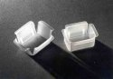
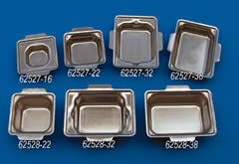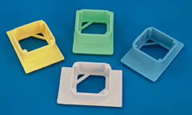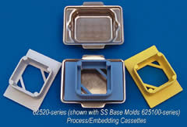
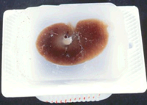
Cutting
Microtome – a machine with automatic regulation of section thickness: 50 – 100 μm is optimum.
Types of microtomes:
sliding microtome – block is fixed in holder, knive or razor moves horizontally | rotary microtome – knive is fixed, block holder moves vertically
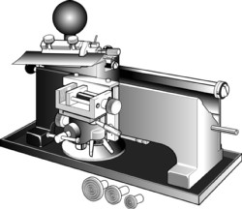 | 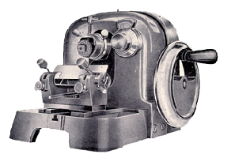
freezing microtome (cryostat) = rotary microtome housed in freezing box (– 60º C); frozen tissue (without embedding) can be sectioned. | 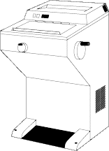
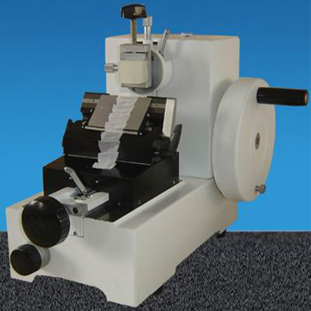

Affixing
Mixture of glycerine and egg albumin or gelatin are used.
Section are transfered from microtome razor on the level of warm water (45º C), where they are stretched; then they are put on slides coated with adhesive mixture, excess of water is drained and slides are put in incubator (37º C) over night to affixing of sections.

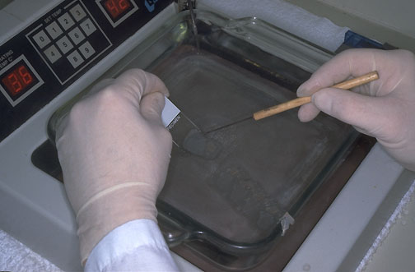

Staining
The reason of staining: different structures within sectiones are not apparent without staining. Cellular structures exhibit an affinity to staining dyes of two groups:

- alkaline (basic or nuclear) dyes – react with anionic groups of cell and tissue
components
basophilia – basophilic structures in the cell
- acid (cytoplasmic) dyes – react with cationic groups
acidophilia – acidophilic structures in the cell

neutrophilia – neutrophilic structures don´t react woth any dyes

Staining methods:
- routine – HE, AZAN (demonstrate all components of tissue)
- special – visualize only some special structures (mitochondria, lipids)
- impregnation – by silver salt for detection of nerve fibers or reticular fibers

ROUTINE HEMATOXYLINE – EOSIN STAINING (HE)

Hematoxyline – basic (nuclear) dye
Eosin – acid (cytoplasmic dye

Staining procedure:
- paraffin must be removed by dissolvin in xylene
- sections are rehydrated in descending serie of ethanol (100% 96%)
- stainin with hematoxyline
- differentiation in acid alcohol and water (excess of dye is removed)
- staining with eosin
- rinsing in water (excess of dye is removed)
- graded ethanols (80% 100%)
- clearing in xylene

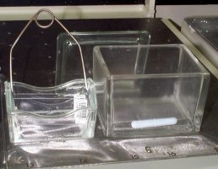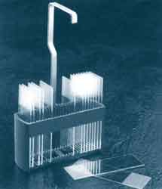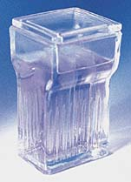
flask slides holder (basket) cuvette

Automatic Slide Stainer  Staining set of boxes with media : | 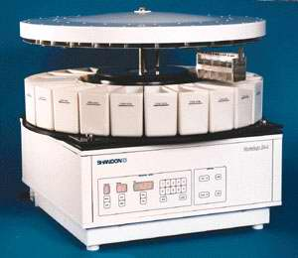

Staining set of flasks (cuvettes) with media – HE staining:

Deparaffination rehydration washing
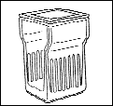 → → → →
Xylene I Xylene II 100% ethanol 96% ethanol H₂O
↓↓

washing staining washing differentiation staining
← ← ← ←
H₂O eosin H₂O acid ethanol hematoxyline

↓↓
dehydration clearing
→ → → →
96% ethanol 100% ethanol xylene III xylene IV

Staining results:

HE = Hematoxyline – Eosin
- nuclei – bright clear blue or dark violet
- cytoplasm and collagen fibers – pink
- muscle tissue - red

HES = Hematoxyline – Eosin – Safron
- connective tissue – yellow

AZAN = AZocarmin – ANiline blue – orange G
- nuclei – red
- erythrocytes – orange
- muscle – red
- collagen fibers – blue

Mounting
Preparates are closed with coverslip (coveglass) to be suitable for microscopic viewing for a long time (permanent preparate). Between stained section and coverslip small amount of mounting medium must be placed.

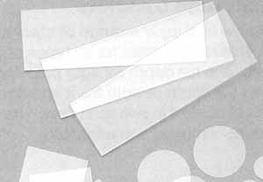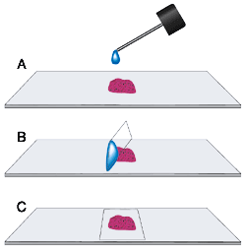

Mounting media:
- soluble in xylene – canada balsam
soluble in water – glycerin-gelatine, arabic gum

Tissue processing for the electron mixroscopy (EM)

Conditions for EM tissue processing:
- pH (index of alkality or acidity) of all solutions (media) must be buffered on 7.2 – 7.4. Cacodylate or phosphate buffer is frequently used.
- Absolutly dustfree setting (! – small particles of dust are seen in EM
- Solutions (media) must be carefull (! – the smallest changes /artefacts/ of cell structure are exposed in the EM more then in the LM)

- SAMPLING – immediatelly after arresting of blood circulation, tissu block sized no more than 1mm³
- Fixation – glutaraldehyde (bond aminogroups) + OsO₄ (bonds lipids) are used as double fixation
- Rinsing – dist. water
- Dehydration - alcohol
- EMBEDDING – gelatine capsule or plastic forms are filled with some medium (which can be polymerized from liquid to solid form) and pieces of fixed tissue are placed into this medium. Epoxyd resins (Epon, Durcupan, Araldite) are usually used as in water insoluble media.
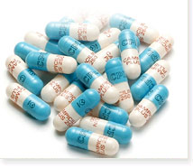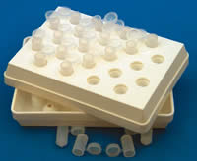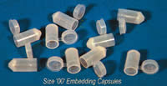

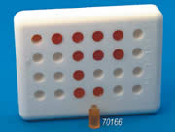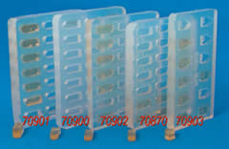

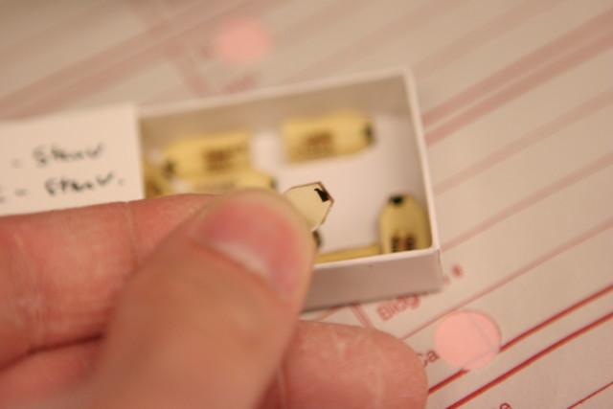

- Cutting – by trimming an excess of hard medium is removed and pyramide with minimal cut surface (0.1 mm²) is prepared. Ultrathin sections (about 70 – 100 nm) in ultramicrotomes. Glass or diamond knives with water reservoir are used. Sections slide and flow on water in small container attached to the knive. Then they are taken to the supporting grids.
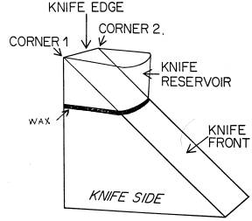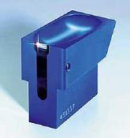

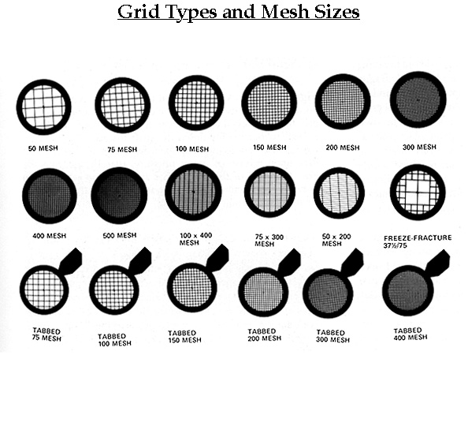
- Contrasting (=Staining) principle of differentiation of structures – different dispersion of beam of electrons in dependence on atomic weight of elements. „electron dyes“ are mixtures of heavy metals: uranylacetate or lead citrate
- study – by EM, material is photographed from fluorescent viewing screen.

Differences between LM and EM
 | LM | EM
Sampling | < 1 cm³  minutes | < 1 mm³  seconds
Fixation | formaldehyde  12 – 24 hours | glutaraldehyde  1 – 3 hours
Embedding | paraffin | epoxid resins (Durcupan)
Cutting  Thickness of sections | microtome  5 – 10 μm | Ultramicrotomes  50 – 100 nm
Staining (LM)  contrasting (EM) | dyes  (hematoxyline – eosin) | heavy metals  (uranylacetate,lead citrate)
Mounting (only LM) |  | ---
Result | histological slide (preparate) | photograph of ultrathin section

