Case 2

26-yo CF with a negative PMH comes to the GI lab for a colonoscopy referred by her PCP with the CC: abdominal pain and diarrhea for 2 months. She had noticed some mucus in her stools but no blood. No weight loss.

What do you think is going on?
Infectious diarrhea vs. IBD?
Ask for any ABx use for URTI, UTI, etc.
Anybody else in the family with the same complaint?
Diarrhea at night?
What happens if she is fasting?

Colonoscopy:

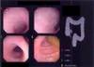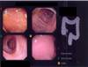
Loss of the normal vascular pattern, granular mucosa, a lot of mucus.
All this is suggestive of IBD - UC.

What labs would you order?
CBCD, CMP, ESR
Stool C/S, O/P, C.diff x 2, WBC

How would you treat this patient?
Start 5-ASA and adjust any further treatment according to the labs and the colon biopsy.

What did we learn from this patient?
Always rule out infection first when a patient is having chronic diarrhea.
Patient may also need a biopsy to diagnose IBD.

Q&A

How to diagnose UC?
History and stool examination permit a presumptive diagnosis of UC.
Always confirm by sigmoidoscopy. Colonoscopy is not usually necessary before treatment and may be dangerous in active stages because of the risk of perforation.
Source: Merck manual

How to diagnose Crohn's?
Diagnosis is usually made by x-ray - barium enema or small-bowel series.
CT can detect extramural complications but it is not routinely needed for initial diagnosis.
Source: Merck manual

How to treat UC?
Check the guidelines from AFP

How to treat Crohn's?
Check the guidelines from AFP

References:
Management of Inflammatory Bowel Disease - AFP 1998
Inflammatory Bowel Disease - NEJM 1996
Inflammatory Bowel Disease - Medical Progress - NEJM 2002

How does UC look on colonoscopy?
It depends on the severity of the disease - mild, moderate, severe. Mild colitis produces redness and swelling of the mucosa, resulting in a loss of the normal vascular pattern, an overall granular appearance, and friability (fragility with ease of bleeding), mucosal granularity, exudate and superficial ulceration.

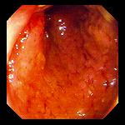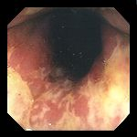
Image source: EndoAtlas

How does Crohn's look on endoscopy?

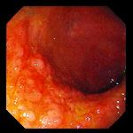
Image source: EndoAtlas

