This 25 year old female presented with worsening breathless. She has no previous medical problems.
Her Chest X-ray is normal.
The pulse oximeter reads 90% so you decide to perform a blood gas:
Results:
Firstly, the pulse oximeter is accurate! Secondly, the patient is sick. Thirdly, the patient has a marked respiratory alkalosis (i.e. she is breathing hard). Fourthly, the A-a gradient is markedly widened
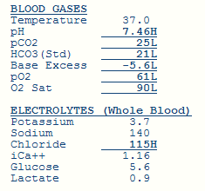

After careful consideration of the diagnostic possibilities you decide to perform a CTPA.
CTPA results: pulmonary embolism (if someone shows you a CTPA and asks you what it shows this is usually the correct answer). Of particular note, the pulmonary trunk is larger than the aorta. This is often indicates the presence of elevated right ventricular systolic pressure.

Before anticoagulating the patient you review the blood tests:
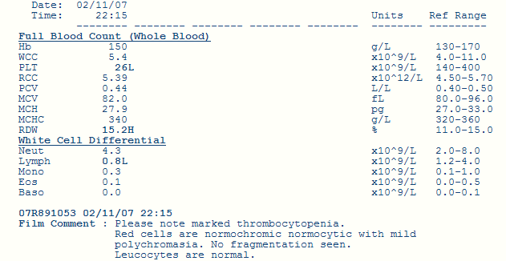
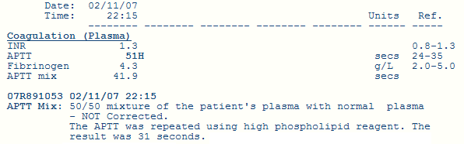

What is the diagnosis?
Thrombocytopenia is significant (given the need to anti-coagulate). The presence of an elevated APPT that corrects with high phospholipid reagent is seen in antiphospholipid syndrome and thrombocytopenia is also a feature of this condition

How would you treat this patient? (by the way the answer is not to ask someone else from another speciality what to do)
The conundrum here is what to do about a life threatening pulmonary embolism is a patient with no platelets. One option is to treat the low platelets so that you can anticoagulate the patient safely. Thrombocytopenia often gets better with steroids in this condition.

While waiting for the steroids to work you need to make sure that patient doesn’t drop dead from a further pulmonary embolism so you order an ultrasound of the legs to assess the situation further.

What does the ultrasound demonstrate?
Left - This ultrasound scan shows a normal vein which disappears with compression.
Right - The other leg looks like this because there is a DVT.

What is this?
An IVC filter to stop the DVT from the leg travelling to the pulmonary artery while waiting for the steroids to kick in.

This is the admission ECG. Describe it.
This ECG demonstrates right ventricular strain with T wave inversion in the anterior leads.

