Life in the fast lane
This 25 year old female presented with worsening breathless. She has no previous medical problems. Chest X-ray was done + describe the findings (Look at screen).

The pulse oximeter reads 90% so you decide to perform a blood gas. What do the results mean?

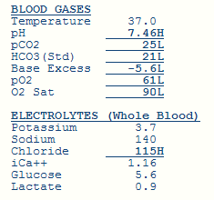

After careful consideration of the diagnostic possibilities you decide to perform a CTPA (CT Angio Pulmonary Arteries/Veins).
What is the result?

Before anticoagulating the patient you review the blood tests:

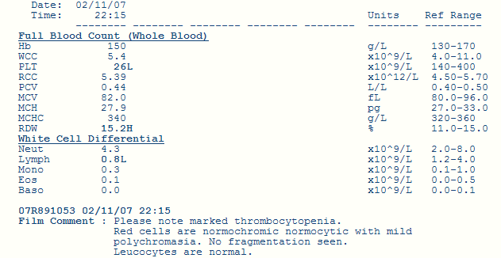
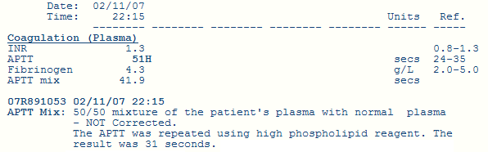

What is the diagnosis?

How would you treat this patient? (by the way the answer is not to ask someone else from another speciality what to do)

While waiting for the steroids to work you need to make sure that patient doesn’t drop dead from a further pulmonary embolism so you order an ultrasound of the legs to assess the situation further.

What does the ultrasound demonstrate?

What is this?

ECG was done on admission. Describe it.

