**T4Green training week Brno, 9 – 13 December 2024**

## Masaryk University, Faculty of Education, Poříčí 9, Brno

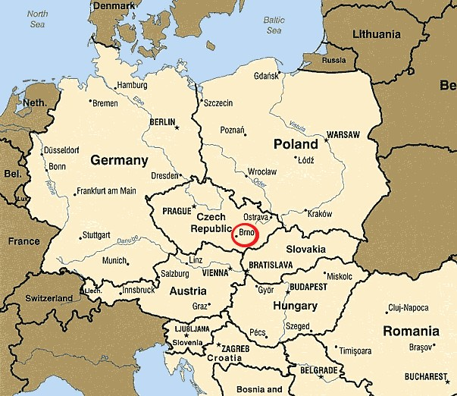

Brno is the second largest city in the Czech Republic. The distance to Prague is 200 km, but we are much closer to Vienna (150 km).

**Location:** Masaryk University, Faculty of Education, **Poříčí 9**, 603 00, CZ

[https:/ /goo . gl/maps/ iaB2ebqssZ5trv ZY7](https://goo.gl/maps/iaB2ebqssZ5trvZY7)

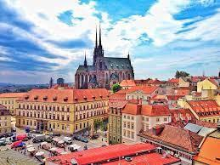

About Brno: Inspirational videos: [https:// ww w.yo utube.co m/watch?v =ErbOZlSukzg](https://www.youtube.com/watch?v=ErbOZlSukzg)

https:/[/www.youtube.com/watch?v=spQwWG0BPHY](http://www.youtube.com/watch?v=spQwWG0BPHY)

# Public transport

Brno has frequent and reliable public transport. Information about fares can be found here: https://old.dpmb.cz/en/

https://pipniajed.cz/en.html

Trams No. 2, 5, and 6 (Poříčí station) stop directly close to the faculty buildings.

In all public transport vehicles, you can pay with your card; just attach it to the yellow terminal located at each car door. The maximum amount you will be charged is 90CZK/day, which is 3.5 EUR, even if you change several times and use the transport frequently. However, be sure to bring your card with you every time you board the bus/ tram.

# Parking

https:/[/www.parkovanivbrne.cz/en](http://www.parkovanivbrne.cz/en)

**Christmas events**

All information about Christmas in Brno, the European City of Christmas, can be found on this website. Christmas markets are held in several locations in the city center and can be walked between. We recommend sampling traditional specialties and alcoholic and non-alcoholic drinks. The giant carousel on Moravské náměstí is also a treat.

<https://brnenskevanoce.cz/en/>

https://www.vanocebrno.cz/en/

# Culture, events

<https://www.gotobrno.cz/en/>

(On this website, you will find information on everything you can think of (entertainment, culture, festivals, food, drinks, sports, attractions)

<https://podzemibrno.cz/en/>

(An excellent opportunity to discover underground Brno

**¨**

**Outside Brno**

<https://punkevni.caves.cz/en> (A fascinating, beautiful, and unique opportunity to get to know the Moravian Karst - stalactite caves that will surely delight you and provide an experience you will never forget).

<https://www.aqualand-moravia.cz/en/>

If you're a lover of water, water fun and wellness, make sure to stop by on your way to Vienna.

**Inspiration for teachers**

<https://vida.cz/en/>

Near the Brno trade fair complex (and far away from the Faculty of Education), playful explorers of all ages will find more than one hundred and eighty interactive exhibits over an area of nearly 6200 square meters that will give them a better understanding of the world around us. A fun and experiential science center can be a learning experience for teachers of STEM subjects and beyond. The center is well attended by families, especially by students and teachers.