**SPONTANEOUS ARTISTIC EXPRESSION AS A UNIQUE WAY OF SELF-EXPRESSION**

*Marie Bajnarová*

Faculty of Education MU, Department of Art

Brno, 603 00, Czech Republic

+420734738138

marie.bajnarova@seznam.cz

***Abstract:*** *The thesis is focused on drawing peculiarities of individuals from Youth Detention Centres (YDC). The individual's spontaneous drawing expression has become the centre of attention. Spontaneous art expression is considered to be another possible natural way of human expression. The author of this text would like to show that there exists a connection between drawn symbols of juvenile delinquents (JDs) and sketches and drawings of known artists of the 20th century. The author intentionally selected artifacts of JDs to compare those with the sketches of famous artists. Further she examines the artistic expression that accompanies the spontaneous individual's expression. The meaning of spontaneous expression is about the present moment, which is being experienced by the creator. Therefore the author seeks the answer to the question, what the JD is experiencing during the process of his artistic formation.*

***Keywords:*** *symbols, drawing symbols, drawn expression, art of the 20th century, delinquency*

**1. Spontaneous artistic expression of delinquents and artists of the 20th century**

This chapter focuses on spontaneous artistic expression of the delinquents. By 'spontaneous artistic expression' we mean a creative activity that is not directly or intentionally encouraged or stimulated by another person. It is about an impulse which arises from the internal needs of a person who decides to creatively and artisticaly respond to external and internal stimulus. According to Roesell [1] a spontaneous expression is related to the artist's relationship to reality and that is why this artistic form does not require a true presentation nor to respect proportions nor precision regarding details, it is about expressing the artist's essence. This is also about being able to reach one's deep feelings and experiences. At this moment, the artist authentically devotes himself into his own perceptions and the art form. A spontaneous creation is about the artist focusing primarily on capturing his current mental state, impressions, feelings and moods, thoughts or his attitudes. The artist is mainly focused on what he is experiencing while drawing his creation. This is an experience which expresses his current state of mind. I can declare that a spontaneous artistic expression allows his creators to further develop his personality. Through this authentic expression the creator reveals himself, opens up to the world and most of all gets to know himself. This unique creative process even enables the artist to express his symbolism.

* 1. **Drawings of juvenilie delinquents from Younth Detention Centres and of artists of the 20th century**

Many artists who I am going to mention tried to express individualy and freely by sketching or painting on canvas their visions, desires, thinking and emotions. They were also inspired by primitive art, some even imitated creations of children or of the mentally ill. Modernists understood this creative process as being really distinctive, impudent and that this revealed the unconscious. The artists's works did not correspond to reality. However, the formation corresponded to what had been happening inside the artists's minds. The artists let themseves be intentionally influenced by the spontaneous expressions of children, primitives, retarded individuals, lunatics and prisoners. The artists saw these people as being creative who were unrestrained by civilization. Paul Klee and Jean Dubuffet were modernists who were most devoted to the artistic expressions of the mentally ill. JDs from YDCs are not mentally ill, however are different from ordinary young children. According to one detention officer JDs are "emotionally handicapped". They experience internal conflicts, conflicts with their loved ones or with their surrounding. They are rebellious, they feel under pressure and are frustrated. Many of them already at their age have gone through so many experiences and have so much life experience, that an adult could be astonished by this. In my opinion their experiences then express their distinctive and impulsive incentives in their self-expression, thus it is helpful to them to express their personality through art activities. The drawings of troubled individuals show features of Art brut, abstract expressionism yet also decorative Art Nouveau.

* 1. **Communication through drawing of juvenile delinquents and their artistic handwriting**

A drawing process inherently belongs to the activity that shows the perception of the world and the person himself. Studying these drawings we can find out what kind of a life the artist lives and what kind of an inner life he has. Some artists show their talent in capturing details while drawing, they also captured rhythm, repeated lines and used principles of the method called Zentagle (Zentagle, also called "the complexities of lines" is a specific way of drawing based on the automatic creation of the artist. Basically it is about doodling, sketching of shapes and searching for new shapes. Zentagle reflects symbols, different patterns, structures and mainly the artist's attitude to the drawing. The method is a simple way to relax. This method applies meditation which causes soothing effects on the artist). I chose a sample drawing of a JD where I can see the sameness to a sketch by Gustav Klimt (1862-1918). The boy drew ornamental tree bark in the same way as Klimt caught the decorativeness of kimonos (see Fig. 1).

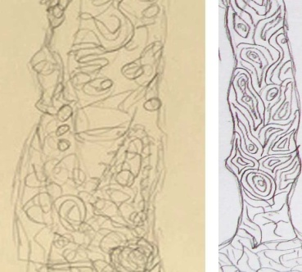

*Figure 1: Details of the kimono sketch by G. Klimt ("Standing woman in kimono", 1917, 50.2cm x 32.4 cm, MoMA) in comparison with tree bark detail of the boy's drawing*

I can also find this similarity in a sketch by Pablo Picasso (1881-1973). In this quick sketch he tried to capture farm environment. This picture intrigues me by its simplicity in expression which is similar to the following drawing. A JD tried to create in a rapid pace his ideal house, the surrounding and the atmosphere (see Fig. 2).

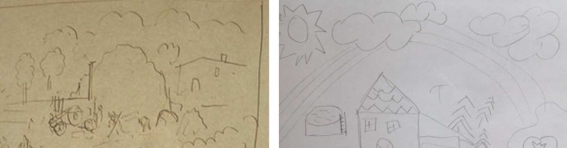

*Figure 2: Details of Picasso's sketch ("Harvesters", 1910, 31cm x 49cm, MoMA) and details of the JD's drawing*

A remarkable drawing for me is a drawing from a juvenile who showed through this process his considerable embarrassment and sadness due to his break-up . He drew his unfortunate love. The portrait of his former girlfriend gives one a feeling of a depressive impression and it is almost frightening. I found similar drawings by the artists Joseph Beuys (1921-1986) and Alberto Giacometti (1901-1966). In their drawings both artists placed emphasis on a portrait and expressively accentuated their emotional states. Beuys blackened his portrait by lines, and this similar drawing process can be seen by the JD. The juvenile did not blacken the portrait of his girlfriend, however smeared black lines around the girl's head, as if by this the juvenile tried to portray isolation and inaccessibility. Whereas Beuys's sketched portrait was also „framed“ as the juvenile's, Giacometti's portrait was smeared all over (see Fig. 3). Another similar symbol in Beuys's portrait and the juvenile's portrait are the eyes. Not one artist drew pupils in the eyes. Three sketches then proof that the artists while drawing had to be absorbed in their negative feelings, maybe even rage, anger and depression.

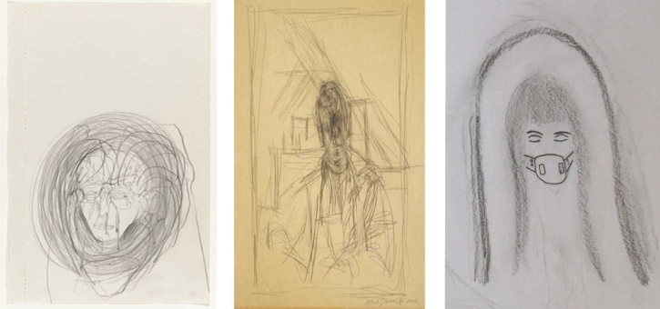

*Figure 3: Beuys's drawing ("Untitled", 1974, 21.6 cm x 13.7 cm, MoMA), Giacometti's drawing ("Untitled", 1951, 65.4 cm x 3 cm, MoMA) and the detail of the drawing depicting the breakup with a girl*

Klee (1879-1940) created fanciful systems, where the forms of writing and drawings were combined. In his work, as well as the JDs, Klee made the eyes much bigger and the heads of the figures as well or he introduced other elements into the ornamental designs. In his works, I found a certain type of graphic design process - drypoint etching. In this graphic design by using the linear technique he illustrated the systematic nature of buildings in a city and experimented with perspectives. To this graphic design, I deliberately chose a drawing that is not drawn in the right proportions however is identical to the artist's simple presentation (see Fig. 4).

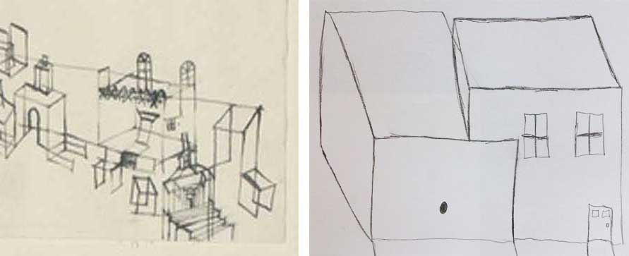

*Figure 4: Detail of Klee's grafic ("View of Ancient City", 1927, 43.5 cm x 63.2cm, MoMA) and a detail of the JD's drawing called "My Garage"*

Most drawings that were created by JD, an individual with behavioural disorder or a person prone to aggression, show the signs of Art brut. It is no wonder that these individuals express themselves through this artistic style since Art brut expresses coarseness and brutality as opposed to cultivation. At the exhibition Compagnie de Brut l'art in Paris yr., 1948, which was made up of 2,000 art works from 63 artists of various disabilities, Dubuffet (1901-1985) wrote his best known text on the subject: "Art brut is preferred above to cultural art ", where brut the artist is put into the role of radical version of the romantic genius freed from all conventions [2]. By this statement he meant the works of people who are not affected by the art culture. Dubuffet admired these artists, especially their unbinding creative process and the indomitable strength of the resulting artifacts. According to him, these artists were not influenced and did not follow the concept of classical or modern art. While looking at their works, the viewer becomes a witness of absolute work of art where he may discover through the artist's inner motivation some kind of a unique and original artistic expression. Dubuffet himself was influenced by a harsh, uninhibited style and his works show farcical, satirical and absurd expressions [3]. A drawing from Dubuffet's sketchbook shows fairy-tail stylized character similar to the fantasy drawing of the JD. In his drawing the character potrays a witch as being one of the detention officers (see Fig. 5).

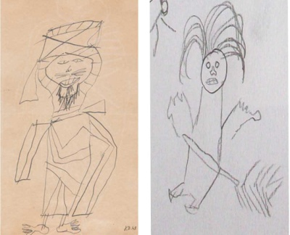

*Figure 5: Drawing from Dubuffet's sketchbook ("El Golea II.", 1948, 30 cm x 12.7 cm, MoMA) and the detail of a fairy-tale character portrayed by the JD*

In one of the JD's drawings of the Sun I found how he interestingly captures female lips. These lips remind me of a sketch by William de Kooning (1904-1997). In his sketches Kooning depicts a naked woman, her emphasised lips are the same as the lips in the JD's drawing (see Fig. 6).

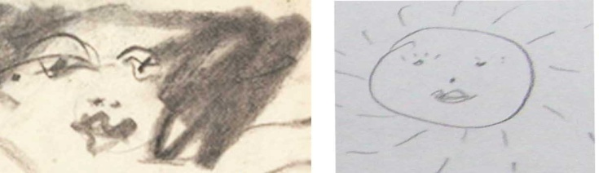

*Figure 6: Detail of Kooning's sketch ("Untitled", 1966, 25.4cm x 3cm, MoMA) and detail of drawing of the revived Sun by the JD*

Spontaneous drawing expressions are evident by the artist Cy Twombly (1928-2011). The principles of his creative process are the complexity of lines, lines themselves, scribbles and composition of letters. His theme usually and deliberately expresses something inexplicable, unclear and confusing. Most JDs express themselves in a drawn form by using this style (see Fig. 7). Doodling evoked calming effects and this became a form of relaxation for them.

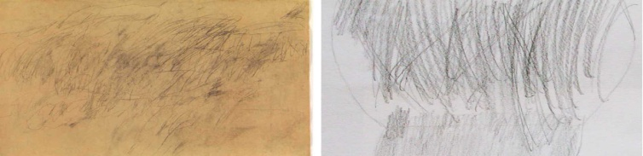

*Figure 7: Cy Twombly ("Untitled", 1955, 62cm x 91.7cm, MoMA) and detail of an expressive artwork of a tree from a JD from a YDC*

Joseph Beuys (1921-1986) and Jean Michel Basquiat's (1960-1988) animated style appeared in most of the JDs' drawings. A game or mere deformation of geometric shapes in Beuys's sketch recalls a representation of a puzzle. Shapes were distorted in a similar way by the JDs while drawing a fence. The strokes are sharp and pointed (see Fig. 8).

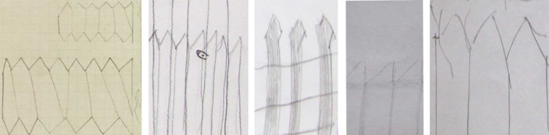

*Figure 8: Beuys's sketch ("Untitled", 1956, 14.6cm x 10.2cm, MoMA) and details of fences drawn by the boys from a YDC*

Another spontaneous drawing by Beuys shows just doodling around on the surface of a sheet of paper. I found conformity of strokes in one of the boy's drawings, who also doodled around on a sheet of paper (see Fig. 9).

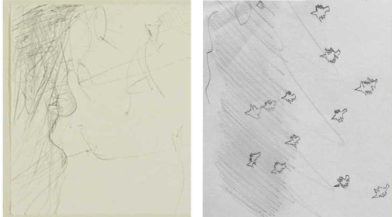

*Figure 9: Spontaneous drawing by Beuys ("Untitled", 1957, 17.4cm x 27cm, MoMA) and detail of the boy's drawing*

Basquiat's works of art are the closest ones to which the problematic individuals are able to identify with . His works include scenes from the hip-hop culture, his bohemian lifestyle and the city environment. He often incorporated script, different codes and symbols in his works. He came to terms with reality through his unique artistic expression. Boys from YDCs refused to draw a figure because of their fear of being diagnosed, therefore some drew characters in a simple short-cut way. This simple and quick way to draw was used by Basquiat (see Fig. 10).

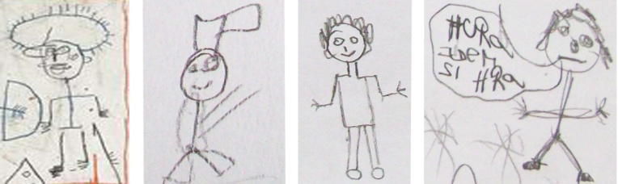

*Figure 10: Detail of a figure by Basquiat ("Untitled", 1981, 101.6cm x 152.4cm, MoMA) and detail of characters from the JDs*

The last sample drawing by Basquita simply shows symbols which he described verbally in a written form. One JD drew most important things from his life and was also able to portray his wishes. Then, in a similar way as Basquit, the boy wrote down what the symbols mean (see Fig. 11).

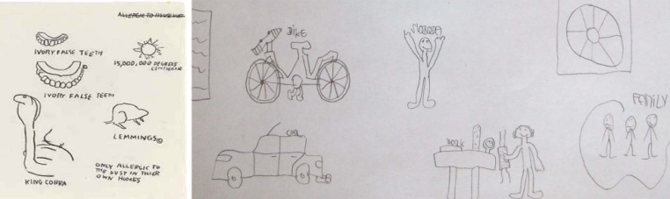

*Figure 11: A drawing by Basquiat ("Untitled", 1982, 41cm x 35cm, private collection) and detail of the drawing by the JD*

**2. Conclusions**

Each person has a unique and distinctive „handwriting“. A common pencil and paper were the agents used for research due to the fact that these agents offer many opportunities to capture the artist's mood. Symbolic images in the drawings show us some kind of communication, the artist talks to us through these. It depends on us how we „read“ these symbolic or graphic images. The thesis points out the characteristic features of the JDs' drawings and of some selected artists. At first glance, we can be amazed by the rendition of the drawings that use unusual shapes, grasping the essence and mental state of the artist and the way of using his leading lines. The artist identifies himself with his drawing and this then becomes very personal to him. The examples clearly express the artists by a specific way of drawing. Their ways are enriched with different peculiarities and originalities. The drawings of the JDs and the drawings of the artists have in common the fact that their drawings reflect their unconscious tendencies and life experiences. I evaluate their drawn expression as being the result of the internal and external forces and motives. If we want to understand the artist's creative expression, we must empathize with his work. Within the drawing process of the JDs, tendency to decorativness and regularity appeared, but also their fear to draw the human figure. The drawings reflect deformations of elements, sharp strokes, shading yet also the dynamic and joy from the drawing process. The drawings of the JDs feature Art brut, abstract expressionism and elements of Art Nouveau, as the artists, as well as the JDs, all tried to capture their current state of mind. By means of drawing they responded to their wishes, thoughts and the current situation in which they find themselves. JDs' drawings included fantasy symbols, writing, letters and ornaments. Most artistic styles used by the young were from Joseph Beuys and Jean Michel Basquiat, probably becaise this art style is idiosyncratic, unique, playful and simply the easiest one for the juveniles.

**References**

[1] Roesell, Vera, *Didactics of Art Education*, Charles Univerzity, Prague, 2003, p. 200.

[2] Foster, Hal, *Art since 1900*, Slovart Press, Prague, 2007, p. 704.

[3] Dempsey, Amy, *Styles, Schools and Movements: The Essential Encyclopaedic Guide to Modern Art*, Slovart Press, Prague, 2002, p. 304.