Involving of parenting through informal education for children less than three years of age in the Czech Republic

Lucie Grůzová, Faculty of education of Masaryk University v Brno, Czech Republic

**Abstract**

This paper presents informal education throught parent and child activities. Phenomenon of early education became a Czech policy priority and there are few processes, which are nowadays as a curriculum reform and social, political and pedagogical problems, how to place children who are two years old into kindergartens although institutional pre-primary education starts in the age of three. It covers the context of family and community learning. The article brings view into a variety of informal activities for parents and children younger than three years of age at the beginning of the educational path in Czech Republic from parents’ point of view.

Key words: childhood, family, family culture, learning family as learning society, parent education, informal education, early educational activities for children zero-to-three, parenting style, grounded theory.

1. **Introduction**

Family life in Europe has undergone many changes in the twentieth century. The economic, political and social processes of twenties century were reflected in the everyday life of Europeans, have shaped the family and relations in families, and have had an influence on the birth rate. One of the main goals of European family policy is to ensure a harmonious balance between professional life and family life. Our society is defined as “knowledge society” or “learning society” with learning communities (Cribbin, Kennedy,2002; Jarvis, 2001; Pedler, Burgoyne, Boydell, 1991) The knowledge cycles have become shortened and it is necessary to keep on learning in order to cope with and face up the changes.

Family life is in context of topics: childhood, parenting and education what are very important continual processes which are running side by side. The family is today characterized by its plurality, and diversity and fluidness (Popenoe, 1993). There is a close relationship between “family learning” and “lifelong learning”. The main point is rather than acquiring knowledge to support learning capacity. Child receives a set of conditions though family learning that help the process of learning and helping family members gain adaptation mechanisms for coping with the constant changes in society.

The article focuses on the characteristics of learners families with children under three years of age who uses informal education.

However there is research(Blackburn, 2005) is at the beginning of educational path. We are speaking about informal education, compare to formal education which is taken place in institutional educational institutions-based, provided by trained teachers; informal education happens outside the institutional educational system, in after-school programs, community-based organizations, museums, libraries, or at home (Průcha at all, 2009). Making choices about parental, informal (relatives and friends) or formal childcare depends on a whole range of factors, which include employment preferences, income, the cost of formal childcare, trust, flexibility, convenience, and also perceptions about child development (see Figure 1 for outline of costs and benefits of these choices).

Figure 1: Childcare choice variables

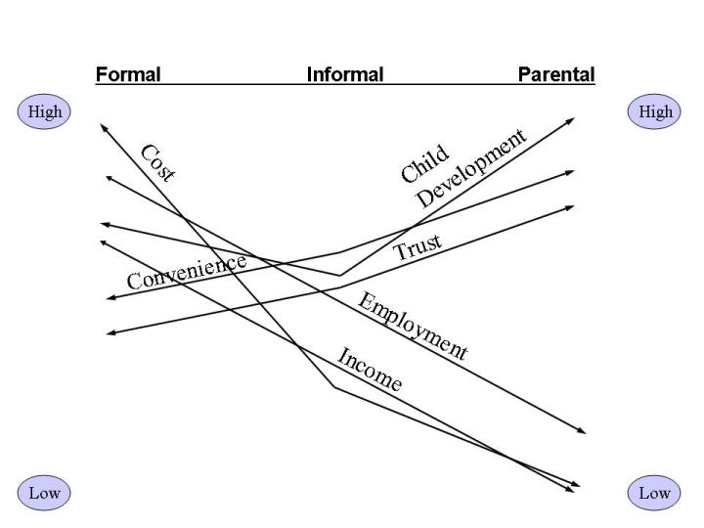

Source: Blackburn, 2005

Education of children up to three of age is defined as early education. Early education definition speaks about a model of education and care with main aim of physical and psychical and cognitive and social development. (Eurydice, 2000) We are speaking more about natural development and maturation than about education. The age from birth to three years is very specific. The family is the first teacher and it has the strongest influence on child. The child´s psychophysical social and emotional development can be supported or impaired by parent action or omissions. We can also speak about family culture (Cherri, 2008). Cherri (2008) defined family culture by four basic aspects: the family atmosphere, cohesion, communication and learning in the family. If we want to define the family culture, which positively affects learning[1] of its members, we can say that there is such a family friendly atmosphere, there is open communication and a large measure of family cohesion. The author concludes that a family with a positive culture is analogous to the concept of the learning organization (Pedler, Burgoyne, Boydell, 1991; Rabušicová at all, 2011), we can say that it is a learning family, for which as well as a learning organization, it is essential a strong culture of sharing and learning among members. According to Cherri (2008) can be considered as a family learning organization if its members continually learn and if they are dominated by a large degree of sharing. Both then affects the strength and power relations in the family. So if we understand the family as a learning organization, the successful firm and strong relationships depend on how intense is sharing (cohesion), communication and family atmosphere. These aspects related to parenting style[2] as a part of family culture. Parenting style is also involved by learning and by experience.

**Theoretical framework**

Czech family is changing. There are changes in different types of families, which could be called for the process of democratization, which manifests itself: Alignment social position of men and women in the family, reflecting the potential for the substitution roles of men and women within the family and in its subsequent actual implementation, the implementation of "flexible" labor division between husband and wife in the family, creation of social conditions for the implementation of these changes by state authorities and institutions.

The time of up to three years of age is becoming an important in terms of entertainment for families with children and education and training in the area of parental action, but also acting on the child.

Now let's focus on research related to educational activities for parents and children and child development. Brain research confirms that early educational activity supports neural connections (Acredolo, Goodwyn, 2007, Gopnik, Meltzoff and Kuhl in Hirst, 2005). Activities aimed at supporting families are likely to protect children from the negative terms of education, prevent child abuse and problems in social-emotional development (MacLeod & Nelson, 2000).

In the context of educational activities aimed at the language development were supported by research conducted in the USA Institutes of Health (Acredolo, Goodwyn). The survey involved more than 140 families with children who were 11 months old, were examined within 36 months. At the beginning of the study, both groups were equal in terms of the following list of characteristics: child's sex, birth order in the family, their effort to create words or express themselves through words, and socio-economic characteristics such as parents' education and income levels. It was found that a group of children, which was intentional program of sign language (Baby Signs), with the language development, was significantly ahead of the control group, in which the following was not spoken.

Since 1990, the Baby Signs program is part of the curriculum in a center for the study of child and family (Center for Child & Family Studies) at California State University at Davis. In addition to the studies conducted by Professor Acredolo and Goodwyn have taken place in that study center and other experts, including C. Vallotton, which examined the interactions between children at an early age and their teachers in a manger environment. The result of her research was that the Baby Signs program has more positives (Tilton, 2010):

• reduces frustration and aggression in the classroom;

• allows infants and toddlers to express their emotions (eg. joy, sadness, fear, anger) and feelings (eg. drowsiness, cold, pain) that can show not only the designation of own situation, but also to describe the situation of other children;

• helps teachers to be more observant and responsive during the daytime mode;

• encourages children from 9 months to engage in early conversations with teachers;

• represents the "international language" in a facility where children are from different linguistic backgrounds.

Further research C. Vallotton was listed as an intervention study under the auspices of the early start (Early Head Start - EHS) in Yolo, California designed for underprivileged families. Respondents were divided into two groups, one group used the Baby Signs program and the other did not. Results of the study showed that the use of sign language seemed to mothers and their children as follows:

• Mothers are able to tune more on the emotions of their children.

• The number of attempts to communicate with the child's mother increased.

• The number of situations where children showed signs of stress decreased.

The results of this study suggest that early intervention in the form of training programs can be an effective way to improve the interaction between parents and children in underprivileged families.

Ch. Farkas conducted a study sponsored by the Government of Chile, which evaluated the impact of early education program (Baby Signs) at-risk families in twenty Chilean nursery in poverty-ridden areas. The study shows similar results as previous research.

we can find research focusing on child development and the importance of "games" on the child's development at an early age also in our literature (Severová, 1982). The author is careful observator of infants and toddlers trying to set out the most important milestones in the development of these children, and the teachers work with them.

Parenting style is very important quality of family culture. Baumrind (in Helus, 2007) proposed three distinct parenting styles: **Authoritarian parenting,** which emphasizes obedience, discipline, parents are less communicative and the main principle is „ just do, what i say“; **Permissive parenting,** which is characterized by maximum of freedom, emotional warmth and a reluctance to enforce rules, the main principle is kids will be kids, finally he finds the sense of things ; **Authoritative parenting,**  which emphasizes parents expectations that children meet certain behavioural standards and encouraging of children to think for themselves and to develop a sense of autonomy. Later, researchers added a fourth style, **uninvolved parenting** (Maccoby and Martin 1983). These four styles classification is usually used.

Basic parenting styles represent borders, but parents might straddle the line between authoritarianism and authoritativeness or between authoritativeness and permissiveness.

Baumrind (1991) have re-stated her definitions of parenting style in terms of two dimensions—“responsiveness” and “demandingness.” Responsiveness is “the extent to which parents intentionally foster individuality, self-regulation, and self-assertion by being attuned, supportive, and acquiescent to children’s special needs and demands” (Baumrind 1991). Demandingness refers to “the claims parents make on children to become integrated into whole family by their mature demands, supervision, disciplinary efforts and willingness to confront the child who disobeys” (Baumrind 1991).

Both of these factors are desirable.

Baumbind proven that children who grow up in families with style leaning against the authority and regardless of age, ethnic origin and status, perform better indicator of the development of personality, cognitive ability tests and the results of school work than the other two parenting styles.

At present there is a large number of educational activities for children up to three years, so I divided these activities by their specialization into several categories. They are:

1. Educational programs focused on psychomotor development: the exercise of babies and toddlers, babies and toddlers massages, swimming, etc..
2. Training programs aimed at developing language: sign language of deaf babies and toddlers, foreign language for toddlers, music rings etc..
3. Training programs aimed at social development of children: Morning baby, nursery-schools (corporate, montessori).

Activities focused on speech development

Yamaha Music School operates worldwide. Originated in Japan in 1954, working since 1967 in Germany and since 1994 it has been in the Czech and Slovak Republic. The principle of Yamaha Music School added: "There are no non-musical people. They are just undeveloped talents!"

Currently Yamaha school offers a wide range of teaching subjects for children from 4 months, youth, adults and seniors. There are extensive teaching concepts and methods appropriate for older children.

Distribution of activities by age:

• babe - for children from 4-18 months, once per week 45 min.

• First steps to the music - for children from 18 months to 4 years, once per week 45 min.

• Rhythmic steps - for children 4 to 6 years, once per week, 45 min.

Sign language program for hearing babies, Baby Signs was developed by a professor of developmental psychology, University at California, Davis - Dr. Acredolo and Dr. Goodwyn. The effects of signing a long-term examined in detail and the results of their research have shown that signing helps lay a solid basis for effective communication that children will remain long after they learn to speak and leave the sign language.

The activity takes place 1 week 45 min.

English for toddlers is very popular; we can find many activities of this kind. This English for children is based on the same principle on which children learn their native language. With repeated listening and positive support in strengthening their language skills children learn English as naturally as they learn their mother tongue.

For example. English for children Helen Doron Early English offers everything a child needs to learn English as their native language - communication skills, proper accent, grammar and rich extensive vocabulary stock.

Baby's Best Start (for children from 3 to 22 months)

- To enrich parent - child relationship in the first months of life, 45 min., Once per week

Fun With Flupe (from 2-5 years) - 30 min., Once per week

Activities focused on the development of motor skills

Swimming for infants and toddlers has many specifics. First of all pools for swimming must meet strict hygiene measures and also controlled by public health offices. They must daily take daily and send them analysis and also almost constantly monitor water purity. It is very important expertise to swimming instructors that you checked above all the swimming club.

30 minutes once per week

Exercise of parents with children aims to support the development of the locomotive - specially selected exercises initially trained with children mum or dad as illustrated lecturer, later children manage themselves. In addition to supporting the spontaneous movement - in each lesson are ready for children colourful obstacle courses, and the development of speech perception of rhythm - exercise is accompanied by poems and songs. It is equipped with plenty of appropriate tools - to motivate kids to move, develop fine motor skills, perception of colours and shapes ...

Table 2 Classification of informal activities for children up to three years old

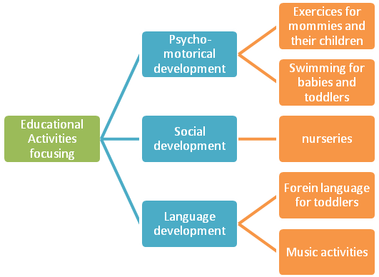

**Research methodology**

There was used a qualitative metodology in the research. Qualitative methodology helps us to investigate the new phenomenon deeply and in a wide range. (Šedová, Švaříček, 2007) Facts were collected by observation and individual interviews with three parents attending parent-child activity Baby signs. Interviews were analyzed. Interviews were written down and analyzed by coding by grounded theory (Strauss, Corbin, 1997).

All three participants were freely consented to participation.

Research answers the research question “If and how parent-child activity affects to family culture?”

The parent-child activity Baby signs was hold in family centre specialized for informal education for children until six years old and parent education with practice three years in Brno in Czech Republic. There were six classes that were observing. After ending of six classes the participants were interviewed for fiflen fifteen minutes.

The parent-child activity Baby signs class was designed in forty-five minutes and had two parts: parent education and educational activities for children (more characteristics you can see in table 1). Parent education was organized like small lecture with discussion afterwards. Educational activities were organized with emphasis on children mood, every class has own topic (meal time, bath time, pets, bed time, in the park, clothes) and there was structure of class (welcoming with puppet, presentation of new baby signs, two topic songs, games and psychomotor activities, goodbyes).

**Table 2: Characterization of Baby signs class**

|  |  |  |
| --- | --- | --- |
| * **Characterization of Baby signs class** | | |
| * **Parent education (15 minutes)** | | * **Educational activities for children (30 minutes)** |
| * **Topics** | | * **Content** |
| Parent-child communication | Basics of communication (stimulus, response) | Games for children (parachute, tunnel..) |
| Let the child play | How to understand child play | Toys for topics, what child uses every day |
| What specifics have children language development | How to speak with child  How do the child learn language  What time do the child speak | Songs |
| Specifics of manual and fictive play | What positive manual play brings to child  What positive fictive play brings to child | Nursery rhymes |
| What is Baby signs | Basics  How to use baby signs  What is specifics of baby signs |  |
| Child development | Specifics of child development  Importance of parent approach |  |

Parts of the research were three families (mothers and children), these families are characterized in findings, they were observed during the classes from point of view of communication, family atmosphere and cohesion. Final interview were focused on changes in family culture during course and what involving parents could see in their parenting style.

**Findings**

Family A

Family A – mother (31 years old), university-educated; one girl child three years old, one boy child 10 month old.

Table 3 Family culture A

|  |  |
| --- | --- |
| Communication | Opened, with respect, some gaps in consistency |
| Family atmosphere | Positive, warmth, children tried strength of borders |
| Cohesion | Middle, everybody is individualist |

The parenting style is permissive style.

Changes after course: Mother A spoke about bigger empathy to her children and uncertainty problems to cope with children emotion.

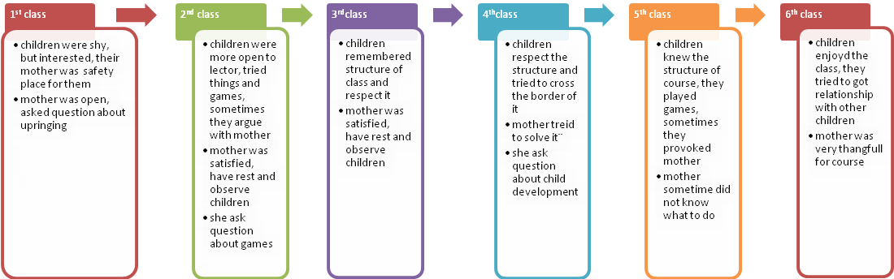

Family B

Table 4 Family culture B – mother (28 years old) university-educated; one girl child two years old.

|  |  |
| --- | --- |
| Communication | Opened, with respect, clear |
| Family atmosphere | Positive, warmth |
| Cohesion | Strong |

The parenting style is authoritative style.

Changes after course: Mother B spoke about fascination of her child development.

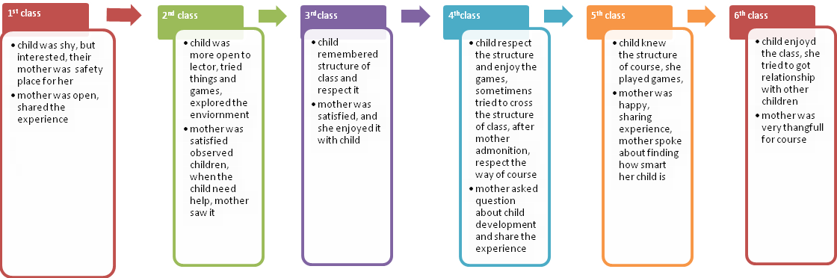

Family C

Table 5 Family culture C - mother (28 years old) university-educated; one girl child 15 month old.

|  |  |
| --- | --- |
| Communication | Opened, with respect, |
| Family atmosphere | Positive, warmth |
| Cohesion | Strong |

The parenting style is permissive style.

Changes after course: Mother C spoke about beautiful development of their relationship, during time they build trust.

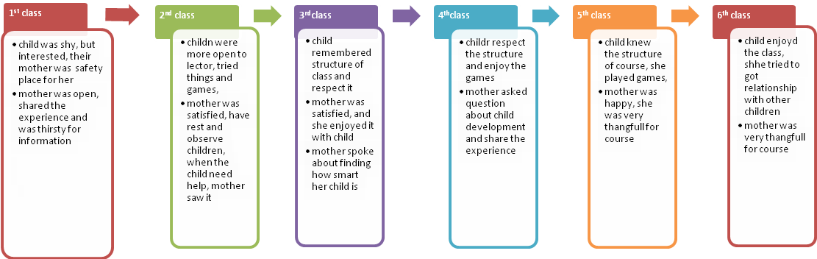

During course there was open atmosphere, we could observe children growing trustful, Mothers were more open in communication with sharing of experience.

**Conclusion**

Currently, the information explosion, when information becomes the measure of success, and also at a time when economic principles implemented across the board in various sectors and also in education, we are starting to recalculate in terms of performance, usefulness and effectiveness. Economist Heckman (2006) says that a good upbringing, education and care in early childhood is one of the effective ways to improve the social and economic society as a whole, by providing better opportunities for socially and culturally disadvantaged groups.

Parent and child build trust. It allows children to share their world. It strengthens the bond between parents and children It reveals how children are actually smart. It promotes positive emotional development. It strengthens the confidence of children and parent education and sharing of experience help mother to communicate more and help children when they learn to speak. It gives impetus to the intellectual development.

Parents spoke about communication between them and children; it involves positive family atmosphere and family cohesion.

We have to say that informal educational activities as baby signs can help to go deeper in parent education, gain more experience with child abilities what influence positively family atmosphere, communication and family cohesion. Mother gained deeper self confidence in upbringing. Children were more oriented in communication and did not tried to cross the border.

**References**

ACredolo, L.; Goodwyn, S. (2009) *Baby signs*. New York: McGraw-Hill ISBN:0-07-138776-5

Allen, K. E.; Marotz, L. R. (2002) *Přehled vývoje dítěte*. Praha: Portál ISBN: 80-736-7055-0

Anderson, B.E. (1992) Effects of day-care on cognitive and socio-emotional competence of thirteen-year-old Swedish schoolchildren. Child Development, 63, 20–36.

Baumrind, D. (1991) Effective parenting during the early adolescent transition.

BELSKY, J. et al. (2007) Are the Long-Term Effects of Early Care? Child Development, Vol. 78.

Cribbin, Kennedy, (2002) Lifelong learning in Action. Hong Kong: Aberdeen. ISBN:962-209-577-1

Europien Commisson, (2011) COMMUNICATION FROM THE COMMISSION, Brussel, available at: [http://eur-lex.europa.eu](http://eur-lex.europa.eu/)

Bertrand, J. (2007), „Preschool programs: Effective Curiculum. Comments on Kagan and Kauerz and on Schweinhart“, Encyclopedia on Early Childhood Development and Strategic knowledge Cluster on Early development, Montreal, available at: <http://www.child-encyclopedia.com/documents/BertrandANGxp.pdf>

Cherri, H. CH. Y. (2008) Intergenerrational learning in Hong Kong: A narrative inquiry. Universitx of Nottingham. <http://etheses.nottingham.ac.uk/486/1/Cherri_Ho_EdD_Thesis_2008.pdf.>

Dewar, G. (2010), Parenting styles: A guide for the science-minded. <<http://www.parentingscience.com/parenting-styles.html#sthash.g7Y8jDKk.dpuf>>

EURYDICE, (2010) *Vzdělávání a péče v raném dětství v Evropě: překonávání sociálních a kulturních dovedností*, Ústav pro informace ve vzdělávání ISBN: 978-92-9201-025-6

Helus, Z.,(2007) Sociální psychologie pro pedagogy. Praha: Grada, ISBN: 978-80-247-1168-3

Heckman, J. J. and L. J. Lochner (2000). Rethinking myths about education and training: Understanding

the sources of skill formation in a modern economy. In S. Danziger and J. Waldfogel (Eds.), Securing

the Future: Investing in Children from Birth to College. New York: Russell Sage Foundation.

Heckman, J, J. (2006). "[Catch 'em Young: Investing in Disadvantaged Young Children is Both Fair and Efficient](http://jenni.uchicago.edu/papers/WSJ_Heckman_01102006_Catch_Em_Young.pdf)." Wall Street Journal, January 10, A14.

# Jarvis, J. (2001) Angles on Child Psychology, CHeltenham: Nelson Thornes, ISBN:0-7487-5975-1

# KUTÁLKOVÁ, D. (2009) *Průvodce vývojem dětské řeči*. Praha: Galén, ISBN: 80-7367-056-9

Maccoby and Martin 1983

NEW, R.; MONCRIEFF, C. (2007) Early childhood education  : an international encyclopedia. Volume 4. The countries*.* Westport: Praeger, ISBN: 978-0313341434

Pedler, M., Burgoyne, J. and Boydell, (1991) The Learning Company T:McGraw Hill, London, Paperback, 213 pp. ISBN 0 07 70747 93

Piaget, J., Inhelderová, B. (1997) *Psychology of child*. Praha: Portál ISBN: 80-7178-407-9

Popenoe, D. (1988). Disturbing the Nest: Family Change and Decline in Modern Societies. New York: Aldine de Gruyter.

Popenoe, D. (1993). American Family Decline, 1960-1990: A Review and Appraisal. Journal ofMarriage and the Family 55:3:527-42.

Pramling, N.; Pramling Samuelsso, I.; (2011) *Educational encounters: nordic studies in early childhood didactics*. Gothenburg: Springer Netherlands, ISBN: 978-94-007-1616-2

ISTANBUL DECLARATION, OMEP, 2013

Pramling, N.; Pramling Samuelsso, I.; *Educational encounters: nordic studies in early childhood didactics*. Gothenburg: Springer Netherlands, 2011.

Průcha, J.; Walterová, E.; Mareš, J. (2009) *Pedagogical dictunary*. Praha: Portál, ISBN: 978-807-3676-476

Průcha, J. (1996) *Teaching evaluation: evaluation of educational programs, processes and results.* Brno: Masarykova univerzita v Brně ISBN: 80-2101-333-8

PRŮCHA, j. (2011) *Children's language and communication - knowledge of developmental psycholinguistics.* Praha: Grada ISBN: 978-8024736037

OECD, (2006) Starting Strong II, Early Childhood Education and Care. Paris: OECD Publishing, available at: [www.oecd.org/newsroom/37425999.pdf](http://www.oecd.org/newsroom/37425999.pdf)

RABUŠICOVÁ, m. at al (2011) About intergeneration learning, Masaryk university: Brno. ISBN: 978-80-210-5750-0

SEVEROVÁ, M. (1982) Games in early education: studie o jejich vývoji a motivaci. Praha: Academia

Sylva, K., Melluish, E., Sammons, P., & Siraj-Blatchford, I. (2007) Effects of early childhood education in England: differential benefits. Paper presented at the Biennial Meenting of the Society for Research in Child Development. Boston, Massachusetts.

Siraj-Blatchford, I. (2000) *Supporting identity, diversity and language in the early years*. Berkshire: Open University Press,  ISBN: 0335204341

Šulová, L. ( 2005) *Early psychological development of the child*, Praha: Karolinum ISBN: 80-246-0877-4

ŠVAŘÍČEK, R., ŠEĎOVÁ, K. (2007) *Qualitative research in educational sciences.* Praha: Portál ISBN: 978-807-367-3130

Tilton, M. a kol. (2010) *The scientific basis Baby Signs program.* Baby Signs ČR available at: <http://www.babysigns.cz/media/media/Vedecky_zaklad_Programu_Baby_Signs_CZ.pdf>

WINSTON FK, et al. Eds. (2009) Driving through the eyes of teens, <<http://www.teendrivetsource.org/stats/support_teens/detail/86>sthash.ZoZJTns.dpuf>

Mgr. et Mgr. Lucie Grůzová

Katedra primární pedagogiky

Pedagogická fakulta

Masarykova univerzita v Brně

Poříčí 31

62300 Brno

Czech Republic

1. Learning is seen as a natural and continuous process.
2. Parenting style is an influence of parent to child it is caused of these differences include culture, personality, family size, parental background, socioeconomic status, educational level, and religion.