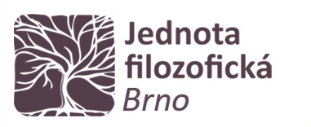

**Pondělí 18. 10. 2021**

**16:00-17:30**

**A11**

**FF MU**

**18. října 2021**

**prof. Sergius Kodera**

**(University of Vienna)**

**Francis Bacon's Uses of Classical myth.**

**Freedom of Interpretation and Ideas of Progress**

**in the De sapienta veterum (1609).**

aaaaaaaa

**Abstract**

The De sapienta veterum (Wisdom of the Ancients) has not been in the limelight of Bacon scholarship. This is all the more surprising, as it was one of Bacon's most successful texts in his day and well beyond. My talk will investigate Bacon's specific (and ingenious) employment of various Classical myths to convey some of his most salient philosophical ideas. Moreover, the presentation will address Bacon’s theoretical claims his ways to appropriate myth in general.

