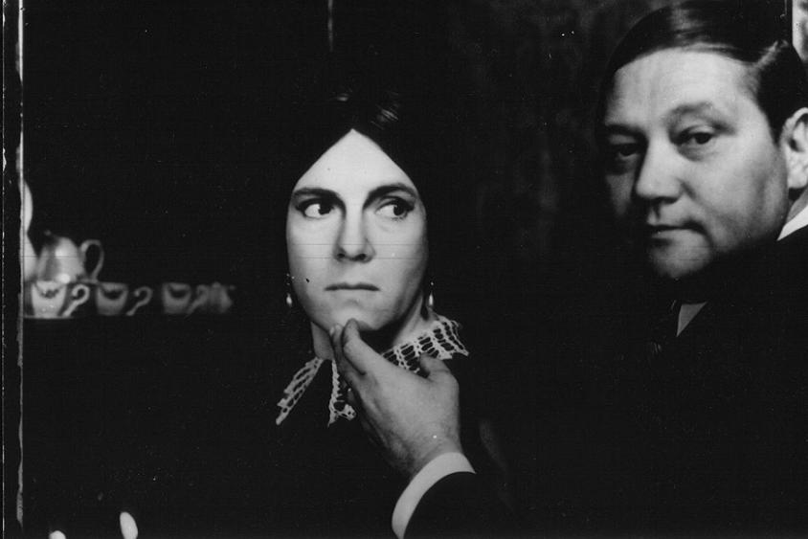

The Cremator, Juraj Herz, 1968

