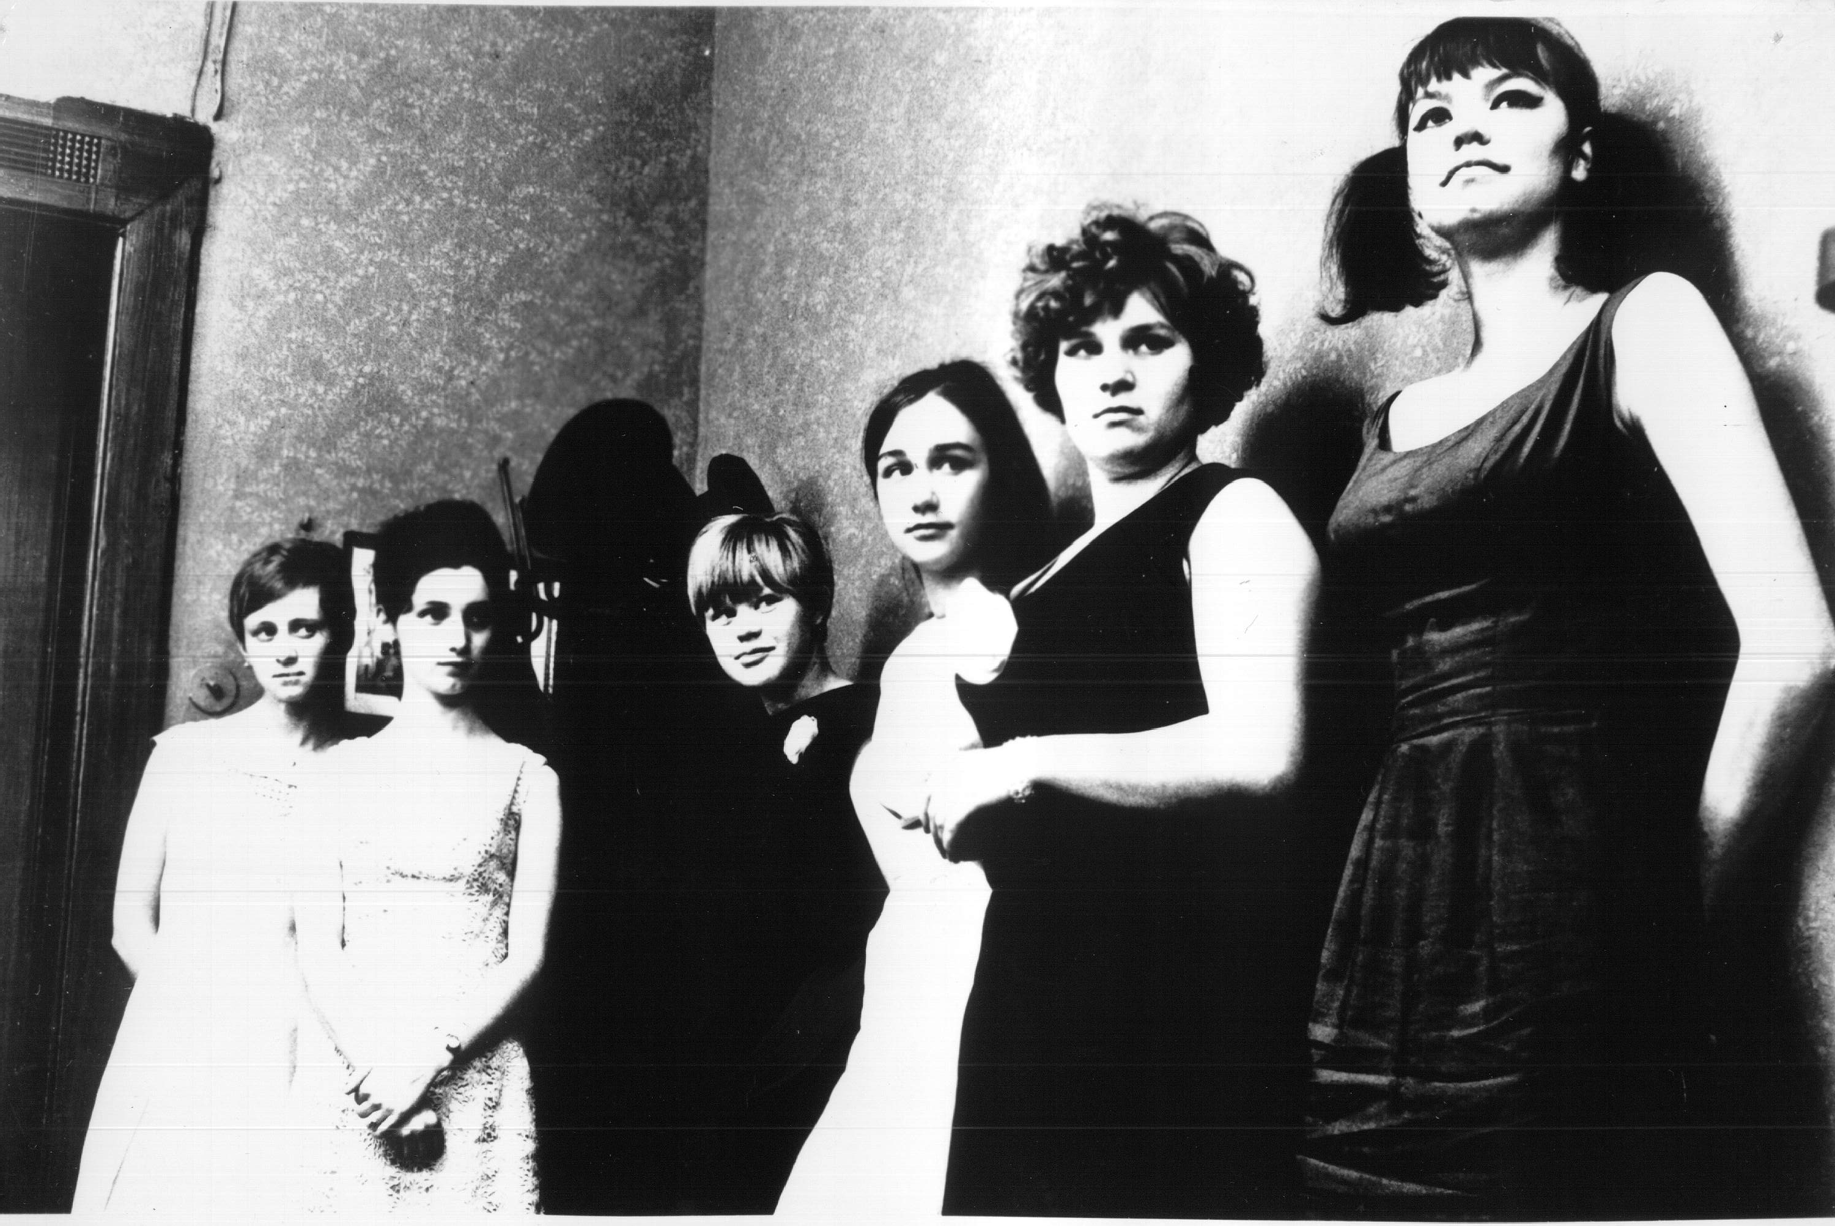

The Firemen’s Ball, Miloš Forman, 1967

