- Ladislav Rychman: The Hop Pickers (Starci na Chmelu, 1964)

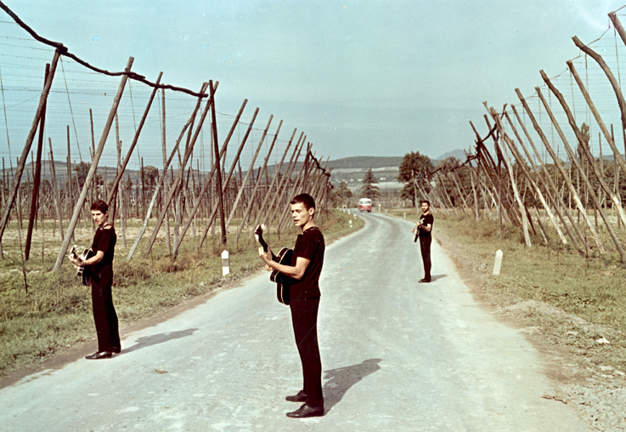

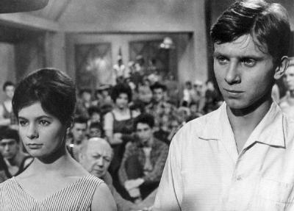
The Hop Pickers (Starci na Chmelu, 1964)

