8. Ivan Passer: Intimate Lighting (Intimní osvětlení, 1965).

Screenplay: Jaroslav Papoušek, Ivan Passer, Václav Šašek. Director of photography: Miroslav Ondříček, Josef Střecha. Editor: Jiřina Lukešová. Music: Antonín Dvořák, W. A. Mozart, Vojtěch Matyáš Jírovec. Cast: Karel Blažek (Bambas), Zdeněk Bezušek (Peťan), Věra Křesadlová (Štěpa), Jan Vostrčil (grandfather), Vlasimila Vlková (granny), Jaroslava Štědrá (Maruš). 71 min.

Ivan Passer began as a collaborator of Miloš Forman´s and a scriptwriter of his films. Intimate Lighting is his first full-length film. He continued his career in the United States after 1968. The story of Intimate Lighting is very simple. The impact of this movie is created by the atmosphere, not by the action. This is a story about the crisis of middle-age and the disillusionment of two friends, both of them talented musicians. Passer is close to the lyrical tradition of Czech cinema and he prefers to talk about his heroes with love.

Assigned reading

Hames, Peter. ”The Czechoslovak New Wave: Ivan Passer.”

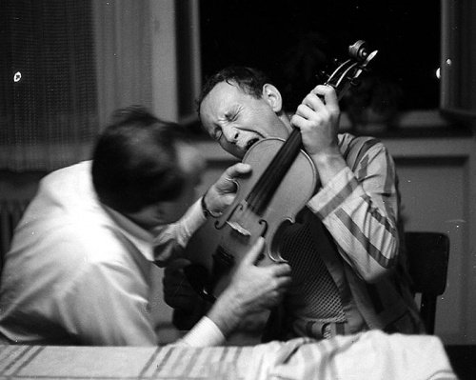
Intimate Lighting (Intimní osvětlení, 1965)

