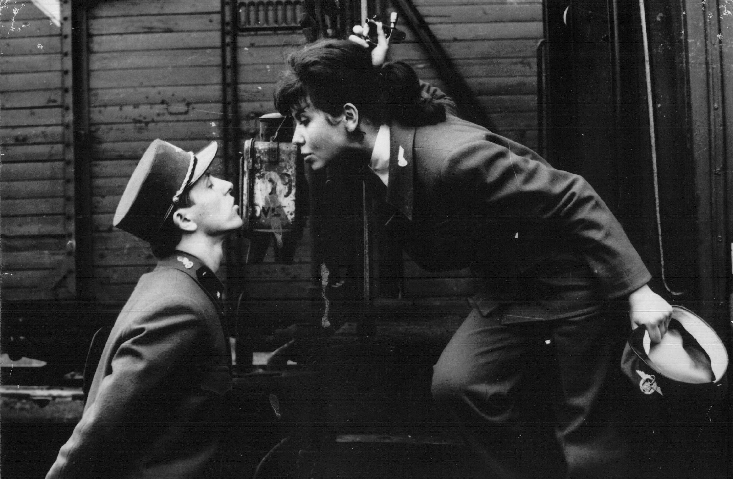

Closely Watched Trains, Jiří Menzel, 1966

