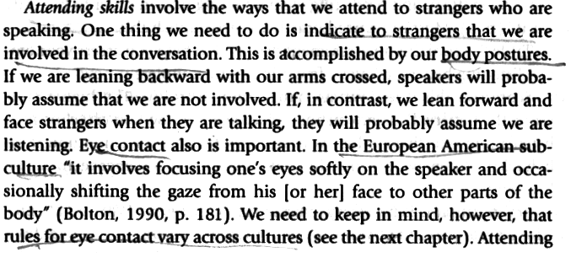

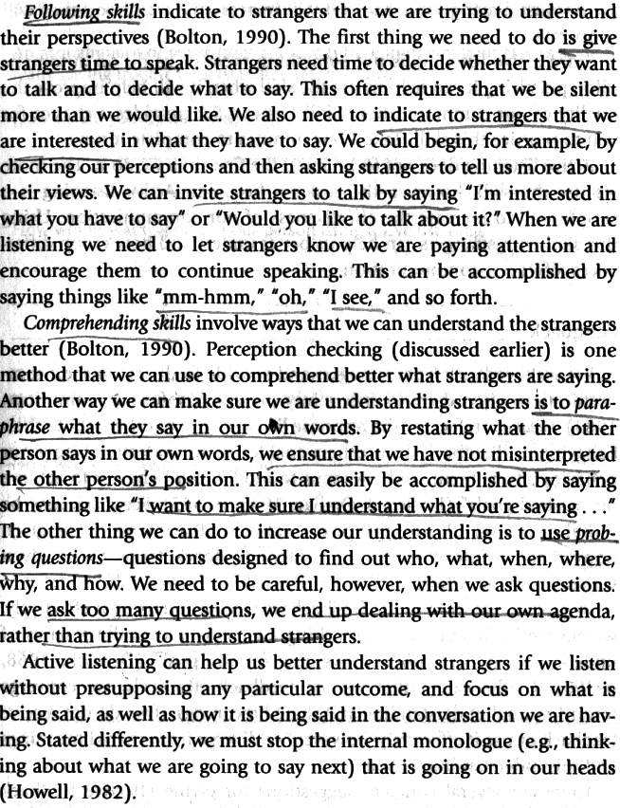

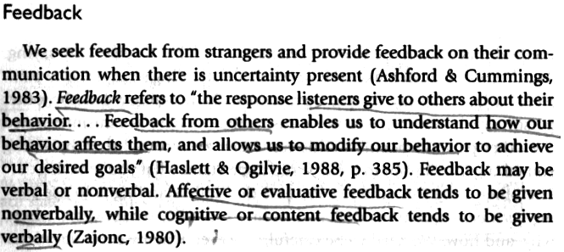
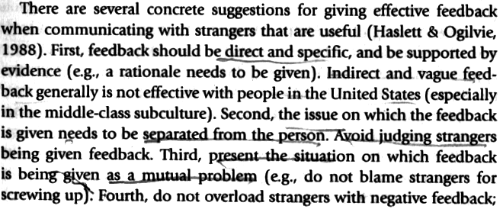
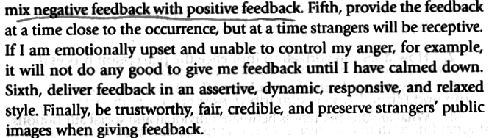

(From Gudykunst, W.B. Bridging Differences. Effective Intergroup Communication. 4th edition, London: Sage Publications, 2004, pp. 184-187)

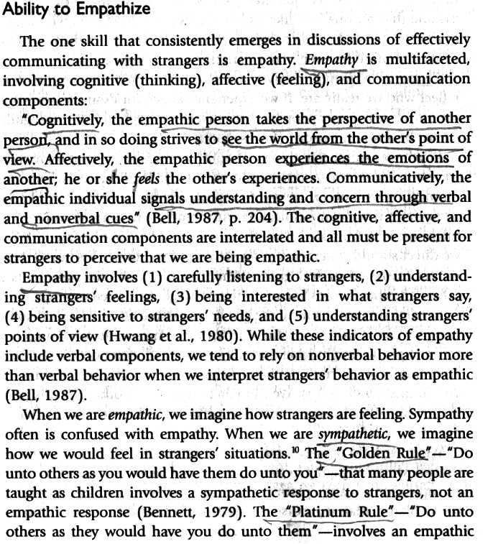
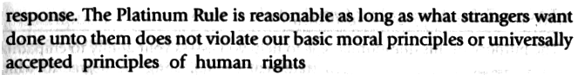

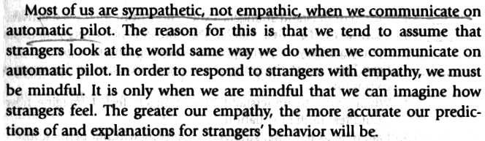

(From Gudykunst, W.B. Bridging Differences. Effective Intergroup Communication. 4th edition, London: Sage Publications, 2004, pp. 260-263)

