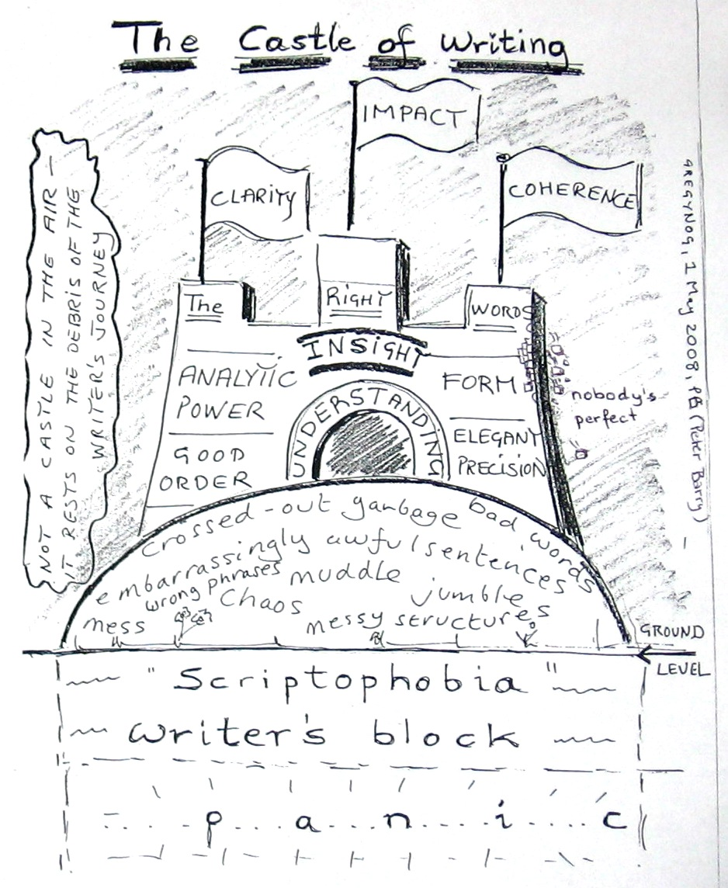
MASARYK UNIVERSITY
Language Centre

ACADEMIC WRITING COURSE
for PhD students and novice researchers

SESSION 3

SESSION 3 PLAN

HOME ASSIGNMENT REVIEW
a) abstract analysis I (Sophia Butt)
b) abstract analysis II (John Morgan)
c) Peer-review analysis (structured vs free writing).
d) Sessions 1 & 2 summary

1. TEXT STRUCTURE

1.1. WHAT IS THE STRUCTURE OF AN ACADEMIC TEXT?

a) What are some basic or “compulsory” parts of every academic text?

b) What parts do academic texts usually consist of?

1.2. Match the following parts of an academic text (a-i) with the comments on their characteristics.

a) title b) acknowledgements c) abstract d) introduction e) methods f) results
g) discussion h) conclusion i) bibliography

1) They are the final part of each text. They should summarise the text and answer all the main questions set in the introduction. The overall value of the work should be stated and recommendations for future research could be indentified if necessary. Special attention should be paid to the last sentence which often contains a profound idea that neatly envelops the whole topic in a single statement.

2) It contains a complete, accurate and consistent alphabetically organised list of all the books, articles, Internet information and other materials used in the process of formulating our thoughts about the subject. Not all of the items in this list are related to citations within the text. In this it differs from a references section that lists all the citations that can be found in the text. The key information of each entry regardless of its style will include: the author(s) surname(s) and initial(s), the full title of the work, the relevant chapter(s) and page number(s), the date and place of publication and the name of the publisher.

3) This part could be seen as a display of necessary politeness but it can also provide an opportunity to show that we are a member of a community and have benefitted from that membership. It allows us to repay our debts. At the same time, however, it allows us to highlight that we are also “intellectually responsible“ for the content of the publication.

4) It is an independent piece of text which provides the gist of an original work. Its structure may vary but usually it includes: (1) the purpose or main aims or hypothesis, and possibly some background information; (2) methods where methodology, procedure and the scope of the study are described; (3) results; (4) conclusions where results and the overall value of the work are interpreted. Stylistically, it is written in well-informed dense sentences that avoid negatives, abbreviations, jargon, redundancies and other language shortcuts which may lead to confusion.

5) These sections have a very specific position. They should be more than summaries (theoretical, abstract and general) and should go beyond results (more integrated with the field, more connected to the real world and, ideally, more concerned with implications and applications). In this part it is important to step back and take a broad look at the findings and the study as a whole.

6) Traditionally, this section simply reports the data that has been collected. It should focus exclusively on a clear description of what has been found and highlight key findings from the data. Stylistically, it is mostly associated with simple past tense.

7) These sections vary across disciplines. In some fields, it is common to have subsections that might deal with materials, the apparatus used, definitions employed, the subjects or participants in the study, or the statistical procedures used. They also vary according to how much information and explanation they contain. At one extreme, they may be very condensed; at the other, elaborately extended. Stylistically, they are mostly associated with passive structures and highly impersonal tone.

8) Although they come first, they are often written last. They should indicate the topic and scope of the study and it should be self-explanatory to their target audience. In some areas, such as the life sciences, they are can be longer and look more like full sentences, in others, the style prefers short groups of words that contain mostly nouns and prepositions. In some areas, all key words are capitalised.

9) Although it forms usually less than 10 % of the text, it is usually one of the most difficult parts to write. It may consist of four main subsections, namely the background, the issue, the aims, and the structure of the work. The background information can be further divided into generalisations, informed statements and reviews of research; while the issue section usually focuses on one clear perspective, e.g. a counter-argument, indication of a gap, general inquiry or research tradition.
(Adapted from: Štěpánek, L., deHaaf, J., Hradilová, A.(2011): p.174)

1.3. Match the sample texts with the sub-headings below.

a) acknowledgements b) abstract c) introduction d) methods e) results f) discussion

1) It is helpful to commence with the general thesis that theories may be under-determined by data: that is, that theories may be incompatible with each other and yet be compatible with all possible data. Theories may conflict yet be empirically equivalent, that is compatible with all the observations that could be made. In this article, I suggest some reasons why the under-determination of theories by data may be more acute in social than in natural sciences, and I shall seek to support this suggestion by citing examples of conflicting theories.

2) Imaging was performed in the error signal mode, acquiring the deflection and height signal simultaneously. The deflection signal was minimized by optimizing gains and scan speed. The height images presented were recorded in the contact mode. The scan speed was roughly linear to the scan size, at 4–8 lines/s for lower magnifications (frame size 1–25 μm). The applied force was corrected manually to compensate for thermal drift. To achieve reproducible forces, cantilevers were selected from a restricted area of one wafer.

3) The strongest exclusionism of immigrants is found in Austria with the mean value of 2.64 on the four point scale. United Kingdom follows with the mean value of 2.58, Germany and Denmark are somewhere in the middle, and Sweden has the lowest score on the scale of exclusionism of immigrants from all countries (1.95). The analysis of variance shows that the differences among countries are statistically significant (F = 270.9; df =4,9224; p < 0.001).

4) Our results demonstrate evolutionarily accessible paths where major functional leaps are produced by domain combination followed by interface optimization. They imply that distinct and sophisticated functions can emerge from combinations of a limited number of primordial domains.

5) The guidance and support of those who supervised this research was invaluable to me. I am grateful to Dr. Michael O’Donoghue without whose encouragement and challenge I would not have commenced this work. I particularly appreciate the supervision of Dr. Julie-Ann Sime whose experience, insight, constructive criticism and practical advice not only guided this work from its earliest thoughts to this stage but has enabled me to develop confidence and ability to participate in academic investigation and discourse.

6) The speed of sound in a fluid is determined by, and therefore an indicator of, the thermodynamic properties of that fluid. The aim of this study was to investigate the use of an ultrasonic cell to determine crude oil properties, in particular oil density. An ultrasonic cell was constructed to measure the speed of sound and tested in a crude oil sample. The speed of sound was measured at temperatures between 260 and 411 K at pressures up to 75 MPs. The measurements were shown to lead to an accurate determination of the bubble point of the oil. This indicates that there is a possibility of obtaining fluid density from sound speed measurements and suggests that it is possible to measure sound absorption with an ultrasonic cell to determine oil viscosity.

(Adapted from: Štěpánek, L., deHaaf, J., Hradilová, A.(2011): p.175)

1.4. INTRODUCTION Choose the most suitable word for the “Introduction” section in the academic context.

a) The purpose of this study IS – WAS – WILL BE to develop concepts to describe, conceptualise and analyse the emerging software component market from the point of view of the industrial buyer.

b) However, light scattering techniques WERE – HAVE BEEN – ARE BEING largely unsuccessful to date.

c) It is OPTIMALLY – OFTEN – GENERALLY accepted that egg and larval quality are partly controlled by diet.
(Adapted from: Glasman-Deal,H.,(2010))

1.5. METHODOLOGY Read the sentences below and explain the expressions in bold.

a) For the sake of simplicity, only a single value was analysed.
b) They were then placed on ice for immediate analysis.
c) After being removed, the mouse lungs were frozen and thawed at least three times.
d) The specimen was monitored constantly for a period of 24 hours.

1.6. RESULTS Read the groups of sentences below and explain the difference in their meanings.

(a¹) We found that the pressure increased as the temperature rose, which indicated that temperature played a significant role in the process.
(a²) We found that the pressure increases as the temperature rises, which indicates that temperature plays a significant role in the process.

(b¹) The temperature dropped sharply when we reduced the pressure.
(b²) At the end there was a noticeable drop in temperature.

(c¹) As can be seen in Fig. 1, the effect occurred in 23% of cases.
(c²) As can be seen in Fig. 1, the effect occurred in as many as 23% of cases.
(c³) As can be seen in Fig. 1, the effect occurred in only 23% of cases.
Adapted from: Glasman-Deal,H.,(2010), p.92)

16.10. DISCUSSION / CONCLUSION Complete the sentences using could, must, may, should, might, ought to, need to, can, have to. Make sure you use the right tense and don’t forget to use negative forms where necessary.

1. Perhaps the damage was caused by heat exposure.
The damage ……………………………………………………………… .

2. We felt sure that the damage was caused by heat exposure.
The damage ……………………………………………………………… .

3. No way was the damage caused by heat exposure.
The damage ……………………………………………………………… .

4. We don’t expect heat exposure to cause any damage.
Heat exposure ……………………………………………………………… .
(Adapted from: Glasman-Deal,H.,(2010), p.178)

2. Processes
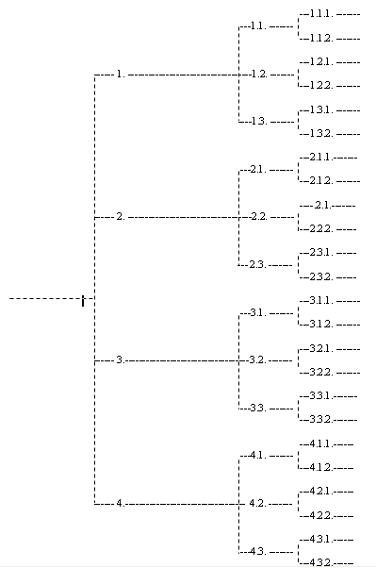
2.1. Planning diagram

2.2. Choose a verb for your paper.

The aim of this paper is to ….

2.3. Work through the following points to outline a working description of the structure of your thesis.

The Story of a Thesis:

The situation my research field is the following: __________________________________________ , therefore I study___________________________________________ (background information: Chapter 1 – introduction). This is important because _________________________________________ (main issue: Chapter 1 – introduction). So I intend to ________________________________________ (aims: Chapter 1 – Introduction). Researchers believe/used to believe that this issue _________________________________________ (Chapter 2 – literature review, or first part of subsequent parallel chapters). But I think that __________________________________________ (review of aims: Chapter 3 – methodology, or second part of subsequent parallel chapters: argumentative evidence may be integrated to some extent within the literature review). So I use this method/theory to do some research ____________________________________________________ (Chapter 3 – methodology, continuing second part of parallel chapters). And I have found that (my) argument suggests that ____________________________________________________ (Chapter 4 – results, or 3rd part of parallel chapters). This means that __________________________________________ (Chapter 5 – discussion, or 4th part of parallel chapters). At this stage, depending on how many chapters you plan to write, it may be useful to include an overall discussion/analysis chapter to tie together previous parallel chapters. Overall, this is important because __________________________________________ (Chapter 6 – conclusion, or whatever your final chapter number is). But I would still recommend that __________________________________________ (Chapter 6 – conclusion, or final chapter).

(Source: Adapted from http://www2.ems.uq.edu.au/phdweb/phfaq02.html in Morgan, J., 2007)

2.4. Brown´s 8 questions: Write for 30 minutes on the subject of your journal article.

1. Who are the intended readers? List three to five of them by name.
2. What did you do? 50 words
3. Why did you do it? 50 words
4. What happened and when you did that? 50 words
5. What do the results mean in theory? 50 words
6. What do the results mean in practice? 50 words
7. What is the key benefit for readers? 25 words
8. What remains unresolved? no word limit

2.5. Concentrate on the specific topic you write about. Prepare a 1 minute introduction of your topic to be presented to a layman. You must not use any specialized vocabulary but generally common words only.

3.EVIDENCE & REFERENCE

3.1.
Evidence is the support for your statements and opinions from other sources. The quality of your evidence is in fact more important than your opinions. Without evidence your work does not belong in an academic environment.
If you are doing primary research you use your own data as the most important evidence. However in most academic papers this is usually done by placing your own work in the context of other academic work. At the end of longer papers you will use references and perhaps appendices to support your paper.
(Adapted from: http://vlc.polyu.edu.hk/AcademicWriter/Paragraphs/paragraph.htm)

Which are the most common ways of referencing?

3.2.
Which statements should be referenced when used or referred to in a piece of academic writing? Do the quiz!

(Adapted from: http://www.greenwich.ac.uk/~bj61/talessi/tlr5.html, http://www.amypadgett.com/2007/05/to-every-action-there-is-equal-and.html;
http://rense.com/general59/weu.htm, http://www.whale.to/m/quotes26.html; Czechóova, K.2005, p.6)

3.3.
In text referencing (using sources)
It is important to support the points you make with evidence and examples from other research thoughtfully and carefully so you do not plagiarise. Look at the student paraphrased versions of Harden’s idea and comment on the quality of their referencing.

Original material:
‘…nurses can be viewed as an oppressed group, a view supported by the fact that nurses lack autonomy, accountability and control over their own profession. Yet nursing is by far the largest occupational group within the sphere of healthcare, so why is it so powerless? For me the history of the domination of nursing is inextricably linked to that of the domination and oppression of women.’

Source: Harden, J 1996, Enlightenment, empowerment and emancipation:
the case for critical pedagogy in nurse education

Student version 1:
Although nurses form the largest occupational group in the healthcare profession, they can be seen as an oppressed group. Harden (1996) states that the domination of nurses is inextricably linked to the historical oppression and domination of women in society. For nurses, she claims this oppression is illustrated by the extremely limited professional independence they have as seen by their lack of accountability and control over their profession.

Student version 2:
Despite nurses forming the largest group in the healthcare professions, Harden (1996) claims they can be categorised ‘as an oppressed group’ (p.33). She explains the domination of nurses as a reflection of the historical oppression and domination of women in society. For Harden (1996), this subservient role of nurses is illustrated by their ‘lack of autonomy, accountability and control over their own profession’ (p.33).

Student version 3:
Nursing is by far the largest occupation group in healthcare. Yet, nurses can be seen as an oppressed group. This view is supported by the fact that nurses lack control over their own profession. They do not have autonomy or accountability. The history of the domination and oppression of women is the link to explaining the domination of nursing.

(Adapted from Alison Brown, 2007)

