A Short Survey of Czech Literature
James Naughton

CZECH LITERATURE SINCE 1918

An independent Czechoslovak Republic was established after the First World War under the leadership of its first president Tomáš Garrigue Masaryk (1850-1937). Masaryk’s own writings on the course of Czech history, his war memoirs, and expositions of his political and philosophical ideas won him a devoted following, though there is doubtful matter in his seductive interconnecting of Hussitism and Czech plebeian or non-aristocratic traditions with modern ideas of democratic government into a Czech “meaning of history”.
Jaroslav Hašek’s (1883-1923) Osudy dobrého vojáka Švejka (The Good Soldier Švejk, 1921-23) is one place to begin a look at post-1918 literature, with its First World War theme and its status as the most widely known Czech-language classic from the interwar period. The anarchistic, war-, army-, church- and state-debunking clever-fool hero of this baggy (strictly speaking unfinished) novel, with his endless zany blarney, has won the undying affection of readers, but also incurred more solemn reactions from earnest thinkers who have seen the indisciplined, evasive, unprincipled, materialistic sides of his behaviour as a bad national model. Does this approach possibly just miss the point? Švejk’s exuberant language becomes a lot more pedestrian in translation, but the exuberance of Hašek and Švejk’s anecdotage still comes across.
Franz Kafka
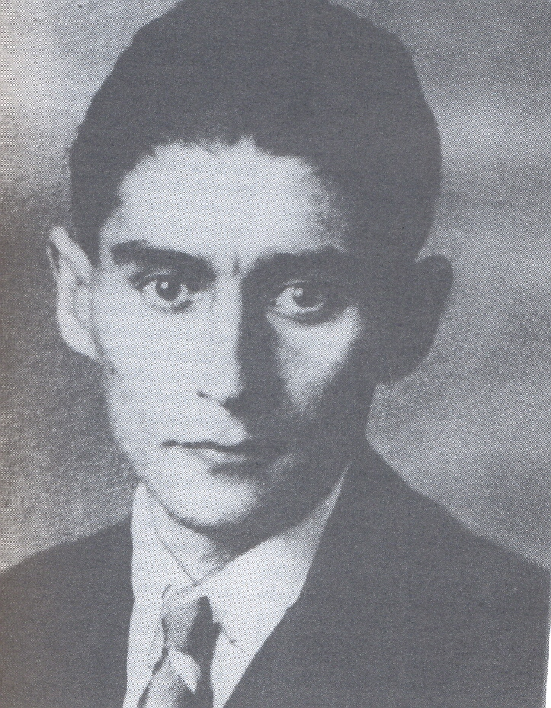
For most readers, however, without doubt, the most famous Prague author of this century is, of course, Franz Kafka (1883-1924). Born of Jewish parents near the Old Town Square in Prague, in 1883, Kafka wrote his literary works in German. However, since this survey is now restricting itself, in the modern period, almost completely to Czech-language writing, we must really only mention him here in passing. Maria Ripellino’s book Magic Prague makes certain comparisons between Kafka and Hašek. However, Hašek’s Švejk would seem to present a quite different kind of fictional absurdity, as well as a cheery unintellectualising attitude to life.
Closer to Kafka in tone and spirit are some stories by Richard Weiner (1884-1937), a Czech Jewish writer and poet from Písek, who later lived as a journalist in Paris, and was close to the Surrealists and avant-garde painters such as the Czech Josef Šíma. Some similarity has also been observed between Kafka and the outsider and refugee anti-heroes of Egon Hostovský (1908-73), a Czech novelist of Jewish family, who went to the United States after the 1948 Communist takeover.
A skilful practitioner of the mystery short-story, especially in its detective form, as well as of anti-Utopian science-fiction, was the Czech author Karel Čapek (1890-1938). An admirer of H. G. Wells and Chesterton, Čapek was rather well known in English translation before the Second World War. His drama R.U.R (=Rossum's Universal Robots, 1920) turned the Golem and related figures into commercially useful products of bio-engineering, who proceed to threaten mankind and the survival of the human soul. The play gave the world the term “robot” (from robota - feudal labour), nowadays associated with fairly unworrying Japanese machine-tools. His detective stories in Povídky z jedné a druhé kapsy (Tales of Two Pockets, 1929) explore epistemological and moral issues with a light, often whimsical touch. The most readily available of his several anti-Utopian novels is Válka s mloky (War with the Newts, 1936). In it the newts (just like the robots) take over the world. Čapek also wrote a much-admired trilogy of novels Hordubal, Povětroň, Obyčejný život (Hordubal, Meteor, An Ordinary Life, 1933-4), which (perhaps even a little postmodernistically?) examine our apprehension of events, persons and the self, using multiple, sometimes conflicting viewpoints, and suggesting the enigmatic in the psychology of the commonsensical “ordinary man”. Dying on the eve of the Second World War, after the shock of Munich, Čapek tends to be seen as a leading representative of the democracy of the First Republic.
The most visible (and perhaps still the most visible) young poets of the First Republic were members of the left-wing avant-garde, in general strongly influenced by modern French poetry (the outstanding translator of which was Karel Čapek). This Czech avant-garde writing moved from a kind of primitivist naivism, and a certain blend of Christian imagery and Marxist proletarianism - as practised briefly by the young poet Jiří Wolker (1900-24), who died of tuberculosis - into a playfully associative, popular-culture-influenced approach called in their manifestos “Poetism”. In general - but this applies in particular to the poet Nezval - they were strongly influenced by Guillaume Apollinaire, whose longer polythematic poem Zone contains a passage about a visit to Prague. The term pásmo “zone” used for the Czech title of this poem soon came to be applied to any polythematic poem of this type.
“Poetism” was posited as modernity's recreational counterpart to Constructivism. it was theorised about especially by the writer on art and architecture Karel Teige (1900-51), and cultivated with huge zest by the poet Vítězslav Nezval (1900-58), in polythematic poems such as Podivuhodný kouzelník (The Marvellous Magician, 1922) and Akrobat (Acrobat, 1927). Nezval later went through an avowedly Surrealist phase, and collections such as Praha s prsty deště (Prague with Fingers of Rain, 1936) reflect this influence. A later collection Absolutní hrobař (1937, Gravedigger of the Absolute) was strongly influenced by the paintings of Salvator Dali and might be said to be his most Surrealist work. Later Nezval rejected André Breton’s doctrine, and returned to a less experimental versifying idiom which was also less alarming for his Communist political comrades. In the post-1948 era this accommodation produced an effusive praise poem to Stalin, though he continued to produce some other effective lyrical works.
Another prominent Poetist was Jaroslav Seifert (1901-86), particularly in his collection Na vlnách TSF (On the Waves of Wireless Telegraphy). Seifert moved away from the Communist Party before the War, outlived much of his poetic generation and became a much beloved grand old poet, winning in the eighties the Czechs’ first Nobel Prize for literature.
The poet František Halas (1901-49), though also left-wing (and fondly regarded for resonantly patriotic poetry from the time of Munich and 1945) could even at times be mistaken for a Catholic poet, so quasi-religious, and obsessed with time and nothingness, is much of his lyric verse. Halas’s themes range from the personal to the political. The 1930 collection Kohout plaší smrt (The Cock Scares Death) opens with a motto from Blake’s “Europe”: “Thrice he assayd presumptuous to awake the dead to judgment.” In his cycle Staré ženy (Old Women, 1935) he addresses the eternal themes of beauty, women, time and aging.
Another poet Vladimír Holan (1905-80) is best known in English for his postwar works, both the often teasingly obscure longer poem Noc s Hamletem (A Night with Hamlet, 1964), and his short, gnomic lyrical reflections, with occasional submerged notes of political protest. Under the Communists (whom he had briefly supported at the end of the Second World War) Holan retired to his house in Kampa park beside the Vltava in Prague, becoming a legendary poet-recluse.
Next to him lived a theatrical avant-gardist Jan Werich (1905-80), famous before the War as a double act with Jiří Voskovec (1905-81 - he emigrated): as V + W, a satirical cabaret duo at Prague’s Osvobozené divadlo (Liberated Theatre).
Left-wing fiction was most prominently original in the work of Vladislav Vančura (1891-1942), full of exuberant verbal acrobatics, archaisms and expressive oddities. His Rozmarné léto (Capricious Summer, 1926), set in a small-town spa, has been transferred (with much original text from the book) into a humorously lyrical film by Jiří Menzel. Another book, Marketa Lazarová (1931), an epic-reviving tale of early medieval brigandage, has also been transferred to the cinema (1967, directed by František Vláčil).
Social and social-psychological fiction from this period has left more a series of worthy attempts than masterpieces. Amongst these Vančura’s Pekař Jan Marhoul (Baker Jan Marhoul, 1924) is untypically imaginative and experimental. Marie Majerová’s (1882-1967) left-wing social fiction is more conventional, though not without documentary qualities: Siréna (The Siren, 1935) with its Kladno industrial setting, and Havířská balada (Ballad of a Miner, 1938) have both been translated.
Period is vividly recreated by the outstanding historical novelist Jaroslav Durych (1886-1962). Though impressive on the period of the Thirty Years’ War in his long novel Bloudění (1929, translated as Descent of the Idol), Durych is arguably at his best in the atmospheric and lyrically effective short volume Rekviem (Requiem, 1930), three stories set at a time just after the assassination of the ambitious charismatic Valdštejn, or Wallenstein. Durych displays a powerful tension between spirituality and sensuality.
A gloomier atmosphere generally in writing from the later twenties may not too unreasonably be said to reflect the demise of post-First-World-War optimism, the onset of the Great Depression, and the political crises of the thirties.
The Munich agreement of 1938 led to the dismantling of Czechoslovakia, and the setting up of a Protectorate under Hitler’s Germany; the Second World War brought near-obliteration of the Jewish community, and at its end the expulsion of most of the three million Germans from Czechoslovakia. An uneasy coalition between Communists and others tipped over into total Communist rule in February 1948. Much artistic energy was suppressed or sent underground by the regimentation and didacticism of Socialist Realist doctrines. Many writers of course adapted to these cultural dictates, whether willingly or otherwise, continuing to publish and make a living.

THE COMMUNIST TAKEOVER OF 1948 UP TO THE COMMUNIST COLLAPSE IN 1989 AND BEYOND

Stalin died in 1953. Agriculture was collectivised, public culture remained closely supervised and regimented, but the Communist regime inched its way, heavily implicated in its own (although by Soviet criteria small-scale) executions and show trials, into the reforms of the sixties, which then moved into the “Prague Spring” reforms of 1968 under Alexander Dubček’s new-style Communist leadership.
As cultural space widened, Czech writers such as Milan Kundera (b. 1929) tried, or perhaps inevitably failed, one might say, to “settle accounts” with history. In Kundera’s first novel Žert (The Joke, 1967), the central protagonist Ludvík fails to compensate for his earlier humiliation at the hands of the Party by sleeping with the wife of one of his humiliators. The action is presented from the differing points of view of four of the characters. In the short stories of Směšné lásky (Laughable Loves, 1963-8, 1970) the author’s characters wander through erotic labyrinths of inauthenticity, thwarted intentions and desires. History and the individual, love and sex, remain antithetically entwined in Kundera’s later writings.
Josef Škvorecký’s (b. 1924) adolescent Danny in his first published novel Zbabělci (The Cowards, 1958) plays jazz, courts girls and gets involved with uprising activity at the end of the Second World War, enabling a de-bunking, de-solemnising view of recent history. His novella Bassaxofon (The Bass Saxophone, 1967) is another work playing with his favourite theme of jazz, where art is portrayed as a provider of spiritual and sensual epiphany and emancipation which also engages with primitive levels of the psyche. Škvorecký goes on to chronicle his fictional Kostelec, alias Náchod, in a whole series of Danny novels. He takes forward his debunkingly satirical view, in Mirákl (The Miracle Game, 1972) and Příběh inženýra lidských duší (The Engineer of Human Souls, 1977), to the protagonists of the Prague Spring itself, and the life of Czech emigrés in North America.
The Jewish community and its fate were focussed on soon after the War by Jiří Weil (1900-59) in the novel Život s hvězdou (Life with a Star, 1949), and later by Ladislav Fuks (1923-94) in his not unrelated novel Pan Theodor Mundstock (Mr Theodore Mundstock, 1963) and other works. The Jewish theme is also explored in a number of works by Arnošt Lustig (b. 1926), such as the novel Dita Saxová (1962).
Ivan Klíma (b. 1931), who lived as a boy in Terezín concentration camp, has a love story “Miriam” placed in that setting. In his novel Láska a smetí (Love and Garbage, 1978) or the stories of Moje zlatá řemesla (My Golden Trades, 1990) he later autobiographically examines the perspectives given to a banned writer post-1968 who takes on otherwise unlikely jobs and occupations.
Another mode of “reckoning with the present” is to be found in the plays of Václav Havel (b. 1936), influenced by Absurdist playwrights including Ionesco and Beckett. In his Zahradní slavnost (The Garden Party, 1963), Vyrozumění (The Memorandum, 1965) and Ztížená možnost soustředění (Increased Difficulty of Concentration, 1968), Havel, later to be President Havel, takes the existential angst and black comedy of the Drama of the Absurd and uses it partly to address a morally and ideologically eroded society. As a leader of the informal group Charter 77, working to monitor Czechoslovakia's behaviour on human rights in the later 1970s, after the international Helsinki accords, Havel continued to write plays, but also notable essays. In his one-act drama Audience (The Audience, 1975), a pseudo-Havel figure faces his boss in a brewery, like the Trutnov brewery where Havel briefly worked.
Another dramatist from this period Josef Topol (b. 1935) is a complex, lyrically expressive writer, still almost unknown to British theatre-goers, though a translation of one of his plays Kočka na kolejích (Cat on the Rails, 1965) has been issued.
In Czech poetry since 1945, apart from the older Holan and Seifert, English-language readers have particularly taken to the wry, analytical and drily playful lyrical commentaries of the scientist-writer Miroslav Holub (1923-98), with their own brand of satirically questioning and not totally un-Absurdist mini-narratives.
Another prose writer with a playful streak is Ludvík Vaculík (b. 1926), whose novel Sekyra (The Axe, 1966) in its themes of father and son, rural life and urbanising change, seeks to reckon with the recent past, but likewise, if not more, with the present and its shifting predicaments. His novel Morčata (The Guinea Pigs, 1977, samizdat 1973) plays teasing narrative games with the reader, while appearing to reflect upon human cruelty and manipulation, totalitarian society and the individual struggle with absurdity.
The exuberant writings of Bohumil Hrabal (1914-97) also address time, the flow of time, sometimes presenting an immediacy of temporal flux in cascades of concrete, sensory and sensual detail. This is notable for example in his lyrically memorialising but also fictionalising books about his Nymburk youth and his parents, Postřižiny (Cutting It Short, 1976) and Městečko, kde se zastavil čas (The Little Town Where Time Stood Still, 1978). Such concerns are wedded to Hrabal’s particular concept of pábitelství, of palavering inventive play, as a modus vivendi amidst a sense of the absurd, whether social and political or philosophical and existential. See also the stories in the English volume The Death of Mr Baltisberger, or on a more philosophical level his novella Příliš hlučná samota (Too Loud a Solitude). His texts often inextricably blend elements of the pub anecdote, popular ramblings and oral improvisations with the inheritance of Surrealism and the imagery of art and film, with juxtapositionings and collages of imagery and expressively interlocking documentary-like details. One of Hrabal’s more extended and ambitious texts is Obsluhoval jsem anglického krále (I Served the King of England, 1980), which also dismantles the solemn mythologies of Czech history since the thirties in the comic, and blackly comic, but not only blackly comic, story of a young waiter who rises in the world and gets involved with the occupying Nazis.
Another, younger writer, with some gentle affiliations with Hrabal, and a lyric and comic gift, applied to themes of his wartime youth, was Ota Pavel (1930-73), whose two admired story collections appeared in Prague in the early seventies: Smrt krásných srnců (Death of Lovely Roebuck, 1971) and Jak jsem potkal ryby (How I Encountered Fish, 1974).
Amongst the historical novelists one of the most effective at giving the genre imaginative and expressive bite (with strong Aesopian references) was Jiří Šotola (1924-89), with novels such as Tovarišstvo Ježíšovo (The Society of Jesus, 1969), Kuře na rožni (Chicken on the Spit, 1976), about an eighteenth-century puppeteer, and Svatý na mostě (Saint on the Bridge, 1978), about St. John of Nepomuk.
Experimental, intellectual prose following somewhat the line of Richard Weiner has been notably practised by Věra Linhartová (b. 1938), who later left for Paris and study of Japan art.
Social mores, the limping Socialist consumer society, careerism, modern-day sex and everyday superficiality are powerfully incorporated in energetic, rhythmically seductive novels by Vladimír Páral (b. 1932), works such as Katapult (Catapult, 1967) and Milenci a vrazi (Lovers and Murderers, 1969). Later he moves into science-fiction fantasies, and also, especially after 1989, what one might call further explorations of the erotic satirical novel.
The years after the 1968 Soviet invasion brought much internal cultural repression, and impoverishment of the domestic publishing scene, though this was far from absolute. Obviously the work of authors who went into exile, such as Škvorecký, or Kundera, who later did so, was affected by all this, in its themes and its sensibilities. But the seventies also saw fruitful directions in the work of several non-exile authors: in the work of Hrabal, both accommodating to regime pressures and disobediently circulating typescript texts, and Vaculík, Havel and others, who distributed their writings in typescript samizdat (e.g. in Edice Petlice, “Padlock Editions”) and were published abroad. The repressive policies very much affected the general reading public at the time (who, although they also read Hrabal, Páral and others, also replaced the American light reading they were later to devour with their own, not very exciting domestic surrogates, disguised as morally uplifting social critiques). However, in retrospect the 1970s in Czech literature were hardly a desert at all.
During the 1980s there also began gradually to appear, even in official publishing houses (against the grain of the times), a number of younger, in fact rather “ideologically subversive” names, such as Alexandra Berková (b. 1949) in prose, or Sylva Fischerová (b. 1963) in poetry. After 1989 a number of other Czech writers also became more visible, such as two novelists-cum-literary-scholars Daniela Hodrová (b. 1946) and Vladimír Macura (1945-99). The latter also produced some sharp short social-semiotic essays, called punningly “semi(o)-feuilletons”, on subjects such as the cultural significance of Macdonald's burgers in post-Velvet Prague society. The most popular of the younger novelists at present would seem to be Michal Viewegh (b. 1962), whose Výchova dívek v Čechách (1994) wears its postmodernism, if that is what we may call it, with a light touch, and has been translated into English as Bringing Up Girls in Bohemia.
The commercial book market since 1989 has altered the publishing scene a great deal, producing a flood of translated entertainment literature, but native output seems to have revived, not only with the support of grants, and continues to find both publishers and readers.

The pages above are adapted from the latter part of my own chapter on Czech literature in the Traveller's Literary Companion to Eastern and Central Europe, Brighton: In Print Publishing, 1995.
© James Naughton, draft last revised 2001

