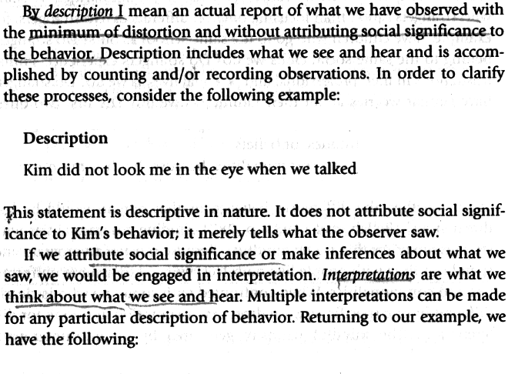
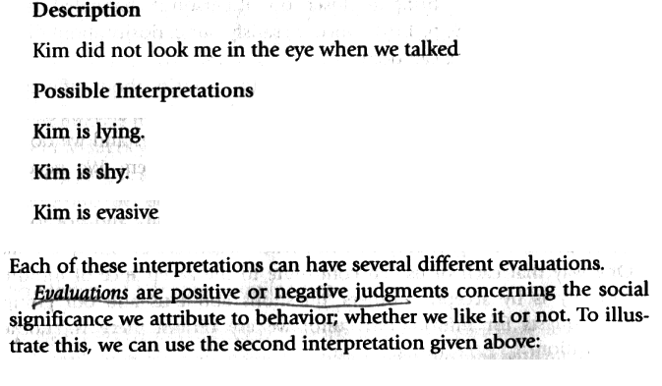
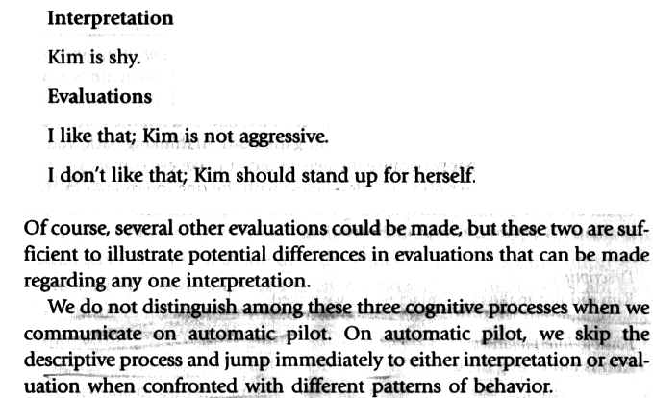

From Gudykunst, W.B. Bridging Differences. Effective Intergroup Communication. 4th edition, London: Sage Publications, 2004, p. 250-251.

