**Academic Language Skills**

1. **Language function** means the verb used in the learning target, such as *identify, analyze, summarize, define, explain, conclude, justify, compare*, sort, and so on.
2. **Language demand** means the assignment or product the student makes, such as *essay, paragraph, sentence, speech, lab report, reflection, play, poem, comic strip, magazine article. poster*, and the like.
3. **Vocabulary**, which includes any words the student should be able to define in order to comprehend the content of the lesson. These words may be specific to the discipline (*artifact*in social studies) or just general words used in school (*list*, *characteristics, infer, analyze*).

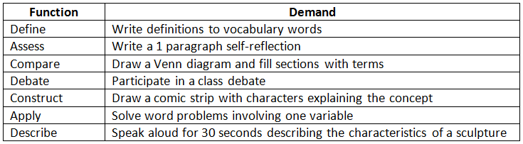

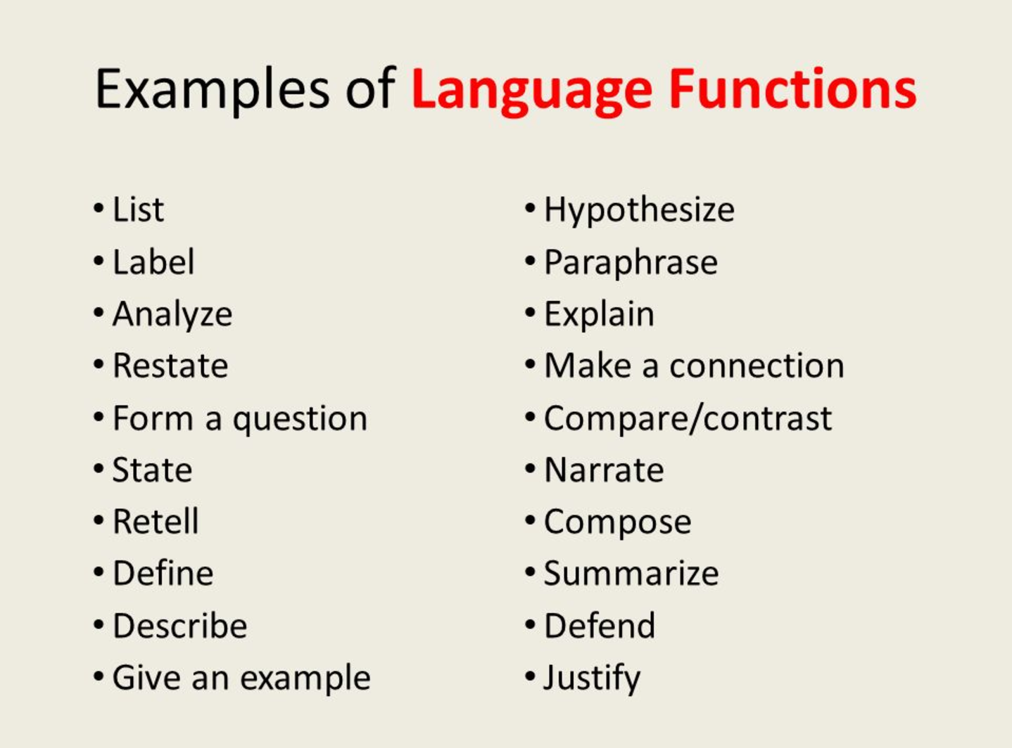

Activity: Work with a partner to find examples of language functions in the given materials 😊