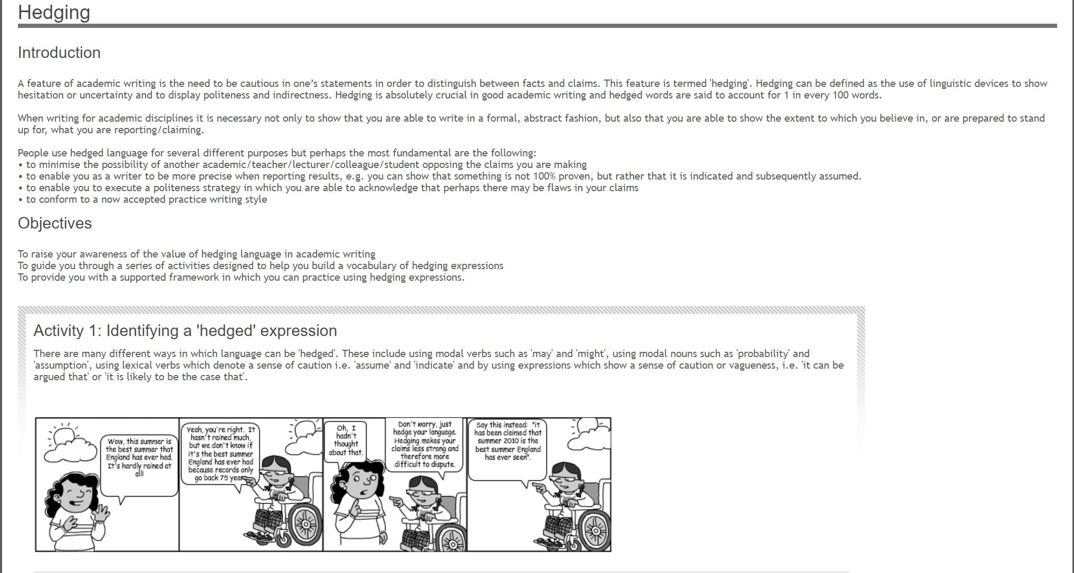

Read the following statements:

* Man **will** be able to cure cancer by 2025.
* Computers **will** replace classroom teachers in the 21st century.
* It **is undeniable** that parenting affects children’s performance at school.
* Use of nuclear power **is definitely** wrong.
* Life **will** end as a result of global warming.

All of these statements are ‘unhedged’ sentences, meaning that they are too certain. Words such as *will*, *undeniable*,*is*, and *definitely* make the writing too absolute. Readers may easily challenge these statements because there may be many alternative points of view. In academic writing, writers need to discuss points which are not usually so definite, and which are often debatable. Therefore, careful, uncertain language needs to be used, such as in the following ‘hedged’ sentences.

* Man **may** be able to cure cancer by 2025.
* It **appears** that computers **may** replace classroom teachers in the 21st century.
* It **seems** that parenting **may** affect children’s performance at school.
* Use of nuclear power **may be wrong in some /situations**.
* **There is growing evidence** that life **may** end as a result of global warming.

These sentences are more cautious, more academic and less likely to be challenged by readers with different opinions. It is important, when you are not 100% certain of a point you are making, to use hedging in your academic writing as well.

**Some of the language used for hedging includes:**

|  |  |
| --- | --- |
| **Modal verbs**  may / may not might / might not can  could | **Verbs**  seem(s) to appear(s) to tend(s) to indicate(s) suggest(s) contribute(s) |
| **Adjectives**  possible some many  most | **Adverbs**  possible likely perhaps often  usually |

**Identify the hedging expression in the following sentences:**

