# **For Millennials, there's no place like home when it's time to save for one**

The road to Meagan Walsh's dream house wound through the room she grew up in.

Like many Millennials, Walsh graduated from college without a job and burdened by student debt. But the 25-year-old's fortunes took a positive turn when she moved back in with her parents in Bethlehem, Pa., and found work.

“Originally, it was their idea, and I kind of rolled with it," she says, later admitting she "didn't have another option.”

Walsh parlayed her two-year stay with her parents into a home of her own. With no rent to pay and minimal expenses like car insurance and cell phone bills, she began saving most of the money she made, initially at her first gig at a social media startup and then at her current job as a leasing agent for a property management company.

“I was banking 75% to 80% of my paycheck,” she says, even after paying $250 each month for student loans amassed at the University of Delaware. She was able to save a 20% down payment of $28,000 to buy a four-bedroom, cape cod-style home in July 2016 for $140,000.

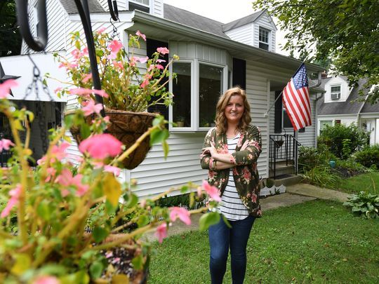

**Allentown, PA, U.S.A -- No place like home: Meagan Walsh, 25, stands in front of her house in Allentown, PA, that she bought with cash she saved after returning home to her parents' house after college. (Photo by Robert Deutsch, USA TODAY)***(Photo: Robert Deutsch, USAT)*

"It's cute," says Walsh, who also had enough cash to restore the hardwood floors and “splurge” on a quartz kitchen countertop.

Walsh's personal finance success story shows that while returning home to mom and dad might not be “Plan A” for most young Americans — and can sometimes be perceived negatively and as a short-term setback — it can also be an effective way for cash-strapped Millennials to boost savings quickly. Not to mention a viable way to speed up the process of buying a house, building equity in that home and living independently.

Related:

[Millennials' fear of stocks could cost them $3.3 million](https://www.usatoday.com/story/money/2017/07/19/millennials-fear-stocks-could-cost-3-3-million-retirement-savings/488571001/)

[Parents: No empty nest for you. Student debt prompts many Millennials to move back home, survey finds](https://www.usatoday.com/story/money/markets/2017/05/10/td-ameritrade-millennial-college-survey/101503580/)

It's also part of a larger trend of Millennials finally starting to get active in the real estate market. After the 2008 financial crisis, many Millennials returned home to live with their parents or shared expenses with roommates. Now, Millennials 36 and younger represent the nation's largest share of home buyers at 34%, according to the National Association of Realtors.

Saving a 20% down payment is “a major hurdle for young adults trying to buy their first home," according to a Bank of America Merrill Lynch report. It is even more challenging for Millennials given their high student debt loads. Outstanding student debt has reached $1.3 trillion, according to the New York Federal Reserve.

More than four out of 10 (43%) Millennials who have completed college said student debt caused them to “delay buying a home,” a TD Ameritrade survey found. And 27% of Millennials between 20-26 said education loans delayed them from “moving out of (their) parents’ home.”

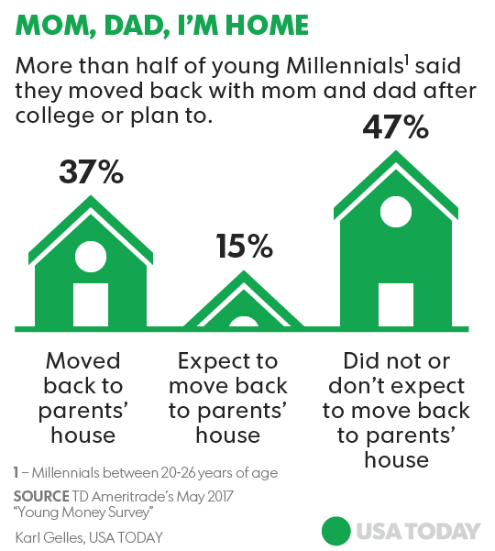

Walsh's boomerang living arrangement after college is not uncommon. Nearly four of 10 (37%) Millennials moved back in with their parents after graduation, according to the TD Ameritrade survey. A boomerang kid is a young adult that goes back to live with a parent after a period of independence.

“Does it make financial sense? Absolutely,” says Tony Ogorek, chief investment officer at Ogorek Wealth Management in Williamsville, N.Y. “It is very challenging for people starting out. Any strategy they can employ to reduce debt and allow them to save is great.”

But there's a caveat, he says. In today’s “gig” economy, where many people work on short-term contracts and their lifestyles become more “nomadic,” it can be risky to invest in a home unless you plan on living there for many years.

In Walsh’s case, she says buying her own home was a better investment than paying rent, especially since she found renting where she lives more expensive than buying.

Tim Manni, 34, a mortgage expert at NerdWallet, took advantage of moving in with his in-laws in the spring of 2015 after his wife sold her condo in Montclair, N.J., where they were living. Manni stayed about six months as the newly married couple shopped for and bought a new three-bedroom home in West Caldwell, N.J., and then did renovations before moving in.

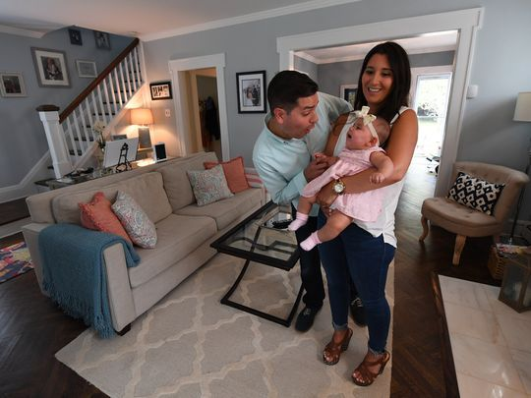

**West Caldwell, NJ, U.S.A -- Tim Manni, 34, and wife Lauren, 33, moved in with her folks for six months after selling her condo while they waited to move in to their new home; they used the $7,200 in savings to pay for closing costs and new furniture. With 6- month-old daughter, Harper. (Photo by Robert Deutsch, USA TODAY Staff)***(Photo: Robert Deutsch, USAT)*

During that time the couple was able to save the $1,200 they had been paying each month on the condo’s mortgage.

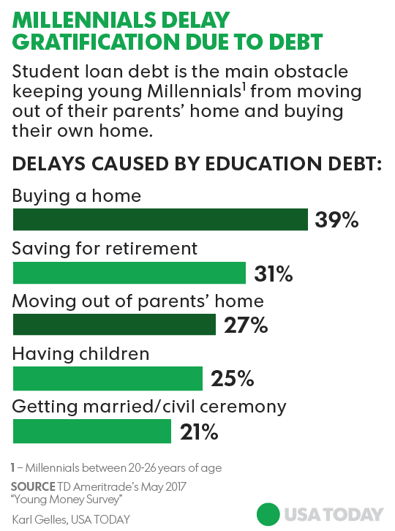

"It really worked out for us,” says Manni, adding that his gracious in-laws let them stay free of charge, while he and his wife reciprocated by chipping in for groceries and picking up the bill for the occasional dinner out.

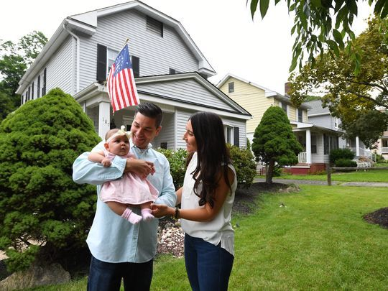

**West Caldwell, NJ, U.S.A -- Tim Manni, 34, and wife Lauren, 33, outside their new home in West Caldwell, NJ. Manni moved in with her folks for six months while the couple waited to move in to their home; they used the $7200 in savings to pay for closing costs and new furniture. With 6-month-old daughter, Harper. (Photo by Robert Deutsch, USA)***(Photo: Robert Deutsch, USAT)*

Returning home is a viable money-saving strategy, assuming there’s ample space in the home you’re returning to and there’s a specified savings goal, Manni says.

“It can be a motivator,” he says. “No one wants to live at home forever or come back home after being out on your own. But if there is a goal in mind, such as a home you are aiming to buy, it is a whole different ballgame.”

In another sign of Millennials’ newfound appetite for housing, 44% of Google searches in the mortgage category so far this year were first-time buyers, up from 11% in 2016, according to Chase Home Lending.

Kate Powers, 23, is one of those young Millennials searching for a home and saving for a down payment while also living rent-free with her parents.

After graduating in 2016 from Marist College in Poughkeepsie, N.Y., her hopes of working and living in New York City flamed out after she realized an entry-level salary wouldn’t provide enough income to afford an apartment without roommates, a living arrangement she wanted to avoid. “My original plan didn’t work out,” Powers says.

She opted to return to Severna Park, Md., to live with her folks and shop for less-expensive real estate closer to home. “My parents were 100% behind it," she says. "They didn’t want me struggling to pay my bills.”

While working a full-time job as an assistant acquisitions editor at a publishing company, where she earns $32,000 per year — as well as a part-time job — she's been able to sock away $25,000. She plans to stay put for another year or so to save enough for a down payment for a home in the $200,000 to $250,000 range.

“Right now, it is definitely the best option financially,” Powers says. “My savings target is $50,000."

“Too many people have a bad view of moving back home,” she adds. “They look down on it. But some of us are trying to help ourselves out.”

Powers enjoys her parents and her sister, who is seven years younger and who she's never had a chance to connect with until now. Her advice is to give living with mom and dad again a try.

"It is not the end of the world to go home,” she says.