21st Century Learning

## Why use technology?

## Exam Alternatives

# Notes from “It’s teacher Vs Google”

# What are we to do with information overload, misinformation and scams?

Are there opportunities for learning here?

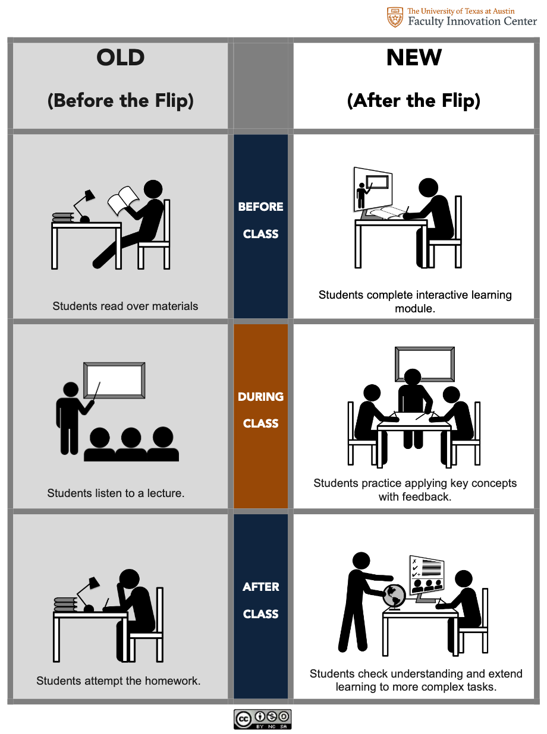

|  |  |  |
| --- | --- | --- |
| Problems | Deal with it | Opportunities |
|  |  |  |

|  |  |
| --- | --- |
| What | Technology Ideas |
|  |  |