8

Democratic consolidation in Poland after 1989
Andrew A. Michta

Our democracy is like a reed - it sways in the wind and a strong gust can hurt it. It was almost never used before, and that is why we lack experience on how to use it now.
Dariusz Fikus, "Demokracja jak trzcina," Rzeczpospolita, May 22, 1995.

Overview
The Republic of Poland, or the "Third Republic" as the Poles refer to it to emphasize continuity with the interwar "Second Republic," is a medium-size country with a population of 38.5 million and an estimated per capita GDP of about US$5,000.¹ Located between Germany and the former Soviet Union, Poland is a pivotal state for the future stability and security in postcommunist Central Europe. After six years of radical political and economic reform, by 1996 Poland has established an institutional framework for democracy and a free market economy. The country has developed a parliamentary-presidential system of government, codified in the 1992 "Little Constitution." In 1990 Poland opened its economic system to market competition by introducing a radical reform package, the so-called "Balcerowicz program" named after the country's finance minister in the first Solidarity government; two years later the country began to see the benefits of the economic "shock therapy." The economic basket case of Eastern Europe in the 1980s, after 1992 Poland began to recover, posting 5.0 and 5.5 percent GDP growth rates in 1994 and 1995, respectively, and reducing the inflation rate to under 30 percent by 1995. Increasingly confident about the economy, in January 1995 the government introduced a new currency; the exchange rate for the new Polish zloty was set by the market at US$1.00 to Pzl 2.40.
Political reform in Poland after 1989 has included free elections, the abolishing of censorship, and the privatization of the media. Poland changed the structure of its parliament by reestablishing the 100-member Senate in addition to the 460-member Sejm (lower house). The country's nascent party system has been gaining strength and by 1996 the political scene was dominated by five parties. Twice over the past six years the Polish society elected the parliament and the president, with an orderly transition of power accepted by all the parties and candidates as a matter of principle. While disputes as to the final shape of the new constitution to replace the 1992 basic law have persisted into 1996, especially in the areas of parliamentary versus presidential authority and the role of the Catholic Church, none of the political players has advocated non-democratic programmatic solutions.
Poland has also reestablished an independent judiciary, with Supreme Court justices appointed by the Sejm to life terms as the nation's highest judicial body. The Tribunal of State, chaired by the president of the Supreme Court, adjudicates on the responsibility of persons holding high state office for violation of the Constitution and the laws. The Constitutional Tribunal, another independent body, renders judgment on the consistency of all legislation with the Constitution; it has already done so effectively in several instances.
In the international arena, Poland has established good relations with Germany, thereby moving to eliminate the historical source of tension in the region. The two countries signed a border treaty and a good neighborly relations treaty in 1991 - the first steps on the road to Polish-German reconciliation. With German support, Warsaw has worked to gain entrance into the European Union and NATO, although the latter policy put it on a collision course with Russia. In contrast to the relations with the West, in 1996 Poland's relations with its neighbors to the East were strained, while uncertainty about the direction Russia would ultimately take remained a paramount concern.
Overall, six years into reform the record of political and economic change in Poland has been encouraging, even though Poland's postcommunist transition remains work in progress. The economy has performed above expectations, but Poland has yet to complete the large-scale privatization program, to address the problem of persistently high double-digit unemployment and to deal effectively with the potential for social unrest caused by the current rapid class stratification. In addition, the political division between those with roots in the anti-communist opposition movement and those who had ties to the power structure of communist Poland has become more pronounced. The 1996 resignation of Prime Minister Jozef Oleksy, amidst allegations that he was an agent of the Russian intelligence service, has deepened the political cleavages in Polish society and once more raised concern about Russian interference in Polish domestic affairs. Other issues, such as the question of church-state relations, civilian control over the
military, and especially the new constitution often led to acrimony and political infighting at the highest levels of the government.
The analysis of democratic consolidation in Poland presented here is organized around several themes central to Polish postcommunist transition, including (1) the legacy of the Commonwealth of Poland-Lithuania and the Second Republic between the two world wars; (2) the legacy of the second world war; (3) the experience of communism and anti-communist dissent; (4) the character of the 1989 revolution and the 1990 fragmentation of the Solidarity movement; (5) the impact of the parliamentary and presidential elections; (6) systemic constitutional issues with an emphasis on the power of the presidency; (7) the evolution of political parties after 1989; (8) Polish attitudes to democracy; (9) the economic reform; and (10) the evolution of civil society and the role of the media. The chapter concludes with an assessment of Poland's long-term prospects, as well as problems that are likely to confront the Third Republic in the remainder of the decade.

The role of pre-democratic experience
The development of a democratic culture depends not only on the presence of democratic institutions and the rise of civil society, but also on the willingness of the citizenry to view the emerging democratic framework as historically legitimate. In that regard, democratic consolidation is affected by the society's predemocratic experience. This is not to suggest that societies with no history of democracy will necessarily fail to democratize, but rather that democratic consolidation has a greater chance for success if the postcommunist society considers its current systemic transformation as a necessary extension of its past. This "historical legitimacy," that is, whether a nation sees itself as sharing in the Western liberal democratic tradition, is particularly important when considered against the relative weakness of political parties and of civil society at the early stages of reform. In Poland democracy has been viewed as part of the country's historical legacy dating back to the Commonwealth of Poland-Lithuania of the sixteenth to eighteenth centuries and to the experience of the Second Republic between the two world wars. It has often been synonymous with the Polish aspirations to rejoin the West.
In contrast to Latin America and southern Europe, transition to democracy in postcommunist Europe has occurred under conditions of a deepening economic crisis, a disintegration of regional security and economic institu-tions, and political instability across the region. Poland was hit especially hard by the economic crisis of the 1980s, with an inflation rate reaching close to 600 percent by 1990, a crushing foreign debt, persistent food shortages, and the collapse of the manufacturing sector. As Poland moved to develop
and consolidate its new political institutions after 1989, it confronted both a deeply dysfunctional economy and a discredited political system. Moreover, the imperative simultaneously to build democratic institutions and to implement economic reform was unprecedented.² It is in this context that the Polish acceptance of the general idea of democracy as a historically legitimate systemic solution has contributed to political reform. For the majority of the Poles, economic prosperity was also associated with democratic institutions. Six years into postcommunist reform those who believed that democracy has made economic reform possible in Poland outnumbered the opponents two-to-one (57 percent for, 23 percent against, with 20 percent undecided).³
Considered against the initial weakness of the political institutions and the lingering communist legacy, the "historical legitimacy" of democratic change in Poland has been important to democratic consolidation. The lessons learned by the Poles from the tortuous evolution of their state may prove to be the ultimate source of Polish democracy's enduring strength. The Poles have regarded democracy as the culmination of their historical struggle for self-determination and independence. The Third Republic has been seen as the direct progeny of the sixteenth to eighteenth century Polish-Lithuanian Commonwealth and the Second Republic of 1918-39, though in fact it is quite different from both. Even more importantly, the Poles have regarded the establishment of democracy as the prerequisite for becoming a "normal state," that is, one built on the systemic principles derived from the West, and as the necessary precondition for joining Western political, economic and security institutions.

The historical roots of Polish democracy
During the fifty years of communism Poland was the most unpredictable among Moscow's satellites. The Poles saw themselves as a Catholic Western nation, which although dominated by Russia, would not shed its distinct national identity. The national "collective memory" of the Poles emphasized their uniqueness and their alienation from foreign rulers, as embodied in the history of the Commonwealth of Poland-Lithuania and the Second Republic. The legacy of the Commonwealth of Poland-Lithuania, a multi-ethnic and multicultural Polish-dominated state, blended Roman Catholicism with the tradition of an "aristocratic democracy." In its tortuous history, the country had risen as the region's hegemonic power in the sixteenth century and disappeared from the map of Europe two centuries later. The legacy of the Second Republic of 1918-39 has given the Poles the experience of regained national sovereignty, parliamentarism, and a pro-Western foreign policy.
Polish history has informed the myth of a unique Polish democratic tradition rooted in individual liberties and civil disobedience to state
authority. Anarchic at the core, the aristocratic ideal of "golden freedom" propagated by the nobility {szlachta) became fused with the suspicion and rejection of organized state authority and, after the absorption of the Commonwealth by the neighboring great powers in 1795/ with a sense that the Polish cultural bond transcended narrowly defined ethnicity.⁵
Polish culture has been formed by influences both from the West and the East. Historical Poland straddled the juncture where Roman Catholicism, Lutheranism, and Eastern Orthodoxy met. Still, Polish national and political aspirations looked to the West. Historically, Poland saw itself as a bastion of Latin civilization against Byzantine Russia.
Between 1795 and 1918 Poland disappeared from the map of Europe. Outside domination became a formative experience for the emerging modern Polish national identity. The majority peasant population remained excluded from politics, while the nobility and the emerging intelligentsia partook in national uprisings and absorbed the revolutionary trends of the time. The Polish insurrectionary tradition grew out of the succession of failed armed uprisings against Russia, in 1794, 1830, and 1863. It has remained a powerful influence in the Polish political culture often invoked with pride by the citizens and politicians alike. Reinforced by the perceived success of Józef Pilsudski's legions in 1918 and by Polish victory in the 1919-20 war with Soviet Russia, it has been a constitutive element of Polish national identity.
The Polish experience of a working democratic system during the Second Republic of 1918-39 was brief and its institutions were never sufficiently consolidated. The military coup of 1926 launched by Pilsudski in the name of saving the country from chaos and preserving its independence placed Poland squarely on an authoritarian path. Nevertheless, during the fifty years of communism after the Second World War the legacy of the Second Republic would sustain the ideal of a sovereign Polish state. Despite the host of economic and political problems, the twenty years of independence would also give the Poles an experience of a nascent party system, a state administration, an independent foreign policy, and a market economy. It passed on to the post-World War II generation a memory of political participation, parliamentarism (albeit limited by the consequences of the 1926 coup), and party politics.
The vastness of the task of nation building prevented the consolidation of democracy in the Second Republic. The interwar Polish state was put together from territories formerly controlled by three neighboring powers, with disparate administrative systems and economic infrastructures. The problem was compounded by the devastation brought about by the war, the overall economic underdevelopment, and low literacy rates. The Second Republic sought to establish a democratic system in exceedingly unfavorable geopolitical circumstances, with its great power neighbors, Russia and
Germany, determined to lay irredentist claims against it, and its principal ally, France, too weak to guarantee its security. Finally, the multi-ethnic character of resurrected Poland, with ethnic Poles constituting 68 percent of the population,⁶ meant that to a large degree Polish national identity would remain class based, especially in the Eastern borderlands (kresy) where the Poles were a minority and where the ethnically Ukrainian or Lithuanian nobility would often regard itself as Polish, but the majority peasant population would not. In the end, the infant Second Republic succumbed to forces by far exceeding the resources available to it; still, it raised a generation that would preserve the idea of Polish sovereignty and statehood through the trauma of the Second World War.

The impact of World War II
For Poland, the end of World War II ushered in over four decades of Soviet domination and communist rule. Three enduring direct consequences of the Second World War relevant to the process of postcommunist political consolidation in Poland are (1) a change in the ethnic composition of Polish society; (2) a change in the class stratification; (3) a territorial adjustment.
Poland lost six million of its citizens in the course of World War II, including almost all of its three million Jews. This tragic legacy of the war resulted in a historically unprecedented ethnic consolidation in Poland. While the Second Republic was a multi-ethnic state, the Holocaust, the postwar expulsion of the Germans from the newly acquired Western territories, and the repatriation of ethnic Poles from the Eastern territories lost to the Soviet Union transformed the postwar Polish People's Republic into an ethnically homogeneous state. This change shifted ethnic relations to the periphery of national concerns, residual anti-semitism and friction between ethnic Poles and the small remaining Ukrainian and Byelorussian minorities notwithstanding.
The ravages of the Second World War brought about the implosion of the Polish class structure. Nazi extermination policies directed against the Jews and the Polish intelligentsia hit hardest at the country's elite, decimating the professional class. Soviet policies, including the Katyn massacre of Polish officers and the elimination of the pro-London resistance during and immediately after the war, aggravated the problem. In terms of its class structure, the Polish People's Republic began the postwar reconstruction as a predominantly peasant nation with the overall levels of education lower than the Second Republic's.
In 1945 Poland lost 30 percent of its territory in the East for which it was compensated with territory taken from Germany. In addition to the lasting Political consequences of the country's shift to the West, especially simmering German irredentism and concomitant Polish insecurity that would become an obstacle to the normalization of relations between Poland and Germany, the shift marked a break in the country's cultural heritage. Historically, Poland had seen its destiny in the kresy, where for centuries it confronted the Orthodox East. The loss of the kresy after 1945 transformed Poland into a central European nation-state. Polish national identity shifted away from the class to the ethnic, linguistic, and cultural bases. It became consolidated in the course of communist domination. Increasingly, the Poles have come to think of themselves as an ethnically homogeneous nation.¨

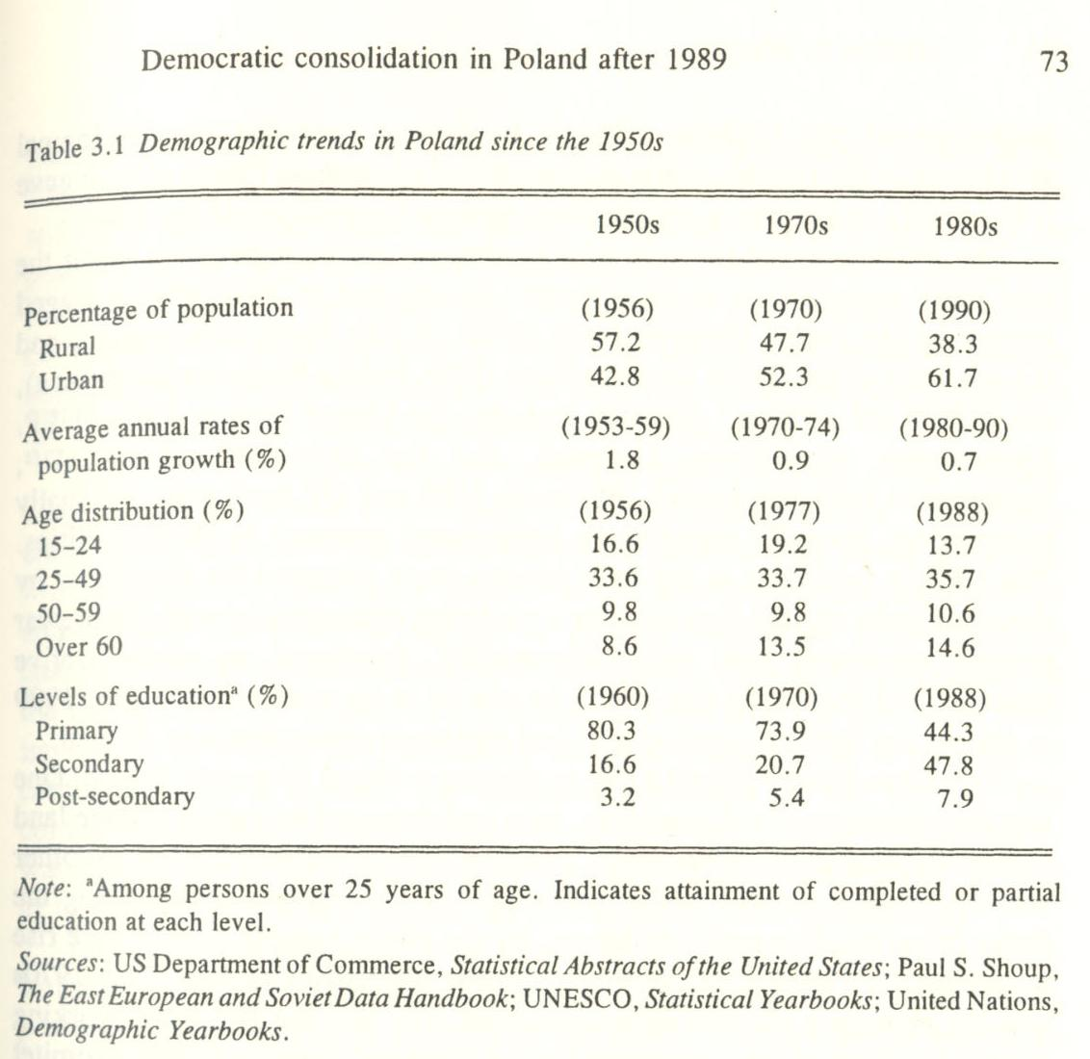

Communism and dissent: to and from Solidarity
Historically, the primacy of the struggle for national independence and statehood placed the question of preferred systemic solutions in the background of Polish politics. In that sense, Polish nationalism was quintessentially a culture in search of a state.⁷ More than forty years of communist rule reinforced this paradigm. Within its broad parameters, the Polish United Workers' (Communist) Party (PUWP, Polska Zjednoczona Partia Robotnicza), the Roman Catholic Church, and the dissident movement interacted and defined the country's political scene. Communism was perceived by the majority of the Poles as synonymous with the loss of independence to Russia. To the dissident movement liberation from outside domination and oppression meant also the restoration of Poland to its rightful place among the community of Western nations. The dissidents identified national independence with reclaiming Western values (becoming a "normal state"), as they reached across the centuries of the nation's history to the formative experiences of Polish politics. The dissident elite viewed the Polish nation-state as historically democratic, Western, and majority Roman Catholic.
Communism remade the class structure of the Polish society. It created a large industrial working class and shifted the majority of the people from the countryside to the cities. In the process, the rural population was reduced from being a clear majority to being a little over a third of the total. Even more significant was a shift in education levels, especially the almost threefold increase in the number of people with secondary education and the more than twofold increase in the number of people with higher education (table 3.1). Communism also raised popular expectations about the level of social security and the state's responsibility to provide it.
Although the Poles rejected communist ideology, the socialist mindset on social welfare issues formed in the communist era would remain a potent force in postcommunist politics. It would be reflected in the voters' choice
in the 1993 parliamentary election, which gave the parties with roots in the communist system a dominant position in the parliament. It would undergird the continued social discontent with the government. It would drive Solidarity to challenge the government in the streets after 1989 when the union became committed to resisting market reform in the name of protecting the vested interests of the occupational groups it represented.⁸
The loss of sovereignty and the communist takeover in Poland after the second world war revitalized the Catholic Church. While in the interwar period the overall political influence of the Church hierarchy on the country's politics had declined in relative terms, the direct assault on religious freedom in Poland by the communist regime transformed the Church in the eyes of society into a standard bearer for the cause of national independence and a sole legal form of opposition to the regime.
During the communist period the Catholic Church remained independent of the state despite the early attempts by the government to assert control over it. The church served as a critical focal point of anti-communist resistance; the PUWP recognized its autonomy after the crisis in 1956 that brought about a truce between the party and the Church hierarchy. The institution of the Catholic Church in Poland provided an ideological alternative to the regime, while its history and its roots in Polish culture gave it its vitality to become a counterforce against the policies of the state.
The PUWP played the role of a hegemonic party, rather than being the sole party organization in the country. Established in 1948 after a rigged merger by the Polish Workers Party (PWP, Polska Partia Robotnicza), and the left wing of the Polish Socialist Party (PSP, Polska Partia Socjalistyczna), the PUWP led a "bloc" that also included the United Peasant Party (UPP, Zjednoczone Stronnictwo Ludowe), and the Democratic Party (DP, Stronnictwo Demokratyczne). While the UPP and DP were only nominally independent, they did establish an institutional presence in Polish politics. The UPP in particular as the only peasant party tolerated for fifty years by the communist regime provided for a modicum of continuity with the prewar peasant movement and, more importantly, developed an administrative structure and leadership that would be crucial in its re-emergence after 1989 as one of the better organized political parties in postcommunist Poland.
Two other factors played a role in shaping political dissent in Poland. One was the resistance of the peasantry, who had managed to sustain private land ownership despite the government's early efforts at collectivization. Another was the relative success of the media and the universities in expanding the limits of permissible political debate. By the 1960s popular dissent gave rise to independent intellectual activities outside the party's control. The 1970s saw the emerging alliance of the dissident elite and the industrial working class in the form of the Committee for the Workers' Defense (CWD, Komitet Obrony Robotnikow), established after the 1976 workers' protest in Radom and Ursus.⁹ In the 1970s the nationalist independence movement was channelled into the ranks of the Confederation for an Independent Poland (CIP, Konfederacja Polski Niepodleglej). Human rights issues raised by the Helsinki conference were at the center of the Movement for the Defense of Human and Civil Rights (MDHCR, Ruch Obrony Praw Czlowieka i Obywatela). Dissent among the intelligentsia fanned the network of "flying universities" which taught subjects deemed subversive by the regime. In the 1980s the spontaneous strikes by shipyard workers at the Baltic Coast fused the various dissident strands into an alliance of all anti-communist forces in Poland. The Solidarity Trade Union movement of 1980-81 was the beginning of the Polish anti-communist revolution. It would endure the 1981 military crackdown and would eventually bring down communist power.
In retrospect, dissent defined the phases of Polish communism. Popular resistance to communist rule gained its first impetus from the 1956 Poznan demonstrations, which brought to power the "national communists" led by Wladyslaw Gomulka and marked the end of Stalinist repression. The subsequent landmarks of Polish anti-communist resistance were the 1968 student riots in Warsaw, the 1970 December bloody shipyard strikes at the Baltic Coast, the 1976 strikes in Radom and Ursus, and the 1980 August strikes at the Baltic Coast that finally broke the PUWP's monopoly on political power. With each of the successive crises, the area of collective and individual freedom in communist Poland rose incrementally as forced collectivization ended, censorship weakened, church-state relations became normalized, economic concessions were won, and finally the state recognized the citizens' right to independent political organization.
In 1980-81, during its sixteen months of legal existence under communism, Solidarity became a movement for national independence. Numbering close to ten million, it cut across the entire political and social spectrum. More significantly, Solidarity brought to the fore grass roots organizations and allowed the Poles to engage in politics outside of state-controlled channels, laying the foundations for a civil society. This was greatly aided by the union's regional organizational structure. Even after the December 1981 imposition of martial law, Solidarity survived underground as an ideal of community and a formula for collective resistance to the regime. The communist decision, in 1989, to open round-table negotiations with Solidarity was a testimony to the strength of the nascent civil society in Poland, as well as to the extent to which communist power had by then decomposed.
The legacy of Solidarity as a movement for national rebirth remains a formative influence in Polish transition to democracy. It sets the Polish postcommunist experience apart from the other countries in the region in several ways. First, Solidarity gave the Polish revolution and the attendant transformation of society an early start. The experience of 1980-81 established the foundations of a civil society and created a sense of community indispensable to the growth of democratic institutions. Second, Solidarity became the formative experience for the new governing elite that would take over in 1989 and would steer Poland through the critical first four years of economic and political reform. The "Solidarity ethos," which emphasized the moral and ethical values of a "normal," that is Western democratic society, was shared by the first four cabinets as well as President Lech Walesa. Third, Solidarity gave rise to Poland's center and center-right political parties of today.

The legacy of the 1989 revolution
The collapse of the communist system in Poland was pacted in that it began in 1989 with a round-table political compromise agreement between the opposition and the communists. However, it occurred against the background of an overwhelming popular demand for change. It was a two-stage negotiated revolution, including (1) the round-table agreement which re-legalized Solidarity, and (2) the subsequent elections to the "contract parliament" which destroyed the communists' ability to govern.
The pacted character of the 1989 revolution blunted the Solidarity leadership's desire for retribution. The policy of the so-called "thick line," pursued by the first Solidarity government of Tadeusz Mazowiecki placed clear limitations on decommunization after 1989. Mazowiecki's decision to concentrate instead on the issue of economic reform subsequently became the target of intense criticism from the right, which blamed it for the return of former communists to power in 1993 and for the nation's inability to come to terms with past abuses. The policy generated the initial popular dissatisfaction with the process through which democracy was being implemented in Poland. The successful presidential campaign of Lech Walesa in 1990 was built around the theme of "accelerating" change and cleaning house. The populist tone of that campaign remains a strong undercurrent in Polish politics.
Prior to 1989 Polish opposition to the regime was unified around a single issue, that is, the quest for national emancipation. The social aspirations were manifested by cyclical crises that exposed progressively ever-deeper fissures in the facade of Polish communism. The unity of national purpose came at a price, however, in that the diverse groups and classes that made up the movement failed to articulate political programs of their own; instead, in the 1980s they shared the "Solidarity ethos," with its emphasis on the ethical values of Western democratic society. In 1989 during the early stage of Polish transition to democracy the "contract" parliament that emerged from the round-table negotiations between the communists and the opposition became a forum for program and party-formation, with fissures appearing early on among the organizations with roots in Solidarity. The 1989 round-table agreement was intended by the communists to ensure their continued control over the key levers of state power through a guaranteed 65 percent majority in the lower house (the Sejm) and the ministerial portfolios of defense, internal affairs, and foreign affairs. In return, the PUWP accepted the principle of free competition for the remainder of the seats in the Sejm and for all 100 seats in the restored Senate. The 1989 election to the "contract parliament" opened the floodgates of genuine political competition. While the new parliament functioned as a legislative body - that is it appointed the government, passed laws, and so on - it also became a vehicle for party-formation by providing a testing ground for political programs and leaders.¹⁰
The Polish revolution of 1989 lacked the symbols of a sudden break with the past. The final decomposition of communist power in Poland took a decade to reach the breaking point. In 1989 the transition of power occurred in a carefully negotiated manner, with the Solidarity leadership well aware of its pioneering role in Eastern Europe and of the danger inherent therein. The experience of the 1981 martial law and the continued treat of direct Soviet intervention in Polish politics were foremost in the minds of the Solidarity leadership in 1989, while the disintegration of the country's economy was the most urgent concern. The Polish revolution of 1989 was contained by the perimeter drawn by the experience of Solidarity during the 1980s and by the fact that in the early stages the Mazowiecki reform government stood alone among Soviet dominated regimes. The Poles were very much aware that they had entered an uncharted territory. Until the 1990 Zheleznovodsk agreement between Germany and the USSR, which facilitated German reunification, the Mazowiecki government could not foresee that a radical restructuring of the entire region would follow.
Another important development of 1989, one with far-reaching conse-quences for the formation of political parties in Poland, was the fragmentation within the Solidarity elite, especially the rift between Solidarity chairman Lech Walesa and the dissident intelligentsia led by Tadeusz Mazowiecki. The schism within Solidarity came into sharp focus at the time of Poland's first free and direct presidential election campaign in 1990, which pitted Walesa against Mazowiecki, with Stanislaw Tymihski, a dark horse populist candidate challenging both (table 3.2). In December 1990 Lech Walesa was elected by a landslide in a run-off against Tymihski by getting close to 75 percent of the vote." This constituted a powerful popular mandate for the president, and it put Walesa in a strong position vis-a-vis the Sejm, which was still composed of deputies elected at the end of the communist period. However, the damage to Solidarity's cohesion done by the bitter acrimony of the presidential campaign and the subsequent "war at the top" could not be repaired. The experience of the presidential election polarized Solidarity between those who supported Walesa's traditional workers power base against the intelligentsia centered around Mazowiecki's candidacy. Walesa's victory tilted the balance of power in the country away from the parliament. The imbalance was underscored by the constitutional provisions dating back to the presidency of General Wojciech Jaruzelski, which gave the president broad powers, including control over the armed forces through the National Defense Committee (NDC, Komitet Obrony Kraju).
The 1990 presidential election was a milestone in Polish transition to democracy in that it broke the unity of the dissident movement at the time when the fundamental question of the constitutional framework was first being addressed. The fragmentation of Solidarity would become the immediate cause of the compromise formula of presidential-parliamentarism, adopted in 1992 in the "Little Constitution," that has bedeviled the country's political scene since. The new Polish basic law reflected the struggle for power between President Lech Walesa and his former Solidarity allies in the parliament. It put off the decision on the final shape of Polish democracy, while it reflected the fault lines in the country's politics at the time.

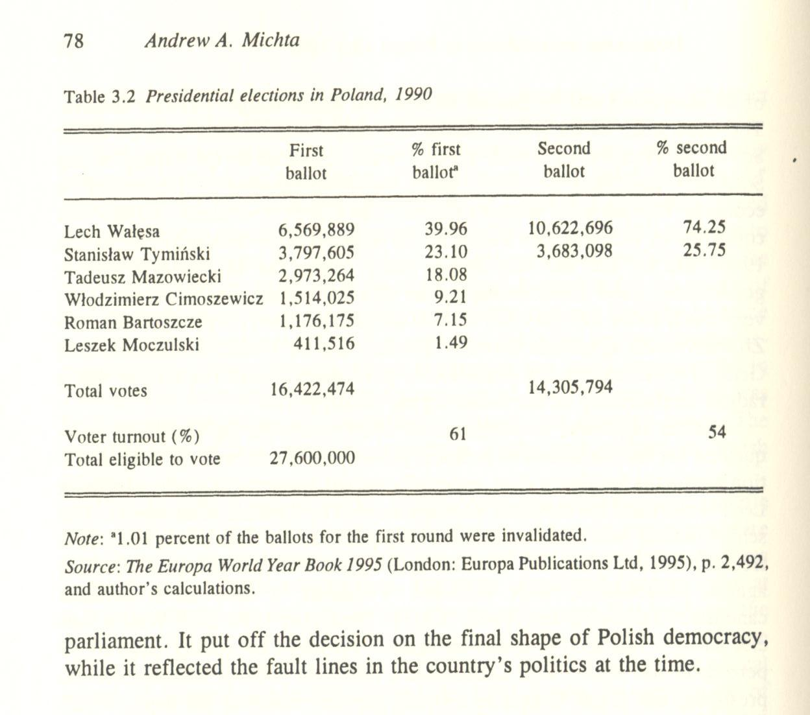

The 1991 and 1993 parliamentary elections
The parliamentary election of October 1991 demonstrated how divided the original Solidarity movement and the electorate had become in the course of two years. On the eve of the Sejm election Poland had over 100 registered political parties.¹² Some of the fringe organizations among them would have an impact on the nation's political scene; for example, the Polish Friends of Beer Party would capture sixteen seats in the 1991 parliament.
A new electoral law was passed on June 28, 1991. It provided for the election of 460 deputies to the Sejm (lower house) and 100 deputies to the Senate. The draft law had been vetoed twice by Walesa before the final version was agreed upon after several protracted debates in the Sejm and the Senate¹³ At issue was the concern of small political parties that feared they would be left out of the parliament if stringent thresholds for representation were adopted.'⁴ The law for the 1991 election to the Sejm was based on the principle of proportional representation, with the stipulation that 391 deputies would be chosen from regional lists and 69 deputies would be chosen from national lists tied to the regional lists (Article 2). All Polish citizens 18 years or older were eligible to vote; candidates to the Sejm had to be 21 years of age and had to have resided in Poland for at least five years (Articles 6 and 8).¹⁵
The voter turnout on October 27 was disappointingly low, estimated on the election day at about 40 percent of the 27.6 million of the Polish electorate.¹⁶ Almost two-thirds of the electorate did not vote. The voters chose from among some 7,000 candidates for the 460 seats in the Sejm and from among 612 candidates for the 100 seats in the Senate. In an indication of the weakness of the nascent political parties, no party received more than 13 percent of the vote in the Sejm election. Final election results, published on October 31 by the State Electoral Commission, set the voter turnout at 43.2 percent. Of the sixty nine political groups contesting the elections, twenty-nine won seats in the parliament. The scope of the fragmentation was best symbolized by the fact that eleven of the twenty nine political parties represented won only one seat in the parliament each. The top ten parties in the 1991 Sejm were: (1) Democratic Union (DU, Unia Demokratyczna) - 62 seats; Democratic Left Alliance (DLA, Sojusz Lewicy Demokratycznej) - 60 seats; Catholic Electoral Action (CEA, Wyborcza Akcja Katolicka) - 49 seats; Polish Peasant Party (PPP, Polskie Stronnictwo Ludowe) - 48 seats; Confederation for an Independent Poland (CIP, Konfederacja Polski Niepodleglej) - 46 seats; Center Alliance (CA, Porozumienie Centrum) - 44 seats; Liberal-Democratic Congress (LDC, Kongres Liberalno-Demokra-tyczny) - 37 seats; Peasant Alliance (PA, Porozumienie Ludowe) - 28 seats; Solidarity Trade Union - 27 seats; and Polish Friends of Beer Party (PFBP Polska Partia Przyjaciof Piwa) - 16 seats (table 3.3).¹⁷ From among the 200 deputies who ran for reelection, the voters returned to the Sejm only 115. ¹⁸

The Democratic Left Alliance carried eleven of Poland's 37 electoral districts; the Democratic Union carried ten; the peasant parties jointly carried nine; the Catholic Electoral Action and the Center Alliance carried two districts each; the Confederation for an Independent Poland, the Liberal-Democratic Congress and the German Minority Party carried one district each. The two biggest winners, the Democratic Union and the Democratic Left Alliance represented two different regions of the country. Most of the electoral support for Mazowiecki's Democratic Union was concentrated in large cities in central and southern Poland; the Democratic Left Alliance was the strongest in the northern and northwestern regions of Poland, in the formerly German areas settled after World War II.¹⁹
The 100 Senate seats were divided up as follows: the Democratic Union won 21 seats, Solidarity - 11, the Center Alliance and the Catholic Electoral Action - 9 each, the Polish Peasant Party - 8, Rural Solidarity - 7, the Liberal-Democratic Congress - 6, and the Democratic Left Alliance - 4.²⁰

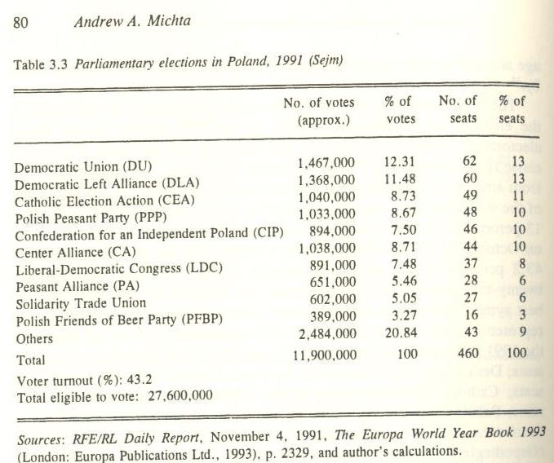

The most important result of the October election was the fragmentation of the Sejm. With twenty-nine political parties represented, none had the prospects of building a strong government. Furthermore, the fragmentation of the parliament reflected the ideological polarization of the Polish electorate, making the passage of a new constitution (including the bill of rights) a truly formidable task.²¹ The two years after the 1991 election were marked by a succession of weak coalition governments on the one hand, and Walesa's increased pressure for greater political powers for the presidency.
In 1993 a new election was forced by the parliamentary vote of no-confidence in the coalition government of Hanna Suchocka, and by the subsequent decision by President Walesa to dissolve the parliament. The 1993 vote marked a dramatic shift in Polish politics by removing from power the Solidarity elite and by legitimizing the postcommunist DLA. The election reduced the number of parties represented in the parliament from twenty-nine to seven (table 3.4) and gave the post-Solidarity parties only 157 seats out of 460 seats. In 1993 the voter turnout of about 52 percent was about 10 percent higher than in 1991.
The dramatic setback to the post-Solidarity parties was largely caused by the new electoral law, passed on May 28, 1993 and signed by President Walesa on June 1, 1993. The new law aimed at curbing the excessive parliamentary fragmentation blamed at the "hyperproportional" regulations of 1991. The most significant provision of the law was the augmentation of the proportional representation principle with thresholds for representation set at
5 percent for political parties and 8 percent for coalitions (Article 3).²² The law put 391 seats up for competitive election, leaving the remaining 69 seats to be awarded as additional bonus seats to parties that cleared at least 7 percent of the popular vote to be distributed to candidates from the so-called "national lists" of the most prominent party candidates (Article 4). The new law also raised the number of electoral districts from 37 to 52, to correspond to the provinces (wojewodstwa) and the two metropolitan areas of Warsaw and Katowice. The 1993 law kept the proportional representation principle, while favoring the largest winners in order to limit as much as possible the political fragmentation of the legislature. By doing so it generated another problem - under-representation. The new parliament left outside the legislative process all of the conservative, nationalist, free-market and Catholic parties. By favoring the biggest vote getters, the election law eliminated political parties that jointly polled 26.4 percent of the popular vote but failed to clear the threshold by a narrow margin, as opposed to 20.4 percent of the popular vote going to the DLA. The most dramatic in its symbolism of change in Polish politics was the inability of Solidarity and the Liberal-Democratic Congress (the latter the greatest champion of Polish market reform) to clear the 5 percent threshold in the Sejm. The PPP and the DLA won jointly only 36 percent of the popular vote; however, the high threshold requirement in the law and the additional bonus seats it gave to the largest winner doubled the actual number of seats in the Sejm awarded to the PPP and the DLA to 66 percent of the total. Since the DLA and the PPP also won 76 of the 100 seats in the Senate, with a two-third control of the Sejm and over three-fourth control of the Senate they now had an effective majority in both houses sufficient to pass a new constitution.²³
The 100 seats in the 1993 Senate were divided up as follows: the Democratic Left Alliance - 37; the Polish Peasant Party - 36; Solidarity -10; the Democratic Union - 4; the Non-Party Bloc in Support of Reform - 2; the Union of Labor - 2; the Liberal-Democratic Congress - 1; the German Minority - 1; others - 7; the Liberal-Democratic Congress lost representation after its 1994 merger with the Democratic Union into the Union of Free-dom.²⁴

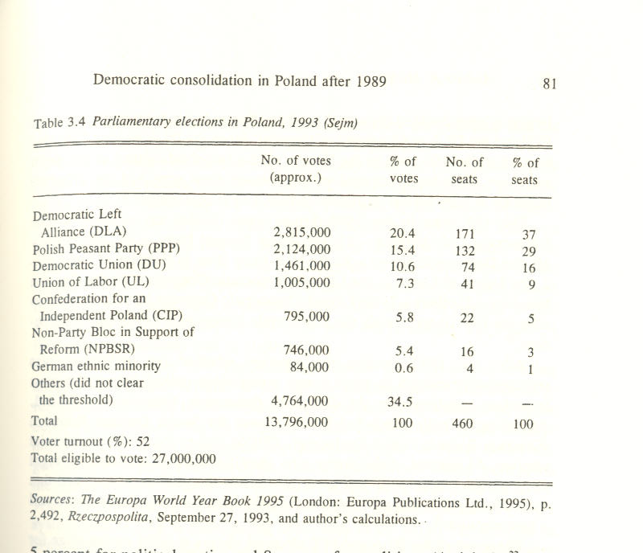

After the 1993 election the question whether the parliament was representative enough to adopt a new constitution ranked among the most important questions for the future of democratic transition in Poland. According to polls conducted by the Center for Social Opinion Research (Centrum Badania Opinii Spolecznej, CBOS) before the 1995 presidential election, 53 percent of the voters who identified themselves with the right wing parties that in 1993 had been left outside the parliament believed that upon taking office the new president should dissolve the legislature and call a new election.²⁵
The scope of the DLA and PPP electoral victory in 1993 set the stage for further polarization of the Polish political scene, as the extra-parliamentary opposition framed its programs in terms of renewed struggle against the "reds." The polarization was underscored by charges coming from Cardinal Jozef Glemp, the primate of the Catholic Church, that the DLA's 1993 electoral victory marked the re-emergence of communist Poland, the "PRL-bis." The election outcome placed the presidency and the parliament firmly on a collision course, with the ruling coalition claiming to act within the limits of the constitutional framework, and Walesa assuming the role of the sole defender of the Polish revolution and the legacy of Solidarity against the entrenched former nomenklatura.

The constitution and the powers of the presidency
The first stage of postcommunist transformation took place under conditions of only partial parliamentary legitimacy. Even more importantly, the "contract parliament" of 1989 was in no position to draft a new constitution. Poland had to wait until 1992 to approve an interim basic law, and as of late 1996 it still awaits a new constitution. During Lech Walesa's presidency, 1991-95, the provisional nature of the basic law and its occasional deliberate vagueness on the issue of presidential versus parliamentary authority resulted in tense and often confrontational relations between the president and the legislature, as both sought to assert their power position.
Polls conducted on the eve and immediately after the first parliamentary election showed general confusion over the division of governmental authority in the country. According to a November 1991 poll by the Center for Public Opinion Research (Osrodek Badania Opinii Publicznej, OBOP) the dominant popular perception was that the country was in chaos. When asked who in their view was in charge in Poland, 24 percent of the respondents named President Lech Walesa, 15 percent named the government, 11 percent named the Catholic Church, and 6 percent named the Sejm; 13 percent of the respondents stated that they did not know who was in charge, and 9 percent responded that nobody was in control.²⁶
After the October 1991 parliamentary election the Sejm moved to bring about constitutional reform. It set up an Extraordinary Commission to recommend revisions to the Constitution. President Walesa submitted to the Sejm a draft proposal for the so-called "Little Constitution" {Mala Konstytucja), which would strengthen the presidency and to some extent the government (Walesa's version of the "Little Constitution" would have given the government the authority to issue decrees with the force of law). Walesa's goal was to create a strong presidency modelled after the French system, and as such it faced strong opposition in the Sejm.²⁷ In addition to Walesa's proposal, three more drafts were reviewed in 1991-92. They were submitted by the Sejm, the Senate, and a group of lawyers from the University of Warsaw. The principal differences among them concerned the authority to form and dismiss the government (Walesa had insisted that this should be the president's prerogative), the procedures for the no-confidence vote in the Sejm, and the scope of the special legislative prerogatives of the government.²⁸
The "Little Constitution" that was finally adopted by the Sejm on August 1, 1992 describes a hybrid presidential-parliamentary system, a compromise solution that accommodated the current political reality in Poland. It was a compromise between the Sejm's insistence on its overall supervision of the government and Walesa's demand for greater presidential powers, while it also attempted to strengthen the government.
The "Little Constitution" established a division between the three branches of government: the legislature (the Sejm and the Senate), the executive (the president and the Council of Ministers), and the independent judiciary. The compromise reached on a number of issues, especially the question of who controls the nation's security policy, foreign policy, and internal affairs reflected the relative strength of Walesa vis-a-vis the fragmented parliament. The parliament may be dissolved by the president if it fails for three months to pass the budget or approve the cabinet (Articles 4 and 21); however, the president cannot dissolve the parliament on other grounds even if the Sejm passes a law which limits his powers. The constitution gives the parliament the right to dissolve itself by a two-third majority vote.
All legislation and decrees require the president's signature. The Sejm, the Senate, the president, and the Council of Ministers can initiate legislation (Article 15). The Sejm can accelerate parliamentary procedure if it decides that a bill qualifies for the "fast track" review (Article 16). The constitution tries to control deficit spending by requiring that all amendments to legislation introduced in the Senate should be accompanied by a clear statement as to how they will be paid for without adding to the budget (Article 17). Most importantly, the Sejm will entrust the government to issue decrees with the power of law, except in the areas of constitutional change, presidential and parliamentary election laws, regional government, budget, civil rights, and the ratification of international treaties (Article 23).
The president is elected through direct popular vote to a five-year term (Article 30). The president is the head of state and the commander-in-chief of the armed forces (Articles 29 and 36). Upon consultation with the minister of defense, the president appoints the chief of the general staff of the armed forces, the chiefs of the different services, the commanders of the military districts, as well as the chief commander of the armed forces. The president can introduce martial law for a period of up to three months, with one three-month extension permitted provided it has been authorized by the Sejm (Article 38). The Sejm cannot be dissolved while martial law is in place nor can the constitution be amended during that time. In one of the most controversial provisions of the constitution, the president has the "leading role" on matters of foreign policy and national security (Articles 33 and 35). This provision became a focus of an intense power struggle between Walesa and the parliament, as he subsequently insisted that the military should be subordinated directly to the president.
The lengthy and complicated process through which a government is selected and approved pits the president and the parliament against one another. As outlined in the "Little Constitution," the president appoints the prime minister, and upon his recommendation, his cabinet (Article 58). (In the past, the government was appointed by the parliament upon the president's nomination). The government must present its program to the Sejm within fourteen days of appointment and it must win an absolute majority vote of confidence. If the cabinet fails to win the confidence vote, the Sejm has twenty one days to appoint a government of its own choosing, which then again has to win an absolute majority vote of confidence (Article 59). Should this attempt to form the government fail, the president again appoints a government, which has to win only a simple majority vote of confidence in the Sejm (Article 60); should this fail, the Sejm gets another twenty one days to appoint yet another cabinet, and must back it up with a simple majority vote. If all four attempts to put together a government fail, the president can either dissolve the parliament or appoint within two weeks a government of his own choice which must win a vote of confidence within the next six months; if it does not, the president must dissolve the parliament and call a new election (Article 63).
A new constraint on presidential powers in the "Little Constitution" is the requirement of the prime minister's or a minister's counter-signature on presidential decisions other than the dissolution of the parliament, calling a new parliamentary election, submitting new legislation, presidential legislative veto, nominating the prime minister, calling a meeting of the Council of Ministers, initiating a referendum (provided the Senate approves the decision), judicial appointments, nominating the president of the Polish National Bank, and calling for an investigation by the Constitutional Tribunal (Articles 47 and 48). This provision was put in place to prevent the president from direct interference in the day-to-day operation of the government. The president can be impeached for violating the constitution or other crimes by a two-third majority in both the Sejm and the Senate and can then be tried by the Constitutional Tribunal (Article 51).
Another limitation on presidential powers is the requirement that the prime minister win the president's approval only for the appointments of the minister of internal affairs, the minister of national defense, and the minister of foreign affairs, regardless of whether the government is being formed based on the presidential or the parliamentary appointments. The government can be dismissed by the Sejm which then can present a new cabinet. The president can no longer dismiss the government although he can change individual cabinet ministers upon the prime minister's request (Article 69).
The relative weakness of Polish political parties in the early 1990s opened the door to Lech Walesa's assertive presidency. The president insisted on maintaining control over foreign policy, internal affairs, and national security affairs, while he also tried to influence the National Broadcasting Council, which supervises both public and private broadcasting in Poland. Among the most contentious issues was the question of civil-military relations, specifically whether the Polish general staff would be controlled by the defense ministry or subordinated directly to the president. In 1992 the conflict resulted in the removal of the defense minister after he had accused Walesa of politicizing the military. In 1994 another defense minister was fired, this time after the senior army officers expressed to Walesa their lack of confidence in the minister's leadership. Both the 1992 "Parys Affair" and the 1994 "Drawsko Affair" led to accusations in the parliament that Walesa was trying to make the army into his base of political support.²⁹
In February 1995, Walesa forced PPP's Waldemar Pawlak to relinquish the office of the prime minister, charging that the government was responsible for slowing down economic and political change. Amidst implied threats that he might dissolve the parliament, Walesa took Poland to the edge of a constitutional crisis, demonstrating that he could destabilize the country's political situation. This all-out confrontation between the parliament and the president reinforced the popular frustration with the apparent gridlock in the system, for which the Poles would blame power-hungry politicians. According to a survey conducted by the CBOS in January 1995, 64 percent of the Poles believed that the war between the highest levels of the government was driven by power considerations alone. Only 19 percent conceded that real differences on issues were indeed at stake, and 13 percent thought that the different political biographies of Walesa and the ruling coalition were the real cause of the crisis.³⁰
Debate over the new constitution has dominated Polish politics since the 1993 electoral victory of the postcommunists. On paper the DLA/PPP coalition has had a sufficient margin in the parliament to pass a new basic law. In practice, divisive social issues, such as church-state relations or abortion rights, have prevented the drafting of the new constitution from moving forward. The Constitutional Commission of the National Assembly has gone on record with its intention to limit substantially the powers of the presidency contained in the "Little Constitution." In the DLA proposal, the Polish presidency would become, much like its German counterpart, limited primarily to representative functions.³¹ The DLA position is a minority view, and in 1995 the party itself showed ambivalence about the plan, as it appeared that its leader Aleksander Kwasniewski stood a good chance to be elected president. Still, the majority of the Constitutional Commission wants to weaken the president's powers by taking away the contentious "presidential ministries," that is Defense, Internal Affairs, and Foreign Affairs. The shift would move the Polish system closer to the classical parliamentary system, whereby the executive power is concentrated in the hands of the government overseen by the legislature.
A new "big constitution" has been in the works virtually since the collapse of communism in Poland. It is unlikely that it will be passed in 1996, despite the victory of DLA's Kwasniewski in the 1995 presidential election. An important stumbling bloc to constitutional reform are the questions of the relationship between the Catholic Church and the state, and the extent to which religion is to be reflected in the new document. Issues such as abortion, religious instruction in schools, and the reflection of religious values in the media have polarized the society and made the Church
a powerful broker in the constitutional debate. In the spring of 1995 the Catholic bishops devoted a special three-day plenary session to the discussion of constitutional issues. The meeting rejected the proposed draft of the constitution as "nihilistic" and "directed against morality." Even before the plenary meeting, the bishops insisted that the constitution should include guarantees of religious instruction in schools, "protection of life from the time of conception," and that it should define the state as "neither secular, nor neutral" on the issue of faith.³²
As time passes, ideological differences have crystallized and positions have hardened, making it more difficult to reach a workable compromise on the bill of rights.³³ It may be that Poland will have to wait for the next parliament to take up the issue of the new constitution, or that in fact the provisionary "Little Constitution" will prove to be much more permanent than it was originally intended.
The constitutional debate will no doubt be affected by the outcome of the 1995 presidential election, in which DLA's leader Aleksander Kwasniewski narrowly defeated the incumbent president Lech Walesa. Kwasniewski's victory in the runoff election on November 19, 1995, gave the DLA a dominant position on the country's political scene by placing both the government and the presidency in the DLA's hands.
The 1995 presidential campaign demonstrated once more how disorganized and fragmented the country's post-Solidarity center and right had become. Lech Walesa, whose popularity among the electorate was low compared to the ratings given his young and articulate opponent, was also challenged by candidates from within Solidarity's power base. Although ultimately he received an endorsement from the Solidarity Trade Union, the Catholic Church favored Hanna Gronkiewicz-Waltz, the president of the Polish National Bank almost to the very end of the campaign, switching its support to Walesa only after it had become clear that Gronkiewicz-Waltz would lose in the first round. Likewise, the Union of Freedom, (UF, Unia Wolnosci) the largest post-Solidarity party since the 1993 parliamentary election, did not endorse Walesa at first and instead nominated Jacek Kuron as its candidate for president. CBOS polls conducted between October 13-17, 1995, identified Kwasniewski as the favorite to win the first round, giving him about 27 percent of the popular vote, with Walesa coming in second with 22 percent and the other candidates trailing far behind.³⁴ In fact, both Kwasniewski and Walesa did significantly better during the first round on November 5 than had been projected. The early exit polls gave Kwasniewski 34.8 percent of the vote to Walesa's 33.3 percent. They were followed by Jan Olszewski with 7 percent, Waldemar Pawlak with 4.8 percent and Hanna Gronkiewicz-Waltz with 2.7 percent.³⁵ These numbers were subsequently revised slightly upward for both leading contenders, with Kwasniewski getting 35.11 percent of the vote and Walesa 33.11 percent. The voter turnout of 64.79 percent was larger than at any presidential or parliamentary election since 1989.³⁶
The results of the first round eliminated fringe candidates and suggested clear voter preferences. The especially poor performance of Hanna Gronkie-wicz-Waltz was a powerful message to the Catholic Church, her strongest support base, that the electorate wanted to impose limits on its involvement in the country's political life. The two weeks leading up to the run-off were filled with intense negative campaigning by both sides. The Walesa camp accused Kwasniewski of falsifying his resume by claiming a degree in economics although he had not actually received the diploma. Kwasniewski retaliated by calling on Walesa to make his income tax declarations public, suggesting that Walesa was hiding the extent of his assets. In turn Walesa pointed out that Kwasniewski failed to report on his income tax return his wife's stock in the Polisa insurance company worth some $20,000.³⁷ Two nationally televised debates between the candidates revisited the issues that had defined Solidarity in the past. Walesa argued that Kwasniewski was a communist masquerading as a social-democrat, while Kwasniewski accused Walesa of trying to capitalize on the political divisions of the past, instead of "choosing the future," Kwasniewski's campaign slogan.
The November 19 run-off gave Kwasniewski a narrow margin of victory over Walesa. The DLA candidate received 51.72 percent of the vote to Walesa's 48.28 percent; voter turnout was put at 68.23 percent (table 3.5). Kwasniewski won in thirty-four provinces, mostly in northern and western Poland, while Walesa took fifteen provinces, mostly in the southeast.³⁸ Immediately after the election Walesa's camp launched a petition drive to ask the Supreme Court to declare the election invalid on the grounds that Kwasniewski misrepresented his credentials to the voters; the petition collected approximately 600,000 signatures. In early December 1995, the Supreme Court reviewed the case and pronounced Kwasniewski's election legally valid.³⁹ Shortly after the election the three "presidential ministers," that is defense, internal affairs, and foreign affairs submitted their resignation.
Although the new president reaffirmed upon taking office in 1996 his commitment to the principal tenets of the economic, security, and foreign policy of his predecessor, emphasizing the necessity for Poland's integration with the European Union and NATO, the opposition remained skeptical. The situation was further aggravated by the resignation in early 1996, shortly after Kwasniewski's inauguration, of Prime Minister Jozef Oleksy, a prominent member of the DLA, amid allegations and a subsequent investigation of charges that he had spied for the Russians.

Political parties
Historically, Polish political culture has favored splintering over compromise. Turmoil within the post-Solidarity camp after 1989, as opposed to consolidation on the left, reflected that pattern. In addition to the impact of the Polish anarchic democratic tradition, the fragmentation of the center and right political parties has been a result of the negotiated 1989 revolution. On the other hand, on the left of the Polish political spectrum the revolution of 1989 left the old PUWP and UPP grass roots organizations and the local cadres largely untouched, despite the official dissolution of the PUWP and a schism within the communist-controlled UPP. The gravity of the economic crisis and the need to concentrate on the implementation of the IMF-recommended Balcerowicz austerity program dominated the agenda of the first Solidarity government, pushing aside ideological considerations and making the "thick line" policy a lasting feature of Polish politics. Another formative factor in the emergence of the Polish party system was the bitterly fought presidential election of 1990 and the subsequent "war at the top" that accompanied it, which polarized the Solidarity movement and made party allegiance a function of personal loyalty.
As both the left and the right in Poland agreed on the need for economic change, ideology entered the process of party formation first outside the area of economic policy, focusing instead on ethics, morality, and church-state relations, as debates on abortion and the role of the church were joined in the presidential and parliamentary elections. Subsequently, however, differences in the approach to economic reform manifested themselves, helping define the parties on economic policy as well as other issues. By 1993 the DLA and the PPP, both with roots in their communist predecessors, emerged as an alternative to the parties with their roots in the Solidarity ethos, because the Polish left was able to capitalize on the social costs of the Balcerowicz program. While parties derived from Solidarity maintained a hard line on economic reform, between 1989 and 1993 the PPP and the DLA defined themselves as the proponents of greater state intervention in the economy, including higher subsidies for the enterprises, protective tariffs for agriculture, and greater spending on social services. Although the left supported the overall direction of market reform, it argued that its social cost was unjustifiably high and could have been made lower through government policy.

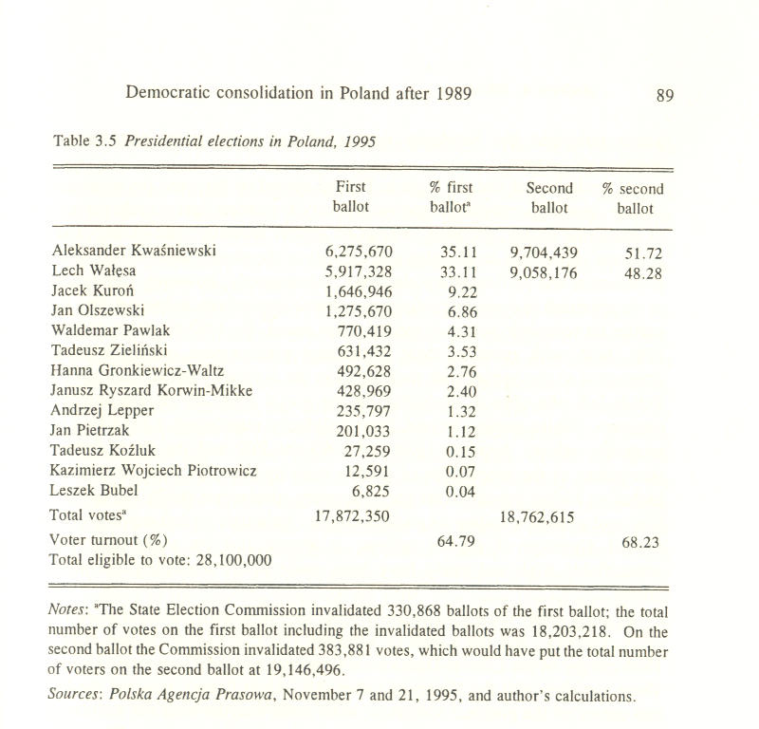
In early 1996 the strongest parties of the Polish party system were the DLA, the PPP, and the Union of Freedom (UF), the latter created after a 1994 merger of the Liberal-Democratic Congress and the Democratic Union. These together with the Union of Labor (UL, Unia Pracy), covered the left and center of the political spectrum, with some overlap with the Solidarity Trade Union, the principal labor organization in the country. The right remained fragmented into a number of small parties which drew on religion, national tradition, and radical market reform ideas for their political programs; parties with a strong populist appeal, such as the Confederation for an Independent Poland (CIP, Konfederacja Polski Niepodleglej) and the Center Alliance (CA, Porozumienie Centrum) also commanded a small support base.

Democratic Left Alliance (DLA)
The composition of the DLA reflects the party's roots. The DLA was created as a broad coalition of left-wing forces organizing for the 1993 parliamentary elections, but it has its roots in the January 1990 breakup of the Polish United Workers' Party (PUWP) into two competing organizations, the Social Democracy of the Republic of Poland (SDRP, Socjaldemokracja Rzeczpospolitej Polskiej) led by Aleksander Kwasniewski, and the Social Democratic Union of the Republic of Poland (SDURP, Unia Socjaldemokratyczna Rzeczpospolitej Polskiej), led by Tadeusz Fiszbach. The DLA became an umbrella coalition of all the forces associated with the former communist establishment. Under Kwasniewski's leadership, the SDRP has become a dominant voice within the DLA, which also includes the former official National Alliance of Trade Unions, (NATU, or Ogolnopolskie Porozumienie Zwiazkow Zawodowych) and some two dozen other groups and organizations. The SDRP membership is estimated at 65,000.
The DLA program supports the system of parliamentary democracy, the rule of law, local and employee self-government, and the rights of minorities. It emphasizes the separation of church and state. From the start Kwasniewski focused his efforts on building a party with a Social-Democratic image among the population. The DLA has attacked the excesses of market privatization, but did not repudiate the reform itself. It became a voice against the growing involvement of the Catholic Church in national politics. In contrast to the PPP, the DLA is a relatively loose coalition of often competing groups. The liberal pro-market policy line propounded by Kwasniewski is strongly opposed by the older hard-line communists who demand the restoration of state subsidies and the slowing down of market reform. That faction within DLA, led after 1993 by Labor Minister Leszek Miller, is closer in spirit (if not policy) to the core electorate of the PPP. The more liberal elements of the DLA, led by Kwasniewski, look to the UF as their potential coalition partner.

Polish Peasant Party (PPP)
The PPP is unique among the Polish parties in that it represents a relatively uniform constituency with a clearly articulated set of political interests. The peasants want agricultural subsidies, subsidized credits, and the protection of Poland's agricultural market.⁴⁰ With an estimated membership of 170,000 (some earlier estimates placed it even at close to 500,000), the PPP has succeeded in making the transition from the communist-era UPP.
In 1990 the Polish Peasant Party - "Renewal" (the successor to UPP) merged with the Polish Peasant Party "Wilanow," reestablished in 1989 to continue the traditions of the prewar peasant movement, and with elements of the peasant "Solidarity" movement.⁴¹ The PPP's "neo-agrarian" program emphasizes agriculture as a critical branch of the national economy and demands that the government guarantee an "equitable exchange" between the cities and the countryside.⁴² In practice, the PPP has pushed vigorously for government subsidies and protective tariffs. Under the leadership of young Waldemar Pawlak, the PPP became a key player in Polish politics after 1993 by entering a coalition with the DLA and claiming the premiership for the party's chairman from 1993 until his ouster engineered by President Walesa in early 1995.
Although it presents a unified front, the PPP is internally divided between two factions representing on the one hand the interests of big agricultural producers and food-processing companies, and on the other hand the small farmers and agricultural laborers. The division has broader national implications, as it forces the peasants to confront the question of the terms on which Polish agriculture has to become consolidated if in the future the country is to join the European Union.

Union of Freedom (UF)
The UF became the largest opposition party in the Polish parliament after the 1993 election. It was created in April 1994 through a merger of the Democratic Union (DU, Unia Demokratyczna), led since his failed 1990 presidential campaign by Tadeusz Mazowiecki, and the Liberal-Democratic Congress (LDC, Kongres Liberalno-Demokratyczny), led by Donald Tusk. In 1993 the LDC found itself outside the parliament, while the DU's position in the Sejm imploded. The UF, which has about 17,000 members drawn mostly from the Solidarity movement has remained divided between a center-left faction, led by Jacek Kurori, and a center-right faction, led by Mazowiecki, Hanna Suchocka, and Jan Rokita. An attempt at healing the rift within the party was made in the spring of 1995 with the selection of Leszek Balcerowicz, the founding father of Polish economic reform, as the party's new chairman in place of Mazowiecki. However, the subsequent fight over the selection of Kuron as the party's presidential candidate deepened the internal divisions within the UF. In 1996 the UF remained the best known and largest opposition party, counting among its membership some of the best known Polish intellectuals.

Union of Labor (UL)
The Union of Labor (UL), led by Ryszard Bugaj, is a left-wing party close in its program to the DLA but without the baggage of communist past. It was established in 1992 by a merger of a number of left-wing groups. It has advocated state intervention in the economy, has criticized privatization, and has demanded continued state protection of large enterprises. The UL political program draws upon the cooperative movement traditions of the Polish left. It emphasizes the redistributive role of the income tax code as a means to limit social inequalities. The party opposes the involvement of the church in Polish politics. The UL as a minority center-socialist party has asserted its role as a swing voter in the 1993 parliament.

Solidarity Trade Union
Solidarity, led by young and charismatic Marian Krzaklewski, has been transformed over the last six years into an organization fiercely committed to the defense of the class interests of the workers. It has demanded government support for the state enterprises and has frequently attacked privatization.

Right-wing parties
The right in Poland is weak and fragmented. Right wing parties seem riven by battles over personalities, and are often described as "sofa parties" in an unflattering suggestion that for some their entire membership would fit on a couch in the leader's living room. Attempts at unity, such as the church-sponsored "Convent of St. Katherine" have so far failed. The Concord for Poland (CfP, Przymierze dla Polski) that had brought together in 1993 the Center Alliance (CA, Porozumienie Centrum), the Conservative Coalition (CC, Konserwatywna Koalicja), Movement for the Republic (MfR, Ruch dla Rzeczpospolitej), PPP-Peasant Alliance (PPP-PA, PSL-Porozumienie Ludowe), and the Christian National Union (CNU, Zjednoczenie Chrzescijansko-Narodowe) disintegrated within months after the election. The same fate befell the "Coalition of November 11" (Koalicja 11 Listopada) that consisted of the Union of Real Politics (URP, Unia Polityki Realnej), the Christian Democratic Party (CDP, Partia Chrzescijanskich Demokratow), the Conservative Party (CP, Partia Konserwatywna), the Christian Peasant Party (CPP, Stronnictwo Ludowo-Chrzescijafiskie), and the National Democratic Party (NDP, Stronnictwo Narodowo-Demokratyczne), which even failed to compete in the 1993 election as a group.⁴³ The Christian-National Union (CNU, Zjednoczenie Chrzescijansko-Narodowe), founded in 1989 after a merger between the political clubs Order and Freedom (Klub Polityczny "Lad i Wolnosc") and Order and Solidarity (Klub Polityczny "Lad i Solidarnosc"), is probably the closest Poland has to a proto-Christian Democratic party. The CNU's electorate is drawn from among Catholics who emphasize moral issues, such as abortion or teaching catechism in schools over other issues.⁴⁴

Populist parties
Poland also has parties that propound a radical populist agenda. The Confederation for an Independent Poland (CIP, Konfederacja Polski Niepodleglej), founded in 1979 by Leszek Moczulski is the oldest political party with roots in the dissident movement and a radical populist appeal and ties to the traditions of the prewar left. The CIP, whose membership is less than 15,000, declares itself to be a successor to the legacy of Jozef Piisudski, the founding father and leader of the interwar Second Republic. The CIP and the Center Alliance (CA, Porozumienie Centrum), led by Jaroslaw Kaczynski, stand apart from the rest of the right in that although they recognize the importance of the Catholic Church in Polish politics, they do not make Christian moral issues and values critical to their programs and they maintain some distance from the church hierarchy. The Center Alliance has roots in the Solidarity faction that supported Lech Walesa against Tadeusz Mazowiecki during the 1990 presidential election, but it did not work with the president afterwards. A different sort of populism is represented by the Non-party Bloc in Support of Reform (NPBSR, Bezpartyjny Blok Wspierania Reform), Walesa's proto-party set up on the eve on the 1993 election and represented in the 1993 parliament. After Walesa's loss to Kwasniewski in the 1995 presidential election, the NPBSR has remained the voice for Walesa's camp in the legislature. It has harkened back to the interwar Non-party Bloc in Cooperation with the Government, as it has sought to appeal to the segment of the electorate most frustrated with the existing political parties.

Party support
Support for political parties in Poland after 1989 has remained fragmented, especially for parties with roots in the Solidarity ethos, but there are signs that the party system has matured. In the 1991 election none of the political parties got more than 13 percent of popular vote; in the 1993 election none got more than 20 percent of the popular vote. However, polling data obtained on the eve of the election by the OBOP showed that five parties had more supporters than opponents, an indication that these parties were consolidating their support base.⁴⁵
A June 1995 poll by the CBOS showed that the greatest level of support among the electorate was still enjoyed by the DLA (21 percent), which far exceeded support for the PPP (13 percent), Solidarity (13 percent), the UF (11 percent), the UL (10 percent), the right-wing parties not represented in the parliament (10 percent), the NPBSR (5 percent) and the CIP (4 percent).⁴⁶
The level of support for different political parties in Poland appears to have stabilized. Polls conducted in 1995 show that fluctuations in the size of support for a given party remain well within the margin of error. The PPP clearly dominates the Polish countryside as the party representing the peasant interests. The DLA has the greatest support in small and medium-size cities (between 20,000-100,000 inhabitants), while in the largest cities (200,000 and up) the DLA competes for support against Solidarity, the UF, and the UL.
The cleavages cut across different educational levels, with college educated Poles supporting mainly either the DLA or the UF, high school graduates supporting the DLA, and those with elementary education supporting the PPP and the Solidarity Trade Union. In terms of income disparity, supporters of the UF and the DLA declare the highest levels of income, while the PPP electorate is drawn predominantly from among those declaring the lowest income levels.⁴⁷
Polling conducted in 1995 by the CBOS suggests that the process of party consolidation in Poland is moving in two general directions, reflecting the overall polarization of the electorate between those who support (1) the "independence" parties and those who choose (2) the "social justice" parties (table 3.6). The polling data suggests that in 1995 the majority of the support base for the NPBSR, the UF, and of the right-wing parties unrepresented in the parliament came from among those in Polish society who considered freedom as the highest value. On the other hand, the supporters of the UL, the CIP, the Solidarity Trade Union, and the PPP considered social justice as their most important value, with the UL commanding the most radically pro-socialist segment of society, and the PPP and Solidarity being overall the most radical among them.
The most interesting result of the 1995 poll was the support base of the DLA, whose electorate, while it still chose in greater numbers social justice over freedom, nevertheless also placed freedom at the top of its values.⁴⁸ The data on the DLA electorate suggest that while in 1995 the DLA was identified with the left it also appealed to a large segment of the centrist vote. In general, with the exception of the UL and the CIP, freedom was the organizing principle for political parties with their roots in the former anti-communist opposition, while the issue of social justice was the organizing principle of the Polish left whose electorate included the former communists as well as those responding to the growing social stratification; on this score, the DLA found itself alongside the Solidarity Trade Union. The 1995 polling of voter party identification suggests that egalitarian socialist values have been internalized by Polish society to a much greater extent than the anti-communist opposition believed and that those have become an integral part of the party consolidation process.

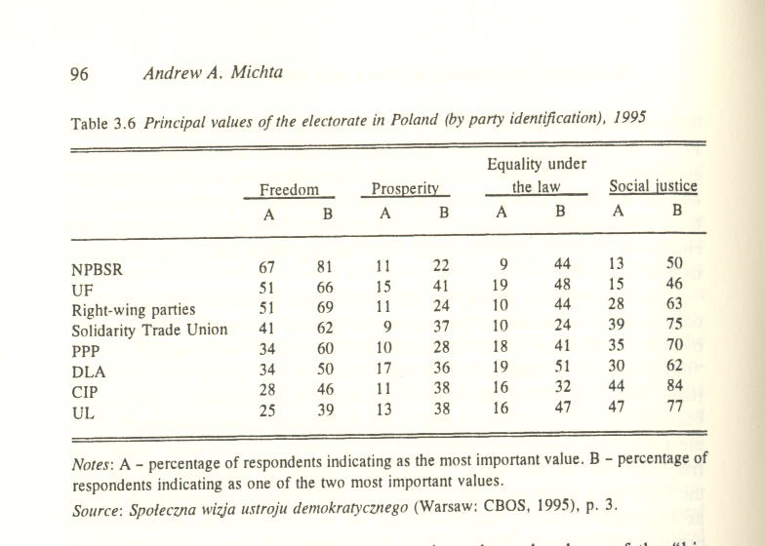

Public attitudes toward democracy
In 1996 Polish transition to democracy remained a work in progress, but there were encouraging signs suggesting that democratic consolidation was taking place and that Polish civil society was maturing. There were still questions about the ultimate staying power of the current political parties, especially on the right, as well as uncertainty about the shape of the "big constitution," but overall the Poles seemed to have accepted democracy as a preferred political system. In 1995 Polish media commentators often remarked that while generally the society was familiar with democratic rules and procedures, it also lacked democratic experience.⁴⁹ In addition, a generational gap appeared to have opened between those who had experienced both the communist system and Solidarity as their formative political experience, and the generation that matured after 1989. While the economic transformation in Poland has been widely accepted by the majority of young people, the experience of the six years of transition has generated considerable alienation from politics among the young. However, according to a CBOS study published in June 1995, the majority of the Polish youth rejected politics not because it considered the system deficient, but because it did not understand it.⁵⁰ The results obtained were disturbing in one respect, however, in that in contrast to the Solidarity generation, the young respondents expressed no objection to replacing democracy with a competent autocrat. According to the poll, 76 percent of the young agreed with the statement: "It would be better if instead of political parties Poland were governed by a decisive and competent man," while 77 percent agreed with the statement that "a bit of dictatorship would not harm anyone," and that "some strong hand should take charge of the bureaucrats and those arguing political parties."⁵¹
The views of the Polish youth, however, constituted a minority position. In 1995 there was a clear generational cleavage in Poland on the issue of democracy versus authoritarianism. While there was also some support for the "government of the strong-hand" among the retirees, these views were more than offset by the majority public opinion in the country. Close to 75 percent of Polish society regarded transition to democracy over the last six years as a positive change. The majority identified democracy with human freedom and new possibilities for individual and social growth, even if it bemoaned the unruly character of the Polish political scene. Moreover, the percentage of those who supported democracy as the best political system for the country had slightly increased over the 1994-95 period. The overall number of those who considered democracy superior to all other forms of government grew from 52 percent in 1992 to 62 percent in 1993 to 67 percent in 1995.⁵²
The overall level of education seems to constitute another cleavage between those who have favored democracy and those who would support authoritarian solutions: the lower the education level the greater the preference for a "strongman" to solve Poland's problems. Interestingly, in 1995 the greatest level of support for democracy and the most powerful rejection of authoritarian solutions was represented not only among the electorate of the UF (69 percent for democracy and 23 percent for authoritarianism) but also among voters for the DLA, which comes in second (65 percent for democracy and 27 for authoritarianism) (table 3.7).⁵³
Support for democracy in Poland has coexisted with a strong sense of frustration with the actual workings of the system. In the 1993 polls 50 percent of the respondents rejected the current political and media elites for failing to speak to their concerns, but they also accepted the general principles of democracy. Asked to identify "us vs. them," the respondents did note include anyone connected to the government, the presidency, or the parliament in the "us" category.⁵⁴ The polls showed that while the majority expressed acceptance of the principles of democratic government in the abstract, they remained disenchanted by the practical experience of democracy, especially the ineffectiveness and incompetence of the elites. While the Poles continue to view democracy as "historically legitimate," the growing popular frustration seems to have focused on the perceived irresponsiveness of the political process. However, the overall popular dissatisfaction with the practice of democracy ought to be weighed against the apparent rising appreciation of democratic values in Polish society and the fact that the Poles associate democracy with successful economic reform.⁵⁵ Although in the polls conducted in 1995 the respondents chose most frequently social justice as an important value, they also placed the greatest emphasis on individual freedom; equality under the law and prosperity come a distant second (table 3.8). The choice of either of the two principal values indicated by the 1995 polls seems to reflect the new class cleavages in Poland, whereby freedom was most often selected by businessmen, professionals, members of intelligentsia, managers, and students while social justice dominated the preferences of the workers, employees of the state sector, the unemployed and those among the professional classes who identified their political orientation as left-wing.

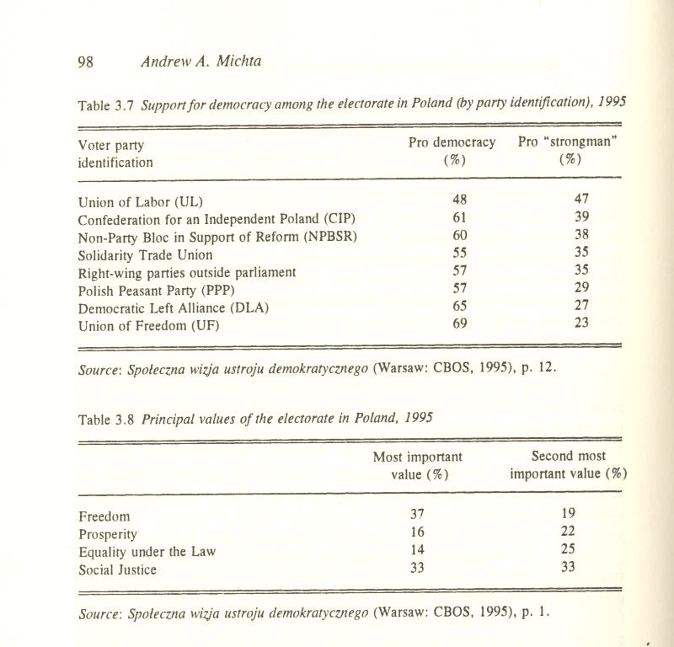

In general in 1995 the higher income levels opted for freedom, while those at the bottom of the social ladder identified social justice as their principal concern. Another interesting result of the 1995 CBOS polling was a pronounced difference in values between Polish men and women, which seemed to cut across the class divide. In contrast to men, who generally chose freedom as the most important value, the majority of women selected social justice as their principal concern, suggesting that women might have felt discriminated against in the new economic order and were therefore more sensitive to the issue of income disparity. The relatively low recognition of the importance of equality under the law, as well as the fact that those who chose it as an important value in the 1995 polls tended to come from among university graduates, suggests that Polish society as a whole still had a relatively low awareness of the importance of law in a democratic society.

Civil society and the media
There are signs that civil society has taken hold in Poland since 1989, as evidenced by the proliferation of nongovernmental organizations and grass-roots activism. The American Committee of Aid to Poland and the Civicus organization estimated in 1995 that since 1988 there might be close to 20,000 nongovernmental organizations operating in Poland. These included political, professional, cultural, ecological, and single-issue groups and associations, women's groups, think tanks, and student organizations.⁵⁶ In addition to the Catholic Church which operated shelters for the homeless, soup kitchens, and the like, a number of small voluntary charities worked closely with the Church and local welfare offices. In 1995 Poland had four national interbranch industrial unions; in addition, there were seventeen major independent industrial branch unions and three agricultural unions. Poland's 2.1 million peasants and agricultural workers were organized in a number of local and regional associations and cooperatives.
Overall, there were over 200 national unions registered in Poland in 1995, the largest among them being the Solidarity Trade Union, the successor to the original "Solidarity" movement, which claimed over two million members, and the National Alliance of Trade Unions (NATU), the successor to the communist-era official trade union, whose membership was estimated at approximately three million. Estimates of union participation in Poland in 1995 ranged from 30 to 40 percent of the country's twenty-one million workers, although the rate of unionization was low in the rapidly growing private sector.
Another area of considerable progress toward democratic consolidation in Poland has been the explosive growth of the free press and broadcast media. In 1990 the Solidarity government abolished censorship and eliminated the state-controlled press distribution network RSW "Prasa Ksiazka Ruch." In December 1991 a new broadcasting law terminated the state's monopoly on radio and television broadcasting. By 1996 Poland had both public sector broadcast media in the form of public radio and television and a rapidly growing network of private and public television stations. The law limited to 33 percent foreign capital in the private radio and television stations.
Privatization has been especially successful in the broadcast media at the local level. Reportedly, in 1995 65 percent of local radio stations in Poland were in private hands, as opposed to only 15 percent of national radio stations. Private ownership of local television stations stood at 25 percent, while only 15 percent accounted for privately owned national broadcasters. The question of licensing private commercial television stations has remained a hotly debated issue.
The print media in Poland have been quickly transformed by the market forces by drawing its resources from advertising fees. In 1995 it was estimated that foreign stakes in all national publications stood at 56 percent and 50 percent in regional ones. German publishers were the greatest shareholders in the Polish press with 18 percent of national and provincial titles. In 1995 almost all of Poland's print publications were privately owned, with a substantial foreign capital stake in them. The newspapers editorial policies ran the entire political gamut from left to right, reflecting the diversity of Polish politics. In 1995 the overwhelming majority of the Poles (82 percent) believed that freedom of the press was the best guarantor of continued political pluralism.⁵⁷
Broadcasting in Poland has been controlled since March 1993 by the National Broadcasting Council consisting of nine members are nominated by the Sejm, the Senate, and the president, the latter also appointing its chairman. Although nominally independent of the government, the Council has been subject to political pressure, as reflected in the 1993 media law which stipulated that radio and television programs should respect Christian values.

Economic transformation
In 1990 and 1991 the Polish government implemented an economic stabili-zation program developed with the assistance from Western economists and the International Monetary Fund (IMF). Introduced on January 1, 1990, the so-called "Balcerowicz Plan" named after the country's finance minister Leszek Balcerowicz, concentrated on fighting hyperinflation, making the Polish zloty convertible, and beginning the process of privatizing the economy. In January 1990 Warsaw freed prices, imposed taxes on excess wages at state enterprises, and all but eliminated government subsidies; by the end of 1991 the subsidies constituted less than 5 percent of the government's budget.
The Balcerowicz program has been a success. The inflation rate went down from 585.8 percent in 1990 to 27 percent in 1995. Today, the Polish zloty is fully convertible internally, with an exchange rate reflecting the currency's real value against principal Western currencies. The transition to the convertible zloty was achieved without the government having to draw upon the $1 billion currency stabilization fund set aside by the International Monetary Fund. The Balcerowicz program also contributed to the revitalization of Polish trade with the West. Already in 1990 Poland achieved a surplus from its convertible currencies exports.⁵⁸
Since the implementation of the Balcerowicz plan, the private sector doubled from 28.6 percent of the GDP in 1989 to 56 percent of the GDP in 1994. In 1992 Poland reversed the decline of the GDP when it posted a 2.6 percent growth; in 1994 and 1995 Poland posted 5.0 percent and 5.5 percent GDP grown rates, respectively, making it the fasted growing economy in Europe. In 1991 the Warsaw Stock Exchange was reopened; by 1994 it listed 44 companies, up from 9 in 1991 (table 3.9).
In 1990 the Polish government passed a Privatization Law to augment small-scale privatization initiated early in the Balcerowicz program. The new law resulted by the end of 1993 in the transfer of over 2,000 enterprises directly to private ownership, which amounted to about 25 percent of the 8,841 enterprises held by the government in July 1990; an additional 6 percent were transformed in to treasury-owned joint-stock companies. In 1994 an additional 321 enterprises were privatized and 244 were "commercialized," that is, converted into joint-stock companies with limited workers' council's influence; this raised the number of privatized enterprises to 29 percent of the total and the number of commercialized enterprises to 9 percent. In February 1995 Poland finally launched a voucher mass privatization program, with the selection of the management for 15 National Investment Funds; in July-October 1995, 413 enterprises were allocated to the Funds, with an additional 106 enterprises added by the end of 1995.⁵⁹ In July 1995 Poland passed a new Privatization Law, which emphasized commercialization, transferred authority away from the Ministry of Privatization to other ministries, and required parliamentary approval for sales firms in strategic sectors. Poland also liberalized its foreign trade by suspending or sharply reducing most tariffs and non-tariff barriers, and by ending the state monopoly on foreign trade. In January 1995 the average tariff on industrial goods went down to 9.3 percent and the import surcharge was reduced to 5 percent. In May 1995 Poland converted quantitative restrictions on agricultural imports into tariffs, as stipulated by the GATT Uruguay Round; in July 1995 it joined the WTO.⁶⁰
The country's banking system was reformed by transforming the branches of nine regional departments of the Polish National Bank (NBP - Narodowy Bank Polski) into independent commercial banks. In 1993 two of the nine large state-owned commercial banks were privatized. All commercial banks have been licensed and supervised by the NBP.
As Poland entered 1996 some big economic issues remained to be addressed, especially in the area of a badly needed reform of the social security system and in the inefficient farming sector. Since 1989 the country has also needed substantial investment to improve its telecommunications and roads, including the planned construction of an expressway network. Unemployment has remained high, reaching 16 percent in 1994.

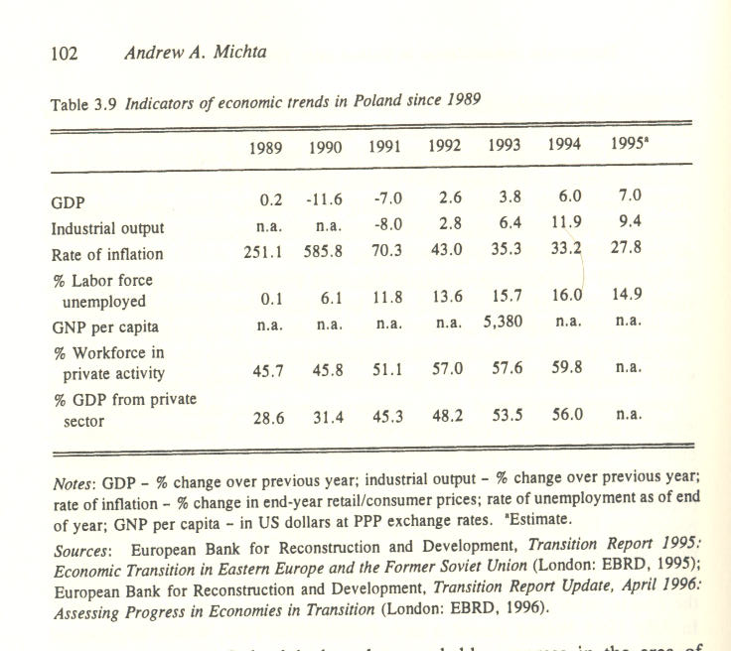

Overall, however, by 1996 Poland had made remarkable progress in the area of economic reform, especially when one remembers how deep was the economic crisis of the 1980s.

Democratic consolidation in progress
Successful democratization requires a mechanism that ensures the accountability and responsibility of those in power and political participation of the people. Democratization means in effect the establishment and consolidation of democratic and representative institutions that foster competition, participation, and civil and political liberties.⁶¹ A democratic constitutional legal framework, competitive elections, and political parties are essential steps in establishing democracy. Political participation within the institutional framework is a necessary precondition for democratic consolidation, for it brings the state and the civil society into the process. It is encouraged by economic stability and a popular sense that the system favors the economic welfare of the citizenry.
Compared to the majority of postcommunist states, the Polish transition to democracy has been a success. The chaotic, even anarchic, nature of Polish politics notwithstanding, Poland has introduced democratic institutions and has continued economic reform despite social pressures generated by the Balcerowicz plan. The political parties have undergone a degree of consolida-tion at the level of parliamentary representation. Although "historically legitimate," democracy is still viewed by the Poles as something of an abstraction, but it is also a system preferred by the majority of the population. The long-term success of democratization in Poland will depend on the consolidation and maturation of the party system, and on the cumulative experience of the practice of democratic government. The process of consolidation will take time. However, inasmuch as the emergence of political parties is the function of the emergence of class and group interests, the extent to which Poland has succeeded in its transition to a market economy bodes well for that process.
The DLA's rise in particular raises an intriguing question about its future in relation to the UF, the largest post-Solidarity party in the parliament after the 1993 election. In 1995 and early 1996 both the DLA and the UF included a substantial centrist element, with the DLA also relying on the postcommunist left and the UF on post-Solidarity right for some of their support base. The recurrent discussion in Polish media on the possibility of a coalition between the DLA and the UF, albeit discounted publicly by both parties, suggests that Poland appears to have today two political parties that draw a substantial portion of their support from a Social-Democratic constituency. The issue of the rise and consolidation of Polish civil society is a more complex question. One can appreciate the extent of change in Polish politics better when treating 1980-81 as the beginning of the breakdown of communist power. It is true that instead of working directly to bring down the communist state, the alliance of Solidarity served to marginalize it and in the process developed a nascent civil society. However, the experience of opposition may not in itself be sufficient to consolidate that civil society to the extent required by democracy.⁶² Could it be that while it instilled in the population the values of civil society, the legacy of vigorous and determined dissident movement in Poland could itself be a contributing factor to the fragmentation and personalization of politics on the right of the spectrum? If that has been the case, the proliferation of nongovernmental organizations and grass-root activities may prove more important than ever to the consolidation of Polish civil society.
From the vantage point of the last six years of Polish reform it appears that the simultaneous implementation of economic and political reforms in postcommunist states can be sustained, but it involves trade-offs. Polish political reform suffered on occasion, as the energy of four Solidarity governments focused on the country's desperate economic conditions; the delay in addressing the constitutional question is a case in point as are the lingering questions about the communist legacy. In the early years of postcommunist transition, economic reform took precedence over the need to consolidate the new democratic institutions. Nevertheless, during six years since the collapse of communism a succession of Polish governments implemented an economic austerity program without undermining the overall popular support for democracy.
Institutional changes in Polish politics since 1989 have been impressive. In the six years since the anticommunist revolution Poland introduced an interim constitution and witnessed the rise of political parties. On four occasions the country went through an orderly transition of political power: after the 1991 and 1993 parliamentary elections and the 1990 and 1995 presidential elections. In 1995 the post-Solidarity parties on the right were weaker than the DLA and the PPP, but the divisions among the principal organizations appeared progressively less a matter of personalities and more a question of political programs, suggesting that a more unified Polish right-wing would eventually emerge as well.
The consolidation of Polish democracy will also be influenced by the degree of Western support for the country's long-term foreign and security policy objectives. Poland needs to become integrated in the Western economic and security system to foster stability and a sense of confidence about the future, the latter especially important in light of the residual fear of Russia and the remaining divisions over the country's communist past. Throughout the postcommunist transformation, the goal of becoming integrated with the West, including the European Union and NATO expansion, has been ever-present in Polish politics.
In 1996 the Polish political scene remained polarized. In the immediate aftermath of the election of DLA's Aleksander Kwasniewski as the country's president one might have expected that the Poles would begin to come to terms with the legacy of communism; however, the 1996 resignation of Premier Jozef Oleksy, who was being investigated on charges of espionage for Russia, revisited the old questions and deepened political cleavages in Polish society. The experience of the practice of democracy had caused some disappointment and lowered popular expectations. And yet, the Poles appeared to have remained committed to the principles of pluralism, freedom of expression, and accountability of elected officials while they criticized their government, their president, and their parliament.⁶³

Acronyms of Polish political parties
CA Center Alliance (Porozumienie Centrum)
CC Conservative Coalition (Konserwatywna Koalicja)
CDP Christian Democratic Party (Partia Chrzescijanskich Demokratow)
CEA Catholic Election Action (Wyborcza Akcja Katolicka)
CfP Concord for Poland (Przymierze dla Polski)
CIP Confederation for an Independent Poland (Konfederacja Polski
Niepodleglej)
CNU Christian National Union (Zjednoczenie Chrzescijansko-
Narodowe)
CP Conservative Party (Partia Konserwatywna)
CPP Christian Peasant Party (Stonnictwo Ludowo-Chrzescijariskie)
DLA Democratic Left Alliance (Sojusz Lewicy Demokratycznej)
DU Democratic Union (Unia Demokratyczna)
LDC Liberal-Democratic Congress (Kongress Liberalno-
Demokratyczny)
NATU National Alliance of Trade Unions (Ogolnopolskie Porozumienie
Zwigzków Zawodowych)
NPBSU Non-Party Bloc in Support of Reform (Bezpartyjny Blok
Wspierania Reform)
PFBP Polish Friends of Beer Party (Polska Partia Przyjaciol Piwa)
PPP Polish Peasant Party (Polskie Stronnictwo Ludowe)
PPP-PA Polish Peasant Party-Peasant Alliance (PSL-Porozumienie
Ludowe)
SDRP Social Democracy of the Republic of Poland (Socjaldemokracja
Rzeczpospolitej Polskiej)
SDURP Social Democratic Union of the Republic of Poland (Unia Socjal-
demokratyczna Rzeczpospolitej Polskiej)
Solidarity Solidarity Trade Union (NSZZ "Solidarnosc")
UF Union of Freedom (Unia Wolnosci)
UL Union of Labor (Unia Pracy)
URP Union of Real Politics (Unia Polityki Realnej)

Notes

1 Data for 1993 from Transition Report 1995: Economic Transition in Eastern Europe and the Former Soviet Union (London: EBRD, 1995) and The Europa World Year Book 1995 (London: Europa Publications Ltd., 1995).
2 See Sarah Meiklejohn Terry, "Thinking about Post-communist Transitions: How Different are They?" Slavic Review 53, no. 2 (Summer 1993).
3 Spoleczna wizja ustroju demokratycznego (Warsaw: Centrum Badania Opinii Spolecznej, 1995), p. 18.
4 Toranska in her book Them gives a striking testimony to the endurance of the "us the people vs. them the state" paradigm in Polish politics through the communist era. It remains important in the present-day process through which the Polish political system is being consolidated. See Teresa Toranska, Them: Stalin's Polish Puppets (New York: Harper & Row, 1987).
5 It is interesting to note that among the greatest national heroes one finds Polonized ethnic Lithuanians, Ukrainians, or Ruthenians. The Polish national epic Pan Tadeusz by Adam Mickiewicz opens with the words "Lithuania, my country."
6 The other major ethnic groups in interwar Poland were West Ukrainian (14%), Jews (10%), Byelorussian (3.7%) and German (3.7%). See Roy E. H. Mellor, Eastern Europe: A Geography of the Comecon Countries (New York: Columbia University Press, 1975).
7 For a good discussion of culture and ethnicity as constitutive elements of the concept of nationalism in Eastern and Central Europe, see Juliana Geran Pilon, The Bloody Flag: Post Communist Nationalism in Eastern Europe (New Brunswick and London: Transaction Publishers, 1992).
8 Jacek Mojkowski, "Dwa buty na lewa noge: Rzad kontra 'Solidarnoscy bitwa o wlasnosd i budzet," Polityka, 10 June 1995.
9 Norman Davies, God's Playground: A History of Poland (New York: Columbia University Press, 1984), pp. 625-33.
10 See: Jacek Wasilewski i Wlodzimierz Wesolowski, Poczatkiparlamentarnej elity: Poslowie kontraktowego sejmu (Warszawa: Instytut Filozofii i Socjologii PAN, 1992).
11 RFE/RL Daily Report, 11 December 1990.
12 Informator o partiach politycznych w Polsce (Warsaw: Polska Agencja Infor-macyjna, October 1991). In addition to the more established groups, the parties included such bizarre organizations as the Party of the Owners of Video Cassette Recorders "V" (Partia "V" Posiadaczy Magnetowidow), the Polish Erotic Party (Polska Partia Erotyczna), or the Polish Friends of Beer Party (Polska Partia Przyjaciol Piwa).
13 "Wybory 91: Scena po pierwszym starciu," Zycie Warszawy, 20-21 July 1991.
14 Ray Taras, "Voters, Parties, and Leaders," in Transition to Democracy in Poland, ed. Richard F. Staar (New York: St. Martin's Press, 1993), p. 26.
15 "Ustawa z dnia 28 czerwca 1991: Ordynacja wyborcza do Sejmu Rzeczypospolitej Polskiej," Dziennik UstawRzeczpospolitejPolskiej no. 59 (Warsaw, 1991). The age eligibility requirements were retained unchanged in the 1993 revision of the law.
16 RFE/RL Daily Report, 28 October 1991.
17 RFE/RL Daily Report, 4 November 1991.
18 "Ze starego do nowego Sejmu," Rzeczpospolita, 6 November 1991.
19 "Polska geografia polityczna: Kto gdzie wygral?" Gazeta Wyborcza, 1 November 1991.
20 RFE/RL Daily Report, 31 October 1991.
21 According to Bronistaw Geremek, the floor leader of the Democratic Union, ideological polarization on issues such as abortion virtually precluded a majority vote on key civil rights issues. Conversation with author, Warsaw, 25 May 1992.
22 "Ustawa z dnia 28 maja 1993: Ordynacja wyborcza do Sejmu Rzeczpospolitej Polskiej," Dziennik Ustaw Rzeczpospolitej Polskiej, no. 45, 2 June 1993 (Warsaw). On electoral laws, see Stephen Holmes, "Designing Electoral Regimes," East European Constitutional Review 3, no. 2 (Spring 1994). Also see Louisa Vinton, "Poland's New Election Law: Fewer Parties, Same Impasse?" RFE/RL Research Reports 2, no. 28 (9 July 1993).
23 For a detailed discussion of the 1993 election results see: Louisa Vinton, "Poland Goes Left," RFE/RL Research Report 2, no. 40 (8 October 1993).
24 The Europa World Year Book 1995, p. 2,492.
25 Aktualne problemy i wydarzenia: Czerwiec 1995 (Warsaw: CBOS, 1995).
26 "Polacy niezadowoleni z rozwoju demokracji," Rzeczpospolita, 19 December 1991.
27 On 19 December 1991, Walesa sent a letter to the Speaker of the Parliament Wiestaw Chrzanowski withdrawing his draft proposal for the "Little Constitution." See: "Prezydent wycofuje projekt malej konstytucji," Rzeczpospolita, 20 December 1991.
28 Stanislaw Podemski, "'Mala Konstytucja:' Koslawa szachownica," Polityka, 14 December 1991.
29 "Kariera szefa sztabu," Gazeta Wyborcza, 6 February 1995.
30 "Nowe kroki prezydenta," Zycie Warszawy, 31 January 1995.
31 Piotr Zaremba, "He realnej wladzy dla glowy panstwa," Zycie Warszawy, 13 June 1995.
32 See "Niemoralna konstytucja," Gazeta Wyborcza, 19 June 1995.
33 Already in 1993 Bronislaw Geremek, a member of the Constitutional Commission, expressed doubt whether a new constitution would ever be passed in light of the intensity of ideological divisions on moral and ethical issues. Conversation with the author, June, 1993, Warsaw.
34 OMRI Daily Digest, 23 October 1995.
35 OMRI Daily Digest, 6 November 1995.
36 OMRI Daily Digest, 7 November 1995.
37 OMRI Daily Digest, 9 November 1995.
38 OMRI Daily Digest, 21 November 1995.
39 "Wybory prezydenckie przed Sadem Najwyzszym: Wazne albo niewazne," Gazeta Wyborcza, 9-10 December 1995.
40 Polskie Stronnictwo Ludowe: Program rozwoju wsi i rolnictwa (Warsaw: Polish Peasant Party, 1992).
41 This section is based on "Political Parties in Poland," in Political Parties in Eastern Europe (RFE/RL, 10 February 1990), and Marek Burczyk, The Polish Political Scene (Warsaw: Ministerstwo Spraw Zagranicznych, 1995).
42 Polskie Stronnictwo Ludowe: Dokumenty programowe (Warsaw: Polish Peasant Party, 1993).
43 Arkadiusz Urban, "Perspektywy jednosci prawicy," Rzeczpospolita, 13 June 1995.
44 For a good discussion of the Polish right on the eve of the 1993 election, see Anna Sabat-Swidlicka, "The Polish Elections: The Church, the Right, and the Left," RFE/RL Research Reports 2, no. 40 (8 October 1993).
45 "OBOP o partiach: Za i przeciw," Gazeta Wyborcza, 23 June 1993.
46 Wybory parlamentarne: Potencjalne elektoraty w czerwcu '95 (Warsaw: Centrum Badania Opinii Spolecznej, 1995).
47 Ibid.
48 Spoleczna wizja ustroju demokratycznego, pp. 3-4.
49 Dariusz Fikus, "Demokracja jak trzcina," Rzeczpospolita, 22 May 1995.
50 "CBOS-pierwsze pokolenie III RP: Zagubieni w demokracji," Gazeta Wyborcza, 19 June 1995.

