9

Party politics and political participation
in post-communist Hungary
Rudolf L. Tökés

The fall of the old regimes in Eastern Europe in 1989-90 was a complex process which in some ways is still unexamined. With few exceptions, most Western postmortem accounts have tended to focus on small groups of visible political actors, founding elections, and the political institutions of the "new democracies." Data and interpretation of this kind, however valuable, have yet to explain the salience of personalities and events, such as the genesis of the new multiparty system, in a broader analytical framework of socioeconomic continuity and change in the affected countries. At issue are the "long-wave" processes of social mobility and restratification, value change, interest group politics, and macroeconomic transformation that helped define the social, ideological, and economic context of regime change in 1989-90.
It is axiomatic that the key components of post-communist politics - actors, institutions, and processes - are products not of an areawide democratic parthenogenesis but of antecedent factors. Of these, pre-communist traditions and the communist regimes' record of political mobilization, ideological indoctrination, social engineering, and institutional transformation were the most important. Therefore, assessments of post-communist politics ought to be informed of the combined legacy of "communist universals" (one-party system, patterns of ideological legitimation, command structure, planned economy, and the like) and of indigenous national policy precedents. ¹
The universals denote systemic similarities among individual units of the Soviet-led international system of ruling party-states. By national policy precedents one understands (with the notable Czech exception) a combination of pre-communist legacies of subject political culture, political decision making, particularly resource allocations, by small elites, and the paramount role of the state and its bureaucracy in public life. To a remarkable extent, these traditions were congruent with the East European communist regimes' goal of "building socialism" in countries under their immediate jurisdiction. Over four decades of communist rule national hybrids of the general and the particular have yielded widely different political outcomes, and, in the end, regime capabilities to cope with and, as and when possible, to adapt to the threat of political collapse in 1989.
In any case, adaptation by East European leaderships to the regional hegemon's political expectations helped foster an external image of close institutional resemblance to the Soviet model. However, beneath the bland facade of institutional sameness among states of "existing socialism" there were significant national variations with respect to resource allocation priorities, leadership styles, patterns of internal political and social conflict management, and strategies of legitimacy building.
The task at hand is to examine the nature of party politics and analyze the dynamics of political participation in Hungary since the fall of the old regime in the spring of 1990. A full and adequately documented discussion of these matters is not possible within the confines of a brief essay. Therefore, I shall endeavor to develop a general framework and, within it, a selective summary of the key issues stemming from the origins and the record of the first ten years (1986-95) of the Hungarian party system. I date the onset of multiparty politics at the entry in 1985-86 of independent, that is, not regime-endorsed, MPs into the Parliament. My case for the explication of these matters is derived from my understanding of the generic and unique characteristics of regime change in Hungary. Much of what follows rests on the proposition that the structure of Hungarian post-communist politics, including the party system and patterns of political participation, are products of a special kind of political transition from communism to parliamentary democracy in that Central European state.
The Hungarian transition scenario took its departure from the nation's "negotiated revolution."² By this I refer, as a critical explanatory variable, to a set of political agreements and understandings between the outgoing and incoming political elites that were concluded in 1989-90. The National Roundtable (NRT) negotiations of June-September 1989, the NRT Agreement of September 18, informal pacts between the new political forces and the incumbents, and the political agreement of May 1990 between the victor, the Hungarian Democratic Forum (HDF), and the runner-up Alliance of Free Democrats (AFD), of the March-April 1990 elections were the major road markers of this process.
The common objective of these agreements was to effect a qualitative change of political institutions and at the same time to preserve social peace and economic stability. The exclusion of the citizenry from the elites' negotiations, although conducive to the holding of confidential discussions between the "insurgents" and the "incumbents," made the outcome vulnerable to grassroots skepticism as to the legitimacy of the entire affair. It is too early to tell whether these elite pacts should be seen as genetic flaws or eventually corrigible birth defects with adverse short-term effects on the nature of post-communist politics.
Upon the surrender of its nomenklatura privileges in May 1989, the by-then only nominally ruling Hungarian Socialist Workers' Party (HSWP) ceased to be a source of coercive and state administrative power. Thanks to the combined efforts of the HSWP's reform wing under Imre Pozsgay, Miklos Németh, and Rezsö Nyers, and of the incumbent state bureaucracy under Prime Minister Németh, the old regime's collapse was peaceful. In fact, it was so peaceful that the entire process of transition from one type of political regime to another may be likened to a "leveraged buyout" kind of business transaction. The participants were the "incumbent management," that is, the Nemeth government, and the insurgent hitherto nonvoting "minority shareholders," that is, the eight constituent parties and social interest groups of the Opposition Roundtable (ORT). The desired outcome was common survival and political relegitimation by way of free elections in March-April 1990 and the installation of a parliamentary government in May of that year.
My emphasis on ex ante political agreements and generally on the consensual essence of the old regime's replacement by a coalition of freely elected democratic parties seeks to call attention to one of the several regionally unique characteristics of Hungary's political evolution during the Kádár era of 1956-89. As I have discussed it elsewhere, Hungary's forty-year-long journey from Stalinist dictatorship to multiparty democracy was shaped by system-wide political-military-economic-ideological imperatives and by the cumulative record of the Kádár regime's strategic policy decisions. ³
The systemic imperatives were driven by the national interests of the USSR. In Hungary's case these called for the political incumbents' compliance with Moscow's general political-ideological line on the "nature of the present epoch." In a Cold War context this included all key issues of East-West relations; Hungary's partial integration into Soviet-dominated security and trade organizations; and the embedding of Soviet-style laws, institutions, and policymaking processes as integral parts of the political system.
Hungary's forty-year-long experience with communist rule was marked by several watershed events and unique policy precedents. The most important of these were the 1956 revolution and its bloody suppression; Kádár's leadership style; the launching and subsequent implementation of the New Economic Mechanism (NEM) of 1968; patterns of semi-public and non-confrontational interaction between the regime and its liberal democratic, Populist, and socialist intelligentsia critics; and the negotiated transfer of power from Kádár's successors to the opposition in 1989-90.
The Hungarian regime's path between 1957 and 1990 was that of a strategic retreat - culminating in its negotiated surrender - from its politically, economically, and ideologically untenable original Stalinist positions. To survive as the national leader, Kádár chose to accommodate public aspirations for limited sovereignty, modest economic progress and, in the context of political-ideological demobilization, made provisions for the citizens' personal space under "existing socialism." Kádár also agreed to come to terms, by way of cooptation and selective marginalization, with the traditionally recalcitrant intellectuals. The remaining critical intellectuals - none of whom were jailed for political reasons after 1973 - were free (censorship and mild police harassment permitting) to have their say and thus became tolerated nay-sayers in the public arena. As will be shown below, these precedents had a decisive bearing on the form and substance of the party system and mass politics of post-communist Hungary.
To make my case, I propose a three-part argument on the origins of the post-communist party system, on party politics and political participation in 1990-94, and on the May-June 1994 elections and the consequent realignment of the Hungarian political spectrum.

Party system: origins, development, and social characteristics
The immediate origins of Hungary's post-communist party system coincided with the commencement of the NRT negotiations between the HSWP, member parties and groups of the ORT, and the "third side" of public organizations on June 14, 1989.⁴ This date was also the terminal point of an eight-year-long (1980-88) process of political succession in the HSWP. The dramatis personae of the succession process were the aging autarch János Kádár, his elderly associates in the HSWP's Politburo, leaders of the party's "successor generation," particularly Karóly Grósz, Imre Pozsgay, and János Berecz, and the clients of both sides among Hungary's political elites. The object of the protracted intraparty struggle for power was the replacement of Kádár and the long overdue reconstruction of the political system.

Political succession and protopluralism
An unintended but, for purposes of eventual partification of public life, vitally important consequence of contestation within the ruling party was the creation of political space for new political actors in the early 1980s. The process of institutional devolution, including the separation of the party and the state and the growing administrative autonomy of the latter, had begun
in the early 1970s. Much of this had been necessitated by the administrative imperatives of the regime's commitment to the consistent implementation of economic reforms. An important part of this process was the growing administrative autonomy of the regime's political auxiliaries, such as the Trade Union Federation (TUF), the Patriotic People's Front (PPF), and the Young Communist League (YCL). Other corporatist entities, such as those of Hungary's "red" and "green barons" of industry and agriculture and those of the technological-scientific establishment, particularly the Hungarian Academy of Sciences (HAS), were also parts of the political equation.
All "civil society"-type groups (much cherished by western political scientists as kernels of democracy in post-totalitarian states), such as "local heritage" clubs, amateur theater groups, and the like, functioned under the aegis of the PPF. With Cardinal Jozsef Mindszenty as an unwanted guest in the US Embassy until 1975, the Catholic Church, very much like the organizations of its Protestant brethren, were bureaucratic appendages of the state's Office for Religious Affairs. The state-approved hierarchy of both Christian churches saw to it that politically nonconformist clergymen, such as those promoting "basic communities" and lending moral support to conscientious objectors, were silenced and cut off from their flock. Neither the Vatican, nor the World Council of Churches objected. For both, the survival of the churches' organizational infrastructure took precedence over the parish priests' and ministers' spiritual autonomy and freedom of conscience.
By the early 1980s, the regime's policy lobbies began to function as protoparties within an increasingly pluralistic policy arena. Kadar's aspiring successors made use of the top nomenklatura elites' growing concerns about the HSWP's ability to keep the regime afloat and enlisted them to help unseat the incumbent leadership team of Kadar and his fellow gerontarchs in the Politburo and the Central Committee. At the May 1988 party conference this improbable alliance of younger party apparatchiki, policy lobbies, technocratic elites, and leaders of the provincial party organization prevailed and caused the removal of Kadar and several of his associates from the leadership.⁵
Kadar's successors - senior Politburo members Karoly Grosz as secretary general, and Janos Berecz, Imre Pozsgay, Miklós Németh, and Rezsö Nyers- tried to salvage what they could from the wreck of the old regime. In addition to the grave structural economic problems (the impact on living standards was marginal until the late 1980s) they inherited from Kadar, they also incurred several political IOUs to their political allies who had helped put them in power. Grosz and his colleagues finessed the issue by encouraging these groups to shed their bureaucratic image and become "social movements." As further incentive, these groups were offered enhanced consultative roles in political and economic decision making. However, these policy lobbies' political empowerment came too late to stem the tide of declining public confidence in the regime's social organizations.⁶
Evidence from the HSWP's archives and interviews with these party leaders indicate that from October 1988 on, Kadar's successors gave up on the idea of a one-party system and began preparations for the installation of a quasi-pluralistic political system in Hungary.⁷ As the reform communists envisaged it, regime-supervised large-scale admission of "social organizations" and citizen groups - including noncommunist parties - in the political arena would still leave the incumbents with sufficient resources to remain in control over the commanding heights of power.
This optimistic scenario broke down in the winter months of 1988-89. Imre Pozsgay's bombshell announcement in late January 1989 calling the 1956 revolution a "popular uprising" (rather than a "counterrevolution") created a political fait accompli. Pozsgay's courageous move was designed to preempt yet another Putsch, that is, the inauguration of a martial law regime by Karoly Grosz and a small group of fellow conservatives in the central apparat. Thanks to Pozsgay, the prudent internal security organs, and the military professionals, these preparations came to naught.⁸ Thus, under the circumstances the Grosz-controlled Central Committee had no choice but to confront the central legitimacy dilemma of the Kádar era. The party elites had to decide whether to resist or to endorse the regime's orderly devolution into a multiparty system. With the adoption of the latter option, the HSWP was committed to recognize, tolerate, and accept the newly emerging "historic" and "new" political parties as legitimate representatives of the nonparty majority of the Hungarian people. As a result, by the end of March 1989, a de facto multiparty system came into being.
In early June 1989, following a complex process of public and behind-the-scenes dialogue between the divided HSWP and the united opposition, an agreement on the initiation of formal discussions was reached. The designated venue was the NRT. It was a political artifact created by the HSWP's reform leaders to broker an agreement on the modalities of the old regime's peaceful liquidation by the incoming and the outgoing elites. Participants of the NRT process included the HSWP, member parties and organizations of the ORT, and, as the "third side," representatives of the regime's transmission-belt agencies that were labeled as "social organizations."

Political parties: "historic" and "new"
The ORT was established in March 1989 as an ad hoc group of seven "historic" and "new" political parties and two civil-society-type organizations.⁹ The historic parties were the Independent Smallholders' Party (ISP), the Hungarian Social Democratic Party (HSDP), the Hungarian People's Party (HPP), and the Christian Democratic People's Party (CDPP). The new parties were the HDF, the AFD, and the League of Young Democrats (LYD, or Fidesz). The social organizations were an originally PPF-sponsored intelligentsia reform club, the Endre Bajcsy-Zsilinszky Society (EBZS), and the white-collar Democratic Union of Scientific Workers (DUSW). The Independent Lawyers' Forum (ILF), a group of proreform legal experts was ORT's convener and expert advisor. The "third side" consisted of official representatives from the PPF, the TUF, the YLC, and five additional regime-sponsored official interest groups.
The labels - historic, new, and regime-sponsored - are convenient but misleading terms (the first refers to parties that had been in existence prior to the communist takeover in 1947-48) that do not explain the origins and the political salience of these party and partylike groups in the summer of 1989. For this reason, a brief overview of the origins and post-1945 track record of each of these clusters seems to be in order.¹⁰

Hungarian Social Democratic Party (HSDP)
The HSDP, the oldest of the historic parties, was founded in 1889. Between 1922 and 1944, when it was driven underground by German occupation, the HSDP was a small opposition party in the Hungarian Parliament. In 1948 the HSDP was coerced into merging with the communist party and for the next forty years it ceased to exist as an independent political actor. The party's revival in late 1988 was materially supported by Karoly Grosz, the HSWP's secretary general following Janos Kadar's exit from politics in May 1988. However, by 1989 the HSDP's traditional skilled blue-collar worker constituency had long disappeared: they either became part-time entrepre-neurs in the "second economy" (and ended up voting for the AFD in 1990), or remained loyal to the old regime (and voted for the HSP in 1990). In either case, after forty years of communist rule the HSDP's elderly leaders were left with few followers. By the end of that year the party split into several feuding factions, and upon failing to receive four percent of the votes cast at the 1990 elections, it faded into oblivion.¹¹

Independent Smallholders' Party (ISP)
The ISP, founded in the early 1920s and well represented in the Parliament prior to 1944, was another historic party. Unlike the HSDP, the ISP received 57 percent of votes cast at the first free postwar elections in November 1945 and was the largest political party. The ISP was also the principal victim of the communist party's "salami tactics." With its leaders driven to Western exile, or in jail, the party continued to exist through the persons of a few prominent fellow travelers. Although the ISP played an important role in Imre Nagy's coalition government in October-November 1956, its remaining leaders ended up in exile or in jail.
Unlike the HSDP, some of the ISP's natural constituency, that is, the small farmers and rural entrepreneurs of Hungary, survived, albeit mainly as members of forcibly collectivized farms throughout the Kadar era. However, rural Hungary had undergone radical social transformation between 1948 and 1989. From the late 1960s on, together with a new provincial proletariat, a new rural middle class of university - and college-trained experts, farm managers, and local professionals was born.¹² For the broader demographic context of this process, see table 4.1. Their interests had little in common with those of the ISP's traditional voters of the 1940s. Still, the ISP's "single-issue" platform, that is, the return of state-confiscated farming land to the former owners, had lost none of its salience in the preceding decades.

Christian Democratic People's Party (CDPP)
The CDPP's ideological forerunner was the Hungarian People's Party under the leadership of the prominent Catholic layman Istvan Barankovics. Together with the rest of the democratic parties, this party too was swept away in 1948. The CDPP's likely mass support was an open question in 1989. On the one hand, the martyrdom of the Barankovics party's spiritual leader, Cardinal Jozsef Mindszenty, was a factor to reckon with. On the other hand, the open collaboration of Mindszenty's pliant successors with the Kadar regime helped tarnish the Catholic Church's image as a champion of political freedom and human rights.

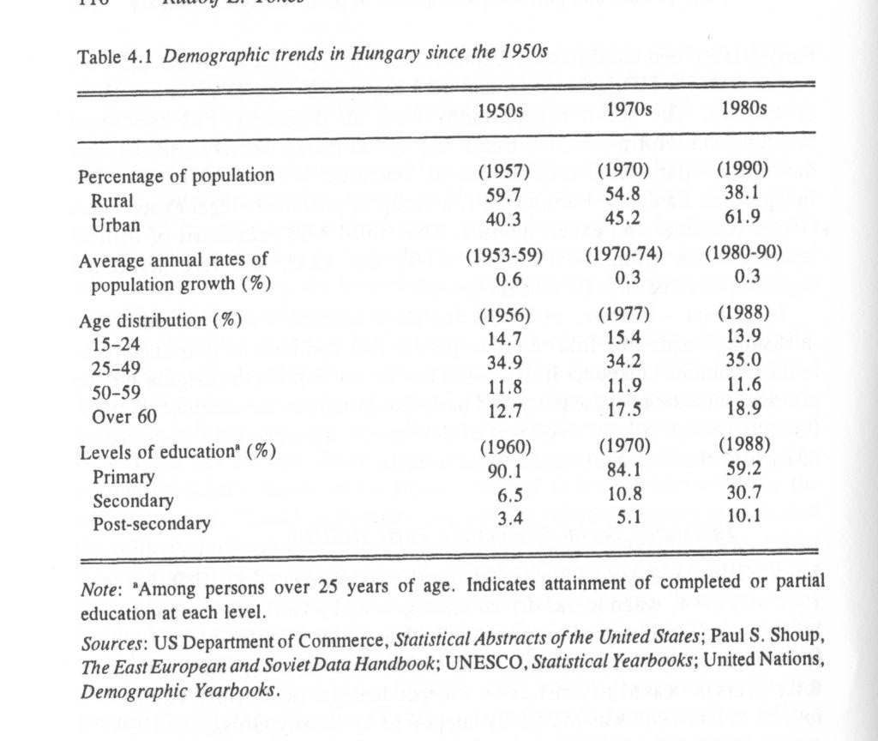

Hungarian People's Party (HPP)
The Hungarian People's Party's origins lay in the left radical Hungarian Peasants' Party of the immediate postwar (1945-48) period. With the notable exception of Imre Kovacs, who fled to the West in 1947, the rest of the HPP's leadership, particularly the writer Peter Veres and the sociologist Ferenc Erdei, chose to link up with the communist party and became the regime's steadfast supporters. The resurfacing of the HPP in 1988-89 as a "people's party" was the result of a political deus ex machina that had been engineered by the reform communist Imre Pozsgay through the vehicle of the PPF of which he had been the secretary general. In any case, the PPF, the EBZS, and at least initially the DUSW were the clever incumbents' (rather transparent) creatures with the mission to disrupt the political resolve of the opposition camp.

Real opposition parties
The regime's real opposition consisted of two radical liberal democratic parties, the Alliance of Free Democrats (AFD) and the League of Young Democrats (LYD, or Fidesz), and of a nationalist-Populist ideological hybrid, the Hungarian Democratic Forum (HDF). The intellectual and social origins of these parties could, with some effort, be traced back to the first part of the twentieth century. In this context the liberal democrats' forerunners had been the bourgeois radical parties of the Dual Monarchy (1867-1918); and the HDF's genesis may be linked to the rural left-wing radical and right-wing nationalist traditions of Hungarian politics in the interwar (1920-39) period.¹³ These precedents, though helpful for establishing these parties' historic credentials and ideological legitimacy, were largely irrelevant to the issues of 1989. What did matter was that unlike the other parties, the AFD, LYD, and the HDF called themselves political heirs to Hungary's native revolutionary traditions, particularly those of 1956.
The "newness" of these parties consisted of their political agenda and the leaders' social background. Both were rooted in the social and political dynamics of the post-1968 "mature Kádárist" era of economic reforms, social transformation, and institutional change. The three parties' political agendas displayed striking similarities in several policy areas:

- all were committed to free elections, political pluralism, rule of law, and the reestablishment of parliamentary democracy;

- all were in favor of recapturing Hungary's national independence and of the peaceful severance of the nation's multiple military, economic, and political ties to the Soviet Union;

- all were in (tacit) agreement on preserving, and subsequently gradually modifying, the basic institutions of the Kádárist welfare state and on assigning to the state the principal responsibility for the protection of the people's political rights, economic well-being, and cultural opportunities; moreover,

- as beneficiaries of an elite-brokered process of political transformation, all three - particularly the two liberal - parties assigned to the intelligentsia a leading role in the political and cultural guidance of post-communist Hungary.

However, beneath the consensual elements of the opposition's political platform there were significant ideological cleavages that became manifest in the course of the electoral campaign of February-March 1990. The HDF's emphasis on Hungary's historic identity as a Christian and European nation, the AFD's harsh rejection of the communist era and its advocacy of Western models of liberal democratic institutions, and the LYD's brand of "new politics" of the young generation were the first harbingers of the coming clashes of ideas, policies, and personalities in post-communist Hungary.

From latent pluralism toward a multi-party system
The new party elites and the early joiners were, almost without exception, members of the new Hungarian middle class that came into being in the 1970s. By "middle class" I refer to middle-aged and, to a substantial extent non-HSWP member, university graduates at the outer fringes of the official nomenklatura system. As educated, socially well-situated, and respected professionals - physicians, lawyers, engineers, educators, writers, and artists - this social cluster made its first appearance as independent or spontaneously nominated candidates at the contested, albeit regime-manipulated, national and municipal elections of 1985. The latter was the regime's last-ditch attempt to endow the Parliament and the municipal assemblies with a
semblance of legitimacy. The elections had been preceded by a process of staged debates between regime-approved, and in one-third of the cases, among the "official" and spontaneously nominated candidates. At the end, for the first time since 1947, the Hungarian voters had a choice to make at the ballot box. Although regime-sponsored candidates prevailed in most cases, the issues - bureaucracy, corruption, resource misallocation, and neglect of community needs - that motivated the 1985 voters to support officially non-endorsed independent candidates and local reformers acquired even greater salience by the end of the 1980s.
It was neither intolerable oppression nor large-scale economic deprivation but a nonrevolutionary yet deeply felt sense of malaise that prompted the more courageous local notables to enter the public arena. They stood for reforms through incremental change within the existing political system. With the exception of a few scores of Budapest intellectuals of the democratic opposition, no one questioned the regime's right to rule or advocated an independent stance in international affairs.
The Hungarian reformers' terms, "soft dictatorship" and "paternalistic rule" of the late Kadar era, adequately characterize the HSWP's style of governance. The HSWP was a catch-all mass party that, thanks to Kadar, was equally concerned with the promotion of the regime's developmental objectives and with the people's material well-being. The party, to which 13 percent of the adult population belonged, was a bureaucratic and, at the end, ideologically permissive host to a representative cross-section of the society. According to reliable survey evidence from the early 1980s, the membership's views, policy preferences, and social values were essentially the same as those of the nonparty majority.¹⁴
With the HSWP's gradual retreat from its traditional high-profile management of public affairs toward a rearguard posture of an "all-people's party," new political space was created in and out of the ruling party for the advocacy of radical reforms of all kinds. This new space was the spawning ground for assorted clubs and other - ostensibly nonpolitical - organizations, as well as for unstructured intelligentsia-led social movements for the airing of the unofficial "second" society's growing concerns about a wide range of social and economic issues.¹⁵
Kadar's exit from the political scene in May 1988 removed the principal obstacle, that is, the living symbol of the crushing of the nation's bid for freedom in October-November 1956, to a new political contract between the regime and the society. Kadar's successors were anxious to distance themselves from the regime's bloody origins. They sought, but eventually failed, to relegitimate the political system by a large-scale cooptation of nonparty groups - the regime's own corporatist policy lobbies, civic groups, and reformist political opponents alike. Thus, it was in this ideologically fluid and politically ambiguous context that the regime's Populist-nationalist critics were given a chance to establish the HDF in September 1987; the democratic opposition to create first the Network of Free Initiatives, and subsequently the ADF as a political party in November 1988; and, after initial police harassment, the radical university students to establish Fidesz in March 1988. The rebirth and the official recognition of political pluralism in Hungary in the summer of 1989 marked the end of a complex two-decades-long process of economic reforms, social restratification, institutional transformation and cognitive change. Still, however ripe the internal conditions were for substantive political change, these were insufficient to bring the regime to the negotiating table. Rather, it was a combination of a new international correlation of forces, particularly Gorbachev's hands off posture with respect to Hungarian internal developments and the US-led diplomatic offensive in Eastern Europe, and the ascendance of the HSWP's reform wing, that was responsible for the political outcomes of 1989.

Political pacts and elite realignment
By agreeing to negotiate, as political equals, with the self-selected political representatives of the reform intelligentsia and by exiling the regime's own social auxiliaries to the "third side" of the bargaining table, Kadar's heirs defined the essential boundaries of post-communist politics in Hungary. As shown in table 4.2, in March-April 1990 all but two (the HSDP and the HPP) parties of the ORT and none of those excluded from the NRT managed . to gain seats in the Parliament. The four percent electoral threshold served as an invisible political hand that separated the eventual winners from the losers of the Hungarian transition process. The voters' exclusion of the "third side's" quickly improvised Trojan horse types of electoral parties, and of the HSWP's left-wing successor party (subsequently renamed as Workers' Party), from the post-communist legislature put the seal of legitimacy on the restricted scope of the party spectrum in the post-communist Parliament. The electoral outcome made for a governable polity - that is, one controlled by the NRT parties rather than by the economic and social marginals of Hungary that the "third side" spoke for in summer 1989.
Unlike the Polish national roundtable discussions between the regime and Solidarnosc that yielded an agreement of sorts on economic and social issues, and provided for semi-free elections, parties of the Hungarian NRT confined the agenda to legal and procedural matters and rolled over the burden of making hard, and inevitably unpopular, economic decisions to the post-communist regime. In any case, the critical political difference between the Polish and the Hungarian negotiations lay in the agreement on the restricted and unrestricted scope of elections in June 1989 and March-April 1990, respectively.¹⁶
The incoming and the outgoing Hungarian elites all wanted change, but chose not to leave footprints on the snowy path of transition to a post-communist Hungary. In doing so, the pact-makers gravely compromised the chances of prompt implementation of overdue macroeconomic reforms. The task of promptly addressing matters such as the downsizing the state's social welfare expenditures and that of the bloated state bureaucracy; the restructuring of industry and agriculture; and confronting the country's crushing foreign indebtedness called for a shared vision and the courage of the elites' political convictions. For understandable reasons, such quixotic virtues were conspicuously absent from the Hungarian political power brokers' pragmatic agenda. Whereas the Polish pact-makers had no choice but to confront the consequences of Poland's economic free fall since 1979, Kadar's "goulash communism," albeit in a more modest fashion, still worked in Hungary.
In the summer of 1989 public opinion polls on voting preferences at hypothetical elections still gave a decisive majority to the HSWP. The ruling party's leading personalities, such as Imre Pozsgay, Miklós Némethand Rezso Nyers, still enjoyed what seemed an unassailable lead in popularity rating and name recognition.¹⁷ Yet, three months later the HSWP was on the brink of collapse and the HSWP new leadership was in total disarray. What had happened?
The regime's unilateral empowerment of the ORT parties as bona fide participants in the political process and the HDF's stunning victories at four parliamentary by-elections in July and August helped level the political playing field in the insurgents' favor. At this point the incumbents were faced with the choice between revitalizing and thus salvaging at least a part of the HSWP's membership of 700,000 (as of September 1989) and reinventing the party as a new reform-oriented democratic socialist party. Instead of a difficult salvage operation, they chose the latter. However, by the time the new Hungarian Socialist Party (HSP) - itself a conglomerate of a half dozen miniparties - was launched in early October, the political document of the NRT Agreement of September 18, 1989 was already in place. Although the party's reform leaders Nyers, Pozsgay and Nemeth managed to oust Grosz and the apparat deadwood, they ended up dismissing the party's membership as well.¹⁸ Moreover, Nemeth's government saw to it that the disoriented Parliament promptly enacted into laws the letter (and some of the spirit) of the NRT Agreement. All of this left the HSP high and dry and compelled it to function not as a "leading force," but as one of the several "old-new" parties in the political arena.

Pacta sunt servanda: the NRT precedent
The NRT Agreement was a multipurpose political instrument that defined the rules of the political game for the transition period and in many respects well beyond the first free elections." The agreement provided for a substantially revised Constitution and the renaming of the state from a People's Republic to a Republic. The creation of a constitutional court and the revival of the office of president of the Republic were also parts of the institutional package that subsequently became important elements of a post-communist system of new checks and balances.²⁰ The Constitutional Court was made up of "new democrat" and reform socialist law professors. The Court has exceptionally broad jurisdiction that ranges from being the court of first instance with respect to citizen grievances concerning the constitutionality of ongoing litigation to being an agency of legislative oversight with respect to pending bills and enacted laws. Though the Court is to be "above politics," the record of its decisions has made it the principal guardian of the old regime's social safety net and a sharp critic of government attempts to curtail the same. The incumbent president of the Republic Arpad Goncz who was reelected for another term in 1994, has had a choice of being a figurehead, or becoming a political activist. By siding with his own party (the AFD) and even more with the HSP, Goncz chose to become the champion of Hungary's homo Kádáricus and thus the hands-down winner of popularity contests with the incumbent prime minister - Christian Democrat and socialist alike. Other items on the agenda included guidelines for a complex campaign and electoral procedure, as well as the unconditional lifting of press censorship for the time that remained for the old regime.

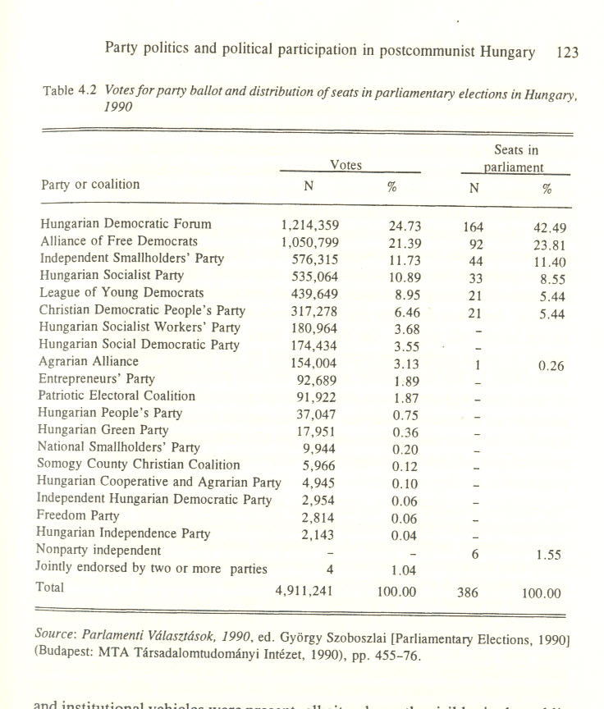

These businesslike arrangements were supplemented by a series of political confidence-building measures. In return for the new parties' legal immunity from police interference in the preelection period, the ORT negotiators extended similar guarantees to all officeholders of the outgoing regime. A comparable tradeoff between short-term government subsidies for the new parties and the opposition's long-term commitment of extending state subsidies for the electoral runnerups that received at least one percent of the national vote was another pragmatic component of the transition arrange-ments. Come what may at the first free elections, all but the truly fringe political forces were financially provided for in the post-communist period. In sum, the rebirth of multiparty politics in the waning years of the old regime in Hungary was the result of latent longitudinal trends in political devolution, institutional pluralism, elite politicization, and the incumbents' declining performance with respect to legitimacy building, resource allocation, and political management. By the mid-1980s the issues, policy options, and escape strategies, as well as the post-communist political leaders and institutional vehicles were present, albeit only partly visible, in the public arena. The survivalist old and the emerging new elites were all in place and well prepared to act on new opportunities to escape from the Kádárist quagmire.
Public apathy and widespread disinclination to engage in demonstrative behavior, such as strikes and protest marches, were an important characteristic of the pretransition period. Indeed, prior to the electoral campaign of February-March 1990 there had been no more than a half dozen instances when the people took to the streets to protest (on national holidays), to celebrate (as on October 23, 1989), or to vote at by-elections and plebiscites, such as those held in July and on November 26, 1989, respectively. The flood of uncensored information, though helpful for the airing of issues, contributed to information overload and to the blurring of partisan distinctions among eighty-odd parties, associations, electoral alliances, and whimsical groups that entered the electoral process. On the other hand, after a sluggish start in the fall of 1989, the hitherto disinterested public had no difficulty in making early decisions as to party preference and choice of electoral platforms.
On the eve of Hungary's founding elections both the parties and the public were "flying blind" with respect to the correspondence between party programs and the social groups and the spatial distribution of voting blocs whose interests the parties claimed to represent. Although the electoral turnouts - 65 percent on March 25 and 45 percent on April 8 - do not quite show it, there was no doubt that the overwhelming majority were anxious to be rid of the old regime. On the other hand, it was equally clear that the public's voting preferences were motivated by the parties' campaign slogans rather than by the substantive message of their programs.²¹
The NRT Agreement was a well-crafted political contract and its crown jewel was a technically complex electoral system that was designed to yield a stable "winners take all" (or most) type of parliamentary representation of political parties. As the Hungarian constitutional lawyer Gyorgy Szoboszlai explained:

“The number of elected MPs was defined as 386 of which 176 were to be elected in individual districts, 152 from within the competition of regional party lists (20 regions were determined, in 19 counties and in Budapest, the capital), and 58 on the basis of competing national lists. The electoral law was liberal with respect to preconditions of candidacy. Each registered party or other electoral organization could present a candidate by collecting 750 recommending signatures in the individual district. The same rule was valid for the independent candidates, but they had difficulties in collecting the signatures. Only registered parties could create regional lists provided they were able to run in one-fourth of the constituencies, at least in two. Those parties could compose national lists who were able to stand at least 7 regional lists. These thresholds resulted in certain selections. In the individual districts there were 10-12 candidates in average; 18 parties and other organizations could enter the competition on regional level, but only 12 could present a national list from among the 65 registered parties.
The voters voted for an individual candidate and for a regional party list in each constituency. In the first round the regional competition was over, but the distribution of the regional seats was not possible until the completion of the second round because of the compensating system. According to this procedure those votes not counted to get a regional seat (on the basis of the well-known d'Hondt system) on the one hand and the votes given for a non-elected party-backed candidate were to be collected on the national level. Seats assigned to the national list were distributed on the basis of this compensating system, counting the so-called lost votes. The minimum number of national seats was fixed in the law as 58, but because of the disproportionality of the regional distribution the actual number turned out to be 90 . . . The combination of the principles of proportionality and disproportionality made the system selective and proportionate for those remaining in competition. This seems to be a rational and just system and justified by the electoral results, except the independent candidates.”²²

In sum, the 1990 electoral outcomes could be seen both as the result of the Hungarian people's collective one-time ideological temper tantrum - as bounded by a complex electoral system - and that of the citizens voting their immediate political aspirations and long-term socioeconomic interests. In the end, the voters eliminated all but six parties. The finalists may be positioned at the left of, and at the right of the ideological center. In the final analysis what mattered was that the people endorsed and democratically legitimated the NRT pactmakers' right to represent the public interest in post-communist Hungary.
Party politics in a new democracy: toward a bipolar system?
Hungary's founding elections gave birth to what proved to be post-communist Eastern Europe's most stable government and party system. The Christian democratic three-party (HDF-ISP-CDPP) coalition government under Jozsef Antall and, after his untimely death in December 1993, Peter Boross was (with the arguable Czechoslovak exception wherein the split of the country into two sovereign states in 1992 may been seen either as evidence of continuity, or that of change) the first post-communist regime that completed its designated term of service. Moreover, it seems certain that the present HSP-AFD coalition government under the reform communist Gyula Horn will remain in power until the next elections in 1998. It is equally likely that the six parties that passed the 4 percent threshold in 1990 (and the 5 percent threshold in 1994) that are still in the Parliament today will again be electoral frontrunners in 1998.
The post-communist polity's institutional structure, including the party system, owes its remarkable stability to several factors. Of these the most important are Hungary's in some ways still semi-Kádárist, preparticipant political culture; patterns of social cohesion of, and ideological cleavages among, the party elites; well-crafted and continuously reinterpreted political pacts; and the political, institutional, and economic checks and balances that define the power relationships among institutional actors. Each of these points requires a brief commentary.

Public expectations and political participation
Political stability in the late Kadar era rested on an unwritten social contract between the people and the regime. Both were traumatized survivors - victims and ostensible victors - of postwar East Europe's only real revolution. Driven by the people's sense of abandonment by the west as well as by the regime's fears of total Soviet domination, both sides were ready to come to terms with one another. Thus, it was not - as uninformed western skeptics would have it - the public's latent procommunist sympathies, but a shared desire for national survival in a, to Hungary's fate indifferent, Cold War international environment, that facilitated this process.
The terms of the "contract" called for the regime's satisfaction of the public's consumerist expectations and trade-offs between the citizens' political passivity and the regime's "self-limiting" exercise of its coercive powers. The outcome made for a depoliticized and inward-looking society that, from the early 1970s on, became wedded to the "good king" Janos Kadar's brand of predictable, non-coercive, and stable political authority. It was not the resurgence of deeply embedded revolutionary aspirations - these had been crushed in 1956 and never again contemplated thereafter - but the regime's defaulting on its economic commitments and the crisis of political leadership after Kadar's exit that prompted the Hungarian public to give a chance to the new and the historic parties of 1989-90.
After the 1990 elections the public quickly put aside its partisan preferences and demanded - as respondents to public opinion polls, rather than through spokesmen for nonpolitical "civil society"-type organizations . which remained silent on the subject - an all-party coalition government.²³ Instead, the public got what many called a "parliamentary circus" in the form of - for the Western publics, perfectly normal - divisive partisan disputes in the legislative chamber. And that has been one, perhaps the main, reason that only a small minority of the citizens - perhaps 100,000, or less than 2 percent of the eligible voters - became declared and dues-paying party members in post-communist Hungary. Although political patronage is alive and well, the traditional advantages (higher pay, access to scarce goods, and the like) of membership in the ruling party (or party coalition after 1990) ceased to be available to the rank-and-file party faithful. Thus, by default, nonelectoral partisan involvement in politics has become the domain solely of professional politicians; economic, cultural, and other single-issue interest groups; and those directly linked up with the parties' patronage network.
The Hungarian electronic and printed media played an important, and still not fully examined, role in thwarting and to a lesser extent aiding, public participation in political events. It is a complex story, but the "media wars" of 1991-93 notwithstanding, it would be fair to say that prior to the implementation of the new media law in late 1995, the TV and the radio tended to serve the government of the day. In any case, neither gavel-to-gavel TV coverage of the parliamentary proceedings (hence the image of "political circus"), nor cleverly edited visual excerpts depicting unconventional events, such as strikes and occasional public protests, have inspired much confidence in the possible efficacy of citizen involvement in politics. On the other hand, during the Antall-Boross era the printed media was (and still is) under overwhelming AFD and HSP control. As the result, nonelite issues have received selective and often muted coverage in the press. With the exception of the ex-nomenklatura-led HSP-supporter trade unions, news generated by the rest of the social, cultural and generational interest groups tend to see daylight either with a "man-bites-dog" kind of editorial slant, or in small circulation journals and occasionally in the "letters to the editor" and the Op Ed pages of the national press. Consequently, mass political participation and demonstrations of the kind that one could witness at one time or another elsewhere in Eastern Europe rarely happened in Hungary prior to 1992.²⁴ The absence of the "street" from political deliberations has thus helped firm up the elites' grip on mass politics.
Intellectuals as party elites
With the exception of the HSP, the rest of the political parties had begun as small intelligentsia circles that found themselves together in the same proreform cultural and political trenches in the mid-1980s. Each of these groups consisted of organizers, activists, resident ideologues; and designated spokesmen (only the Free Democrats had a few women in the inner circles) with similar educational and professional backgrounds. Hungarian analysts described these preparty clusters as "tribal" and "clan-like" and the leading members as being totally preoccupied with their personal intellectual agenda.²⁵ At any rate, while these groups' evolution from friendship circles to "social movements" and, from there, to political parties tended to weed out many political amateurs, behind the party facade most of them remained debating clubs of querulous intellectuals.
The "hard core" of the new parties' "founding fathers" were prudent enough to coopt a few real experts (lawyers, successful entrepreneurs, and experienced administrators) into the leadership.²⁶ They were also pragmatic enough to put themselves in the top twenty to thirty slots of their parties' national lists that virtually guaranteed a seat in the Parliament. However, with the socialists' exception, (all seasoned veterans of apparat politics), once elected, they were not disciplined enough to stick together as members of the same party caucus. As Bill Lomax explained, the root causes of disunity lay in the new parties' sense of identity and political style:

The self-identities of the parties are . . . rooted in emotive commitments rather than on rational choice. The political identities and cleavages they represent are based neither on social interests, nor social programs, nor structured belief systems, but on cultural, emotional or even spiritual identifications through which their members come to belong to sociocultural camps with common life styles and behavior patterns. Such political styles are very good at identifying enemies and scapegoats, but they are highly detrimental to the processes of bargaining and the pursuit of compromises that are the essence of pluralist democracy.²⁷

Parties-in-Parliament: the government coalition
The 1991-94 Parliament began with six parties and a small group of independents. Four years later there were about twenty parties (some of them with one or two MPs) as well as countless "platforms," "factions," and policy caucuses within each of the six main parties.²⁸ What had happened? As Bill Lomax explains in an other essay, each of the six parties were, or became, Western European-style catch-all "people's parties" that reflected, sometimes in an extremely distorted fashion, the left-center-right ideological spectrum of the society at large.²⁹
In its original configuration the HDF was a party of left- and right-wing Populist intellectuals. When the conservative Jozsef Antall took the helm as party chairman and especially after he became prime minister, the socialist sympathizers were driven out of the party. In the next two years the István Csurka-led radical rightists broke with the HDF, launched a party of their own, and they left "Forum" divided among Christian democratic, national liberal, and moderate Populist factions.³⁰ From 1992 on, along with the HDF's waning fortunes in the polls, more than two score backbenchers joined other parties or the caucus of nonparty independents.
The authoritarian schoolmaster-style leadership of prime minister and party chairman Jozsef Antall, though important in keeping the backbenchers in line, was also responsible for the stifling of intraparty disputes on policy alternatives.³¹ Antall's conservative ideological agenda tolerated no internal dissent and drove his party into politically damaging confrontations with the predominantly liberal and socialist-sympathizer intelligentsia, particularly with the media elites. This strategy, though helping to keep party divisions alive, as shown in table 4.3, undermined his party's standing in the polls and, in 1994, at voting booths as well.
The HDF's coalition partners, the ISP and the CDPP, underwent similar experiences. The major difference between the two was the remarkable ability of the Smallholder József Torgyán-led faction of nine MPs to wrest the party's leadership from the ISP's thirty-three coalition loyalists. The case in point, as demonstrated from time to time in similar intraparty feuds, may be called the "in the kingdom of the blind the one-eyed man is king" syndrome. In other words, true to classical democratic and nondemocratic political traditions, it was always the "born politicians" and shrewd parliamentary tacticians who typically prevailed in confrontations with the political innocents of the backbenches. The outcome may have seemed chaotic but, at least in Hungary, it was only a facade for the pragmatic politicking - based on compromises and the swapping of favors - among the handfuls of professionals of both the government and the opposition parties.³² The result was manifest instability and latent stability in Hungarian party politics.

Parties-in-Parliament: the opposition
In ideological terms, the parliamentary opposition was divided between liberal (AFD and LYD) and socialist (HSP) camps. As the second largest parliamen-tary party, the AFD was an odd conglomerate of a small, tightly knit, all-intellectual party executive, originally headed by the philosopher Janos Kis; middle-class professionals; small entrepreneurs; and an assortment of single-issue constituencies. The party's subsequent splintering, realignment, and reunification are a complex story that need not be discussed here.³³ What stands out is the pattern of battles between oversize egos, clashes among proponents of nonnegotiable philosophical postures, and periodic showdowns between pragmatists and ideologues.

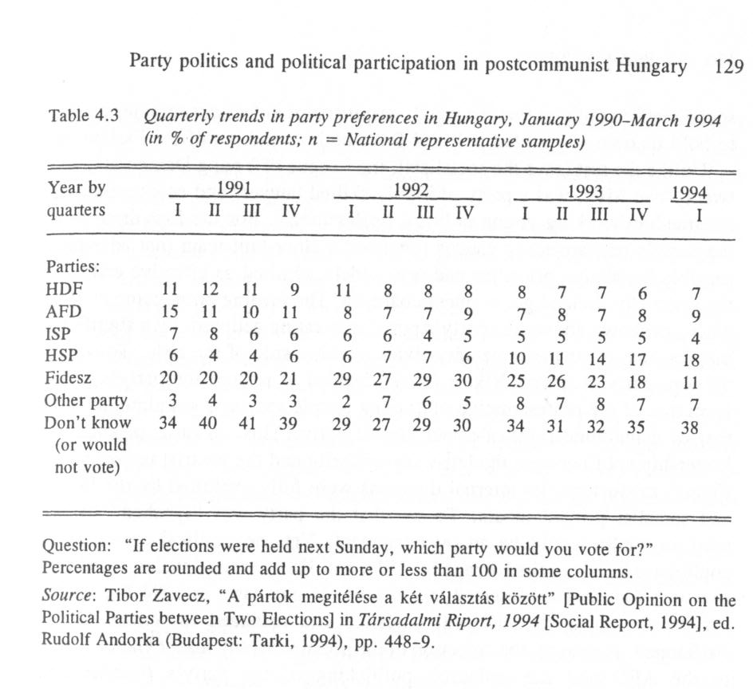
Withal, it is a small wonder that in the midst of internecine feuds, the party became an effective advocate of solid policy alternatives on issues such as privatization, budget reform, and social welfare policies that managed, despite some defections to other parties, to hold its own as a united political force both in and out of the Parliament.
Unlike the rest (save the socialists), the League of Young Democrats, with twenty-two MPs, was a party of highly skilled lawyers and economists who became hardworking young political professionals. For the first three years the party's parliamentary caucus remained a close-knit team that advocated sensible legislative priorities and was widely admired as effective critics of the internally divided government coalition. The turning point came in 1993 when, as shown above, the party's popularity rating eclipsed, by a significant margin, that of its parliamentary rivals at either side of the aisle. To stay at the top, party chairman Viktor Orban decided to remold the party's image from that of the representative of "young people and their grandmothers" to that of a mainline right-of-center liberal party. This, in turn, prompted a leadership split between the left-wing minority and the centrist majority. To Fidesz' misfortune, its internal divisions were fully exploited by the liberal and socialist printed media. To say that the party was "lynched" by the partisan media would be an overstatement. Yet, no political organization could have survived the barrage of AFD- and HSP-inspired vicious publicity to which Fidesz was subjected in 1993-94. In any case, in 1994 Fidesz did survive the socialists' electoral landslide and managed to remain in the Parliament. However, the defection of the popular deputy leader Gábor Fodor to the AFD and the maladroit politicking of the party's founder and incumbent leader left the party as a still visible, but for the foreseeable future, a marginal player in Hungarian politics.
The HSP was a "quarantined" political outcast in the first three years of Hungary's post-communist politics. At the beginning, neither the well-entrenched government coalition nor the then viscerally anticommunist liberal parties had any use for survivors of the old regime. The party's electoral defeat, however painful for the socialist faithful, was far from complete in April 1990. In September-October 1990, the nominally "independent" holdover village and small-town apparatchiki of the former ruling party (of whom 84 per cent were reelected) made a clean sweep at the village government elections. The "new democrat" HDF-ISP-CDPP coalition and AFD, Fidesz, and HDF, as individual parties, may have controlled the national government and the large cities, respectively, but much of the countryside remained in socialist hands.
After the departure of Imre Pozsgay from the HSP and the forced resignation of Rezso Nyers, former foreign minister Gyula Horn became the party's leader. The principal advantage of the party's parliamentary isolation lay in the leaders' ability to distance the party's parliamentary caucus from the other parties' record of trying, but inevitably failing, to satisfy unrealistic public demands for stable living standards, full employment, and growing
social-welfare benefits. Given the resource constraints on the government's ability to satisfy these expectations, all the socialists had to do was to keep a low profile, behave correctly, and await the, to them inevitable, downturn of their rivals' public support.
Unlike the rest of the party elites, the HSP leadership was a disciplined team of seasoned political veterans with a great deal of previous administrative experience as top party and government policy managers. To their credit, they redefined the party's identity as "social democratic" and willingly embraced the rules of the democratic political game.³⁴ Instead of engaging in self-destructive ideological disputes, Horn and his colleagues diligently rebuilt the party's grassroots organizations and maintained close political ties with the growing and increasingly affluent community of "party apparatchiki and red/green-barons-turned-entrepreneurs" of Hungary. Though initially shunned by the other parties, the HSP, as discussed above, retained its influence over key social and communications resources in the post-communist era.
The HSP's political prospects were further strengthened by the party's substantial real estate holdings, business assets, and well-invested cash that the leaders managed to salvage from the shipwrecked, but immensely wealthy HSWP.³⁵ Again, unlike its competitors with their hand-to-mouth existence on state subsidies and meager income from membership dues, the HSP's campaign chest was never short of money to finance local and national elections. The solid string of the HSP-sponsored candidates' by-election victories in 1991-94 was important evidence of the party's continued viability as a cohesive and well-financed political machine.

Partisanship: old issues and new cleavages
From the parliamentary interaction of the six parties and the growing cluster of independents and one-man to two-men miniparties there developed new patterns of party politics. Together with the growing professionalization of legislative politics, there has been a growing distance between the parties-in-Parliament and their grassroots organizations.³⁶ The latter, with the socialists' signal exception - their trade union auxiliaries gained new strength in the Antall era - have become scattered remnants of the (short-lived) political movements whence the new and historic parties originated in the late 1980s. As part of this process, new power centers of party politics have come about in Budapest, in the counties, and various regions of Hungary.
The political configurations of these local centers were not mirror images of national politics but issue-oriented multi- and occasionally all-party ad hoc coalitions on behalf of local, regional, and other sectorial interests. Here again, the socialists' administrative experience and efficient "old comrades' networks" were important assets for the overcoming of their political rivals' well-meaning but inexperienced local activists. The point is that due to the top party politicians' inevitable preoccupation with the technical minutiae of the workings of the legislature or, at the local level, with the administrative details of contentious issues - privatization, public housing, water supply, waste disposal, and school budgets - party labels lost their immediate salience.³⁷
Between 1989 and 1992 the number of registered "civil associations" increased from 8,574 to 19,950.³⁸ The potential efficacy of these groups for the promotion of sectorial interests was attenuated by the party system, by the existence of corporatist bodies of "interest reconciliation," and by the parliamentary party caucuses' modus operandi. Let us consider each of these built-in impediments:

(1) The party system, particularly the method of selection for the parties' national lists, was designed to preempt potentially powerful sectoral interests by the cooptation of token representatives of religious, ethnic, cultural-scientific, business, labor, female, and so forth, constituencies. In doing so, artificial "rainbow coalitions" were created - under the watchful eyes of the political professionals.

(2) "Civil groups," such as assorted professional and business "chambers," have their origins in the late Kadar era when these nomenklatura peer groups served as the regime's lightning rods within their respective constituencies. The largest is the National Council for Interest Reconciliation. It is made up of representatives of business, labor and other social organizations to deal with the government to craft "social pacts" - mainly to set national wage scales indexed to next year's inflation.

(3) Because individual MPs are bound by strict party discipline, they are by and large immune to constituency pressures and, by posing as guardians of public (versus particular, such as pressure group) interests, they tend to be impervious to most kinds of extra-party civil pressures.³⁹

Because of the parties' relative immunity to grassroots pressures, the inevitable consequence was the blurring of party identification and the public's reemerging "them-and-us," kinds of zero sum adversarial attitudes toward that powers that be. Dichotomous perceptions of "parties and party leaders in power" versus "parties and party leaders in opposition," and the "local (all parties) versus national" (the ruling coalition) were evidence of growing public distrust of Hungary's post-communist political institutions.⁴⁰ The main line of division was between those who saw themselves as victims (the overwhelming majority) and those who were beneficiaries (few cared to admit to have done well since 1990) of the parties' legislative record in post-communist Hungary. In any case, whereas at least initially, most key legislative items - legal reforms, institutional transformation and foreign policy - enjoyed all-party support,⁴¹ all shortfalls - unemployment, inflation, and budget deficits - were laid at the Antall-Boross government's door by the disenchanted public.⁴² Data on economic trends since 1989 tend to support these propositions. (On this, see table 4.4.)
There is a great deal of survey evidence on public attitudes toward political parties, party leaders, and political institutions.⁴³ The general trend has been that of the public's negative/suspicious/hostile attitudes toward the national government and the top incumbents of the state bureaucracy. Whereas the ADF-affiliated president of the Republic Arpad G6ncz was always at the top of the monthly popularity charts, by 1992-93 the prime minister's popularity (on a scale of 1 to 100) had sunk from the mid-60s to the mid-30s. The opposition leaders Viktor Orban, Gábor Fodor, Ivan Peto, and Gyula Horn were perennial favorites - more or less in an inverse ratio to their parties' capacity to effect desired outcomes in the national legislature.

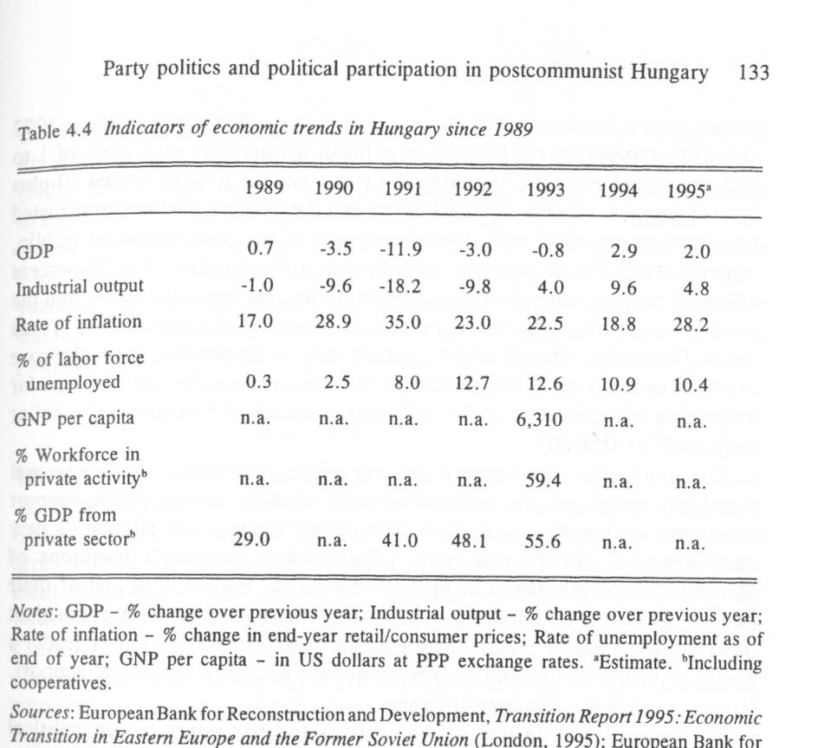

Paradoxically, the public's low esteem for the government, that is, the agency held responsible for inflation, taxes, and unemployment, was also shared by the Parliament and the political parties. According to three 1992 and 1993 surveys on public trust in political institutions, on a scale of 1 to 100, the president of the Republic, the army, and the police enjoyed 50-plus percent support, whereas the Parliament and the political parties were trusted by less than one-third and about one-fourth of the post-communist public, respectively.⁴⁴ The net winners, as recipients at the level of 45 to 55 percent of public support, were the Constitutional Court, the judicial system, and the local governments. The trade unions, particularly the unreformed Trade Union Federation, though initially trusted only by 28 percent, gradually rose in public esteem and by May 1993 was the winner of nationwide elections for bargaining representative of the still largely unionized blue-and white-collar employees of Hungary.
The consistent gap between the opposition politicians' high personal popularity rating and the much lower level of their parties' public support represents an important analytical dilemma for the study of Hungary's new party system.⁴⁵ On the one hand, pre-communist Hungary's traditions of identification of the names of prominent political leaders with that of their party - such as the "Bethlen party" in the 1920s - served as a convenient label for the general public. From this it seems to follow that a leader's personal popularity is readily convertible into his party's electoral support. However, such has not been the case.
The larger than life-size role of party standard-bearers as top political spokesmen on all matters helped obliterate their parties' ideological identity in the public eye. Whenever possible, chairmen of each of the six parliamentary parties' sought to appear as a national leader - often with little or no reference to his partisan affiliation. Because it was these party leaders' individual standings in the Hungarian media's monthly "beauty contests" that legitimated, albeit only in the opposition parties, their position in the party hierarchy, the question of the political salience of personal versus party popularity could be fully resolved only at the quadrennial national elections. At such occasions - much to the credit of the Hungarian voting public - the party standard bearers' national popularity ratings proved to be not automatically convertible into personal parliamentary mandates in individual electoral districts.
To a somewhat lesser extent, the same was true of the relationship between the party leaders' personal popularity and votes cast for candidates in individual voting districts. With the exception of few scores of "safe" seats - usually for "native sons" - the top party leaders entered the Parliament via national and regional party lists rather than through the inherently chancy individual districts. From this one might advance a tentative hypothesis on the declining salience of "great men" and charismatic political leaders in Hungarian party politics. In my view, the only "great man" (of sorts) who
still matters is the "good king" Janos Kadar of 1968-80 - not the man, but his still cherished legacy as provider and guardian of the non-elites' interests. (Since Jozsef Antall's death, some of his heirs in the HDF have been seeking to capitalize on their late leader's "intellectual patrimony" - with no visible results to date.) In any case, the Kádárist model of party politics tended to overshadow personalities, thwart divisive disputes, and cater to public yearnings for manifest stability and predictable political outcomes. Much of this is compatible with the institutional dynamics of Hungary's post-communist politics.

Institutional safeguards: holdover elites at the helm
The NRT Agreement, as modified by party pacts and all-party constitutional amendments since the summer of 1990, still serves as the basic framework of institutional checks and balances in Hungarian politics. Central to the arrangements are the built-in obstacles to removing the incumbent govern-ment by parliamentary vote of no confidence. This is augmented by the powers vested in the "semi-strong" president of the Republic and those of the Constitutional Court.⁴⁶ Prior to the local government elections of 1994, the opposition-dominated municipal and local governments served as important counterweights to the political center. These new political artifacts, however important to the formal functioning of a pluralistic polity, were kept afloat by the unwritten parts of ex ante and ex post facto agreements between the outgoing and incoming political elites of 1989-90.
At issue is the overwhelming - and inherently undocumentable - influence of the holdover state bureaucracy and that of the old/new entrepreneurial and media elites over public policy. The state bureaucrats' jobs are de facto entitlements that are protected by ironclad guarantees of the Labor Code and by the 1991 Law on Public Employees. Yesterday's "red barons" are today's managers and key stockholders in partly state-owned enterprises and business firms. These creatures of the old party state have retained and converted their administrative-managerial control of state resources into public-private "recombinant property."
The term was coined by David Stark in his excellent case study on industrial privatization in Hungary.⁴⁷ As he explains, official data on the size of the private sector and the reported share of national income derived from this sector are wholly misleading. The actual size of the private industrial sector is 12 to 15 percent, rather than 60-plus percent. The difference lies in the partly state-owned, that is, with state ownership of less than 50 percent of shares, mixed-ownership firms wherein the incumbent management is free to divert company assets to insider-owned satellite firms, and bill the state for costs of depreciation and operating deficits. Thus, "recombinant property" is a form of organizational hedging, or portfolio management, in which actors are responding to extraordinary uncertainty in the organizational environment in diversifying their assets, redefining and recombining resources. It is an attempt to have resources in more than one organizational form - or similarly - to produce hybrid organizational forms that can be justified or assessed by more than one standard of measure. . . . [P]arallel to the decentralized reorganization of assets is a centralization of liabilities, and these twinned moments blur the boundaries of public and private: On the one hand, privatization produces criss-crossing lines of recombinant property; on the other, debt consolidation transforms private debt into public liabilities.⁴⁸
This legal hybrid shelters key economic actors from the exigencies of party politics, as well as from political responsibility for the government's unpopular measures in aid of marketization, balanced budgets, and the like. Thus, the parties may pass laws and enact budgets, but their implementation is still the discretionary domain of the nonparty and still predominantly prosocialist holdover state bureaucracy. The same, as discussed above, is true for the country's still largely state-owned, but only indirectly controlled, productive assets in the hands of yesterday's captains of industry and commerce. All this makes for manifest "stability" - if Hungary's glacial regression toward ever-higher foreign indebtedness may be called such - and even "social peace" of sorts, but begs the question of the parties' role in the process.

Political parties: cui bono?
The leading Hungarian political scientist, Mihaly Bihari, characterized the party system as a libego (hovering, or floating in midair) phenomenon that is detached from the mainstream of politics and public affairs.⁴⁹ The term is apt because it denotes the thus far only superficial integration of the parties into a broader matrix of what the Hungarian public have traditionally understood by "politics." Until now both pre-communist and communist party politics have been elite affairs that admitted few outsiders into the professional politicians' boszorkdnykonyha (witches' kitchen). Pre-communist popular perceptions of party politics were heavily laden with suspicion of "chicanery of the gentlefolk," and with skepticism as to what, if any, good might come from party politics. The Hungarian people have yet to accept the political parties as indispensable to democracy and good government.
The public's traditionally low sense of political efficacy is still a major factor that affects political participation and electoral turnout. The by now habitual absence of one-third to one-half of voters from the polls at national
and local government elections, though essential to keeping the six- (now seven) party system afloat, raises new questions about the long-term stability of the post-communist party system in Hungary. A partial answer (and a tentative prognosis) may be inferred from the citizens' habit of bypassing established political structures in the pursuit of their private interest.
The Kádárist tradition of individual érdekérvenyesítés (interest realization) by means of one-on-one bargaining with members of the state bureaucracy is alive and well in Hungary today. The survival of such informal channels has kept the doors wide open to corruption and fostered contempt for official venues, such as the hopelessly overloaded civil courts, of interest adjudication between the citizens and the state. Hungary's homo Kádáricus sees no moral contradiction between expressing high regard for the judicial system - as an abstract proposition from the local to the Constitutional Court - and going about his business and routinely violating a dozen laws and regulations a day. The well-heeled party leaders - in late December 1995 the government coalition announced a 30 percent pay hike for top public servants, including MPs - make for poor role models for the average citizen. He will be lucky if his next pay raise will be only one-third less than the inflation rate of 30 per cent forecast for 1996. The parties, yet again, proved to be irrelevant to the satisfaction of citizen interests at the constituency level.

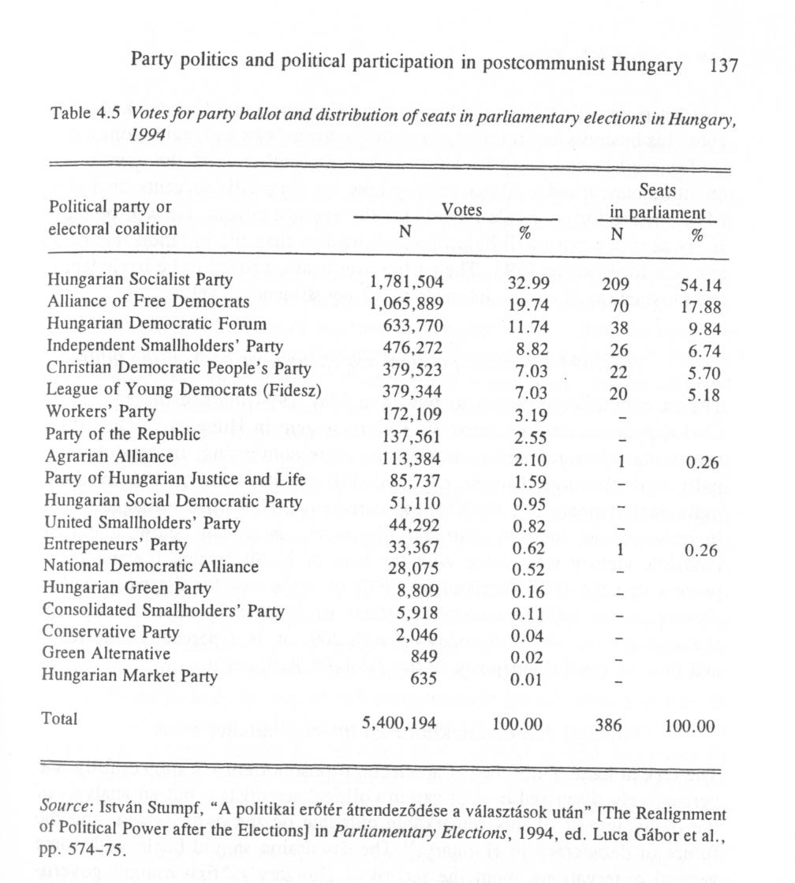

The 1994 elections: political sea change, or back to the future?
The ex-communists' return to power in May 1994 marked the end of the Christian democrat-dominated 3+3 party system in Hungary.⁵⁰ The HSP's spectacular electoral victory was all the more convincing: its candidates in individual electoral districts captured 150 of the total of 176 available individual mandates. In 1990 the top vote-getter, HDF, had managed to win in only 111 of the 176 districts. Moreover, as shown below, the HSP landslide victory was sealed with the help of 32.99 percent (versus 24.73 percent that the HDF received in 1990) of votes cast for the party ballot. Thanks to the built-in multiplier effects of Hungary's majority cum PR electoral system, the HSP ended up with 209, or 54.1 percent of the seats, and thus an absolute majority in the 1994-98 Parliament.

Political democratization: an interim balance sheet
The task at hand is not that of an electoral postmortem - a subject fully and perceptively discussed by Hungarian political scientists - but an analysis of the likely impact of this remarkable outcome on the party system and the future of democracy in Hungary.⁵¹ The discussion should begin with some general observations about the record of Hungary's "first-round" government. The positive aspects of the record were:

- the instauration and the firm embedding of basic laws, institutions, and procedural guarantees for the rule of law in Hungary;

- the enactment of legislation to facilitate the transformation of the national economy from a centrally planned command economy to a market economy, with special reference to measures to promote privatization and, in a trickle-down fashion, the citizens' access to private property;

- the development of modern continental European parliamentary procedures, the growing professionalization of lawmaking, and the routinization of the rules of political interaction among the parliamentary parties, particularly between the government and opposition;

- the beginning of the development, by way of ad hoc interaction, of dialogue between independent-minded members of parliamentary parties and extraparliamentary interest groups, policy lobbies, and civic associations; and

- the universal acceptance by all political actors of democratic, court- and state bureaucracy-supervised and enforced rules of the political game at all levels of the political system from the Parliament down to local governments.
The legitimacy of elected officials, of new and reformed institutions, and of the political processes of Hungary's parliamentary democracy was firmly established by 1994. Much of this may be summarized by calling the outcome institutional stability with built-in capacity for incremental change.⁵² Though "full democratic consolidation" - whatever it means - will not be achieved until the enactment of a new constitution, the institutional and political achievements of the transition period are firmly embedded in Hungary.
Items on the negative side of the ledger must be attributed to the still unresolved legacies of the past, particularly to the country's still semitraditional political culture that the party elites of the first-round post-communist polity could not, and have not been particularly anxious to, overcome. These include intractable issues of

- social justice that could not be made available to all members of the society. The Hungarian people - at least 60 to 70 percent of the voting public - had become accustomed to cradle-to-grave economic security that the government of the deeply indebted state can no longer provide;

- political justice, by way of full compensation for all victims of the old regime, and vigorous screening and prosecution of those guilty of crimes against the society, cannot be delivered in a political system that owes its immediate origin to an elite-pacted, "forgive and forget" negotiated revolution. The post-communist regime has neither the resources nor the political will to satisfy such public expectations;

- intelligentsia politics that entailed the gratuitous "ideologization" of intra- and interparty disputes among the new party elites, as well as between them and the HSP and its political auxiliaries, such the TUF and the media elites.

Prime Minister Antall's confrontation-seeking "symbolic politics" of pursuing political legitimacy through the government-assisted revival of Hungary's pre-communist ruling elites' values and ideologies was responsible for the awakening of Hungarian public opinion to the threat of backsliding into the authoritarian past. The liberal and the socialist opposition made good use of Antall's ideological posturing and rallied the post-Kádárist middle class for the defense of the post-communist status quo.⁵³
The HSP and the AFD were subsequently joined by the intelligentsia and, at the end, by the majority of the voting public. The HSP and AFD-sponsored "Democratic Charter" movement of 1992 - itself a reaction to Istvan Csurka's ravings and rantings - though began as a political cabal, was legitimate democratic political strategy that helped mobilize the public and cleared the way for the realignment of party loyalties.

Party politics of the "second round"
With their absolute majority of seats in the Parliament the victorious socialists could, if they so chose, have governed alone. On the other hand, the socialists' parliamentary majority fell short of the two-thirds necessary to pass "fundamental" laws or to amend the Constitution. Moreover, to retake the helm only four years after the spectacular collapse of the HSWP and assume sole responsibility for the combined economic debt of not one but two previous regimes entailed unacceptable political risks. In any case, as beneficiaries of another, possibly one-time, protest vote, it was uncertain whether the HSP had a solid enough electoral mandate to go it alone.
The AFD was the socialists' "natural" coalition partner as well as a • relatively low-risk choice with which to share some of the governing power and, in case something went wrong, all the political responsibility for keeping the economy afloat. The two parties' political mating dance took the form of protracted negotiations held behind closed doors. The entire affair bore an uncanny resemblance to the HFD-AFD negotiations of April-May 1990 - with the critical difference that the two-party pact of June 1994 was not a zero-sum but a "win-win" game for the participants.⁵⁴ For the HSP, coalition with the liberals responded to the ex-communists' need for a democratic fig leaf, as well as to the HSP technocrats' demands for continued marketization and privatization.
As the liberals saw it, the HSP's offer of, inevitably junior, partnership in a coalition government entailed risks and opportunities. The outcome had a vital bearing on the very survival of the AFD as self-declared standard-bearer of a liberal democratic Hungarian society that has yet to be born, let alone provide a 30 percent-plus share of the electoral support necessary to form a liberal-led government coalition. In September-November 1989 the AFD-led ad hoc coalition had to resort to the desperate measure of forcing a plebiscite against the HDF- and HSP-sponsored candidacy of the still very popular reform politician Imre Pozsgay for the presidency of the Republic. The gamble paid off: the outcome eliminated Pozsgay, secured the AFD's second place at the 1990 elections, and subsequently the presidency for the AFD backbencher Arpad Goncz.
The AFD's repeat performance as electoral runner-up, albeit with a huge gap of 13 percent (and 139 parliamentary seats) behind the winner, four years later posed a set of difficult political alternatives for the party's real leader
(party chairman Ivan Peto of the original "hard core") and its electoral standard-bearer (the ethnic German Gábor Kuncze, the AFD's candidate for prime minister). On the one hand, the AFD could have become the leading force of a deeply divided cluster of five opposition parties - only to see its legislative priorities savaged by the HSP, by the parties of the defeated Christian democratic coalition, and, for good measure, by the vengeful Fidesz. On the other hand, by joining the HSP government and shackling Prime Minister Horn with the terms of the coalition pact, the AFD could gain valuable administrative experience yet preserve the option of bailing out as and when it seemed expedient.³⁵ In the meantime, the AFD leadership is in a position to reward its party faithful by political patronage and access to lucrative opportunities in the state-controlled economic sector.
The Horn government's political record has been adequately covered in a recent collection of studies on that subject and need not be discussed here.⁵⁶ However, the transformation of the party system from a 3+3 to a 2+4 model and its likely consequences merit a brief assessment cum prognosis on the future of party politics in Hungary.

Government and opposition: a preliminary assessment
According to a July 1994 survey of HSP voters, they had, in declining order, supported the Horn team in expectation of quick remedies for inflation, rising prices, unemployment, poverty, environmental degradation, and the Parliament's legislative performance.⁵⁷ In any case, 69 per cent of the socialist voters were convinced that with the HSP in power, the "advantages of the pre-1990 regime would be restored."⁵⁸ If these views are indeed widely shared among the nearly 1.8 million HSP voters, prospects of the socialists' medium- and long-term political hegemony are open to doubt. At issue is the political cohesion of the HSP's parliamentary caucus of 209 MPs, of whom more than 170 are new to the Parliament. The point is that 150 of them had come in as winners in individual electoral districts - most often on the strength of unmet local economic demands.
Unlike the party-machine-appointed candidates who gained their seats via party lists, MPs from individual voting districts have been an unpredictable lot. In the previous Parliament 30 of the 164 HDF MPs - most of them originally from individual districts - defected to other parties or joined the independents' caucus. In any case, though segmented (with the party chiefs' blessing) into several "factions" and "interest groups," the HSP's parliamentary contingent should be seen not as one but at least three to four nascent parties with policy priorities of their own. Should push come to shove, one or more of these ad hoc clusters might, as they have several times in 1995, defy the leadership on key policy issues. The record to date has been one of simmering disputes, the isolation of radical economic reformers, and the appeasement of the trade union caucus by the neo-Kádárist HSP executive.

(1) By hitching its wagon to the HSP, the AFD has lost some of its earlier public image as a vigorous promoter of sound legislative alternatives and a source of policy innovation. The party's toehold in the government, by way of two substantive ministries (Internal Affairs, and Education and Culture) headed by Kuncze and, until the end of 1995, by the Fidesz defector Gábor Fodor, respectively, and some other subcabinet appointments, have yet to stem the liberals' eroding popularity in the polls. On the other hand, the AFD's "me-too" parliamentary role is more than balanced by the liberals' function as political counterweight to the HSP's antimarket, antiprivatization redistributionists as equal partners in the standing HSP-AFD interparty consultative committee. Other than the government's financial experts and Hungary's Western creditors, this body is about the only impediment to the government succumbing to Horn's periodic relapses into demagoguery and his caving in to demands of his party's welfare lobby.
The AFD's role as the government's "internal opposition" has tended to preempt the agenda of the four opposition parties in the Parliament. The shouting match between the government - "the last four years of the Antall government brought Hungary to the brink of ruin" - and the opposition -"lets talk about the preceding forty years" - has yet to subside into routine parliamentary interaction. Instead, what seems to be emerging is a new kind of political interplay between the "1 + 1" government and a "4 + 1" opposition.

(2) The HDF is the largest opposition party and, next to the upstart LYD, the greatest loser in the 1994 elections. In several ways, the party is captive to its political record and to "Antall's orphans," that is, to the tired politicians who served their late political master rather than the voters who brought them to power in 1990. Long simmering disputes between the party's Populist and liberal wings came to a\head in March 1996. Under the leadership of Iván Szabó who had been minister of finance in the Antall government, a group of sixteen HDF MPs left the party to form the Hungarian Democratic People's Party (HDDP). The remaining twenty-two HDF MPs (one of them chose to join the independents' caucus) rallied around Sándor Lezsak- a village school teacher and a self-taught Populist ideologue. Since neither faction has much of a political identity, let alone wide popular following of its own, the Lezsak group is likely to end up joining forces with some extra-parliamentary right-wing parties, while the HDDP might want to team up with the CP-Fidesz (if the young liberals will have them) prior to the 1998 elections.

(3) The CDPP is the only party of the Antall coalition that lost no votes in 1994. Though much courted by the HSP - the Catholic vote was dispersed among all parties both in 1990 and 1994 - the party's new leadership is staying the course. Whichever party ends up at the top in 1998 would do well to take on the CDPP as a respected, but politically lightweight, coalition partner.

(4) By the end of 1994, the LYD - having changed the party's name to Citizens' Party-Fidesz - has more or less recovered from the devastating impact of its precipitous slide from the top of the polls in mid-1993 to barely passing the 5 percent parliamentary threshold a year later. Viktor Orban is still at the helm, albeit his powers are now shared with his extremely able deputies. If tenacity, political savvy, and professionalism will matter to the Hungarian voters in the years to come, CP-Fidesz could be a key player in the next elections. In the meantime, the party is trying to keep the opposition together and its leaders on speaking terms with one another.

(5) The ISP under József Torgyánis the " 1" in the "4 +1" equation of the parliamentary opposition. At this time it is unclear whether the ISP is a "Torgyan party" and the personal political vehicle of a shrewd provincial lawyer cum populist demagogue, or the kernel of an emerging rural nationalist protest movement with an excellent chance to double is electoral support in the next three years. (In August 1995 and again a year later, ISP caught up with and overtook HSP in the popularity polls, and the end is not yet in sight).⁵⁹

Party politics: short-term perspectives
Unlike the rest of Hungary's post-communist political institutions that will at best be fine-tuned but not drastically modified by a new constitution, the party system is still in the process of transformation from a unipolar toward a bi- or possibly tripolar configuration. In early 1995 the leaders of HDF, CP-Fidesz, and CDPP came to a tentative agreement on the forming of Citizens' Federation (CF) to coordinate parliamentary strategy. CF was also meant to be the kernel of a multi-party right-of-center electoral alliance for 1998. The would-be partners have yet to act in unison: the CDPP, having learned its lesson of playing second fiddle to HDF under Antall, wants to see thorough house cleaning there as a condition of cooperation - the HDPP might fit the bill; the veteran oppositionist CP-Fidesz, especially Orban, are not about to defer to the former helmsmen of the Antal-Boross "Titanic" -though probably not averse to take on Ivan Szabo, former foreign minister Géza Jeszenszky and the rest as "third fiddlers"; and, more to the point, none of them can get along with the ISP's feisty leader, József Torgyan.
As befitting a pluralistic democracy, Hungary's party system will be shaped by the interplay of newly surfacing social forces, the "invisible hand" of a slowly emerging market economy, and the powerful remnants of the country's Kádárist political legacy.⁶⁰
It is axiomatic that the "long-wave" restratification of Hungarian society will continue to yield unexpected electoral results in the years to come. Given the share of nonvoters and that of ballots cast for electoral runner-ups that are redistributed among the finalists, the present party system will have to find a way to respond to currently unmet social interests. Foremost of these is the challenge of fiscally prudent political representation of the needs of the economic victims of the state's inevitable retreat as provider of last resort.
The Horn government's decision to trim the social safety net in March 1995 - followed by backtracking and further watering down of austerity measures by the Constitutional Court - is the first of many attempts yet to come to implement needed but unpopular measures to keep Hungary afloat. Similar efforts to downsize the state bureaucracy that have come to naught under every postwar regime from the Stalinist Matyas Rakosi to the Christian democrat Jozsef Antall must be actually implemented by the quintessential apparatchik-bureaucrat Gyula Horn himself.
The jury of public opinion is still out with its verdict on the Horn regime. However, the steadily declining living standards and the snowballing, since mid-1995, of widely publicized scandals involving the misappropriation and brazen embezzlement of extremely large sums of money (bank bailouts, kickbacks from secret privatization transactions, and astronomical profits from government contracts) by Horn's cronies from the old HSWP apparat suggest that the countdown for the next elections may have begun in the fall of 1996.
The political parties' staying power and eventual constituency support will depend on some foreseeable and many unpredictable contingencies. What seems certain is that due to the loss of substantial amounts of state subsidies (apportioned according to respective shares of seats in the Parliament) the opposition parties' financial resources will be inadequate to match the incumbents' campaign chests.⁶¹ However, as shown by the socialists' modest campaign expenditures yet stunning success in May 1994, this need not be a fatal handicap. Money helps, but it is the issues, more precisely the state of the economy, rather than campaign advertising that will, as it did in 1990 and 1994, determine electoral outcomes in Hungary in 1998 and beyond.

Notes

1 The term is Ezra Vogel's and its specifics are discussed in Change in Communist Systems, ed. Chalmers Johnson (Stanford: Stanford University Press, 1970), pp. 27-8.
2 The term is mine, and it is one of the central themes of Rudolf L. Tokes, Hungary's Negotiated Revolution: Economic Reforms, Social Change, and Political Succession, 1957-1990 (Cambridge: Cambridge University Press, 1996).
3 Ibid., ch. 9.
4 See Andras Bozoki, "Ut a rendszervaltashoz: az Ellenzeki Kerekasztal" [Road to the Change of the System: The Opposition Roundtable] Mozgo Vildg, no. 8 (1990), 23-37.
5 George Schopflin, Rudolf L. Tokes, and Ivan Volgyes, "Leadership Change and Crisis in Hungary," Problems of Communism 37, no. 5 (September-October 1988), especially pp. 27-39.
6 Laszlo Bruszt and Janos Simon, "Politikai orientaciok Magyarorszagon a rendszervaltas eveben" in A lecsendesitett tobbseg [The Silenced Majority] ed. Laszlo Bruszt and Janos Simon (Budapest: Tarsadalomtudomanyi Intezet, 1990), pp. 33-74.
7 On this, see Imre Pozsgay, 1989 - Politikuspdlya apártállamban es a rendszervdl-tdsban [1989 - A Political Career in the Party State and in the Change of the System] (Budapest: Puski, 1993) and my interviews with Karoly Grosz and Janos Berecz cited in Tokes, Hungary's Negotiated Revolution, ch. 8.
8 Tokes, Hungary's Negotiated Revolution, ch. 7.
9 On the new and historic parties, see MagyarorszdgPolitikai Evkonyve, 1988, ed. Sandor Kurtan, Peter Sandor and Laszlo Vass (1988, hereafter Hungarian Yearbook) (Budapest: R-Forma Kiado, 1989), pp. 699-709; Az Ellenzeki Kerekasztal. Portrevdzlatok, ed. Anna Richter [The Opposition Roundtable, Portraits] (Budapest: Otlet, 1990).
10 Cf. Tamas Fricz, "A magyarorszagi partrendszer kialakulasarol es jellemzoirol: 1987-1992" [The Development and Characteristics of the Hungarian Party System: 1987-1992], unpublished dissertation, Budapest: Institute for Political Studies, 1993. See also Andras Korosenyi, "Stable or Fragile Democracy? Political Changes and Party System in Hungary," in Flying Blind. Emerging Democracies in East-Central Europe, ed. Gyorgy Szoboszlai (Budapest: Hungarian Political Science Association, 1992), pp. 344-56.
11 Gyorgy G. Markus, "Parties, Cleavages in Post-Communist Hungary: Is the Weakness of Social Democratic Forces Systemic?" in Flying Blind, pp. 331-42.
12 Cf. Ivan Szelenyi, Socialist Entrepreneurs (Madison, WI: University of Wisconsin Press, 1988).
13 Tokes, Hungary's Negotiated Revolution, ch. 4.
14 Lajos Geza Nagy, "Tortenelem kepek es jovo-kepek" [Images of History and Ideology. The Stratification of Ideological Beliefs in the Early 1980s], unpublished dissertation, Budapest, 1989.
15 Cf. Elemer Hankiss, East European Alternatives (Oxford: Clarendon Press, 1990), chs. 6-8.
16 Text of the Polish Roundtable Agreement is in Trybuna Ludu, 1 April 1989 and in FBIS-EEU Daily Report, 5 May 1989, pp. 19-35. For the full text and appendices, see Poruzumenia Okralego Stolu [The Roundtable Agreement] (Warsaw, 1989). Photocopy of the typewritten original of the Hungarian NRT agreement is in Richter, The Opposition Roundtable, pp. 310-15.
17 On trends in public opinion in 1989, see Agnes Bokor, "Public Opinion Concerning the Process of the Regime's Change," in Social Report, 1990, ed. Rudolf Andorka, Tamas Kolosi and Gydrgy Vukovich (Budapest: TARKI, 1992) pp. 418-45; Bruszt and Simon, The Silenced, passim; and Gyorgy Csepeli and Antal Orkeny, Alkonyat. A magyar ertelmiseg ideoldgiai-politikai optikdja a 80-as evek vegén [Sunset - Hungarian Intelligentsia Perceptions of Ideology and Politics in the late 1980s] (Budapest: Institute of Sociology, ELTE, 1991).
18 In a politically self-destructive leadership decision, the disbanded HSWP's membership was given three weeks to decide whether or not to join the HSP. Only 20,000 to 25,000 did so by the end of 1989.
19 Tokes, Hungary's Negotiated Revolution, chs. 7 and 8.
20 On the structure and functions of Hungary's post-communist political institutions, see Alkotmdnytan [Constitutionalism], ed. Istvan Kukorelli (Budapest: Osiris-Szazadveg, 1994). See also Gyorgy Szoboszlai, "Political Transition and Constitutional Changes," in Democracy and Political Transformation, ed. Gyorgy Szoboszlai (Budapest: Hungarian Political Science Association, 1991) pp. 195-212.
21 For a full discussion of voluminous survey evidence on the voters' political motivations in early 1990, see Rudolf L. Tokes, From Post-Communism to Democracy: Party Politics and Free Elections in Hungary (Sankt Augustin bei Bonn: Konrad Adenauer Stiftung-Forschungsinstitut, 1990). See also, Bokor, "Public Opinion."
22 Szoboszlai, "Political Transition," pp. 207-8.
23 Laszlo Bruszt and Janos Simon, "A 'valasztasok eve' a kozvelemenykutatas tiikreben" [The "Year of Elections" in the Mirror of Public Opinion] in Hungarian Yearbook, 1990, especially pp. 633-46.
24 Mate Szabo, "The Taxi Driver Demonstration in Hungary - Social Protest and Policy Change," and Andras Bozoki, "Democrats Against Democracy? Civil Protest in Hungary since 1990," in Flying Blind, pp. 357-81 and 382-97.
25 See Miklos Gaspir Tamas, Mdsvildg [Otherworld - Political Essays] (Budapest: Uj Mandatum Kiado, 1994).
26 For a biographical directory of MPs elected in 1990, Az 1990-ben Megvdlasztott Orszdggyules Almanachja I., [Parliamentary Almanac, 1990], vol. I., ed. J6zsef Kiss et al. (Budapest: Magyar Orsz3ggy<3l6s, 1990).
27 Bill Lomax, "Hungary: The Development of Democratic Politics," unpublished manuscript, 1994.
28 See "Partpreferenciak es Tagoltsagok" [Party Preferences and Cleavages] in Parlamenti Választdsok 1994 [Parliamentary Elections, 1994], ed. Luca Gábor, Adam Levendel and Istvan Stumpf (Budapest: Osiris-Szazadveg, 1994), pp. 70-149.
29 Bill Lomax, "Obstacles to the Development of Democratic Politics," The Journal of Communist Studies and Transition Politics 10, no 3 (September 1994), 81-100.
30 The split in the HDF was precipitated by the publication of a bitter right-wing nationalistic and anti-Semitic pamphlet by the playwright HDF vice-president Istvan Csurka. It was an alarming episode that prompted the US media and Hungary's post-communist neighbors to reach premature conclusions about the extent to which such beliefs are held in Hungary. Csurka's Party of Hungarian Life and Justice received 1.59 percent of the votes in the 1994 elections, or about
one-half of the votes (3.19 percent) cast for the communist Workers' Party. These numbers are fair indicators of public support for right-wing nationalist and left-wing Leninist extremist groups in Hungary in the 1990s.
31 On Antall, see Tokes, Hungary's Negotiated Revolution, ch. 10 and Sandor Revesz, Antall Jozsef Tdvolrol, 1932-1993 [Jozsef Antall in perspective, 1932-1993] (Budapest: Sik Kiado, 1995).
32 Party politics has been the subject of countless, mainly unsystematic and frequently partisan studies in the Hungarian press and literary-political journals. The most useful accounts on political parties can be found in the Hungarian Political Science Association's Politikatudomdnyi Szemle and the Hungarian Yearbooks for 1990-95. Three works, A tobbpdrtrendszer kialakuldsa Magyarorszdgon, 1985-1991 [The Development of Multi-party System in Hungary, 1985-1991], ed. Mihaly Bihari (Budapest: Kossuth, 1992), Istvan Schlett, Szinjdtek vagy hdborii? A magyar politika negy everdl [Theater or War? Four Years of Hungarian Politics] (Budapest: Cserepfalvi, 1995), and Tamas Fricz's monograph cited above are still the best sources on this subject.
33 The most authoritative account is by the party's former chairman, AFD MP Peter Tolgyessy, "A kerekasztaltol a koalicioig" [From the NRT to the (HSP-AFD) Coalition], Nepszabadsdg, 18 November 1995. See also, Zoltan Ripp, Szabad Demokratdk [Free Democrats] (Budapest: Napvilag Kiado, 1995).
34 Attila Agh, "Organisational Change in the Hungarian Socialist Party," Budapest Papers on Democratic Transition 1994. [Also on Internet:gopher://gopher.mek. iif. hu:7070/00/porta/szint/tarsad/politika/agh76.hun]
35 On the basis of the HSWP's (incomplete) financial report to the Parliament in the fall of 1989,1 estimated the fair market value of the party's assets at HUF 150Bn, or $3Bn at the October 1989 rates of exchange. Tokes, Hungary's Negotiated Revolution, ch. 8. The party's current (1995) assets consist of (a) over 300 office buildings; (b) several party-owned business firms; (c) several party-controlled "nonprofit" foundations; (d) partly party-financed privatized enterprises controlled by former HSWP officials; (e) state budgetary subsidies; and (f) dues and gifts from members and sympathizers. See Gábor Juhasz, "Partpenzek Magyarorszagon" [Party Finances in Hungary], Mozgo Vildg, no. 8. (August 1993); Gábor Juhasz, "1993-as partmerlegek" [Party Balance Sheets for 1993], Heti Világgázdaság (6 May 1994), pp. 95-100; Gábor Juhasz, "Partkepviselok az allami cegekben" [Party MPs in State Enterprises], Heti Világgázdaság (24 June 1995), pp. 83-9; and Janos Dobszay, "Torvenyserto alapi'tvanyok" [Illegal Foundations], Heti Vildggazdasdg (14 October 1995), pp. 109-11.
36 Cf. Attila Agh, "Bumpy Road to Europeanization: Policy Effectiveness and Agenda Concentration in the Hungarian Legislation, 1990-1993," in The Emergence of East Central European Parliaments: The First Steps, ed. Attila Agh (Budapest: Hungarian Centre for Democracy Studies, 1994) pp. 69-85.
37 On this, see the essays by Gyorgy Csepeli, Laszlo Lengyel, Istvan Stumpf, Agnes Bokor and Laszlo Keri in part I, "Partok es kotodesek" [Parties and Attachments] in Parliamentary Elections, 1994, ed. Luca Gábor et al., pp. 18-69.
38 Cf. Laszlo Vass, "Europeanization of Interest Groups in the New Hungarian Political System," Budapest Papers on Democratic Transition, 1990. As of December 1994, 110 of these were national organizations with the mission of erdekvidelem [protection of interest]. For a full list, see Hungarian Yearbook, 1994, pp. 755-60.
39 Kathleen Montgomery, "Interest Group Representation in the Hungarian Parliament," Budapest Papers on Democratic Transition, 1994. Because two-thirds of the MPs polled refused to respond to Montgomery's survey, her findings, however sensible, require further corroboration.
40 According to a March 1993 survey, the least trusted political institutions, on a "distrust-trust" scale of 1 to 100, were the political parties, the trade unions, and the Parliament with 27, 28, and 31 percent, respectively. Hungarian Yearbook, 1993, p. 732.
41 About one-half of the 107 bills enacted into laws between May 1990 and late 1991 were passed unanimously. Sandor Kurtan, "Pártok és Törvények," Budapest Papers on Democratic Transition, 1991.
42 Cf. Mate Szab6, "Adaptation and Resistance: the Institutionalization of Protest Movements, 1990-1994," in Democratic Legitimacy in Post-Communist Societies, ed. Andrds Bozoki (Budapest: T-Twins Publishing House, 1994), pp. 137-54.
43 "A politikai kozvelemeny a Median kutat£sainak tiikreben, 1991-1994" [Public Opinion on Politics, 1991-1994 in the Mirror of Surveys by Median, Inc.], ed. Beta Marian, in Hungarian Yearbook, 1994, pp. 718-56.
44 Ibid., pp. 731-4.
45 Agnes Bokor, "A partok es a politikusok nepszerfisegenek 6sszeftiggeser61" [On the Relationship between Party Preference and Personal Popularity] in Parliamentary Elections, 1994, ed. Luca Gábor et al., pp. 88-97.
46 For an excellent description of the workings and interaction of the key branches of the government and those of the media with the powers that be, see B61a Pokol, Magyar Parlamentarizmus [Hungarian Parliamentarism] (Budapest: Cserepfalvi, 1994).
47 David Stark, "Recombinant Property in East European Capitalism," Public Lectures, no. 8 (Budapest: Institute for Advanced Study, Collegium Budapest, 1994).
48 Ibid., p. 7.
49 A tobbpdrtrendszerkialakuldsdMagyarorszdgon, ed. Bihari, passim.
50 Mihály Bihari, "Parliamentary Elections and Governmental Change in Hungary in 1994," in Hungarian Yearbook, 1995, pp. 31-45.
51 See Andris Korosenyi, "The Reasons for the Defeat of the Right," Occasional Paper no. 1 (Budapest: Windsor Klub, July 1994); Luca GSbor, "Ert6kel6sek" [Assessments], in ibid., pp. 491-585; and Gyorgy Szoboszlai, "Vlltozdsok a vfilasztSsi teikepen: parlamenti es onkormanyzati vAlasztdsok" [Changes in the Electoral Map: National and Local Elections], Hungarian Yearbook, 1995, pp-82-98.
52 See Balance. The Hungarian Government, 1990-1994, ed. Csaba GombSr et al. (Budapest: Korridor Center for Political Research, 1994).
53 Istvan Schlett, "A politika nyelvezetenek alakulasa a rendszerv£ltds utan" [The New Language of Politics after the Change of the Regime], Tdrsadalmi Szemle 49, nos. 8-9 (1994), 28-34.
54 The text of the two parties' voluminous "political prenuptial contract" is in Hungarian Yearbook, 1995, pp. 648-729.
55 On the AFD's political options in June 1994, see Ivan Peto, "Az MSZP-SZDSZ kormanykoalicio" [On the HSP-AFD Government Coalition], in Hungarian Yearbook, 1995, pp. 168-86.
56 See Question Marks: The Hungarian Government, 1994-1995, ed. Csaba Gombar et al. (Budapest: Korridor Center for Political Research, 1995).
57 Agnes Bokor, "Az MSZMP szavazotaboranak harom retege" [Three Clusters of HSP Voters], Hungarian Yearbook, 1995, p. 542.
58 Ibid., p. 546.
59 Endre Hann, "Partok es politikusok nepszerusege" [The Popularity of Parties and Politicians], Heti Vildggazdasdg, 9 September 1995, pp. 90-92, and Nepszava, 11 December 1995.
60 The Horn government's most comprehensive attempt to come to terms with these issues has been a major planning document, "Magyarorszag az uj Europaban. A Kormany modernizacios programjanak politikai koncepcioja" [Hungary in the New Europe. Political Theses of the Government's Modernization Program], Special supplement to Magyar Hirlap, 18 November 1995.
61 Cf. Bela Pokol, Penz es politika [Money and Politics] (Budapest: Aula Kiado, 1993).

