Man Is Not Alone, Josef Mach, 1971
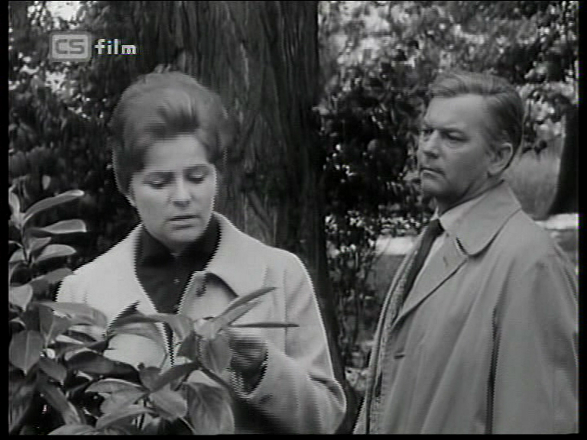

1929, Antonín Kachlík, 1974
