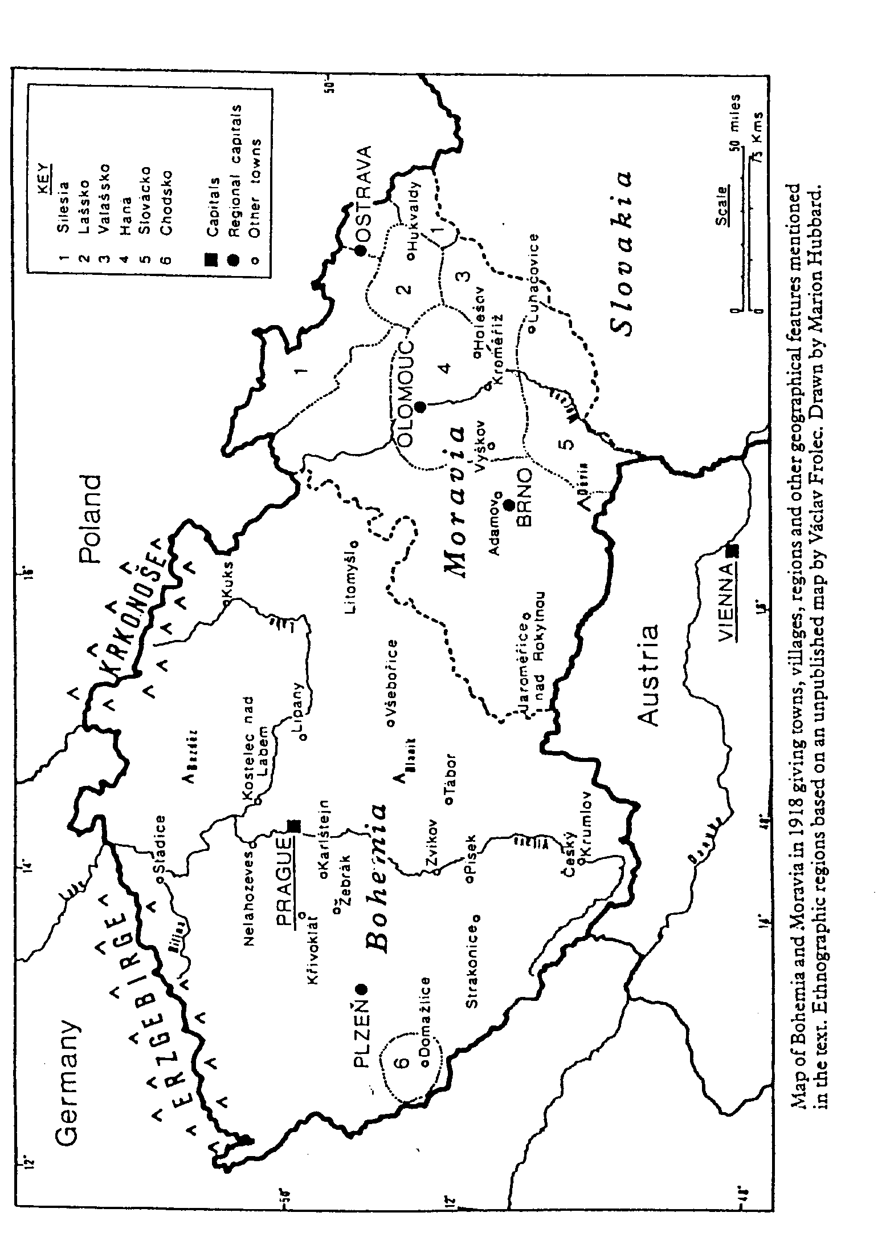
4

Czech nationalism
John Tyrrell

Já ale pravím: Nelze déle
tu trpěti cizácké sbory.
Už potřebí se chopit zbraně
a vyhnat z vlasti Branibory,
již hubí zem, náš jazyk tupí,
pod jejichž mečem národ úpí!

(But I say this: we can no longer tolerate foreign hordes here. We must now take up arms and drive the Brandenburgers from our homeland. They are destroying our country, blunting our language and under their sword the nation suffers!)

So begins Smetana’s first opera, The Brandenburgers in Bohemia. The libretto provides a number of situations in thirteenth-century Bohemia (then occupied by the German Brandenburgers) that Smetana’s nineteenth-century Czech contemporaries would easily be able to apply to their own times. Like the Brandenburgers, the Austrian Habsburgs were occupying Bohemia. But before the Habsburg domination the Czechs could look back to centuries of independence. By the fourteenth century the native Přemyslid dynasty had died out and new rulers from outside were elected. Under the Luxembourg dynasty, in particular the great king and Holy Roman Emperor Charles IV ( 1346-78), Bohemia developed into a European power. Its capital Prague, a Gothic city of great beauty, was the third largest in Europe with the first university (1348) to be established north of the Alps after Paris, Oxford and Cambridge. Later dynasties such as the Polish Jagellons proved less effective, while the Habsburgs, elected in 1526, soon showed themselves to have no interest in preserving the integrity and traditions of the historical crownlands of Bohemia, Moravia and Silesia. The last Habsburg monarch to have his seat in Prague was Rudolf II, and his reign (1576-1612) was a period of cultural and scientific flowering. But the anti-Habsburg rebellion, in essence a power struggle between Catholic absolutism and a Protestant oligarchy, came to a head under Rudolf’s intolerant successor, and the political incompetence of the Czech aristocracy led to its defeat at the Battle of the White Mountain in 1620, as significant a date to the Czechs as 1066 is to the English. It marks the end of the Czechs’ power to elect their own ruler and the end of their freedom in an independent kingdom.
During the next two centuries the Czech lands became increasingly integrated within the Habsburg Empire. The most tangible differences between the Czechs and the Austrians – language and religion – were eroded. The enforced re-Catholicization of the Czechs began almost immediately after the Habsburg victory and was consolidated in 1624 through such measures as handing over Prague University to the Jesuits. As a result many Czechs fled the country, the first of many subsequent waves of Czech emigration. Over language the Austrians trod more cautiously. There had always been Germans in the area, particularly in the border lands settled by Germans (much later to become notorious as the Sudeten Germans), and in the second half of the thirteenth century a Přemyslid king, Přemysl Otakar II, had systematically encouraged skilled German craftsmen to settle in his kingdom. Unlike the Flemings and Huguenots in Britain, the Germans had resisted integration and after 1620 the German minority gained increasing power – in the towns in civil and governmental administration, and as landowners. But the Bohemian Diet continued to issue some patents in Czech into the eighteenth century and it was not until Joseph II’s reforms towards the end of the century that Czech, as a language of educated people, was dealt a near death blow. In 1780 Czech was abolished in grammar schools; four years later German replaced Latin as the administrative language of the empire.
Public decree was reinforced by private ambition. The fluent command of German needed for professional and government posts meant that Czech parents began to use German in the home to better their children’s chances. By the middle of the nineteenth century the Czech middle class was almost completely Germanized. German language and habits were accepted as those of a superior society, with Czech increasingly regarded as the primitive language of peasants and servants.
Some idea of the stranglehold of German on the Czech lands at this time can be gained by considering the linguistic background of the chief Czech opera composers of the nineteenth century. Smetana (1824-84), Dvořák (1841-1904), Fibich (1850-1900) and to some extent Janáček (1854-1928) were all educated in German. All wrote their early vocal works in German: in Fibich’s case, three juvenile operas and over a hundred Schumannesque lieder; in Dvořák case his first opera, Alfred. Smetana kept his diary in German into the 1860s. He wrote to his wife and her family in German whilst in one of his first surviving letters in Czech, to his friend Ludevít Procházka (11 March 1860; Löwenbach 1914, 5-6), he endearingly apologized to him for his mistakes in grammar and orthography. He continued to make such mistakes for the rest of his life. Two of his most overtly nationalist operas, Dalibor and Libuše, were written to texts translated from German. Even such a fervent nationalist as Janáček, later chauvinistically to boycott German trams and the German opera house in Brno, wrote all his love letters to his future wife in German.
Czech survived by its teaching at village schools and by the secret reading of the Kralice Bible ( 1579-94), the humanistic culmination of two centuries of Czech bible translations and a codification of the language comparable to that achieved in English by the King James Bible. But if Czech were ever to become a means of expressing Czech nationalist ambitions it was necessary to re-establish its intellectual credibility and to revitalize as a medium of intellectual and literary discourse a language abandoned by most Czech writers in the eighteenth century. Ironically, it was in German that the first battles for the revival of the language were fought. The first Czech grammar (1809), by Josef Dobrovský, and the first volume (1836) of František Palacký’s history of the Czech nation both appeared in German. These, together with Josef Jungmann’s Czech-German dictionary (1834-9), represent the intellectual foundations of the Czech National Revival (Národní obrození) in the nineteenth century.
Writers followed. The first literary milestone of the new period is generally taken to be a Byronic narrative poem, May (Máj), published in 1836, the year of the death of its author, Karel Hynek Mácha, at the age of twenty-six. Equally influential in shaping Czech sensibilities were Božena Němcová’s The Grandmother (Babička, 1855), a novel of Czech country life, and Karel Jaromír Erben’s elaboration of folk beliefs in his beautifully crafted ballads, published as a collection, A Garland of National Tales (Kytice z pověstí národních), in 1853. These works have lost none of their popularity with Czech readers, nor their potency as an evocation of the Czech countryside, its people, its customs and its folk mythology.
The effect of a burgeoning Czech literature, together with the influential models of nationalist movements elsewhere, particularly among other Slav peoples such as the Poles, was to encourage or even create a Czech national consciousness. Previously inert material now became invested with a warm glow of nationalist sentiment that could be appealed to for patriotic purposes. Images of historical rulers and the past glory of the nation, of a civilization with a sophisticated literature stretching back into the distant past, or of a contented Czech countryside with its own distinct way of life, customs and music, were carefully fostered and imprinted on the minds of a susceptible Czech community.
An excellent example is the treatment of the Libuše legend. Up to the early nineteenth century this story, though purporting to relate to a Czech princess, the legendary founder of Prague (see pp. 135-41), was taken up by Italians, Germans and Czechs alike as suitable material for dramatic or operatic treatment, without any specific nationalist dimension. There is, as Petr Vít demonstrates (1982), little difference in approach between Kreutzer’s Libussa composed to a German text and given in Vienna in 1822 and Škroup’s Libuše’s Marriage, composed to a text by a prominent poet of the Czech National Revival in 1835. The intensely patriotic effect of Smetana’s opera half a century later was not achieved by the central legend alone, but by presenting it in the context of a whole number of nationalist symbols, deliberately inserted to trigger off a nationalist response. Thus Přemysl, seen alone in Act 2, addresses his invocation to the lime trees “Ó, vy lípy”. As Macura argues (1983, 93-107), after the wide dissemination of the ‘bible of Slavness’, Kollár’s epic poem Sláva’s Daughter (Slávy dcera, second edition 1832), a Czech audience by the 1880s knew that a lime tree was ‘Slavonic’ (as opposed to the ‘German’ oak) and that by singing about lime trees Přemysl was both invoking a now well-established nationalist symbol, and at the same time reinforcing it.
With a nation that feared the demise of its language as a vehicle for cultured expression, it was inevitable that the written word would become particularly important. Indeed print nationalism, as Bernard Anderson has shown ( 1983, 41-9), is often a crucial factor in fostering national awareness, though an awareness inevitably restricted to those who could read. Consequently, until the 1848 Revolution the Czech National Revival remained a largely middle-class phenomenon. The only permanent gain of the Revolution was the clearing away of the last vestiges of serfdom – the abolition of robota, or forced labour (Joseph II’s reforms of 1781 had begun the process by abolishing nevolnictví, which tied peasants and their descendants to the land). The effect of this, together with increasing mechanization, was to release the agricultural populace for industrial work in the towns, and thus to change the linguistic balance there. The middle-class patriots who had begun the National Revival in the first half of the nineteenth century were now joined by a flood of lower-class native Czech speakers from the country. During the nineteenth century Prague turned from a city with an overwhelmingly German culture to one whose culture increasingly reflected the fact that its population was predominantly Czech-speaking.
The linguistic tide was clearly turning in favour of the Czechs, but their prime political objective – autonomy – was not realized until the end of the First World War when the break-up of the Austro-Hungarian Empire brought about an independent Czechoslovakian state (rather than a federalization of the empire, which had been the aim of the historian Palacký and other farsighted reformers). During the nineteenth century, frustrated political energy was channelled elsewhere, into clubs and cultural organizations. Austria’s defeat by France at Magenta and Solferino in June 1859, through which it lost most of its remaining Italian possessions, brought down the government. This included Count Alexander Bach, the notorious minister of the interior who from 1852 had presided over the most repressive period of Habsburg rule in the nineteenth century. Concerned that disaffection among other peoples in the empire might lead to further territorial losses, the new government adopted a more conciliatory stance and lifted restrictions on cultural and other activities. The 1860s saw the beginnings of many new Czech ventures. In 1862 the influential Národní listy, the first independent Czech newspaper for over a decade, began publication and the same year the gymnastic organization Sokol (falcon) was founded on the model of the earlier German Turnverein. The movement spread rapidly throughout the country, building Sokol halls (useful gathering places for other cultural-patriotic purposes), and inculcating an almost mystical patriotic sensibility whilst promoting physical education. The Sokol movement survived closures by the Austrians and the Nazis during two world wars and clung on until 1952, when it was incorporated into the new socialist republic’s even more massive physical-cultural organization.
A similar nation-building role was supplied by the choral societies that proliferated in the 1860s. The most distinguished of these was the Prague Hlahol, founded in 1861 as a male-voice choir and directed in its earliest years by Smetana (1863-5) and Bendl (1865-77). In 1873 another composer, Janáček, took over the Brno male choral society Svatopluk (founded in 1868) and wrote some of his earliest pieces for it. Like the choral societies that sprang up during the political upheavals in London and Paris in the early 1830s, the Czech choral societies provided a type of group activity which could draw in members with little musical training. The better societies achieved a high standard and built up a solid, sober repertory but others were little more than a pretext for meeting and for singing texts in Czech, often with wildly inflated patriotic sentiments.
But by far the most important focus of national endeavour from the 1860s was the building of the National Theatre in Prague. Since theatre was almost the only way of reaching out to an often illiterate public and the one ‘literary’ activity that could operate as a popular community experience, it had played a most important part in the National Revival from the late eighteenth century onwards, despite the lack of a permanent home for Czech drama until the 1860s (see Chapter 2).
The National Theatre was opened with great pomp in June 1881. It replaced a more modest building, the Provisional Theatre, erected in 1862. The Provisional Theatre made possible a permanent Czech ensemble – drama, opera and ballet – to be created in preparation for the bigger theatre, and a repertory of new and translated works to be built up. For some twenty years, many more than originally envisaged, collections were needed to pay for the erection of the National Theatre, which soon became the most tangible expression of Czech nationhood. While the Provisional Theatre had been built with state funds, the National Theatre was the result of a huge exercise in private fund-raising by Czechs throughout Bohemia and Moravia and among scattered Czech communities and Pan-Slav sympathizers abroad. The building’s origin was proudly recorded in the motto above the proscenium arch: ‘Národ sobě’ – ‘The nation to itself’. The stops and starts in the thirty-year process bear witness to the inexperience of the organizers and the obstacles raised by the obstructive Austrian authorities; similarly the ease with which the money was raised again in 1881, after a fire had destroyed much of the building a few weeks after its opening, reflected the growing wealth and national consciousness of the Czech community.
The Provisional Theatre opened in 1862 with a play by a young Czech writer, Vítězslav Hálek, followed the next evening by an opera, Cherubini’s Les deux journées, sung in Czech. The opening of the National Theatre in 1881, and its rebuilt version in 1883, were celebrated not by a play but by an opera, Smetana’s Libuše. Opening with an opera rather than with a play was an acknowledgement that the greatest achievement in Czech theatre in the previous two decades had been in opera, rather than in spoken drama. The ceremonial nature of opera was also felt to be more appropriate to such an occasion. And while spoken drama can provide a range of nationalist signals and references, from the use of the Czech language itself and the patriotic sentiments expressed in it to the enactment of Czech history and legends and the depiction of Czech locales through sets and costumes, opera was able to add its own even more powerful resources.
Gratifying though it was to hear Czech spoken from the stage of a lavishly decorated theatre, it was even more flattering to national pride to hear Czech sung, ennobled by music into the grandest style the theatre had at its command. The inbuilt emotional reference system of mid-nineteenth-century harmony was something that composers could draw on to exploit to the full the nationalist impact of a work. Music could fill out the emotional implications of a text and make absolutely clear where the audiences’s sympathies should be. Thus the opening scene of Smetana’s first opera, The Brandenburgers in Bohemia, begins with an exchange between two Prague citizens, Oldřich and Volfram, from whom we learn about the sad state of the country. To a disturbed, swirling accompaniment, Oldřich describes how ‘from village to village the Brandenburger mercenaries rampage like wolves, looting churches, pillaging monasteries, murdering children, old men, women!’ Then, with an abrupt shift up a semitone, he declares, con summa forza: ‘our fields lie fallow, bespattered with innocent blood, and our lovely Czech land is turning into a barren desert’ (Ex. 1). For the first time in the opera the voice settles into a songlike arioso, in contrast to the irregular parlando that has prevailed hitherto. Note-values lengthen and two sequential phrases lead to the heart of the matter: as Oldřich utters the first syllable of the first ‘česká’ (Czech) his part leaps up a fourth to the accompaniment of an ‘affective’ diminished seventh chord (a); a last drop of pathos is wrung out when the accompaniment shifts against the held voice part to create another emotionally loaded device, an appoggiatura of the ninth (b), resolved on to the second syllable of ‘česká’. It is as if up to now all the words have been printed in small type while the reference to ‘our lovely Czech land’ appears in huge illuminated letters.
There is another example in the opening scene of Act 2, a hymn sung by a sorrowing village people cataloguing their woes and about to abandon their homes and flee to the safety of the woods. At first a solo voice – a village elder – and a four-part chorus alternate unaccompanied. As the music gathers momentum the orchestra creeps in and when the volume reaches fortissimo the elder finally reaches the crucial words, ‘Through their cruel acts they have destroyed our lovely Czech land and enslaved the glorious Czech nation’ (‘Naši krásnou českou zem ukrutenstvím pohubili, a ten slavný český národ zotročili’). The chorus repeats his words to a full orchestral accompaniment, now with a telling alteration: on the first syllable of ‘českou’ (Czech) there is a climactically placed dominant thirteenth – another emotionally loaded effect to clinch the patriotic argument.
Smetana was too sophisticated a composer to repeat such devices on every similar occasion, but many examples can be found in his works up to his final opera The Devil’s Wall. As Jan Racek has demonstrated in his study of patriotism in Smetana’s music, on key words like vlast (fatherland), národ (nation), and sláva (glory) there is often a noticeable musical underlining of the sentiment with affective harmony or with striking melodic leaps and melismas (Racek 1933, 92-134) – a musical parallel to the trembling of Smetana’s voice (in Dolanský much-quoted anecdote, 1918, 236) when he proclaimed the words ‘my nation’. In those operas portraying Czech rulers such as Dalibor and Libuše Smetana wrote particularly stirring ceremonial music for entrances and exits, a special sort of Czech ‘pomp and circumstance’ music to dignify and monumentalize the ruler.

Ex. I
(Assai moderato; piu mosso)
OLDŘICH
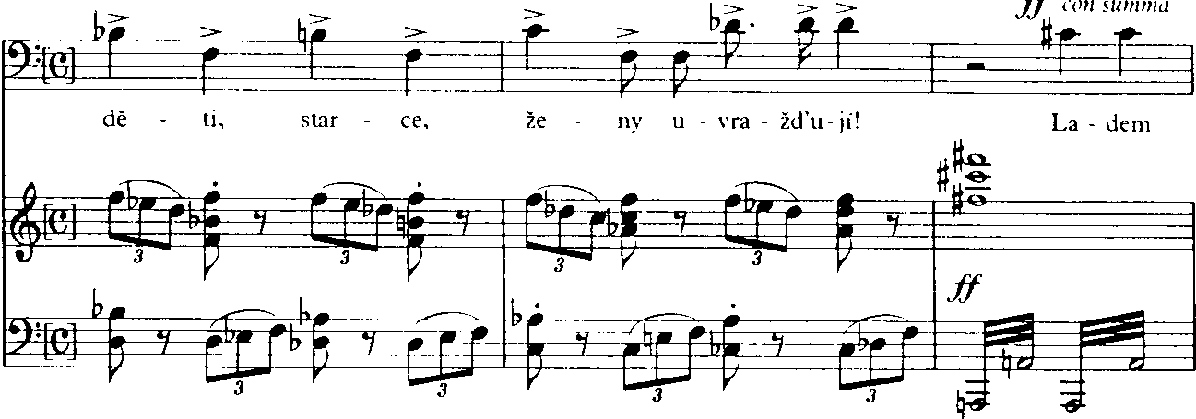
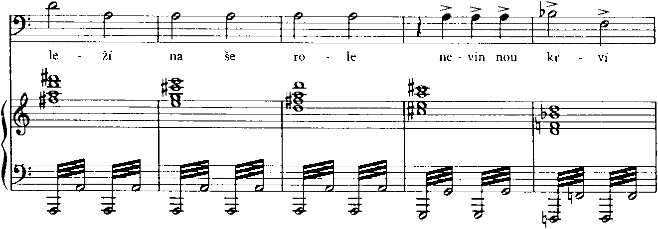
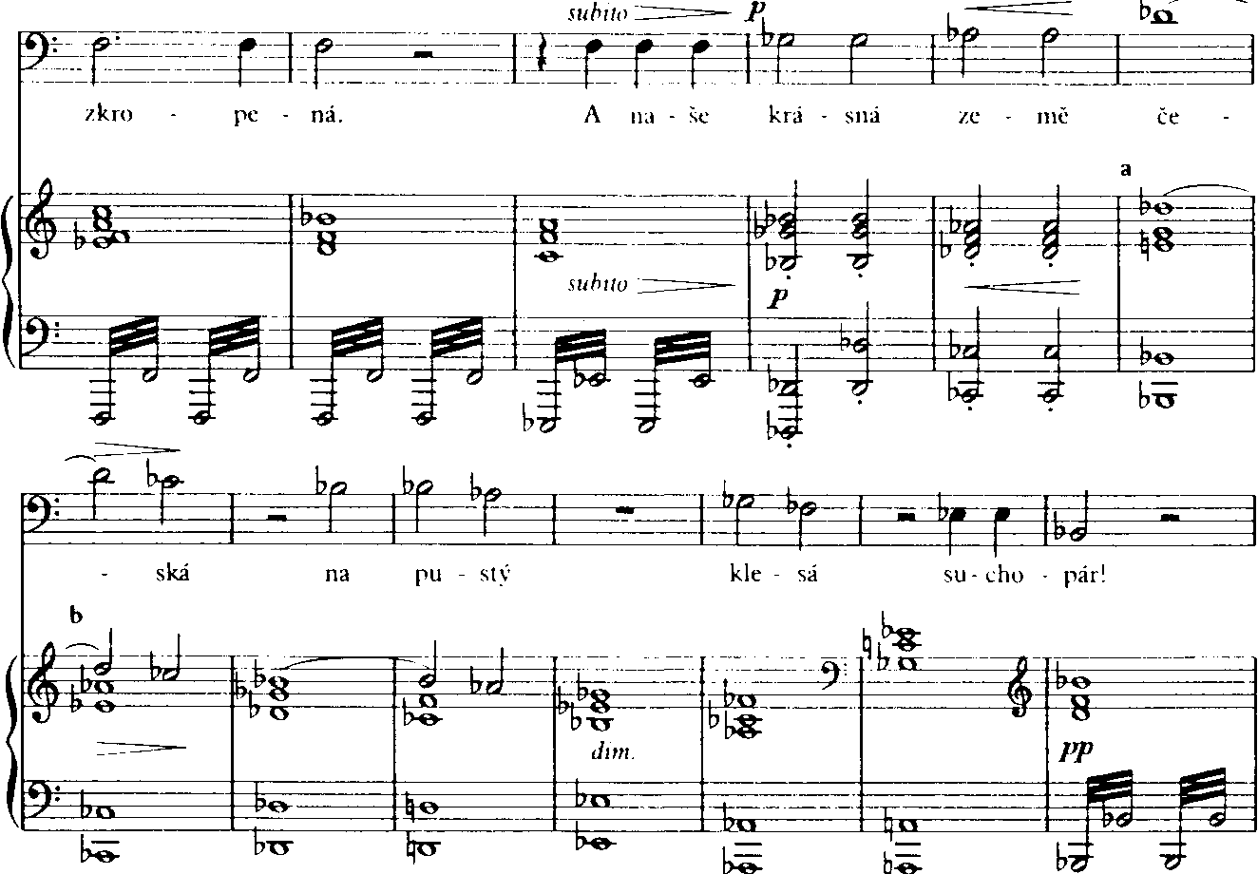

It was operas of this sort, rather than plays, that provided the ceremonial at the ‘chrám umění’, the ‘shrine of art’, as the catch phrase of the time put it. That music should form such a significant part of the expression of Czech nationalism is not surprising. Unlike the peoples of nationalist movements on the fringes of Europe, the Czechs, at the heart of Europe, had a well-established musical tradition. With their proximity to Vienna they were well placed to follow developments there, as it became an increasingly important and influential musical centre in the late eighteenth century. Solidly trained Czech musicians were sought after for musical posts throughout Europe and contributed significantly to the formation of the Classical style. With no gallant political folk heroes, and no writers or painters of international standing, the Czechs could at least boast of their musicians. ‘What Czech does not love music?’ asks the jailer Beneš in Dalibor. At a local level the humble musician-teacher, the village schoolmaster or kantor, inspired affection and gratitude for keeping Czech culture alive at the lowest ebb of the nation’s fortunes. Playwrights, librettists and composers fondly contributed to depict Czech musicians at work, a recognition of their preeminence in national hagiography.
Once it had found a permanent home where it could be displayed and where it could prosper, opera became the chief vehicle of Czech cultural nationalism. Where other nations expressed their nationhood in the adulation of the monarchy or the military, or in the obeisance to a flag, a constitution or ‘la gloire’, the Czechs celebrated their nationhood in operatic rituals staged at the National Theatre. The building became endowed with a unique, almost sacred seriousness of purpose. In the words of Zdeněk Nejedlý, one of the most influential arbiters of Czech cultural and political tastes in the twentieth century, it was ‘not a place of entertainment, but a hallowed place, a shrine, a school, where the nation had to speak with the highest form of its own language about its feelings and its dearest aims’ (Nejedlý 1935, i, 114). Hence the disapproval of performing at the National Theatre anything thought to be light-weight. Nejedlý dismissed both operetta and ballet as not being ‘art’ at all, but merely social phenomena symptomatic of the frivolous and decadent societies in Paris and Vienna, and took comfort in their lack of success on the Czech stage (Nejedlý 1911, 228-34).
Czech nationalism differs from other nineteenth-century nationalisms in that its deepest roots go back to a much earlier epoch, to 1415, when Jan Hus was burnt for heresy at the Council of Constance. His martyrdom united the country, still more so when reinforced by the persistent and unsuccessful crusades waged against it by the whole of Catholic Europe. Hussitism became for the Czechs not just a faith but a form of patriotism. Four centuries before Napoleon’s wars provoked the nationalist movements of the nineteenth century, the Czechs, in defence of their country and their faith, found a nationalism with strong ethical overtones which have persisted ever since. Although the Jesuits were able to re-Catholicize the Czech population in the seventeenth century and replace the cult figure of Jan Hus with their own candidate John of Nepomuk, whose effigy, in swaying Baroque drapes, still adorns many wayside shrines of the Czech countryside, no Habsburg or Jesuit was ever able to dissolve the moral residue of Hussitism in the Czech nation. Nationalism in the Czech lands was permanently intertwined with moral values. Jan Racek’s book on Smetana (1933), revised in the heady postwar days of 1947, provides an apt example with its almost incantatory use of the epithet ‘ethical’ constantly applied to the actions of its heroic subject.
This approach is typical of much Czech writing about music. If music and in particular opera provided the most public focus of Czech cultural aspirations, they also formed the battleground for rival interpretations of these aspirations and how best they should be realized in music. Czech writers on music, much more than the composers, threw themselves into the fray with a ferocity and partisanship that often startles the outsider. That one composer is preferred to another is natural, but among the Czechs the choice was seldom a matter of mere personal taste or artistic excellence but rather one of political alignment. Because of the ideological burden that nationalist opera was forced to bear in nineteenth-century Bohemia, attitudes towards individual composers became charged with extramusical significance.
Thus the polemics between the Liszt-Wagner and Brahms camps, when translated into Czech terms – the ‘progressive’ Lisztian Smetana versus the ‘conservative’ Brahmsian Dvořák (confusingly also a Wagnerian) – locked into political debates of the late nineteenth century between the staročech (Old Czech) and mladočech (Young Czech) parties. In a letter explaining the Czech political scene to a pupil he had taught in Sweden (Kraus 1906, 411) Smetana characterized the staročeši as the ‘feudal-clerical’ party, the party of the propertied and monied classes, and the mladočeši as the free-thinking party, the party of artists, journalists and men of letters. Smetana, naturally, was a mladočech. Less is known about Dvořák’s political affiliations, but his association with František Rieger, the prominent staročech politician whose daughter supplied Dvořák with two librettos, was proof enough for hostile commentators of his staročech inclinations. Since the mladočech party was, as Smetana wrote, the party of ‘artists, journalists and men of letters’ it is understandable that mladočech writers would find themselves better disposed towards Smetana than to Dvořák. Smetana did not lack committed propagandists from such quarters and they include some of the most important and influential Czech writers on music of their time, such as Otakar Hostinský and Zdeněk Nejedlý. For almost a century from the 1870s, when Hostinský began writing regular reviews and articles, until Nejedlý’s death in 1962 these two scholars dominated their contemporaries and constituted a strongly pro-Smetana lobby, if necessary at the expense of other figures. Here is Nejedlý in his first book, published in 1901, when he was twenty-three.

Smetana’s slogan was modernity and Czechness, so he sided enthusiastically with the progressive Weimar school, with Berlioz, Liszt and Wagner. He was the founder of Czech music by virtue of the fact that he based our national opera on modern Wagnerian music drama... and our symphonic literature with his first symphonic poems culminating in the cycle Má vlast.
[...] Now let us turn to Dvořák. Smetana based Czech opera on modern soil, Dvořák on the soil of old French and Italian operas. His operas go in the opposite direction from those of Smetana. Dimitrij is Dvořák’s best work; it is at the same time his most conservative – nay, his most regressive. Dvořák negates the development of Czech opera.
(Nejedlý 1901, 172)

Smetana’s appeal was strengthened by two further factors. Unlike Dvořák, who was courted by foreign publishers, wrote freely for foreign commissions and was prepared to spend some of his mature years cultivating his reputation abroad, Smetana returned home as soon as conditions had relaxed sufficiently for Czech culture to flourish and devoted himself unsparingly to the advancement of opera aimed specifically at the Czechs. Such a patriotic, ‘ethical’ gesture when he could easily – like Dvořák – have established a career abroad, has also weighed heavily in Smetana’s favour. Nejedlý, writing in 1913-14, put the case with characteristic trenchancy; ‘Smetana was a thousand times the more potent artist [of the two] since he never sold off his art, in which nationality was a basic element, in return for a little success abroad’ (Nejedlý 1980, 114). The hostile, insensitive treatment Smetana received at the hands of staročech administrators while conductor at the Provisional Theatre, especially when deafness compelled him to give up his appointment, his heroic battle against deafness and ill health and the vindictive nature of some of his opponents have all solicited a strain of emotional protectiveness that has coloured much Czech and even foreign writing about him.
Writers such as Nejedlý devoted particular energy to the question of Smetana’s spiritual successor. Dvořák clearly would not do, and Nejedlý’s choice lighted on Zdenek Fibich.

Fibich continued in the progressive endeavours of Smetana. Having taken over Smetana’s watchword, he led Czech music to greater glory, ever higher. Thus the history of modern Czech music in the nineteenth century will be denoted by two chapters of which the first will bear Smetana’s name, citing Libuše, Má vlast and the quartet ‘From my Life’; the second will bear Fibich’s name citing The Bride of Messina, Hippodamia, The Fal1 of Arkona and Moods [Impressions and Reminiscences].
[...] . . .There is only one historical consequence. Fibich is the true successor of Smetana while Dvořák represents the negation of the direction of both of these masters. Therefore the famous Czech trinity should correctly read: Smetana-Fibich contra Dvořák.
(Nejedlý 1901, 172-3; Nejedlý’s italics)

And since Fibich, dying in 1900, needed a successor himself, Nejedlý provided one in his book Modern Czech Opera after Smetana (Česká moderní zpěvohra po Smetanovi, 1911). The book ends with the motto: ‘The Bride of Messina – Eva – The Bud’, in other words Fibich – Foerster – Ostrčil.
Today such a map of Czech opera seems a little odd. Despite the best efforts of Nejedlý and his followers, Fibich never quite captured the popular imagination. He, Foerster and Ostrčil account for no more than four operas that can still be occasionally heard in Czechoslovakia. What Nejedlý could not foresee is that Dvořák, for all his shortcomings as a natural operatic composer, would leave behind him several operas that seem to speak to the Czech heart more directly than anything by Fibich, Foerster or Ostrčil. Nor, when briskly writing off Janáček’s Jenůfa after its Prague triumph, could Nejedlý have realized that its composer, a figure quite outside his golden succession, would do more to establish Czech opera as a vital force beyond the boundaries of Czechoslovakia. Today when a foreigner thinks of Czech opera he tends to think more of Janáček than any of his predecessors.
The map of Czech opera proposed in this book is inevitably a different one from that offered by Czech polemicists of the nineteenth and early twentieth centuries. It is different, too, from that offered by many of their successors, whose writings provide fascinating proof of the tenacity of nationalist attitudes. It would be naive to presume that it will be any more accurate; every historian writes within a context of his own geographical, historical and ideological assumptions, however he may strive for objectivity. But it may strike the reader that a foreigner with some sympathy for the achievements of the Czech nation may be able to write with fewer constraints than those whose outlook has been restricted by the emotional bonds of the Czech nationalist art they sought to describe. For a start there is no necessity to see Smetana as a hero figure. This means that it is not necessary to ignore and disparage his predecessors, contemporaries and successors so that he might appear all the greater; to play down the role of his librettists in order to present him as the only begetter of his operas; to assume that he wrote with a natural and instinctive Czechness that eschewed harmful foreign influences (apart from a few carefully sanctioned ‘progressive’ ones). Neither is it necessary to assume that although Smetana knew that his operas would be first performed in the tiny Provisional Theatre he wrote for the grander theatre of his imagination and that therefore the conditions at the Provisional Theatre and the voices available there had no effect on what and on how he wrote. To forego some of these assumptions is not to underrate Smetana’s very considerable achievement; in fact to see him in the broader context that this book offers can only reinforce that achievement. Take away these assumptions and many new and productive areas of investigation open out, areas which Czech musicology only now, and with some caution, is at last beginning to examine.¹

In: Tyrrell, John. Czech Opera. Cambridge University Press, 1988, ch. 1, pp. 1-12.

