Music in the Czech Lands
22 September 2010

History of the Czech Lands - principal dates

863 - Constantine and Methodius arrive to Great Moravian Empire
935 (?) - murder of Prince Wenceslas (Václav)
1306 - Extinction of Přemyslid dynasty
1346-78 - reign of Charles IV
1415 - Master John Huss (Mistr Jan Hus) burned at the stake in Konstanz
1419-34 - Hussite revolution
1576-1612 - reign of Rudolf II (Habsburg)
1620 - Battle of White Mountain
1740-80 reign of Maria Theresa
1780-90 reign of Joseph II
1848 - revolutionary uprisings
1860 - October Diploma
1882 - Charles University divided
1914-18 - First World War
1918 - independent Czechoslovakia founded, 1st president T. G. Masaryk
1938-09 - Munich Agreement
1939-03 - independent Slovak state, Czech lands occupied by Hitler
1945 - liberation by Soviet and U.S. armies, reconstitution of Czechoslovakia
1948-02 - Communist putsch, 1st communist president K. Gottwald
1953-03 both Stalin and Gottwald die
1956-02 - Khrushchev’s secret speech denouncing Stalin’s crimes
1960 - general amnesty (thaw)
1968-01 - Prague Spring democratic movement (Vaculík, Kundera, Havel, Dubček)
1968-08-21 - Occupation by five armies of the Warsaw pact
1969-89 - Normalization
1977 - Charter 77
1989-11 - Velvet Revolution, president Václav Havel
1993 - Czechoslovakia divides
1999 - Czech Republic joins NATO
2004 - Czech Republic joins EU

29 September 2010
no lesson

6. October 2010

Theater visits - Wiener Staatsoper (Vienna State Opera)

Thu 21 October - Richard Strauss: Salome (20.00 p.m.)
Sat 23 October - Paul Hindemith: Cardillac (20.00 p.m.)

Folk music in Bohemia and Moravia

Basic vocabulary and terminology:
Czech - český
Bohemia(n) - Čechy, český
Moravia(n) - Morava, moravský
Czechia - Česko

folk
folklore as a source of inspiration
František Ladislav Čelakovský (1799-1852)
Karel Jaromín Erben (1811-1870)
Božena Němcová (1816-1862)
František Sušil (1804-1868): Moravské národní písně s nápěvy do textu vřazenými (1835, 1860) - 2400 folk songs
(new edition: Moravské národní písně)
Gubernatorial Collecting (1819)
Main ethnographical regions of the Czech lands

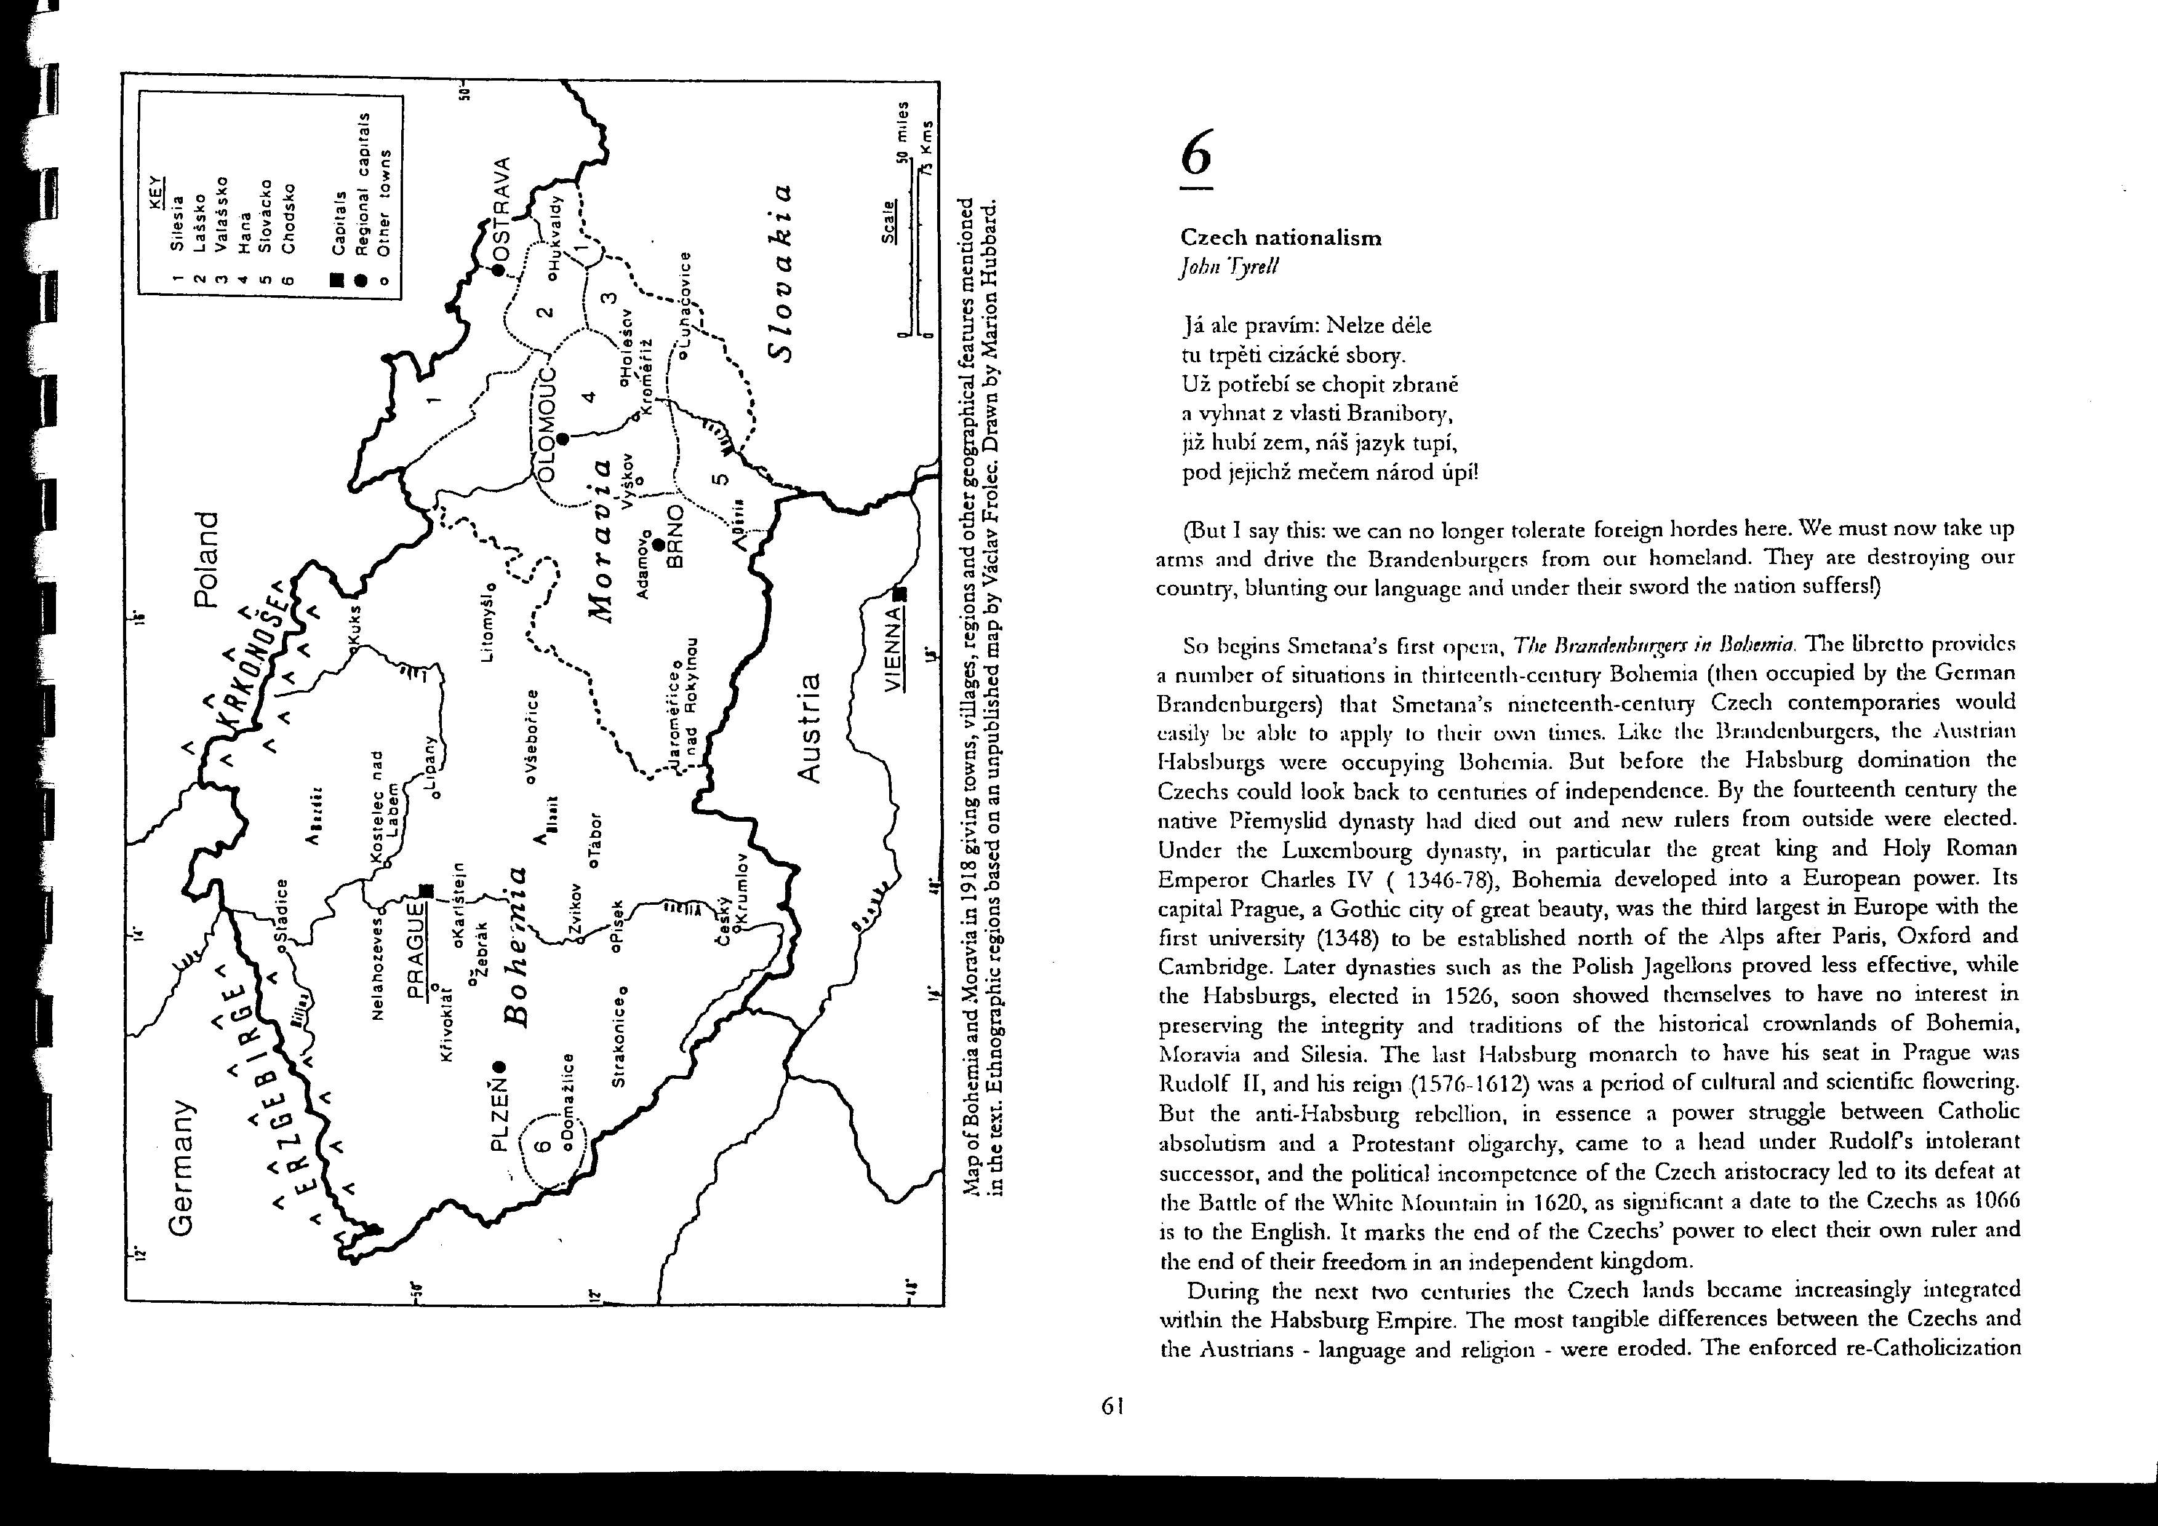
+ Horácko (Českomoravská vrchovina / „Vysočina“)
+ Horňácko (part of Slovácko)

Two main types of folk music in the Czech lands:
Western / Bohemian / instrumental x Eastern / Moravian / vocal
differences in rhythm, modality, form

Gregorian chant – latin, one-voice, liturgical
Neums

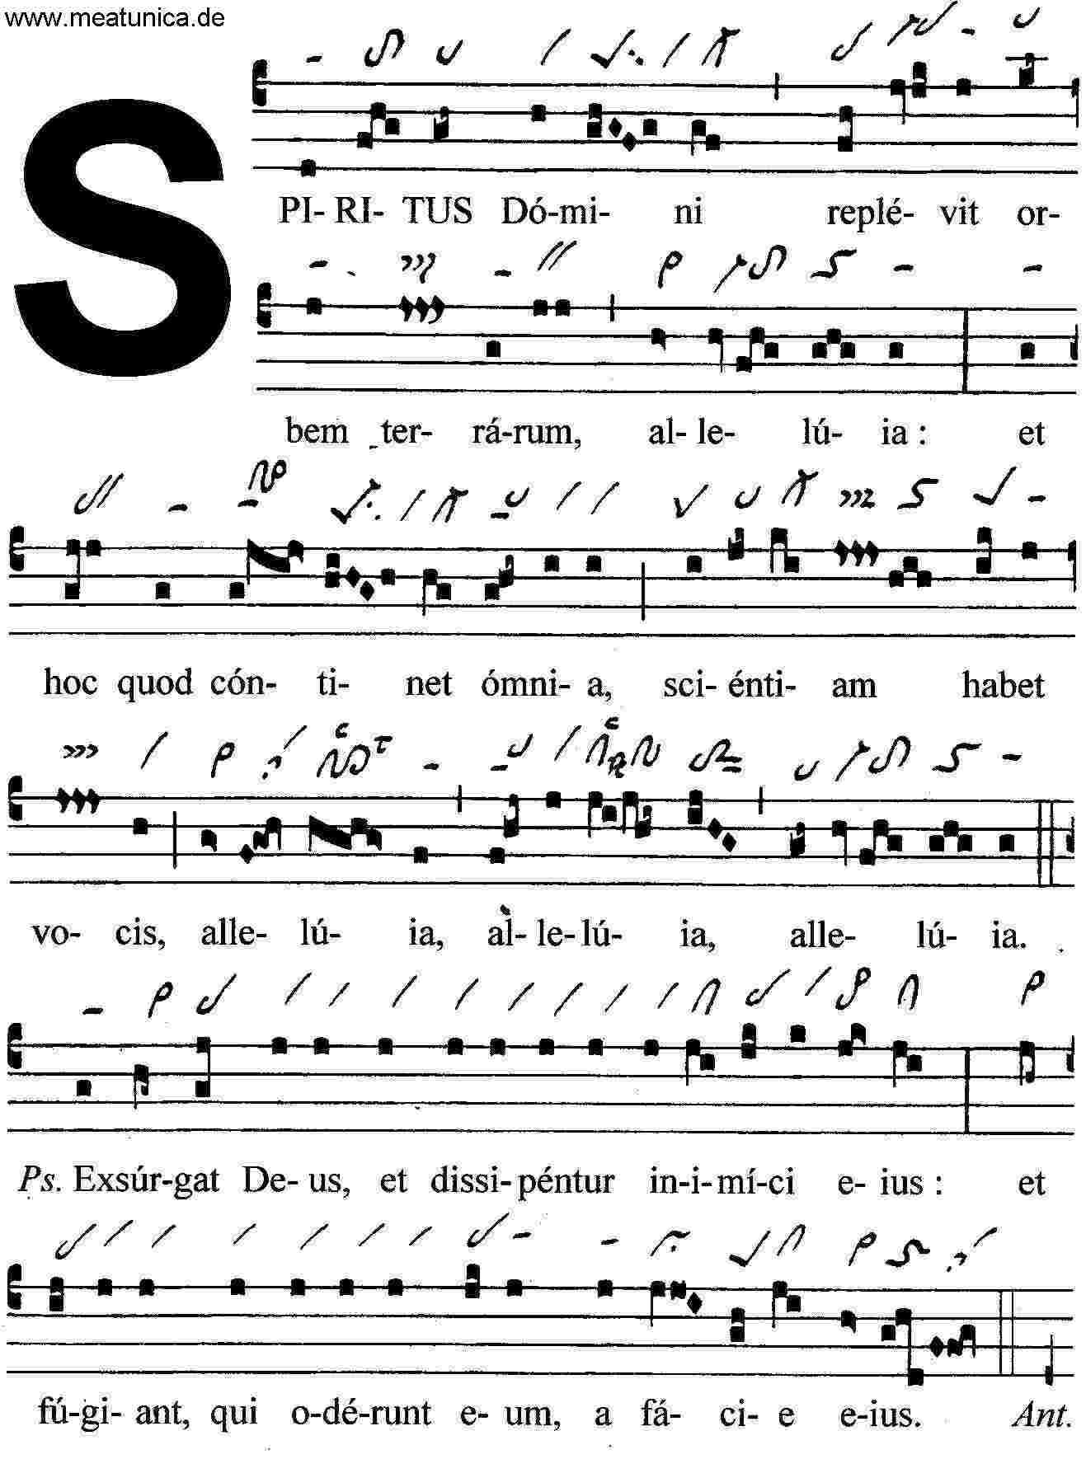
13 October 2010

MUSIC EXAMPLES
Gregorian Chant sung by Svatomichalská gregoriánská schola:
Spiritus Domini (live recording)

Moravian folk music from Horňácko:
Sung by František Okénka, played by his band

Preletěuo vtáča / Little bird flied – track 1, 0’57
Verbujú – Zapuakaly děvčata – Něbojte sa chuapci - Studená voda na járku – Něbudem sa díučiny prosit / They recruit – Girls crying – Don’t worry, boys – Cold water – I won’t beg the girl – track 3, 6’37
A tam hore pri Urbíně / There, up in Urbín (choral song) – track 7, 3’39
Ne do trňá / Not in the thornbush (suite of vulgar songs) – track 15, 3:53

Leoš Janáček (1854-1928): Moravian folk poetry in songs
a) original version for voice and piano
track – song – duration
1. Láska / Love – 1’22
7. Chodila po roli / She walked through field – 1’03
16. Zelená sem sela / I seeded the green – 1’07
18. Koníčky / Horses – 1’02
37. Lavečka / Bench – 1’34

b) arrangement for voices and string quartet by Iva Bittová, Vladimír Godár and Škampa Quartet, sung and played by Iva Bittová with the Škampa Quartet
6. Svatba komáří / Mosquitos’ wedding – 0’56
7. Kouzlo / Magic – 0’35
8. Oříšek léskový / Nut – 0’29
9. Jabluňka / Apple-tree – 3’10
26. Milenec vrah / lover murderer – 2’49
43. Muzikanti / Musicians – 1’09
53. Pohřeb zbojníkův / Bandit’s funeral – 3’34

Instrumental music from Romania (Ceanu Mare, Transylvania):
Suite of dances (no constant rhythm) - track 1, 3 mins
Guitar music - track 5

Antonín Dvořák: Slavonic dances
No. 1 in C, Furiant – track 1, 4:02
No. 15 in C, Serbian wheel - track 15
--------

Leoš Janáček: Rozloučení (Parting) for male chorus – track 12, 3:17

Iva Bittová, Vladimír Václavek: Bílé inferno (The White Inferno, 1997)
Vzpomínka – CD 1, track1

Věra Gondolánová and band: Jewels of Romany Music (2004)
Taboris (traditional, arr. Antonín Gondolán) – track 5, 3‘28
Od Buchlova (traditional) – track 6, 4‘45

phenomenon of „dechovka“ (brass music)
foresters’ songs
http://www.youtube.com/watch?v=9b7-qTV8gbE

Popular music unfluenced by folklore (Balkans)
Ilya Lukov: Obicham te (Bulgaria)

Recommended source and literature:
Transitions in Time – Traditional Folk Music in Moravia in 20th century
(2 CDs with detailed information and a scholarly study in English)

20 October 2010

Great Moravian Empire
863 Constantine and Methodius arrive
liturgy in Slavonic language, later moved to the east

Czech State

earliest Czech songs: Hospodine pomiluj ny, Svatý Václave

Prague Chapter, monasteries, liturgic hymn books

five last Přemyslids 1197 – 1306:
establishment of towns, German colonisation, Gothic culture, liturgic chant

Luxembourg dynasty 1310-1437

Hussite wars
Czech liturgy

František Palacký (1798-1876)
The History of the Czech Nation in Bohemia and Moravia
(5 vols, 1836-1867)
austroslavism

Zdeněk Nejedlý (1878-1962)

Battle of White Mountain (1620)
30 years’ war (1618-1648)
execution of 27 noblemen (1621)
Brno siege 1645

Rožmberk orchestra – half 16 – 30y war (Třeboň, Krumlov) – European composers
Harant’s orchestra in Pecka
Emperor’s orchestra (Rudolf II. 1576 – 1612) – Philipp de Monte
(Majestát 1609)

Alois Jirásek (1851-1930): Temno (darkness / gloom)

Adam Michna of Otradovice (1600-1676) - musicus poeticus

Czech emigration
Paris: Krumpholz, Dusík (Rejcha +1836)
Mannheim: Stamic[/tz], Richter
Northern Germany: Benda brothers (+Zelenka)
Italy: Mysliveček, Pichl
Wien: Vaňhal, Koželuh, Vranický brothers, Kramář, Míča, Voříšek
(Russia: Mareš, Nápravník)

Jakub Jan Ryba (1765-1815)

National revival (from 1775 on)

Josef Dobrovský (1753-1829)
Josef Jungmann (1773-1847)
(+ Palacký)
3 November 2010
Bedřich Smetana (1824-1884)
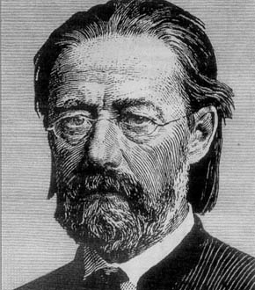
Smetana’s aesthetics
nationalist question (Young Czechs, Old Czechs)
Zdeněk Nejedlý
Gothenburg
October Diploma
National Theatre
deafness
Hussite chorals

listening:
Festive Symphony
Má vlast (My country)
Prodaná nevěsta
Libuše
24 November 2010

Antonín Dvořák (1841-1904)

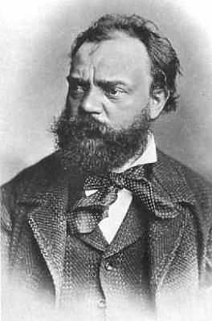

See also http://www.antonin-dvorak.cz/

Symphony No. 3 in E flat

Slavonic Dances Opp 46 and 72
Stabat mater op. 58

Josefina Čermáková – singer
Anna Čermáková / Dvořáková – AD’s wife

Provisional theatre opened 1862

Requiem op. 89

Classical / romantical synthesis

Te Deum op. 103

Zdeněk Nejedlý

String Quartet No. 12 in F op. 96

Symphony No. 9 in E minor op. 95

8 December 2010

Leoš Janáček (1854-1928)
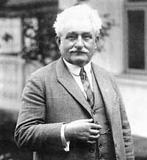

Hukvaldy - Brno (Prague - Vienna - Leipzig)

aspects:

(1) women
Zdenka - Olga - Kamilla - Gabriela - Kamilla
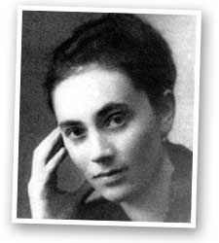
(2) Russophilia
(3) folk music, speech melodies

http://www.leos-janacek.org/lex/1s2.htm
http://www.muzikus.cz/klasicka-hudba-jazz-clanky/V-hudbe-zivot-Cechu~29~cervenec~2004/

operas:
Šárka - Beginning of a Romance - Jenufa - Fatum - Excursions of Mr. Brouček - Káťa Kabanová - The Cunning Little Vixen - The Makropulos Affair - From the House of the Dead

Hudební listy
Karel Kovařovic: Ženichové

15 December 2010
Underground movement after 1968

1945 - liberation by Soviet and U.S. armies, reconstitution of Czechoslovakia
1948-02 - Communist putsch, 1st communist president K. Gottwald
1953-03 both Stalin and Gottwald die
1956-02 - Khrushchev’s secret speech denouncing Stalin’s crimes
1960 - general amnesty (thaw)
1968-01 - Prague Spring democratic movement (Vaculík, Kundera, Havel, Dubček)
1968-08-21 - Occupation by five armies of the Warsaw pact
1969-89 - Normalization
1977 - Charter 77
1989-11 - Velvet Revolution, president Václav Havel

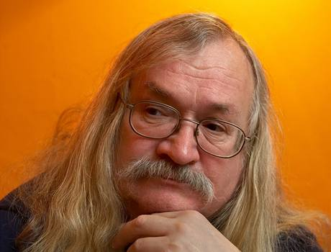

Ivan Martin Jirous - MAGOR (*1944):
Zpráva o třetím českém hudebním obrození (Report on the Third Czech Musical Revival, 1975)

- radical refusal of any pressure
- refusal of any specific art programme
- emphasis on authenticity in both art and life
- refusal of any totalitarian structures

PPU
Plastic People of the Universe
Dvacet / Twenty
Zácpa / Constipation
Jó, to se ti to spí / Oh Yeah, How nicely you sleep

Jasná páka / Hudba Praha
Pal vocuď, hajzle! / Piss off, bastard!
Ryba Badys

Václav Havel (*1936)

