7

In Search of Czechness in Music
Michael Beckerman

Writing about abstract principles of musical composition in his 1910 study, “The Importance of Real Motives,” Leoš Janáček makes the following cryptic remark: “To nourish instrumental motives with Czechness (českost) is only to take them to the source, into the present, into the sphere of Czechness.”¹ At first glance the word “Czechness” may appear amusing, a product of Janáček’s peculiar and volatile mind.² But the fact is that every scholar who attempts to deal with nineteenth-century Czech music ends up trying to articulate that very element which makes Czech music Czech. For example, in his Music of the Romantic Era of 1947, Alfred Einstein writes of Smetana’s chamber works: “All three compositions are autobiographical, full of original and vigorous invention, but formally underdeveloped and rhapsodic. Yet all three are not only very personal: they are very Czech.”³ This is followed by the pregnant question: “In what does this ‘Czech’ element consist? In the genuine use of the folk melodies? Smetana, saw quite clearly that the matter did not end there.”⁴ Leaving the question open, Einstein goes on to discuss the operas, but returns to the idea of “Czechness” in his final remarks about The Bartered Bride: “The ‘Czech’ element was not costume or folk masquerade; the spiritual element was not psychology or naturalism: and thus was realized the ideal of a merry folk opera.”⁵ End of inquiry, leaving the reader only with an idea of what Czechness isn’t!⁶
Since the publication of Einstein’s work, there has been renewed interest in treating the issues raised by Janáček. Although the question or “national style” is often dealt with in a straightforward manner in both introductory and specialized works of music history, it is, in fact, riddled with the most puzzling assumptions and contains endless philosophical culs-de-sac.⁷
Particularly in the last decade, scholars have attempted to create a model and a vocabulary for such concerns by exploring the subject with greater intellectual rigor and by examining finer details in the development of national schools. In his “Nationalism and Music” of 1974,⁸ Carl Dahlhaus sought to put the movement into a sociological context by asserting that there should be no artificial division between our analytical perception of a national work and the spirit in which it was created and received. In 1983 Richard Taruskin demonstrated that Balakirev endeavored to create a Russian national school by combining Glinka’s ideals with progressive Western formal and compositional models, while in 1984 Malcolm Brown traced the way four generations of Russian composers have used the famous Slava theme to refer to a specific historical tradition and communicate through a well-understood series of musical symbols.⁹ Most recently, Taruskin has offered a persuasive and broadly argued view of Russian music.¹⁰ He not only draws attention to the reactionary role of the state as a shaping force of Russian nationalism, but also explores the extent to which nationalism was and was not a factor in determining Russian musical developments.
These concerns have also been raised specifically in regard to Czech music. At the recent International Smetana Conference the question “what is Czech about Czech music” fluttered over the proceedings like an elusive butterfly.¹¹ Several years ago, the Czechs themselves began addressing this question. Ottlová and Pospíšil focused on attitudes toward “Czechness” in the musical criticism of the 1860s in the Czech lands,¹² and a new, full-length work titled Hudba v českých dějinách (”Music in Czech History”) offers valuable sections on “The National Awakening and Music History,” “Music and Society,” and “The Idea of National Music.”¹³
This accelerated interest in the subject opens up lines of inquiry that seek to go beyond the generalizations of the past. Despite the elusiveness of the topic, we must explore it further, for a fuller understanding of these matters will not only illuminate the question of national music, but will add an important dimension to the consideration of nineteenth-century music as a whole.
Dahlhaus proposes a kind of “comparative nationalism” to deal with the problem: “The delineation of a national style should begin not by considering how it stands out against the background of a universal European style . . . but by comparing it with other national styles and concepts of what constitutes a national style.”¹⁴
This is all well and good, but our first task is to set up viable models of individual national traditions. My object in this study is to provide one such model for Czech music, with the hope that additional models will be offered for other national musics. It is my belief that certain qualities of the Czech national tradition can best be explored under the auspices of a search for the elusive quality that Einstein stopped short of articulating – what Janáček called “Czechness.”
Our first task must be to limit the field of inquiry. First, the search for “Czechness” will begin with the historical period from 1850 onward. Although some earlier music by Czech composers has qualities that some have called “characteristically Czech,” self-conscious nationalism and the accompanying desire to invest music with specific national elements seem to emerge only about the middle of the nineteenth century. If we cannot isolate “Czechness” in this period, we never shall.¹⁵
Second, by Czech music we are referring to the music composed by Czech-born and Czech-speaking composers who perceive themselves to be part of the western European musical mainstream.¹⁶ All too often national musics are considered “dialects” of a so-called German mainstream. This is a baffling concept indeed. In the first place, a mainstream is by definition fed by the intermingling waters of diverse tributaries. Furthermore, the idea of a specifically German mainstream should be treated with some suspicion, for any stream without Berlioz, Chopin, and Liszt is not “main,” and any stream that includes them is not German.¹⁷ From the beginning Czech music has been a part of the Western European tradition. Smetana achieved his first success not as the creator of a Czech national style, but as the representative of modem music in Gothenberg, Sweden.¹⁸ His primary musical models were not Stamic, Voříšek, and Tomášek, but Mozart, Beethoven, Schubert, Liszt, and Wagner.¹⁹ Dvořák always maintained close contacts with Vienna, and avidly studied the scores of Schubert, Liszt, Brahms, and Wagner.²⁰ Even the passionate slavophile Janáček kept far closer tabs on western developments than on musical events in his beloved Russia. Martinů was a consummate cosmopolitan, studying with Suk in Prague and with Roussel in Paris.
If all these composers were tied so closely to Western European traditions, why should we bother to search for some hypothetical Czech element which might unite them? The answer is obvious. Almost all the important Czech composers working in this period insist on telling us, in many different ways, how Czech they are, and how they wish to be considered part of a tradition. The following sample of remarks shows this clearly.

SMETANA: I am, according to my merits and according to my efforts a Czech, and the creator of a Czech style in the branches of dramatic and symphonic music – exclusively Czech.²¹

DVOŘÁK: Forgive me, but I only wanted to say to you that an artist also has his country in which he must have firm faith, and for which he must have an ardent heart.²²

JANÁČEK: My latest creative period is a new jet from my soul which has made its peace with the world and seeks only to be near the humble Czech man.²³

SUK: I do not bow to anyone, except to my own conscience and to our noble Lady Music...and yet at the same time I know that thereby I serve my country, and praise the great people from the period of our wakening who taught us to love our country.²⁴

MARTINŮ: Rhythmic vitality plays an important role in Czech music, so I compose with vital rhythms. Sometimes I use Czech folk songs as themes, but more often I create thematic material colored by the style and spirit of the Czech folk idiom.²⁵

Although these five statements demonstrate the close relationship between the speakers and their country, they do not reveal a great deal about the music itself. What does it mean to have created “an exclusively Czech style,” especially for a composer like Smetana, who said of Liszt: “Let me admit openly that I have him to thank for everything I have achieved?”²⁶ What is the result of Dvořák’s “ardent heart,” who is the “humble Czech man” of Janáček’s imagination, and how does Josef Suk “serve his country?” Finally, cannot one find Martinů’s “vital rhythms” in any musical culture? And by “Czech folk idiom,” does he mean the songs of western Bohemia, Eastern Moravia, or Slovakia?
If a search for “Czechness” that begins at this metaphysical end of the spectrum seems frustrating, a brief look at the “scientific” end is even more confusing. From a theoretical point of view, it seems highly unlikely we should find specifically Czech musical elements. For example, let us postulate that “Czechness” is composed of certain musical traits which can be objectively verified and analytically defined, such as:

1. First beat accent (related to speech and folk song).
2. Syncopated rhythms (often related to characteristic dances).
3. Lyrical passages, often as a trio in a dancelike scherzo.
4. Harmonic movement outlining triads a major third apart.
5. Two-part writing involving parallel thirds and sixths.
6. Oscillation between parallel major and minor modes.
7. Use of modes with lowered sevenths and raised fourths.
8. Avoidance of counterpoint.
9. Use of melodic cells which repeat a fifth above.

These devices can be found in Czech music in abundance; yet they are also found elsewhere in Liszt’s Hungarian Dances, for example, Copland’s ballet scores, and Schubert’s string quartets. There are also many “bona fide” Czech compositions that lack these characteristics. Are they then, temporarily, “not Czech?” And are composers that exhibit these details in greater concentration “more Czech” than other composers? Must we consider Liszt, Copland, and Schubert “honorary Czechs?”²⁷ There is in fact no single musical detail that can be shown to occur in Czech music and nowhere else. Finally, can one even argue that the quotation of authentic Czech folk tunes is a characteristic that lends “Czechness” to a work?
Example 1 seems to have virtually all the prerequisites of Czech national music. It was written in Prague in 1867, one year after the first performance of The Bartered Bride, and uses themes taken from Kulda’s Marriage Among the Czech People. Yet it sounds more Russian than Czech. And indeed, it is Balakirev’s Overture on Czech Themes, later rescored and retitled, In Bohemia. Even though certain passages bear a superficial resemblance to Smetana and Dvořák, this is “Czech music” with a thick “Russian” accent. The third theme in particular (ex. 2), with its first-beat accent, is treated initially in the manner of a naigrysh, a repeated pattern also heard in Glinka’s use of the “Kamarinskaya” theme.

Example 3: Smetana, The Bartered Bride, act III, sc. 2.
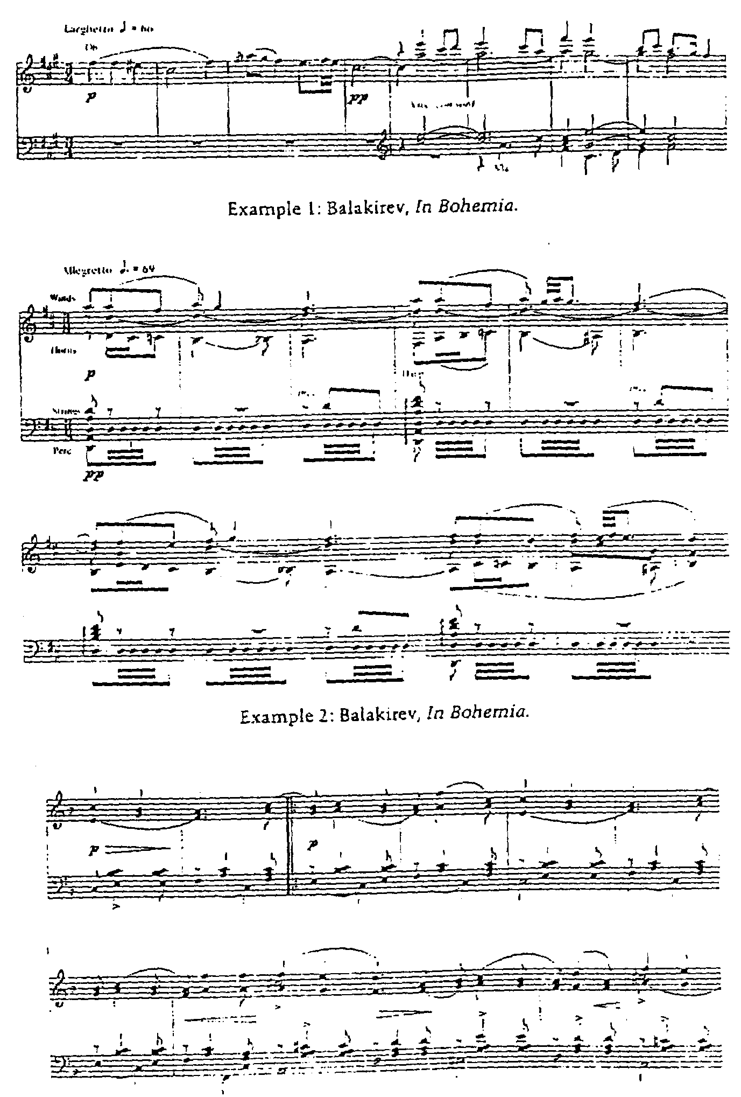
In a familiar theme from The Bartered Bride we can observe how Smetana treats similar material (ex. 3). The motive, almost a duple-meter duplicate of Balakirev’s third theme, moves through a series of keys in the following manner: F: I-vi-i-(IV)-b vi-i-I. This type of pattern occurs quite frequently in the work of Smetana, Dvořák, and later composers. We also see here a good many of the above-mentioned “Czechisms”: first-beat accent, dancelike syncopations, third relations, parallel thirds and sixths, avoidance of counterpoint, an oscillation between major and minor triads. Is the difference between examples evidence of a Czech and a Russian manner of treating material, or of contrasts in style between Balakirev and Smetana? In other words, how does one separate “national elements” from the personal styles of the most influential members of a national school?

It appears that a full discussion of “Czechness” cannot proceed from an exploration of musical details alone. Yet perhaps these details, seen in relation to the more rhapsodic pronouncements of Czech composers, can guide us to a more congenial point located at the middle of our analytic continuum, where “the Czech style” can be placed in a broader context.
When Josef Suk praised “the great people who taught us to love our country,” he was not referring to simple patriotism or political nationalism, but was summarizing the effect of the national awakening in the Czech lands, since those “great people” taught the Czechs to see all the diverse and disparate elements of their country as a unity. Thus, in the view of the Czech nationalists, the shape of the Moravian hills, the sound of the Czech language in its many dialects, the burning of John Hus, the view of Prague from Hradčany, and all the folk songs and ancient chorales were not to be considered separate, unrelated entities, but as treasures belonging together. Furthermore, it was felt that any Czech musical style should derive from this context and reflect it.²⁸
This notion of an “exclusively Czech” style was first fully developed and realized by Bedřich Smetana. Finding the basis on which it was created and the manner in which it was transmitted must therefore be an important part of our study if we are to argue that “Czechness,” rather than being an objective collection of musical materials, arises from a particular context. There are two further reasons for attempting to create a model of Smetana’s design for a Czech style as a preliminary step. First, even though he may not have been the first Czech composer to be concerned with such matters, he was the most articulate and aggressive in discussing his motivation:

I hope that if I have not yet reached the goal I set for myself, I am at least approaching it. And that goal is to prove that we Czechs are not mere practicing musicians as other nations nickname us, saying that our talent lies only in our fingers, and not in our brains, but that we are endowed with creative force, that we have our own characteristic music.²⁹

Second, he became such an awesome creative force in the Czech lands that subsequent composers had to deal not only with their own reconciliation of Czech and Western elements, but with Smetana’s powerful personal interpretation of the process as well.
Leoš Janáček wrote about Smetana’s music, “here is Czechness in music, so palpable that it is even possible to measure it.”³⁰ He cited three fundamental characteristics: Smetana’s love of nature, his concern for the events of everyday life, and his ability to evoke the deep recesses of Czech history. For this reason he was “čestější” or “more Czech.” But, according to Janáček, he also knew the thinking of the West, of Wagner and Liszt, and was therefore “světovější” or “more universal” as well.³¹
Seen from this perspective, Smetana’s vision of Czech music seeks to unite the real or imagined glories of the nation’s past with the equally resplendent wonders of the projected future. We may recognize at once that this principle is at the root of almost all nationalist philosophies (and perhaps a central characteristic of Romanticism as well). In order to recreate the Czech past, Smetana cultivated numerous historical themes, characters, and symbols, such as the Brandenburgers, Libuše, Šárka, the Hussites, and Vyšehrad, as well as myths and fantasies, like Blaník and The Devil's Wall. These were musically symbolized both by original thematic material, such as the famous Vyšehrad motive, and by authentic historical melodies, such as the Hussite war song Ktož jsú Boží bojovníci (”Ye Who are God’s Warriors”).³²
The future was suggested by uniting specifically Czech subjects with the most progressive trends in European music, the literal “music in the future.” Just as Balakirev came to grief in the late 1890s in Russia partially because he was seen as an ally of new music, so Smetana was accused of being a modernist who wished to build a musical style on forward-looking, contemporary, “non-Czech” traditions.³³
In this desire to recreate the past with the technique of the future, Smetana was very much a part of his times, and was no doubt affected by Liszt and Wagner. But it is in how he united the past and future that Smetana differs from many of his contemporaries, for he created an “eternal present” of the Czech people through the use of local subjects, as in The Bartered Bride, The Kiss, and The Two Widows, and by the evocation of the Czech countryside, in works like From Bohemia's Woods and Fields and Vltava. We must keep in mind that although much thinking about nationalism implies a certain level of abstraction, the nation was a visceral phenomenon for the Czechs. Love of country meant love of lakes, the arrangement of the fields, rivers, towns and villages, as well as historical, political, and linguistic factors. Needless to say, this eternal present was musically symbolized by folk song and dance, and communicated through various levels of folk stylization.³⁴
Smetana’s prescription for a Czech style was transmitted through several generations of Czech composers. In a sense, Smetana was to the Czech lands what Wagner was to Europe; whether or not composers chose to accept his approach, they were all indebted to him in some way.³⁵ Indeed, Czech composers could escape neither Smetana nor each other, and it is possible to conceive of composers like Smetana, Dvořák, Janáček, Foerster, Suk, Novák, Martinů and many others as a kind of extended artistic family. Consider only the following: Dvořák played under Smetana’s baton; Smetana wrote his Czech Dances in response to the younger composer’s Slavonic Dances. Janáček idolized Dvořák and conducted Moravian premieres of many of his works. Both Suk and Novák studied with Dvořák, and Suk married his daughter. Janáček, Foerster, Novák, and Suk all knew each other, and the last two were especially close at certain times. It was Suk, the pupil of Dvořák and teacher of Martinů, who, standing in the middle, as it were, was most aware of a tradition:

In the recognition of Janáček, I see the recognition of Czech music. Smetana, Dvořák and Janáček are the fundamental pillars of Czech creative music. Let us not say that Czech music has reached its high water mark. We wish for a further proud and healthy expansion, just as Smetana, Dvořák, and Janáček would have wished, naturally, an expansion such as they deserve.³⁶

The means by which other composers transmitted, integrated, and interpreted Smetana’s ideas about Czech music is rather complex, and deserves a full-length study all its own. The broader outlines make it clear that certain elements were used to suggest a context and to identify with an “exclusively Czech” tradition. For example, in the broadest sense, Smetana’s choice of subjects from Czech history as a basis for operatic and programmatic works has its analogy in literally hundreds of works by subsequent composers. The links with a tradition are further specified by the employment of musical symbols rich in associative possibilities. One of the most important of these is the previously mentioned Ktož jsú Boží bojovníci (”Ye Who are God’s Warriors”), a powerful declamatory Hussite chorale. The original version appears in the Jistebnický kancionál of 1420,³⁷ and differs in slight details from the 1530 Mladý Boleslav version used by Smetana and later composers (ex. 4).³⁸ At the close of the opera Libuše, the melody follows Libuše’s prophetic words about the Hussites (ex. 5):

The land is trembling all over and
Shaking to the depths.
And only they stand firm.

In the programmatic context of Má vlast the melody becomes an ostinato that permeates the two final movements, Tábor and Blaník. Smetana himself clearly articulated the significance of this motive: “The content of this work cannot be analyzed in detail for it embraces Hussite pride and glory and the unbreakable nature of the Hussites... On the basis of this melody the resurrection of the Czech people, its future happiness and glory develops.”³⁹ He thereby clearly associated this melody with Czech destiny, again connecting the past with the future.Dvořák continued this tradition of “Hussite pride and glory” in his Hussite Overture of 1883, which combined the spirit of the Hussite times, represented by this theme, with earlier moments in Czech history, depicted by the use of a variant of the famous Svatý Václave or St. Wenceslaus Chorale. At the beginning of the work a phrase from the chorale is juxtaposed with the opening of the Hussite song; at the close these phrases are developed further and played in reverse order. Dvořák thus forged a link with both Smetana and the Hussites, and created another musical symbol, which was taken up by later composers. Some thirty-four years later, in 1917, Janáček used the same song as a model for the Hussite victory march in the Excursions of Mr. Brouček. Twenty years after that, in 1937, Vítězslav Novák neatly concealed a version of the melody in “The March of the Taborites” from his South Bohemian Suite. As an example of the longevity of this tune we may even cite Karel Husa’s Music for Prague 1968 where it appears, slightly altered, in the timpani part (ex. 6). In several of these instances there is a clear identification with contemporary events. Janáček’s references comes during World War I, Novák’s on the eve of World War II, and Husa’s in 1968, each case proclaiming the invincible and eternal nature of the Czech people depicted by Smetana in Libuše. Josef Suk’s claim that the resemblance of the main theme of his Praga to the Hussite melody is coincidental (ex. 7) provides the best kind of evidence. If we take him at his word, we can see how deeply such motives reach into the core of the tradition.⁴⁰ We might postulate (though it cannot really be proven) that the "Hussite mode" makes itself felt in Czech music even in the absence of programmatic reasons, as in the close of Janáček’s Glagolitic Mass and the beginning of the last movement of Dvořák “New World” Symphony. Dvořák’s quotation of the Svatý Václave melody initiates another such tradition.⁴¹ Janáček arranged the work for organ in 1902; Suk, in 1914, composed Meditations on an Old Czech Chorale. Four years later, Martinů used the theme in his Czech Rhapsody, and in 1941 Novák quoted it in his Svatováclavský triptych. It also plays a subtle role in Martinů’s Symphony No.6, of 1953. In these instances we have once more an identification with historical events involving the two world wars and the independence of Czechoslovakia. These are but two of many possible examples illustrating how Czech composers identify with the nation’s past by employing musical symbols, and at the same time proclaim their own place in the more recent musical traditions of the Smetana school. The continuation of Smetana’s tendency to look to progressive strains in Western Europe is less easily documented, and certainly, considering the fact that Czech composers were writing tonal music well into the 1950s, seems to dispute any claims of modernism. But there is a strong tradition in the Czech lands of involvement with new music from Western Europe. Although Dvořák is always grouped in theca company of “Romantic classicists,” Wagner and Liszt were critically important to his development in the 1860s and ‘70s,⁴² and some of his later scores (particularly Rusalka) contain impressionistic passages. Novák and Suk both went through periods when their musical language was rejected for its extreme chromaticism, while Janáček, born in 1854, is usually discussed in the context of composers born twenty to thirty years later. Foerster was an early champion of Mahler’s music; and Martinů, especially during the twenties and thirties, was an acknowledged member of the Parisian avantgarde, drawing from a rich collection of musical styles including impressionism, expressionism, jazz, and atonality.
Despite their strong commitment to the avant-garde, the Czechs are nevertheless associated with conservative trends. The reason for this involves what may be called the “critical cement” of Smetana’s design for a Czech style: the reliance on folk music models and folk stylizations.⁴³ Folk music permeates Czech music on all levels, from the most literal to the highly symbolic. First and foremost, there is a tradition of non-functional, stylized dance sets, which seem to act as paradigms:

Smetana Memories of Bohemia 1859
Dvořák Slavonic Dances 1878
Smetana Czech Dances 1879
Janáček Lachian Dances 1890
Novák Two Wallachian Dances 1904
Foerster Dance Sketches 1907
Martinů Three Czech Dances 1926
Borova Three Czech Dances for Two Pianos 1949

We may also note that by basing musical works on folk material Czech composers automatically accepted a particular type of rhythmic organization that is a pre-fixed musical reflection of the Czech language. Thus, the typically Czech first-beat accent is but one step removed from the accent patterns of Czech speech.
Smetana and Dvořák also initiate a tradition – subsequently carried on by almost every composer – of arranging folksongs and setting folk texts. Even Suk, who uses few explicit folksongs and dances in his works, has them in mind as models. Writing about the lyrical theme from his Fantasy for Violin and Orchestra he says, “It is as if a young Czech girl were singing simply and movingly somewhere down by the forest.... It is the song of our woods, fields, and meadows.”⁴⁴
The folk ethos is also suggested by recurring symbols. For example, the image of a young girl singing becomes both a sonic symbol and a visual ideal, richly reflected in the iconography of the period.⁴⁵ Martinů combined both in a charming metaphor in his 1925 ballet-sketch Vzpoura (”Revolt”). The plot deals. with the instability of the contemporary musical scene, in which wildness and cacophony prevail. Critics are killing themselves, and even Stravinsky has fled the scene. Suddenly, a young girl in a Moravian folk costume appears, singing a simple folksong that pacifies the warring musical camps.
Many such symbols are part of the Czech tradition. In a paper exploring the use of the bagpipe in Czech music, John Tyrrell argues that “when a Czech opera composer brings a bagpipe to play on stage he is tapping a rich and suggestive vein of national associations.”⁴⁶ Indeed the bagpipe, with its drones and accompanying wind band, seems to have functioned as a sound ideal; as a symbol of the pastoral, it was part of what Dahlhaus would call the “acoustical substratum” of the Czech composer. Tyrrell provides evidence of this by citing bagpipe-like passages which occur when no bagpiper is called for in the libretto or stage directions.
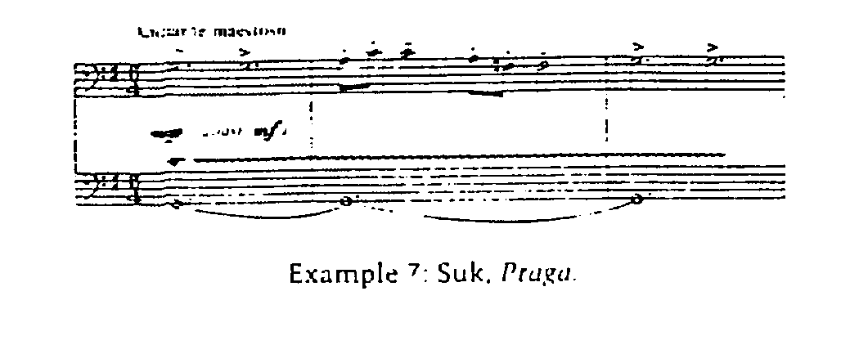
As a final example of the way traditions are passed down in Czech music, we may cite the cycle of duets Milodějne kvítí (”Love-Potion Flowers”), written in 1942 by Janáček’s pupil, Václav Kaprál.⁴⁷ In composing this explicit memorial to his daughter, also a composer and a student of Martinů, he carries on an autobiographical and memorial tradition represented by Smetana’s quartet “From my Life,” Janáček’s Elegie for his daughter Olga, and Suk’s O Mátince (”About Mother”). Kaprál’s choice of genre recalls Dvořák’s Moravian Duets and Janáček’s Folk Nocturnes, while his harmonization of the title words duplicates Janáček’s harmonization of the folk song Kvítí milodějne from Moravian Folk Poetry in Song. In such ways, the Czech composer creates within a rich web of associations and traditions, and though the style of Czech music changes, much of the content – to use Bruno Nettl’s distinction – remains the same.⁴⁸
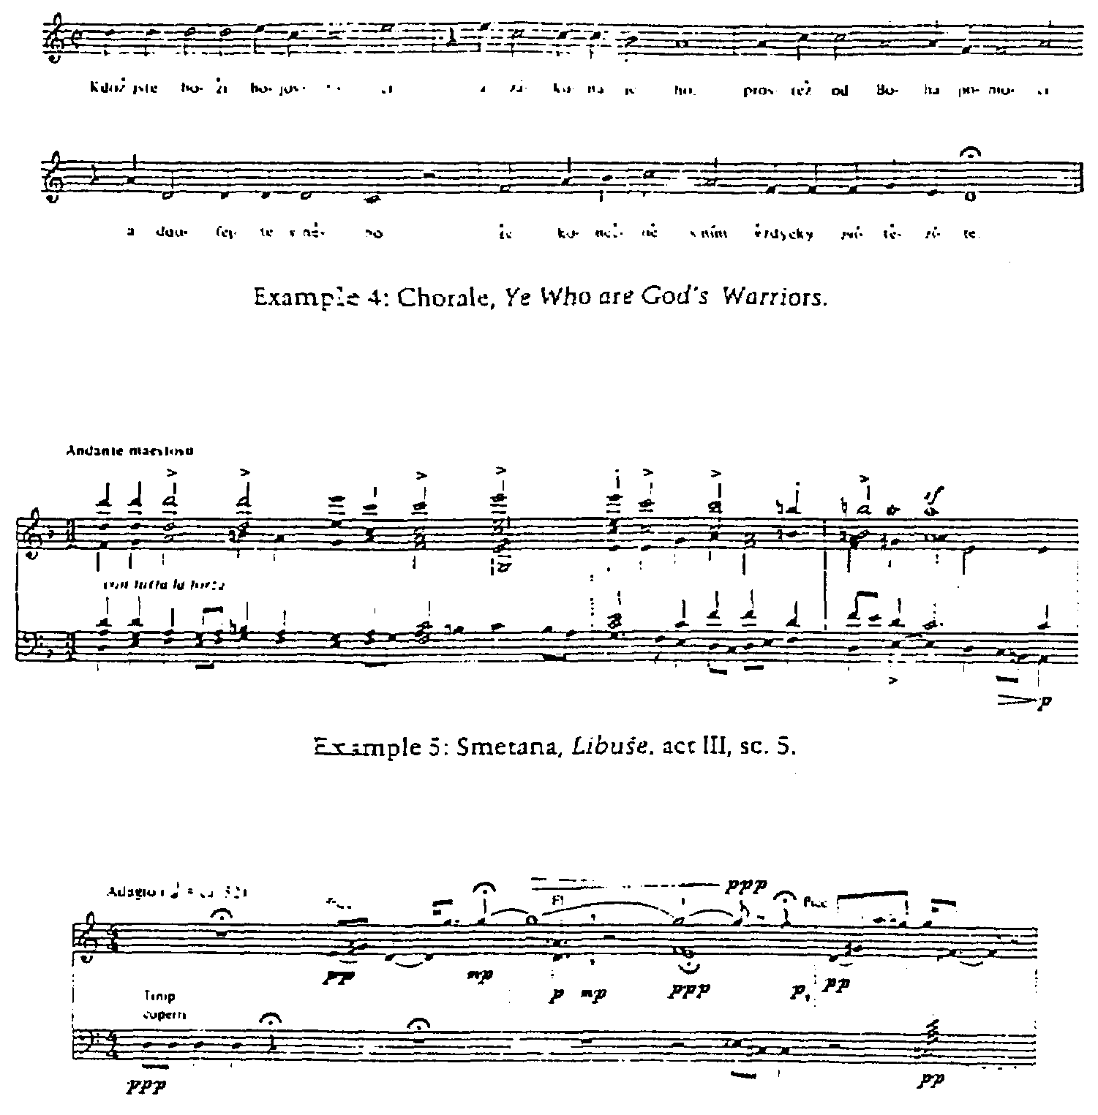
Up to this point we have dealt with a cluster of elements that contribute to what Janáček called “Czechness.” But perhaps we must realize that Czechness is more than the sum of its parts; that these sights, sounds, events, ideas, and legends give rise to a peculiar sensibility. The “Czech style” emerges only when both Czech and non-Czech elements are filtered through this all-embracing world view.
Let us consider the opening lines of The Bartered Bride:

Why shouldn’t we be happy,
when God gives us our health?
Which of us knows whether future fairs
will find us so merry?⁴⁹

Even though this work can be heard, as Einstein said, as a merry folk opera, these opening lines are colored by a subtle foreboding and an overlapping of emotional elements; although simple, the passage is not simple-minded. This quality is reflected in Smetana’s setting when, after eight “merry” measures of tonic and dominant, there is an unexpected move to the supertonic via its dominant, which seems to parallel the subtle pathos in the text (ex. 8).
Mark Germer has discussed how the Czech pastorella tradition cuts across all conventional lines, mixing sacred and secular, urban and rural, and local and universal elements.⁵⁰ This interpenetration is also a characteristic of Czech music, and it occurs at the deepest level of what we have called “Czechness,” where conventional barriers between urban sophistication and rural naiveté, progressive and conservative approaches, and popular and serious styles are dissolved. In this approach then, the eternal is mixed with the quotidian, and the utterly ingenuous coexists with the most stylized.
Perhaps the most potent image associated with this sensibility is the “malý Český člověk” or the “little Czech man” with whom, we may remember, Janáček wished to identify.⁵¹ The idealization of simplicity and directness is quite clearly reflected in many of the important personalities of the Czech tradition, where the line between the village Musikant and the professional composer is drawn as thinly as possible. There is probably no other tradition in which so many of the members began their careers as ensemble musicians Dvořák, Suk, and Martinů, and in which the role of the composer as virtuoso is so limited.
Thus we find chat Czech music tends toward a simplicity and directness of expression: in it joy appears as serious as suffering, the everyday is as important as the momentous, and the mass and the individual have equal weight. We may argue that this sensibility is at the root of the way Czech composers think about themselves and their music: there is a lack of posturing and bombast, a horror of externalizing compositional craft, and finally a reluctance to place themselves above their music. Thus, Einstein’s judgmental comment about Smetana’s music being “formally underdeveloped” is appropriate only if Smetana’s music is seen from a German perspective; from an equally valid Czech perspective, the music is “ideally developed.”
This leaves us with a problem. A theory of Czech music based on musical details alone poses severe limitations, while this broader search for a “Czech” sensibility pushes us into the realm of metaphysical speculation and ultimately, to incoherence. It seems clear that to understand “Czechness” fully we must have both an almost abstract awareness and at the -same time an attentiveness to specific cases. Hence the “Czechness” we are seeking must come about as the result of a process.
Fur example, the opening chords of Má vlast are not specifically Czech: I-vi-V⁶-I in the key of Eb (ex. 9).⁵² Yet when Smetana juxtaposes these chords with the image of the great rock Vyšehrad, and that image is further abstracted into a symbol of the enduring quality of the Czech people, the chords become imbued with a sensibility, and the sensibility becomes tied to something concrete. Having been suffused with Czechness, the chords become Czech and impart this quality to surrounding material, which ultimately redefines and enhances the very sensibility that produced it. In the same way a work, or a series of works, with explicitly Czech references, whether musical, programmatic, or both, tends to impart a Czech sensibility to other works in the composer’s oeuvre which might not otherwise have such a connotation.
In Art and Illusion, E. H. Gombrich tells the story of Kenneth Clark moving backwards and forwards in front of a painting, crying in vain to find the point from which he could examine both the intricate details of brush stroke and the painting as a unity, the point at which the whole and the sum of its parts are simultaneously perceptible.⁵³
”Czechness” is very like a painting in this sense. Though it may be associated with certain elements, it does not necessarily derive from chem. When one steps too close, it seems to vanish in the multiplicity of details, none of which individually captures that quality. The essence of Czech music is not merely the sum of its parts; it both transcends them and alters their meaning.

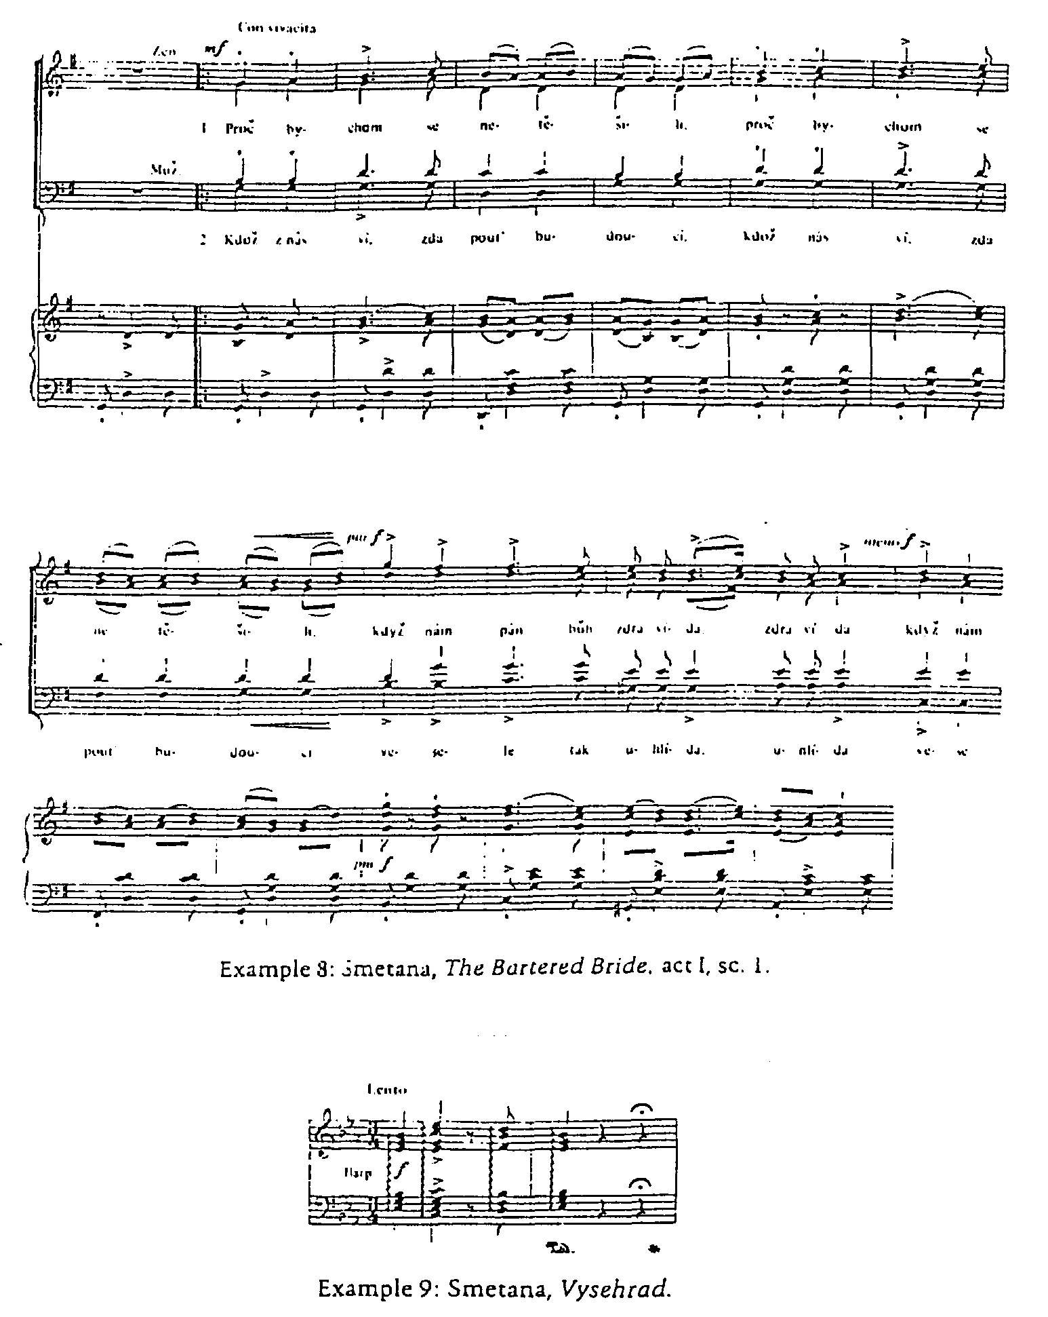
Thus we may finally make a distinction between “the Czech style” and “Czechness” itself. While the former may be considered a series of descriptive or analytic generalizations based on the actual characteristics of a body of music, “Czechness” itself comes about when, in the minds of composers and audiences, the Czech nation. in its many manifestations, becomes a subtextual program for musical works, and as such, it is that which animates the musical style, allowing us to make connections between the narrow confines of a given piece and a larger, dynamic context.
Thus even though we cannot precisely define “Czechness,” any more than we can fully articulate “Russianness” or “Germanness,” we must realize that the participants in nineteenth-century musical life believed in such things and valued them. As such, they must be considered as “aesthetic facts” without which one cannot clearly interpret the nuances of communication in the music of this period. The study of nineteenth-century Czech music must begin with an acknowledgement that for the Czech composer and his audience. Czechness is as real as the river Vltava, Smetana’s eternal image of waters which, by flowing through a country, unite a land, and its culture, history, and people.

NOTES
1 Leoš Janáček, “Váha reálných motivů” (”The Importance of Real Motives”), Dalibor 2 (1909-10), 227. Also in Leoš Janáček: Hudebně teoretické dílo 2, ed. Zdeněk Blažek (Prague, 1971, pp. 141-43.
2 For some examples of Janáček’s flamboyant writing style, see Leoš Janáček: Leaves From My Life. ed. and trans. Vilém and Margaret Tausky (New York. 1982).
3 Alfred Einstein, Music in the Romantic Era (New York, 1947), p. 299.
4 Ibid.
5 Ibid., p. 300.
6 Even Gerald Abraham writes: “Dvořák’s music is profoundly Czech in a way that Smetana’s, for all his patriotism, seldom is.” The Concise Oxford History of Music. (Oxford. 1979), p. 697.
7 For an example of the difficulties of dealing with national styles, see Leon Plantinga, Romantic Music (New York, 1984). The author’s discussion of nationalism begins oddly with a discourse on the Viennese waltz. Also, the grouping of such utterly diverse composers as Berwald, Tomášek, Sterndale Bennett, and Tchaikovsky under a single “nationalist” banner seems to deprive the word of any meaning whatsoever. See also my fn. 17.
8 Carl Dahlhaus, “Nationalism and Music,” in Between Romanticism and Modernism: Four. Studies in the Music of the Later Nineteenth Century, trans. Mary Whittall (Berkeley and Los Angeles, 1980), pp. 79-101.
9 Richard Taruskin, “How the Acorn Took Root – A Tale of Russia,” this journal 6 (1983), 189-212; Malcolm Brown, “Theme as Prototype in Russian Music,” paper delivered at the Romantic Music Festival, Butler University, 1984.
10 Richard Taruskin. “Some Thoughts on the History and Historiography of Russian Music,” Journal of Musicology 3 (1984), 321-39.
11 The International Smetana Centennial Conference was held in San Diego, California, in March of 1984. See my re port m this journal 8 (1984), 87-88. Proceedings of the Smetana Centennial Conference (henceforth PSCC) are forthcoming.
12 Marta Ottlová and Milan Pospíšil, “K otázce českosti v hudbě 19. století” (”On the Question of Czechness in 19thCentury Music”), Opus Musicum 11 (1979), 101-03. Also published as "Zur frage des Tscheschischen in der Musik des 19. jahrhunderts,” in Hudba slovanských národů (”Music of the Slavic Nations”) (Bmo, 1981), pp. 99-104.
13 Hudba v českých dějinách (”Music in Czech History”) (Prague, 1983). See Petr Vit’s “Doba národního probuzení” (”The Age of National Revival,” i.e. 1810-60), pp. 287-327, especially pp. 290-91, 14-16, and 32 l.
14 Dahlhaus, p. 90.
15 Arguments have been made for the existence of Czech elements in fifteenth-century works such as the Hussite songs of the Jistebnicky koncionál, and even earlier.
16 This eliminates émigrés of Czech and Czech-German descent, as well as Czech-born composers such as Gustav Mahler who spoke German and did not see themselves as part of a Czech culture. Arguments have, however, been made for Mahler’s “Czechness.” See John Yoell, “Gustav Mahler’s Czech Connection,” forthcoming in PSCC.
17 This would appear to be one of the critical questions in the historiography of nineteenth-century music. Is Liszt to be considered a cosmopolitan neo-German or a Hungarian patriot? Is Chopin a classicizing Francophile or the real father of the Polish national school? Historical fantasy is not yet an acceptable scholarly genre, but one can imagine the differences in the musical geography of the century had Liszt and Chopin remained at home, or had Smetana remained m Gothenberg or Weimar. Even the view, which is being expressed more often, that Wagner and Verdi deserve to be counted among the “nationalists,” complicates the picture somewhat.
18 For a description of Smetana's stay in Gothenberg, see Brian Large, Smetana (London, 1970), pp. 70-97.
19 For an interesting discussion of Schubert’s influence nn both Smetana and Dvořák, see Vojtěch Kyas, “'Smetana e Dvořák e il loro rapporto con Schubert,” Nuova Rivista musicale italiana 18 (1984), 52-62.
20 Jarmil Burghauser, “Smetana’s Influence on Dvořák’s Creative Evolution,” forthcoming in PSCC.
21 Bedřich Smetana in a letter to Dr. Ludevít Procházka, Dresden, 31 August 1882. Printed in František Bartoš, Bedřich Smetana: Letters and Reminiscences (Prague, 1955), pp. 250-51. Originally pub. as Smetana ve vzpomínkách a dopisech (Prague, 1939, 1954).
22 Dvořák in a letter to Simrock, Berlin. 10 September 1885. Printed in Otakar Šourek, Antonín Dvořák: Letters and Reminiscences (Prague, 1955), p. 98. Originally pub. as Dvořák ve vzpomínkách a dopisech (Prague, 1938, 1951).
23 From a speech made on 11 July 1926 at the unveiling of a memorial plaque at Janáček’s birthplace in Hukvaldy. Printed in Jaroslav Vogel. Leoš Janáček Prague, (1962, 1981), p. 333.
24 Quoted in Jiří Berkovec, Josef Suk (Prague and Bratislava, 1969, p. 65.
25 In Brian Large, Martinů (New York, 1976), p.140.
26 See Bartoš, p. 225, fn. 21.
27 For example, one might argue that, based on the above characteristics, a1l Czech music, with minor variations, emerges from the Scherzo of Schubert’s C-.Major Quintet.
28 Janáček expresses such a notion in the following passage: “I have written a thing which was liked in southern, western, and northern Bohemia, which was liked in Prague, and in Moravia and Slovakia. And it occurred to me to ask mw self what actually is the power of art There is something in it, a sort of vibrating string, which sounds everywhere and links us together wherever we may be.” In Bohumír Štědroň, Leoš Janáček: Letters and Reminiscences (Prague. 1946). Originally pub. as Janáček ve vzpomínkách a dopisech (Prague, 1946).
29 Bartoš, p. 210.
30 Leoš Janáček, “Tvůrčí mysl” (”The Creative Spirit”), Lidové noviny 32 (1924). Also in Leoš Janáček: Fejetony z Lidových novin (Leoš Janáček: Feuilltonns f'rom the Lidové noviny) (Bmo, 1958), pp. 220-23.
31 A full translation of this article, with the title “Inspired Mind,” can be found in Music News From Prague 2 (1984), I.
32 This song was considered the rallying cry of the Hussite movement and was first used in Karel Šebor’s The Hussite Bride (1868)ů see fn. 7.
33 See Robert Ridenour, Nationalism, Modernism and Personal Rivalry in 19th Century Russian Music (Ann Arbor, 1981).
34 These levels range from the usage of authentic Czech folk tunes as the basis for musical works, to the so-called ohlas lidové písně (”folk-song echoes”), such as the dances from The Bartered Brid,. to folklike passages in other contexts such as the “wedding party” section written into the program of Vltava.
35 Plantinga comes close to the conclusion when he aptly says about Smetana that “his personal idiom comprised of diverse elements, some of them imitative of Bohemian folk styles, came to be accepted as uniquely representative of his nation’s musical culture” (p. 351).
36 Speech by Josef Suk upon receiving an honorary doctorate at Masaryk University in Brno in 1934 in Štědroň,
37 For the original version of this melody see Jaroslav Pohanka, Dějiny české hudby v příkladech (”A History of Czech Music in Examples”) (Prague, 1958), p. 28.
38 I am indebted to Malcolm Brown’s “Theme as Prototype in Russian Music” (see fn. 101 for the approach employed m this section. 39 Bartoš, p. 265 40 In this case, however, the meter and tempo designations suggest a real kinship with Smetana’s treatment of the theme (see ex. 5). 41 For the original Svatý Václave melody, see Pohanka, p.
42 See Burghauser.
43 We hopefully have reached the point in style criticism where the evaluation of the “modernity” of a particular musical work is no longer based on a given composer’s use of tonality. The notion that folk music is tonal, and therefore all music based on folk melodies is therefore more or less conservative, is insupportable.
44 Quoted in Berkovec, p. 29.
45 Many of the covers of piano-vocal scores of operas by Smetana, Janáček. Dvořák, and others feature water colors of a young girl in folk costume. Such pictures also appear frequently in published editions of folk-song settings and settings of folk texts, particularly those of Janáček and Martinů. To the best of my knowledge there is no iconographic study of this phenomenon or the role it plays in determining an attitude toward the music itself.
46 John Tyrrell, “Švanda and his Successors: The Bagpiper and his Music in Czech Opera,” forthcoming in PSCC. Of course, the association of the bagpipe with pastoral settings is a European tradition dating back to the Middle Ages Drones alone do nor Czech music make, as even the briefest glance at such works as Beethoven’s Sixth Symphony and Brahms’s First Serenade reveals. However, Tyrrell convincingly shows that the persona of the bagpiper himself is quire important, and composers may even evoke a specific “Czech wind band” sound consisting of bagpipes, clarinets, and fiddle.
47 Václav Kaprál (1889-1947), Czech composer and teacher.
48 See Bruno Nettl, The Studv of Ethnomusicology: Twenty-Nine Issues and Concepts (Urbana, 1983), p. 47-49. See: especially p. 48. “We may regard musical ideas, motifs, lines, tunes as analogous to words or concepts in a language. If a rune retains its integrity through changes of scale, mode, meter, form, and singing style, that aspect of o which remains constant – and this is often very difficult to pin down – can be regarded as content.”
49 Translation mine.
50 Mark Germer, “On the importance of the Pastorella,” forthcoming in PSCC.
51 The idea of the “malý Český člověk” permeates the novels of Čapek, is at the core of Hašek’s Good Soldier Švejk, and can be said to play a not inconsiderable role in the novels of Kafka.
52 One might be tempted to argue that the passage reflects the Czech penchant for first-beat accent, but the similarity between it and the pilgrim’s Chorus from Tannhauser might turn Wagner into an “honorary Czech.”
53 E. H. Gombrich, Art and Illusion (Princeton, 1961), p. 6.

In: Frisch, Walter and D.Kern Holoman and Joseph Kerman, ed. 19th Century Music. Volume X, number 1. Summer 1986.

