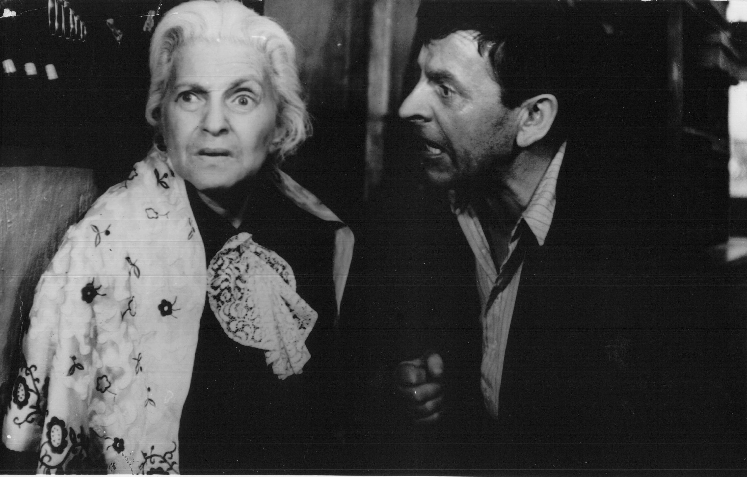

The Shop on Main Street, Ján Kádar, Elmar Klos, 1965

