### [Healthcare ethics and the beginning of life](https://moodle.utb.cz/course/view.php?id=26803#section-12)

**Introduction**

Healthcare has changed incredibly over the last few decades. The care of pregnant women has also changed and related things like laws, individual views of the world.

One of the most controversial topics in this world is without a doubt the topic dealing with the beginning of life therefore, this essay summarizes the available approaches and views on the topic about the beginning of life and specifically focuses on the ethical aspects - the ethics of assisted reproduction, the ethics of prenatal diagnosis and as well the ethics of abortion.

**Text of the essay**

1. **The beginning of the life**

In modern medicine, science and bioethics is the question “When does human life begin and is the fetus person” one of the most controversial. Intelligence, self control, self-awareness etc. are one the list of necessary condition for being a person. Those abilities are developed from the thirtieth week of pregnancy, so from that perspective is every fetus a person from the third trimester. At the moment of birth is the human a legal person with rights. (Kurjak, s. 89). Ancient Greek Philosopher Plato and his Jewish and Christian admires thought that individual human souls existed before they would inhabit into the bodies. Some religions (mostly Christian thinkers) that God directly created the human soul. (Kenny, 2018, s. 15) And in the Bible in the Gospel of Luke can be found reference to fetal movement, where Mary is pregnant with Jesus and Elizabeth with John, and Mary told her about her moving fetus. It indicated that the fetus is “life”. The first movement, in traditional Cathlolic theology, was the moment when into the embryo came the soul. (Scott, 2017, s. 117) Thomas Aquinas (in the thirteenth century) believed in a complicated version of this theory and he held the opinion that human being does not count until the soul is part of the human body. And the soul is created by God at 40 days for males and at other 50 days for females. (Kenny, 2018, s. 16-17)

Someone understands the beginning of life as early as the fusion of a mature ovum with a sperm. In this case it means that the embryo should have the same degree of protection as any other person. The Society for the Protection of Unborn Children is followed for this theory. (Scott, 2017, s.117) For me, as a mother of two children, life begins with the very fusion of sex cells and it is incredible to watch how the embryo develops day by day. And if someone does not feel up to being a parent, or could not provide loving arms, there are many people in the world who would give anything to have this opportunity.

1. **Assisted Conception**

After the birth of the first child through the assisted human reproduction of Louise Brown, several doctors and pioneers of the Steptoe and Edwards method in England in 1978, Ganhou's technique was highlighted and expanded through numerous trials. A number of improved procedures have been initiated, the main goal of which is to treat infertility and subsequently prevent genetic damage, in addition to everyone having the right to start a family. With all the successes achieved in the various fields of assisted conception, questions of ethics and morality will become present with respect to new inventions of improvement while facilitating technical performance. Problems such as the embryonic character or the freezing and fate of the gametes, as well as their elimination, post-mortem reproduction or womb substitutions, such as donated gametes, human clones and or pre-diagnosis implementional, were and still are ethical goals. (Silva, Santana a Santos, 2019, s. 38)

Ethical problems are not caused, for example, by drug treatment, but in the case of using the techniques already listed, a problem can arise. It also depends on how infertility is viewed - for example, as a disease that can be treated. An insulin injection is given to a patient suffering from diabetes (naturally), but a patient suffering from infertility is in some cases unethical to donor sperm/egg, even though he/she would like to be treated and have a family. (Scott, 2017, s. 120)

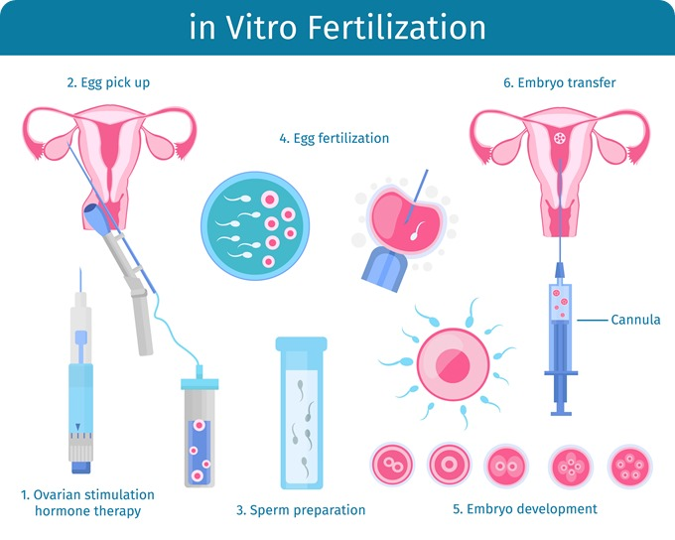

picture 1- IVF, [www.news-medical.net](http://www.news-medical.net)

**2.1. In vitro fertilization (IVF)**

IVF is a method where the egg is fertilized outside the female body, it also includes testing the egg for genetic defects and the subsequent return of the egg to the uterus of another woman or the uterus of a donor. The IVF method is very often used by infertile couples, but also by uncoupled women to become mothers. One of the unsolved problems of this method is that the viability of the eggs is not guaranteed. Thus, when fertilization occurs and the eggs are returned to the uterus, this can cause multiple embryos at the same time, increasing the risk of death during (or shortly after) birth and birth defects. Sometimes selective reduction is carried out, but this can be against religious and other beliefs. When IVF treatment ends, couples must decide what to do with their excess embryos. The choice is to store (freeze) the embryos for further cycles of treatment, to donate to other infertile couples or to donate to stem cell research. The agreement is signed with informed consent. (Phalen, 2017, s. 119)

**2.2. Surrogacy**

The process in which a woman gestures and gives birth under pre-agreed conditions to another couple or person (future parents) is referred to as surrogacy. This surrogacy can be unpaid (=altruistic) or paid (=commercial); it is further divided into full/direct/traditional and host/gestational. the surrogate provides her own eggs in full surrogacy, in guest surrogacy the eggs are from the donor or from the intended parents. Paid surrogacy is allowed in the US, in certain cases in the countries of Russia, Georgia and Ukraine; in other countries only an unpaid form of surrogacy is allowed; the problem is legal status. Thousands of babies are born through surrogacy, but in certain countries and families this is unacceptable due to culture, ethics and religion. (Jones et al., 2021 ,s. 140)

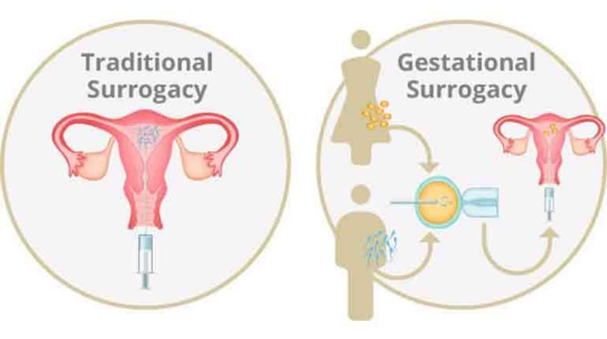

picture 2, Surrogacy, [www.practostatic.com](http://www.practostatic.com)

In my opinion - it is great that nowadays science and technology can help couples who can't have children naturally. On the other hand - many young people, after a few months of trying for a baby, visit an IVF centre where they pay a lot of money and it does not always work out. I personally think that IVF has become a huge business. I have also heard the opinion that "test tube" children are more susceptible to diseases, but only experts can judge this. Personally I do not share this, because I have healthy children from IVF in my immediate surroundings.

1. **Prenatal Diagnosis**

During the pregnancy, screening tests are offered - most often in the form of ultrasound examinations and blood tests to detect fetal abnormalities. A woman may or may not undergo tests. Thanks to modern technology, today's test results are more accurate than in the past -for example, it is possible to undergo a blood test for Down's syndrome as early as around the 10th week of pregnancy, but this earlier information also brings ethical dilemmas, in the event of a diagnosis of the disease - whether a woman should undergo a termination of pregnancy or whether to continue it. (Scott, 2017, s. 121)

In addition to the health of the fetus, prenatal diagnosis can detect a fetal abnormality, but also inform about genetics and clarify the risks of recurrence for the next pregnancy. Thanks to advances in test technology (as well as a more affordable price), expectant parents can learn more prenatal information and possibly not only prepare emotionally for a complicated birth and newborn care. Prenatal genetic testing can be invasive or non-invasive. The non-invasive form is safer and widely used, for example in combination with ultrasound, but false positive/negative results can occur. The invasive form is more accurate, but there is a small risk of miscarriage. Is it necessary to undergo genetic prenatal testing that can harm the embryo? There is a need for providers to balance the potential for harm with making the information even better and more beneficial. (Richardson a Ormond, 2018,s. 1-2)

I believe that genetic prenatal testing brings far more benefits than possible side effects and risks. Modern and constantly developing tests provide parents with more and more new information, and although the test results are not always correct, couples can prepare for them or terminate the pregnancy in time.

**4. Abortion**

The termination of a pregnancy is called abortion. It is also the termination of a potential human which can happen naturally or unnaturally. Naturally, it means miscarriage- expulsion of the embryo/fetus or absorption the fetus/embryo into the mothers body and it can not naturally survive. This abortion is usually sad and has ethical or unethical aspect because of the end of human life. In case of unnaturally abortion, there are many ethical implications and reasons. One of them can be only the “convenience” or preventing children from suffering. This topic divides people - everybody has “right to life” and on the other hand “right to choose” be or not to be a parent. Another option for elective abortion are multiple pregnancies where the number of embryos is reduced, the reason is not to have problems with multiple pregnancies. (Phalen, 2017, s. 118)

Abortion is lawful in case of mental or physical abnormality, in this case there is no treshold. In other cases, abortion is only up to the 24th week of pregnancy. In the case of public opinion polls, we would find that a small percentage would be strict in their opinion about free abortion - either never or always. Most of the population would not agree to abortion, but the exception could be cases of fetal abnormalities or rape. The main basis of the different positions is based on the opinion about the beginning of life, which is described in the first chapter. In most cases, a person is against abortion if they believe that life begins at conception. The womens have the right to choose and the fetus's right to life, even though it is still inside the womb. (Scott, 2017, s. 124)

Personally, I agree with the majority opinion of the population and it is okay to have an abortion due to rape, some illness and other possibilities. In any case, the decision may also be influenced by the person's religious belief and social situation.

**Conclusion**

Some of the most controversial questions in the world are "When does life begin" and "Is a fetus a person". The view and origin of life is influenced by many attributes - for example, religion, culture, ethics and morality. Some believe that life begins with the fusion of sperm and egg; the successors of Thomas Aquinas, on the other hand, believed that the human soul enters the human body after 40 days (for men) and 90 days for women after the fusion of the gametes.

Today's modern technology and science offers help to couples in the treatment of infertility. One of them is IVF, which was first tried in the 1970s and has since helped thousands of couples to be parents. However, not all cultures view infertility as a disease. Another possibility is surrogacy, and even here various ethical problems can arise, also the fact that surrogacy is prohibited in some countries plays a role here, the most benevolent is in the USA.

The penultimate part discusses the ethical aspects of prenatal testing. The non-invasive form is very common and harmless, the invasive form can harm the fetus, but has more accurate information. But does the potential damage to the embryo balance this information? Of course, because modern genetic prenatal tests provide information not only about the fetus, but also, for example, the risks of recurrence for the next pregnancy.

But it can also happen that the pregnancy does not have a happy end, there can be a natural abortion, but also an elective one. If a woman decides to terminate a pregnancy /embryo without an abnormality/, is it still ethical? Doesn't the child inside the womb have the same right to choose as his mother?

**References**

JONES, B. P., N. RANAEI-ZAMANI, S. VALI, et al. Options for acquiring motherhood in absolute uterine factor infertility; adoption, surrogacy and uterine transplantation. *The obstetrician* [online]. 2021, 23(2), 138-147 [cit. 2022-09-28]. ISSN 14672561. Dostupné z: doi:10.1111/tog.12729

KENNY, Anthony. The beginning of individual human life. *Daedalus* [online]. 2008, 137(1), 15-22 [cit. 2022-10-04]. ISSN 00115266. Dostupné z: doi:10.1162/daed.2008.137.1.15

KURJAK, A. Controversies on the beginning of human life - science and religion closer and closer. *Psychiatria Danubina* [online]. 2021, 33(Suppl 3), S257-S279 [cit. 2022-10-04]. ISSN 03535053. Dostupné z: <https://search.ebscohost.com/login.aspx?direct=true&db=cmedm&an=34010252&scope=site>

PHALEN, Robert F. *Core Ethics for Health Professionals* [online]. Cham: Springer International Publishing, 2017 [cit. 2022-10-07]. ISBN 978-3-319-56088-5. Dostupné z: doi:10.1007/978-3-319-56090-8

RICHARDSON, Anastasia a Kelly E. ORMOND. Ethical considerations in prenatal testing: Genomic testing and medical uncertainty. *Seminars in Fetal and Neonatal Medicine* [online]. 2018, 23(1), 1-6 [cit. 2022-10-10]. ISSN 1744165X. Dostupné z: doi:10.1016/j.siny.2017.10.001

SCOTT, Anne. *Key Concepts and Issues in Nursing Ethics.* 1. vydání. Galway:Springer International Publishing, 2017. 225 s. ISBN 978-3-319-49250-6

SILVA, Daniel Chosé da, Bárbara Pessoa de SANTANA a Aarin Leal SANTOS. ETHICS AND HUMAN RIGHTS IN ASSISTED REPRODUCTION. *UNINGÁ Review* [online]. 2019, 34(3), 35-48 [cit. 2022-10-09]. ISSN 21782571. Dostupné z: <https://search.ebscohost.com/login.aspx?direct=true&db=edsdoj&an=edsdoj.5bd4fd81ebd94b8483a0ff015990d8ef&scope=site>

Bc. Klára Gacíková, M210144